Vacuum and Hyperoxygenation Therapy for Non Healing Wounds
Diabetic, Varicose
Shared by Rishi Valley Rural Health Centre

- The wound is cleaned with saline, debrided

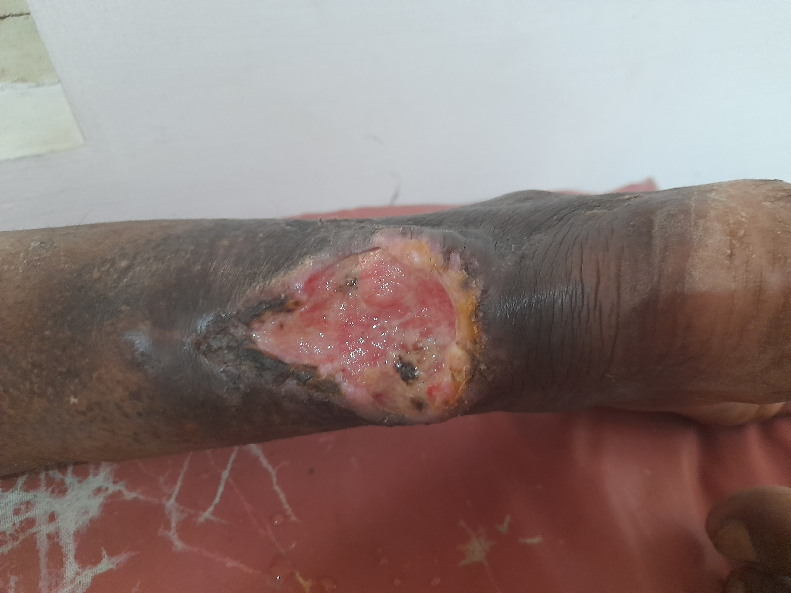

- The wound is covered in a sterile saline soaked gauze
- A small cut is made to introduce a sterile rubber catheter

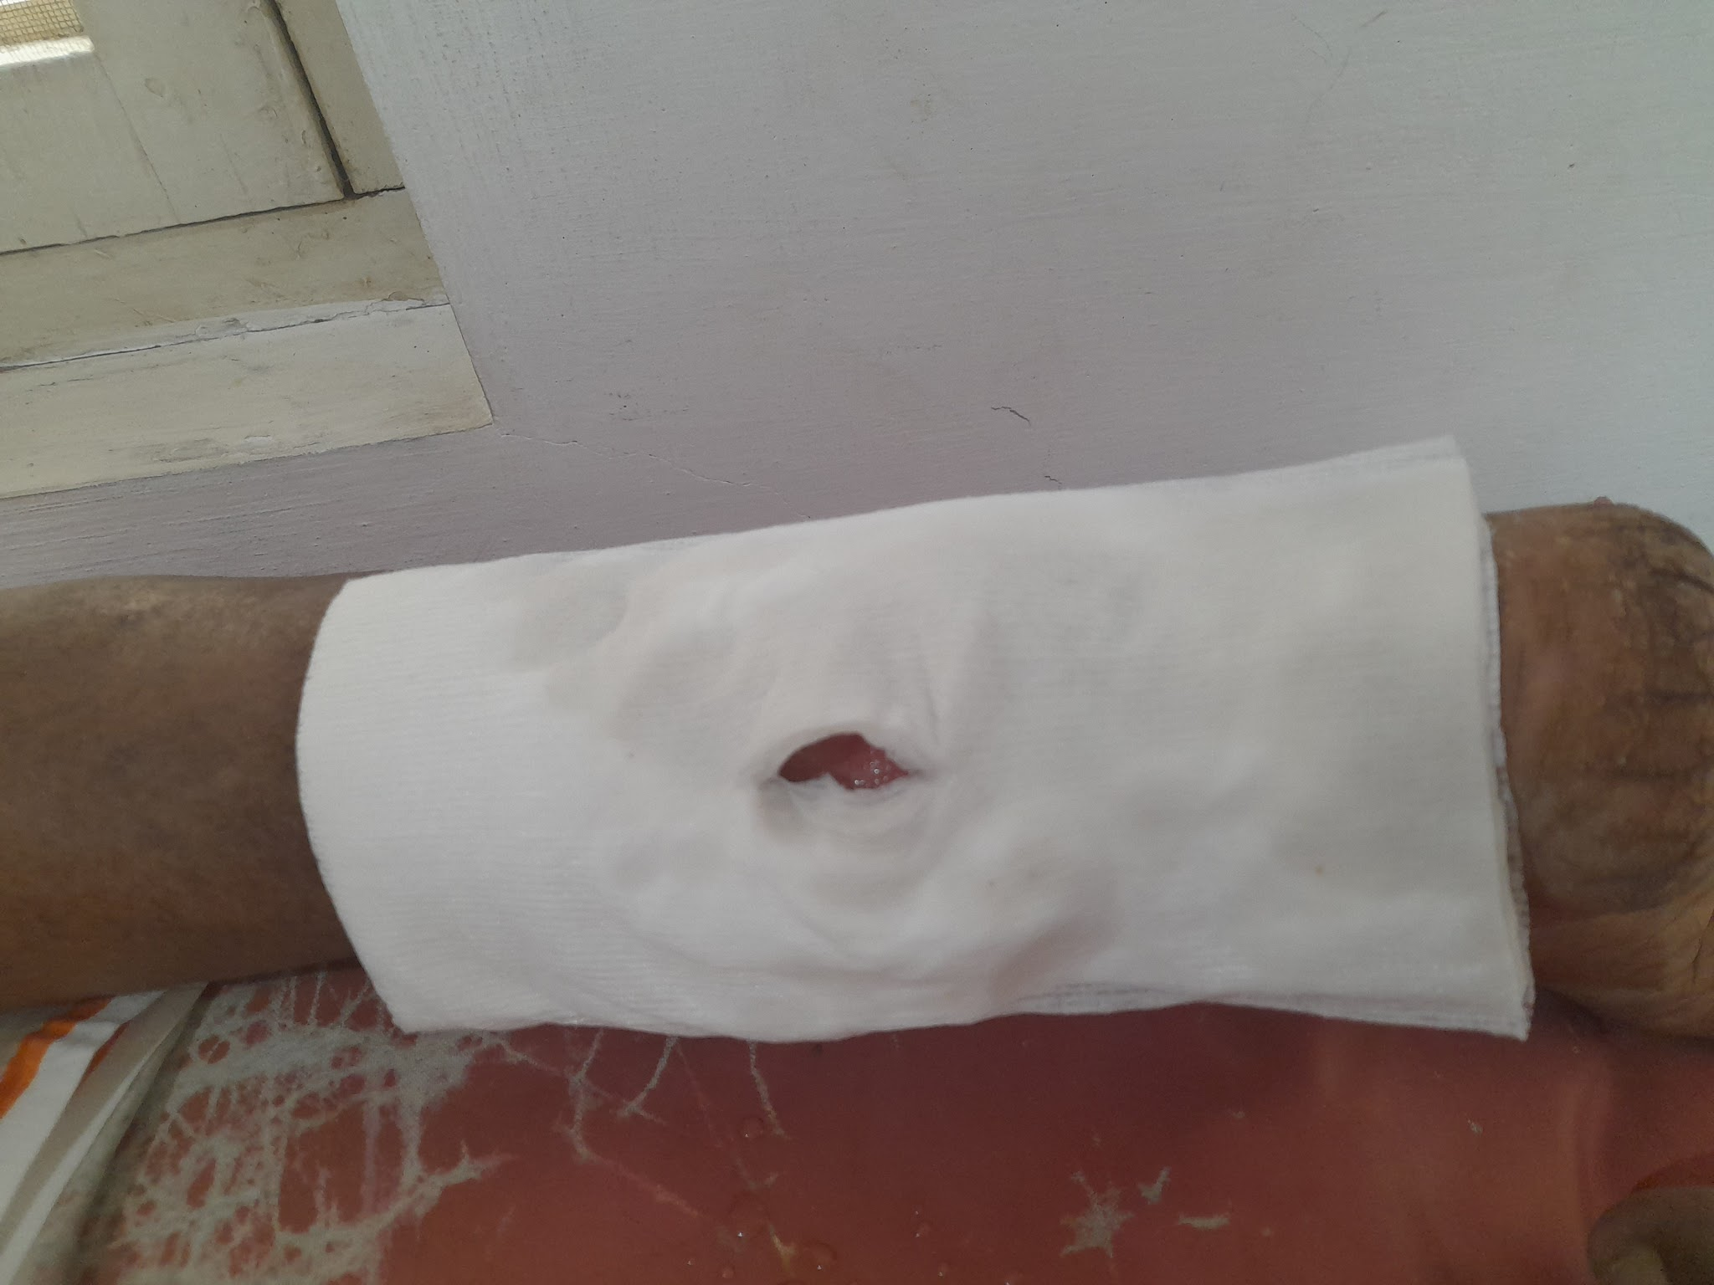

- Sterile Foley's Catheter Introduced, connected to Bedside Suction Pump
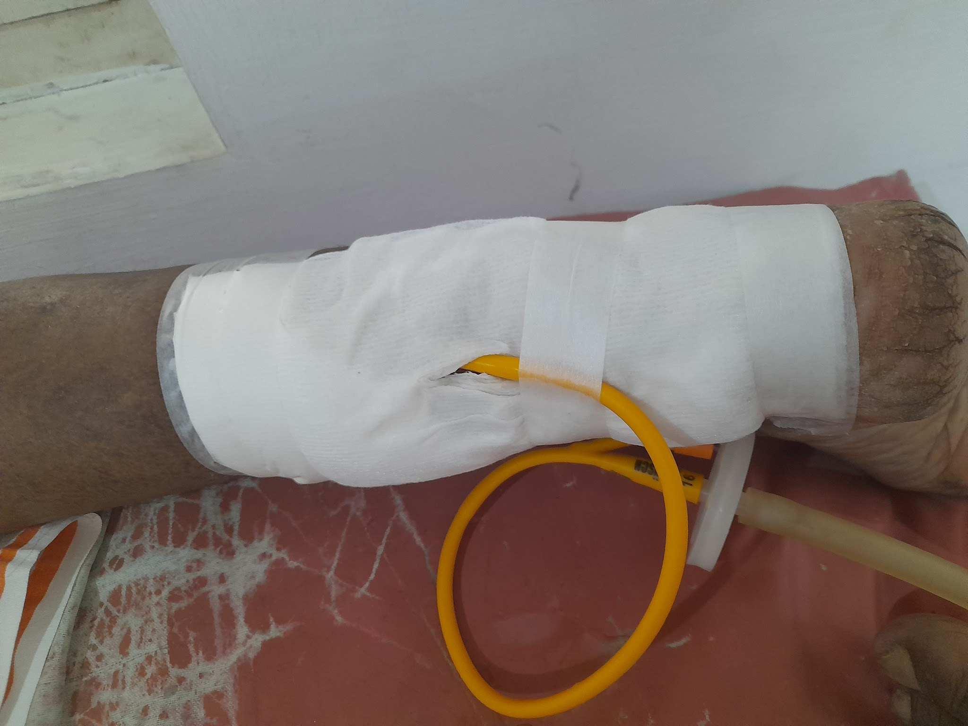

- The whole dressing is wrapped in Cling Wrap

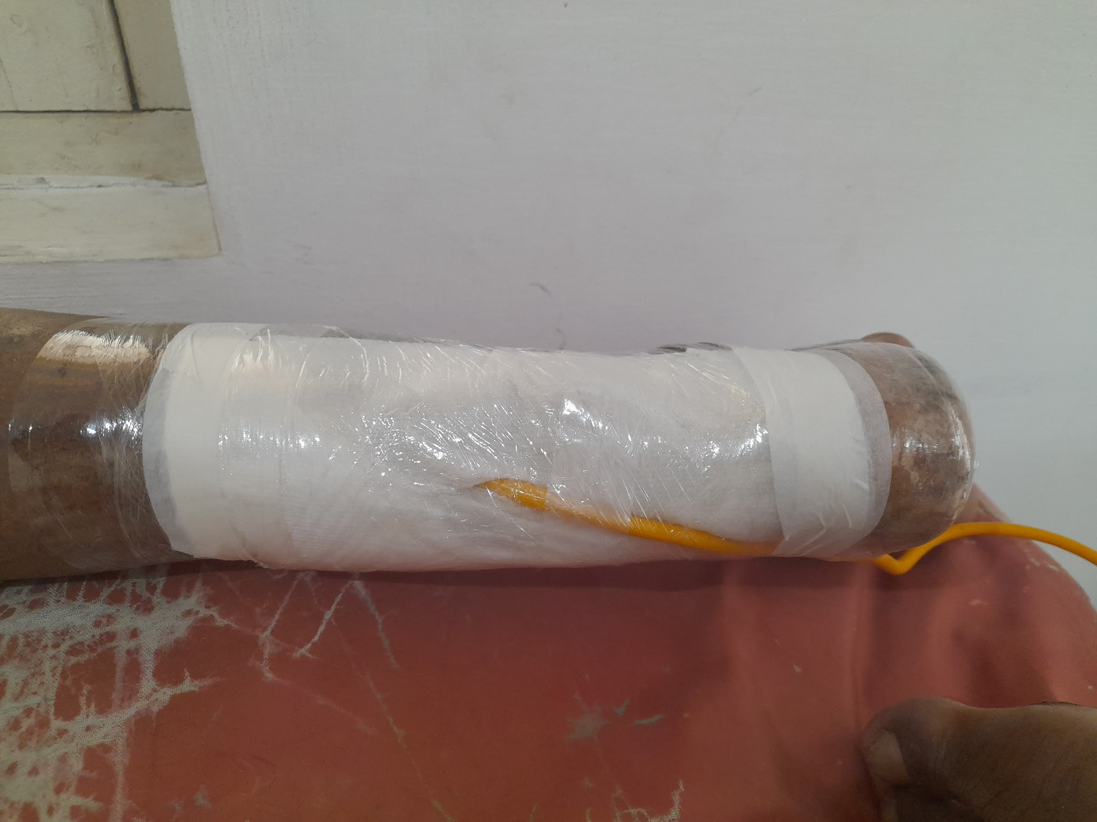
- The entire set up below

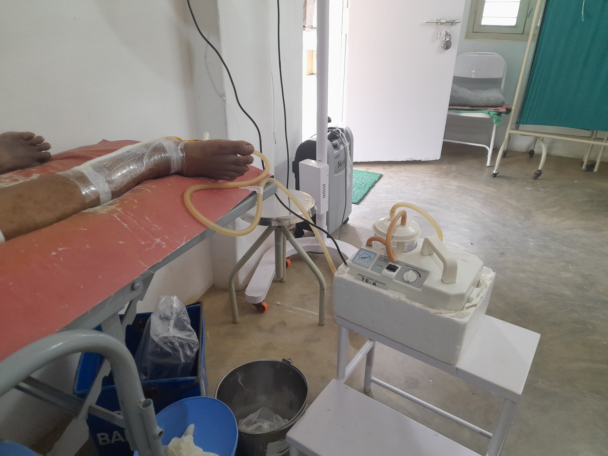

PROTOCOL
- Connect Suction
- Run suction at - 100 mm Hg for 30 minutes.
- Disconnect Suction from Foleys and Connect Oxygen tube from Concentrator
- Oxygen from Oxygen Concentrator at 5 lpm or 10 lpm depending on the Concentrator for 30 minutes
- Disconnect Oxygen Concentrator and reconnect Suction, - 100 mm Hg x 30 minutes
- Remove dressing
- Now apply antibiotic dressing - mostly sofratulle, placentrex depending upon wound
- The above protocol is followed as an OPD procedure
  - Ideally daily
  - Practically 3 times a week
  - Many a time once a week
- Patients are unable to come daily.

PHOTOS OF WOUND HEALING
Patient 1

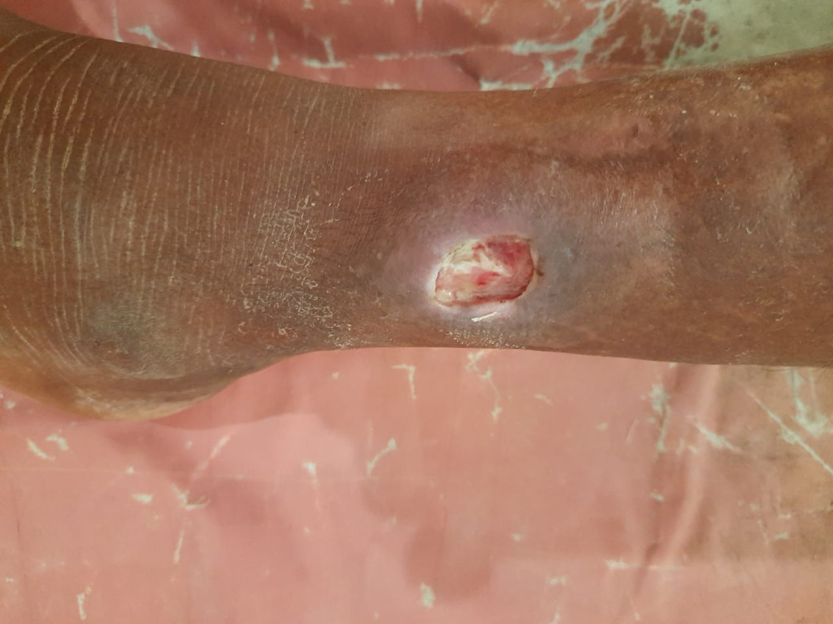 Day 2

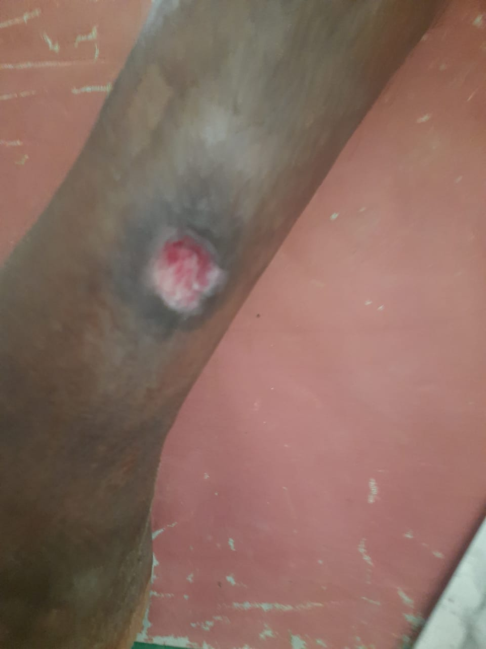 Day 4 Clean wound

Wound healed over next 2 weeks with saline and placentrex

PATIENT 2

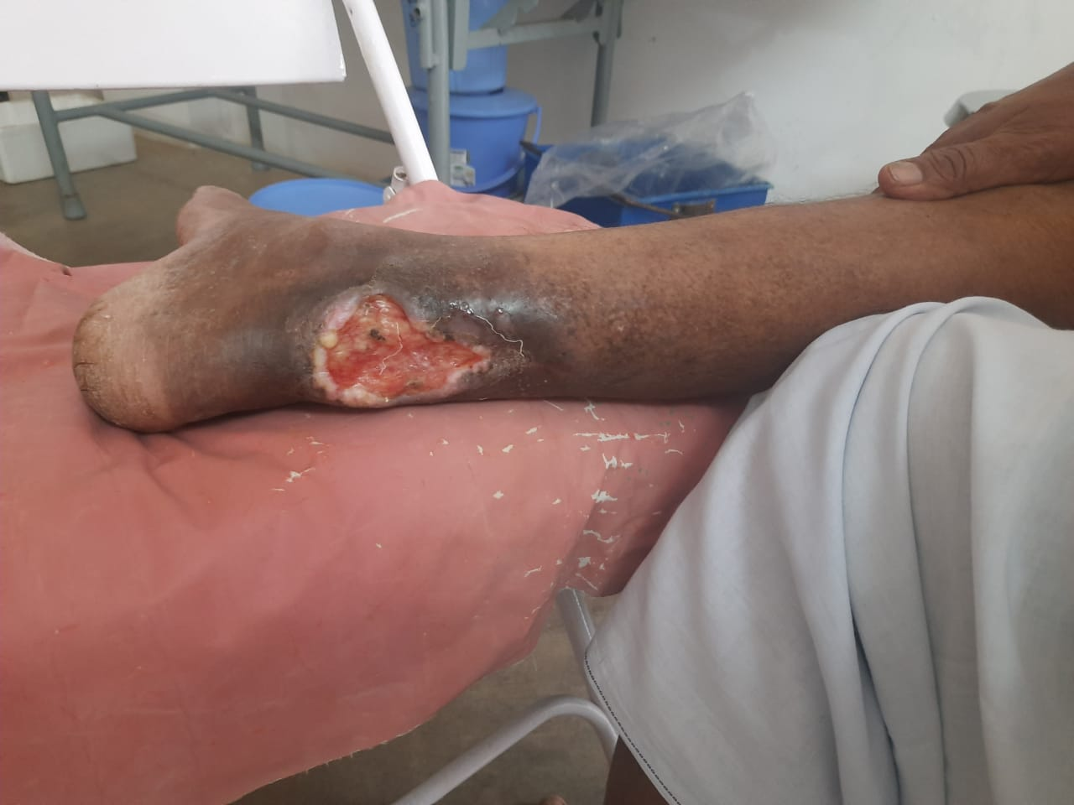 Day 1

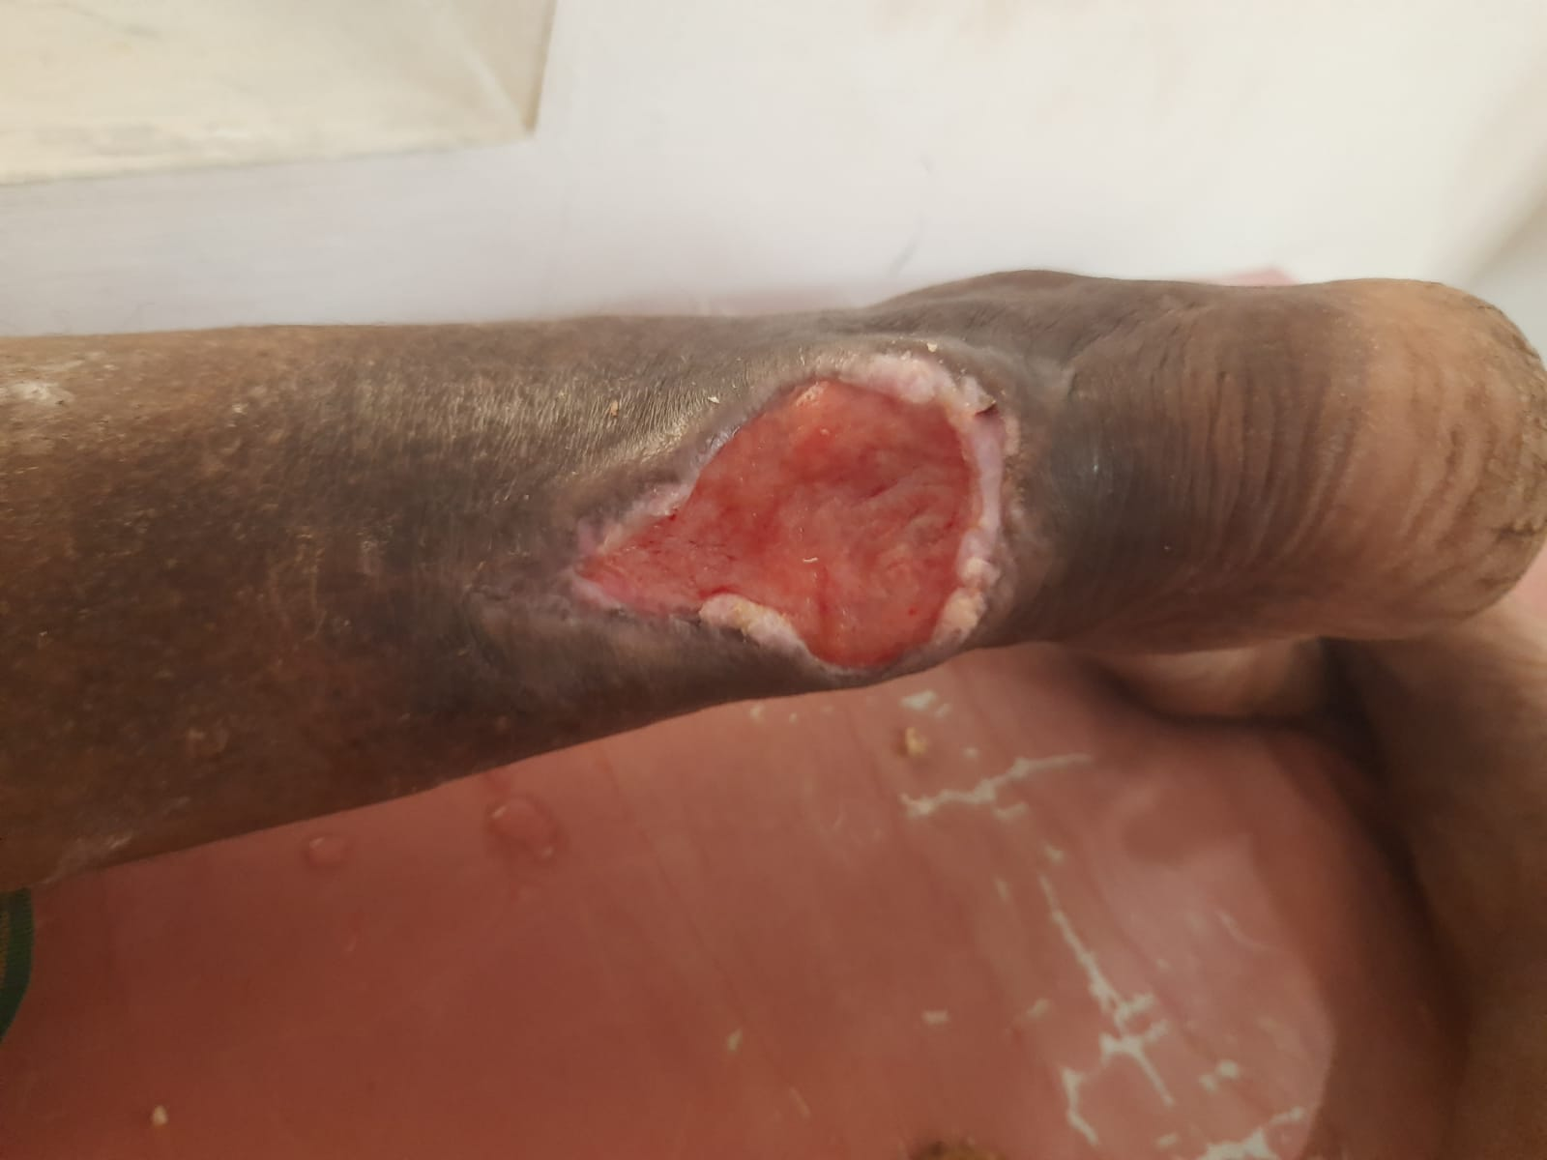 Day 5

Wound healed over next 4 weeks

