Manual Series No.1

The GAH Toolbox

2024-2025
7th Edition

An Orientation Manual for Clinicians
Gudalur Adivasi Hospital

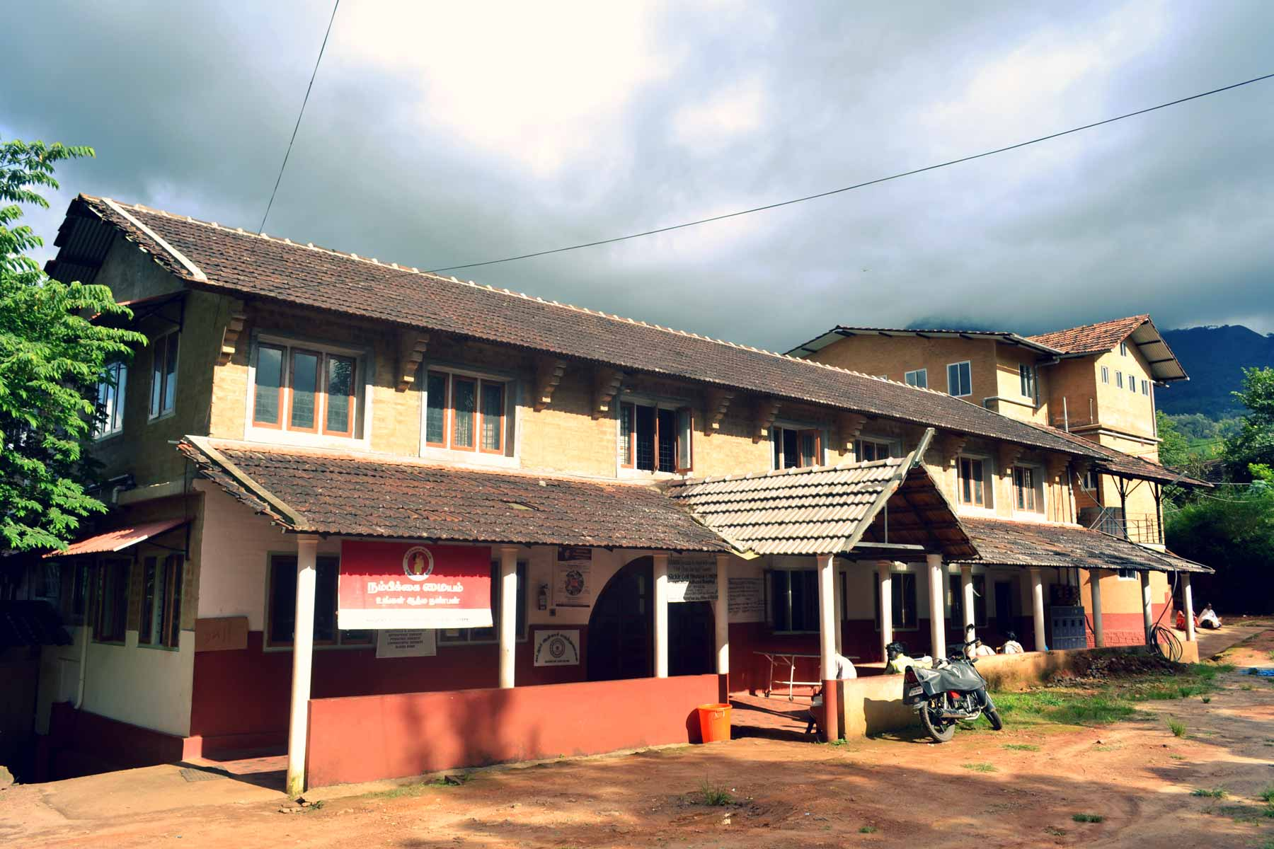

Association for Health Welfare in the Nilgiris
Post Box.20, Thottamoola, Gudalur.
Nilgiris, Tamil Nadu. India. 643212
www.ashwini.org ashwinigudalur@gmail.c

PREFACE
The GAH Clinical Guidelines Toolbox is an orientation manual that will familiarize clinicians who have recently joined the hospital with the following:
- Orientation to the Hospital – the first part , which must be read to understand the background of the work
- Commonly seen problems
- Investigative methods available for diagnostics
- Common nursing orders
- Interventions/medications available for various disorders as currently used in the hospital

The manual assumes that clinicians will rely on their clinical skills of history taking and physical examination to arrive at a presumptive diagnosis or differential diagnosis.
The manual will summarize how each diagnosis is typically investigated and treated. Guidelines take into account our clinical experience, local resources, local cultural sensitivities, established guidelines, and evidence from medical literature. No attempt has been made to describe surgery or procedures with equipment not available in the hospital. In general, the cost of investigations and treatments are a central consideration in clinical-decision-making.

The GAH toolbox is in constant flux - new investigational tools and medical treatments are added as needed. The reader’s input in keeping the Toolbox up to date is highly valued.
Every attempt has been made to ensure accuracy of information and doses. Please advise if any errors or omissions are encountered in the manual. The investigation and treatment protocols serve as guidelines only. Care for each patient should be individualized as appropriate.

References are generally from Current Medical Diagnosis 2019 (CMDT), The Green Book ( Primary Orthopedics) , the Blue Book ( Primary Anesthesia),Oxford Handbook and Medscape.

Thanks are due to Kannan of the MIS team at ASHWINI for getting the manual published.

Editors
June 2020

1st Edition – March 2007 Editors: Dr Nandakumar Menon, Shylaja Devi,Mrudula Rao
2nd Edition – Sept 2009 Editors: Dr Nandakumar Menon, Shylaja Devi,Mrudula Rao
3rd Edition – Nov 2011 Editors:Drs.Gopal Menon, Nandakumar Menon, Shylaja Devi,Mrudula Rao & Abraham Tharakan
4th Edition – May 2016 Editor: Drs. Nandakumar Menon, Sheldon Rao, Royson Dsouza, Mrudula Rao & Kathryn Boyd
5th Edition – June 2020 Editor: Drs. Nandakumar Menon, Paul Heron, Mrudula Rao, John Stephen, Veena Shesadiri, Namrita George
6thEdition – August 2021 Editor: Drs. Nandakumar Menon, Alisha Kalyanpur, Royson D’Souza, Aleena Rodrigues, Kalaidasan Shriram
7th Edition - January 2025 Editors: Drs. Nandakumar Menon, Royson Dsouza, Anju Joseph, Patrick Paul
GAH Treatment Guidelines
Table of Contents:

General Information 6
Introduction 6
Adivasis: The Original Settlers 6
Background: Gudalur Adivasi Hospital 6
Admissions Policy 7
Outpatient Clinic 7
Immunizations 7
Legal Cases 7
Patient Registry for TB, Sickle Cell Disease & Mental Illness 8
Mandatory Reporting 8
Services Provided 9
Recording Patient Details – SOAP 10
Typical Nursing Orders 11
Investigations 12
Medication Formulary & Drug Doses 13
English-Malayalam/Tamil Translations 14
GAH Treatment Guidelines 16
Chapter 1: Medical Emergencies 16
  - Shock 16
1.2 Snake Bites 18
1.3 Acute Transfusion Reactions 21
Chapter 2: Pediatrics 23
2.1 Acute Diarrhea in Children 23
2.2 Bronchiolitis 25
2.3 Pneumonia in Children 27
2.4 Neonatal Sepsis 29
2.5 Neonatal Hypoglycemia 32
2.6Neonatal Jaundice 34
Chapter 3: Infectious Diseases 35
3.1 Antibiotic Primer 36
3.2 Urinary Tract Infections 38
3.3 Soft Tissue & Bone Infections 40
3.4 Varicella Zoster 42
3.5 Bacterial Endocarditis 42
3.6 Tuberculosis 43
3.7 HIV/AIDS 46
3.8Typhoid Fever 46
3.9 Leptospirosis 47
3.10 Measles 47
3.11 Animal Bites 48
3.12 Parasitic Infections 49
3.13 Needle-Stick Injuries 49
3.14 Clostridium Difficile 50
3.15Influenza A H1N1 Clinical Management Protocol 51
3.16 Fever of Unknown Origin 51
3.17 Prevention of Mother to Child Transmission of Hepatitis B Infection 52
Chapter 4: Cardiovascular Diseases 53
4.1 Acute Pulmonary Edema 53
4.2 Acute Myocardial Infarction 54
4.3 Congestive Heart Failure 55
4.4 Hypertension 56
4.5 Rheumatic Heart Disease 58
4.6 Peripheral Arterial Disease 60

Chapter 5: Respiratory Diseases 62
5.1 Streptococcal Pharyngitis & Tonsillitis 62 5.2Acute Otitis Media 62
5.3 Sinusitis 63
5.4 Bronchitis 63
5.5 Pneumonia in Adults 63
5.6 Asthma 65
5.7 Chronic Obstructive Pulmonary Disease 66

Chapter 6: Renal Diseases 69
6.1 Post-Streptococcal Glomerulonephritis 69
6.2 Benign Prostatic Hypertrophy 72
6.3 Difficulty Urinating 73
6.4 Urinary Tract Stones 74
6.5 Epididmo-orchitis/Torson testes 75
6.6 Prostatitis 76
6.7 Pyelonephritis 77
6.8 Cystitis 78
6.9 Chronic Kidney Disease 79
6.10 Non – specific Urethritis 83

Chapter 7: Gastro-intestinal Diseases and General Surgical Conditions
7.1 Acute Gastroenteritis 84
7.2 Acid Peptic Disease 85
7.3 Abdominal Ascites 86
7.4 Guidelines for Endoscopy 86
7.5 Cholelithiasis (Gall stones) 87
7.6 Hemorrhoids 87
7.7 Anorectal Abscess
7.8 Fistula in Ano 88
7.9 Acute Appendicitis
7.10 Inguinal hernia
7.11 Umbilical hernia
7.12 Acute pancreatitis
7.13 Acute hepatitis
7.14 Liver abscess 88
7.15 Breast Lump

Chapter 8: Orthopedics & Rheumatology 89
8.1 Arthritis 89
8.2 Acute Osteomyelitis 89
8.3 Rheumatoid Arthritis 90
8.4 Osteoarthritis 91
8.5 Gout 92
8.6 Back pain 94
8.7 Dermatomes 96

Chapter 9: Hematology & Oncology 97
9.1 Iron Deficiency Anemia 97
9.2 Sickle Cell Disease 100
9.3 Lymphadenopathy
9.4 Carcinoma Esophagus
9.5 Carcinoma Stomach
9.6 Carcinoma Breast 101

Chapter 10: Endocrinology & Metabolism 102
10.1 Hypothyroidism 102
10.2 Hyperthyroidism 102
10.3 Euthyroid Goiter 103
10.4 Diabetic mellitus
10.5 Hypoglycemia 107
10.6 Diabetic Ketoacidosis 106
10.7 Diabetic Foot 108
10.8 Dyslipidemia 109
10.9 Hypokalemia 110
10.10 Hyperkalemia 111

Chapter 11: Neurology 113
11.1 Febrile Fits 113
11.2 Epilepsy 114
11.3 Status Epilepticus 115
11.4 Meningitis 115
11.5 Stroke 118
11.6 Migraine 120
Chapter 12: Dermatology 122
12.1 Scabies 122
12.2 Impetigo 122
12.3 Recurrent Staphylococcal Infections 122
12.4 Superficial Fungal Infection 123
12.5Fungal infection of nails 124
15.2 Alcohol Withdrawal 140

Chapter 16: Other Miscellaneous Disorders 149
17.1 Gynecomastia 152
17.2 Bilateral Parotid Enlargement 154

General Information

Introduction
Adivasis: The Original Settlers
- The word Adivasi can be translated as ‘Tribal’ or ‘Aboriginal’. Adivasis have been living in remote forested regions of India for thousands of years, making up 8% of the population. Largely isolated from the mainstream, each community has developed its unique culture, language, and spirituality. In South India today, Adivasis live mostly in the hilly regions of Kerala, Andhra Pradesh, Karnataka, and Tamil Nadu.
- In the Gudalur Valley of Niligiri Hills, Adivasis lived relatively undisturbed until recently. Over the past 150 years, Adivasis have been progressively displaced from their land and now work mostly as labourers in tea and coffee estates. Non-Tribals now outnumber Adivasis 10:1. Due to cultural differences and relative disparities in education and wealth, Adivasis have found themselves in an inequitable position in their new environment.



Background: Gudalur Adivasi Hospital (for details visit www.ashwini.org)
- The Gudalur Adivasi Hospital (GAH) is a non-governmental (not-for-profit) organization providing health services to an estimated 20,000 Adivasis in over 320 hamlets spread across 1000 square kilometers in the 2 taluks – Gudalur and Pandalur taluks of the Gudalur Valley.
- The origins of the work goes back to 1986, when ACCORD helped the Adivasis form the Adivasi Munnetra Sangam (AMS- https://www.adivasi.net/history.php). Subsequently other societies were formed to deal with specific issues:, ASHWINI (Association for Health Welfare in the Nilgiris) – health, VIDYODAYA (https://www.adivasi.net/vidyodaya.php) – education, ATLM – tea leaf marketing.


- ACCORD started community health work in 1987 with the training of Adivasi health workers. Inpatient care started in 1990 with the formation of ASHWINI & the GAH. A core principle has been to train Adivasis to manage all health care and administrative activities.
- The ASHWINI Health System has a 3 tier system with Village Health Volunteers in the villages, 2 Health Animators (Community Health Nurses) each working out of 8 Area Centres in Gudalur, Srimadurai, Devarshola, Devala,in Gudalur taluk and Ponnani, Pattavayal, Ayyankolly & Erumad in Pandalur taluk and the 50 bed GAH in Gudalur. The area centres are stocked with all the medicines which are dispensed to the patients by the HA.
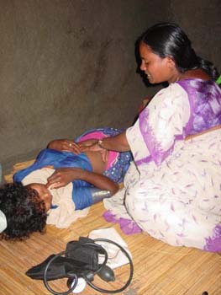

- Up until November 2007, Adivasis who belonged to AMS were enrolled in a health insurance plan that covered hospital admission, inpatient medications, obstetrical care and surgical procedures. The insurance policy was underwritten by the Royal Sundaram Insurance Company based in Chennai. The premium paid by Adivasis was nominal (2007 rates: Rs 25 per person per year for inpatient coverage of Rs 2500 per person per year) and symbolized voluntary participation in a program that encouraged shared responsibility for health. However, the reimbursements collected from the health insurance program did not cover the actual operating costs of the hospital. Additional revenue was generated from fundraising, charitable donations, governmental support and fees charged to Non-Adivasi patients. Also, the hospital frequently hosts visiting specialists who donate their time and skill for comprehensive patient care.


- From Nov 2007- Sept 2015 expenses for inpatient care were covered by the Tamilnadu Government through the TNHSP (Tamil Nadu Health Systems Project). In 2015 the insurance was handed over to the NHM under the CMCHIS. The insurance premium, however, is still being collected and is used for expenses incurred for referrals to tertiary care centres ( mainly Calicut Medical College).
- Approximately 17,000 of the 20,000 Adivasis in Gudalur Valley are AMS members and benefit from the health system. There is a charge of Rs.60 for tribal (Sangam members) outpatient care, and this fee includes the cost of all outpatient consultations, investigations, procedures and medications prescribed. Non sangam tribals pay for the OP investigations and medicines. Non-AMS Adivasis are equally welcome to the hospital and are encouraged to join AMS Inpatient care is free for all tribal patients ( Sangam and Non sangam). The Adivasis may access GAH 24 hours a day, 7 days a week.
- In theory, the public health care system should provide free health care to the local population but due to limitations in this system, GAH has attracted a high volume of both Adivasi and Non-Adivasi patients. Therefore, in order to maintain quality care for the Adivasis, the hospital restricts the number of patients seen daily ( except on Sundays) in the outpatient dept., and also admits only a limited number for inpatient services.
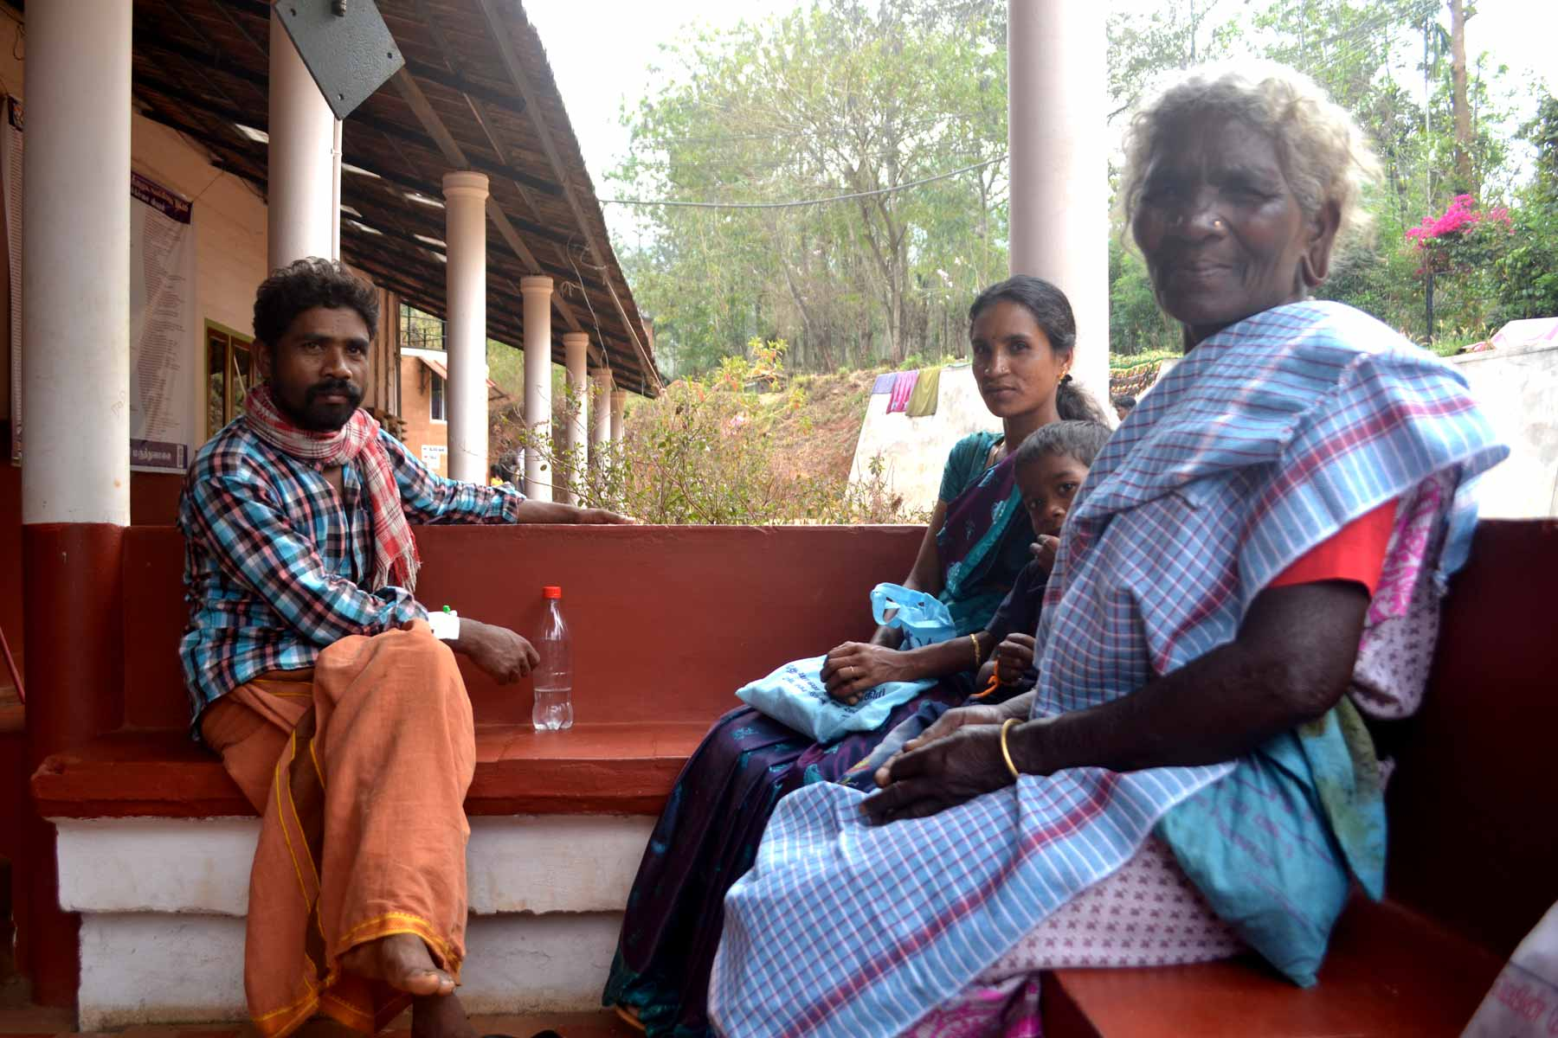

Sangam Number
- All AMS members have a 8 digit Sangam number (first 2 digits –for the area, next 2 fhe or the villages, the next 2 for the family and the last 2 for the individual in the family. This unique number is used for all the records to identify the individual.
- Each Adivasi family has a notebook with each member in the family having pages allotted to his/her with their name and sangam number written to avoid any mistakes. Patients are asked to bring their books to the Area Centres and Hospital and all details are recorded there.
- There is a digital recording system BAHMNI where currently the pharmacy,lab reports, pathololgy, endoscopy and dischare summaries are recorded.
Admission Policy
- The threshold for admitting tribals patients is low as many of them live miles from the nearest bus stop and therefore often request admission. Where any doubt exists, ask the senior nurse on duty.
- Likewise, once a patient is medically stable for discharge, the actual discharge date is discussed with the patient.This is often a Sunday when allsystemsfamily members are off from work and can come to the hospital and organize transport home.
- All admissions must be examined thoroughly and the details recorded in the chart, including all systems, including the peripheral pulses. Patients above 40 years must have a rectal examination. All female patients must have a breast examination and VIA/VIL and PAP smear as needed . The sickle cell status of all patients must be recorded. If there is no record, sickle prep test must be ordered.
- All babies born in the hospital have blood drawn ( heel prick) and the blood sent on a filter paper for sickle cell testing by HPLC at Neogens Lab in Blore. All newborns also have a hearing test done before discharge.
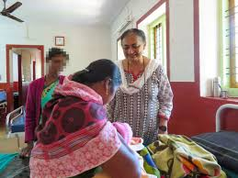

Outpatient Clinic
- The outpatient clinic for adivasis run daily from 8:00am to 4:00 pm ;however they are seen whenever they come. GAH gets the highest traffic of Adivasi patients on Sundays because it is typically their day off of work. The tribal patients are asked to bring their notebooks where all the family details are recorded.
- Non-Adivasi (NT) patients are seen on all days except Sundays between 8:00am and 1:00 pm. They pay a consultation fee of Rs120 as well as for the investigations and prescribed medicines. New patients pay Rs 150.
- Each NT patient is also given a notebook where the findings are recorded.
- For both T & NT patients, on the 1st page the most important problems of the patient are recorded, including important investigations like MRI, CT, ECHO, USS etc. and IP admissions diagnosis. For NT patients the lab results are recorded on the back of the book.These books are kept by the patient and brought every time the patient visits the hospital.
- The high incidence of TB and malnutrition necessitates a weight check for every patient. Childrens' weight should be correlated to <5 growth charts and if malnourished should be classified as Moderate or Severe based on the card.
- All tribal patients must have their sickle cell status indicated in their OP notebook. If the test has not been done it should be ordered.
- Given the high incidence of essential hypertension in adults, all adults should have their blood pressure checked.


Immunizations
- Government immunization programs are effective and the majority of children seen at GAH have received their basic immunizations (BCG, Hep B, DPT, OPV, measles). In the past, we have seen measles outbreaks attributed to inappropriate storage of the live vaccine prior to administration.
- All children born after May 2005 have had HHHep B immunization.
- For any open wounds, tetanus immunization status should be verified. If there is any doubt that a tetanus immunization was given in the past 5 years, order Tetanus toxoid (TT) 0.5 ml IM immediately.
- The pneumococcal vaccine is available. It should be considered only for Sickle Cell Disease patients according to guidelines in the Toolbox.
- Hemophilus influenza, mumps, and rubella vaccines are not available.

Legal Cases
- All potential legal cases are referred, to government hospital. Cases involving assaults, motor vehicle accidents, suicide attempts,wild animal attacks or any cases where a civil or criminal lawsuit may be filed, should be triaged, emergency care given and the patient referred to Gudalur Government Hospital (GH) .
- In addition, patients who are ‘dead on arrival’ should be sent to Gudalur Government Hospital so that proper police inquiry, post-mortem examinations, and death certificates can be arranged. Do not complete a death certificate for an “unexpected death” without conferring with senior staff as it might be death from suicide or homicide and would need to be referred to GH

Patient Registers
- GAH maintains registers for patients diagnosed with TB, Sickle cell disease, Oncology, Mental illness. Pediatric Surgery, Urology, Orthopedics, & General Surgery. The registers summarize active clinical issues and follow-ups for individual patients.
- Please remember to update the register every time you diagnose or follow up on one of these patients. Please confer with senior staff to get oriented to these registers.

Mandatory reporting
- Patients with suspected poliomyelitis (eg, all children with acute flaccid paralysis) must be reported to the District Medical Officer (form available, confer with senior staff).
- All patients with fever need to be reported online daily.
- As a recognized center for TB and HIV testing, our hospital automatically reports all TB and HIV cases to the state government.

SERVICES PROVIDED
GAH is part of the ASHWINI Health System that takes care of all the health problems of Adivasi patients and referral services when required. GAH has a labour room, 2 operation theatres equipped with laparoscopy & C Arm, 24 hrs laboratory with facilities for basic and advanced diagnostics (in collaboration with Thyrocare), hemoglobin electrophoresis, & microbiology, Upper GI endoscopy and colonoscopy, Xray, Ultrasound, Blood Bank, Audiometry, 24 hrs Pharmacy & Counselling. GAH is a Government recognised TB & Sickle Cell Disease Centre. The ASHWINI Adivasi School of Nursing obtained permission in 2017 to conduct ANM course for 20 students/yr. Currently the School is associated with the BSS (Bharat Sevak Samaj) for conducting courses in Nursing, Lab, Pharmacy, Accounts, and Computer courses.

Full time staff:
Dr. Mrudula- Family Medicine & Medical Supdt
Dr. Dhanya Dentist & Director runs the Dental OPD at GAH 6 days a week 9am-1pm with Dr. Aishwarya
Dr. Royson Jerome Dsouza- General and colorectal surgery
Dr. Evelina Jane K- Obstetrics and Gynaecology
Dr. Anju Teresa Joseph- Anaesthesiology
Dr. Surabhi Shastry – Jr.Doctor
Dr. Thanushree Arumugam – Jr Doctor
Dr. Akaash Muthaiah- Jr Doctor
Dr. Smitha- Research officer
Dr. Shylaja – Advisor
Dr. Nandakumar – Volunteer Surgery & Academics
Dr. Anna Oomen – Neurobiochemistry and laboratory

Volunteer Doctors-
Cardiology
Dr. Veenu from Mysore visits once a 1-2 months

Laproscopic GYN Surgery
Drs. Rajiv, Rekha & Tarun Kurian from Chennai

Ortho Surgery
Dr.Binu T Kurian

Pediatrics
Dr. Ann Agnes Mathew (Pediatric Neurologist)
Dr. Shalini Chico (Neonatologist)

Pediatric Surgery
Drs. Shubha & Kiran Mahadevappa

Psychiatry
Dr Vivek

Vascular Surgery
Dr. Shivananda Siddappa

Urology
Dr. Gnanaraj Jesudason
Dr. Devaprasath Jeyasekaran

Hepatobiliary Surgery
Dr. Philip Joseph
Dr. Anand Bharatan
Dr. Jayapal

Spine Surgery
Dr. Shekar Bhojraj
Dr. Harikrishnan
Dr. Shushruth Raj

Online Consultations
Dr. Harshad- Radiology
Dr. Binu Kurian, Dr. Sameer, Dr. Saji M Joseph- Orthopaedics
Dr. Shekar Bhojraj, Dr. Harikrishnan- Spine surgery
Dr. Madhulika- Oncology
Dr. Dulari Gupta- Neurology
Dr. Veenu John- Cardiology
Johnite Academics Whatsapp group- discussion of challenging cases
DoctorNet organisation- for arranging for referrals for higher diagnostics and treatment (for both Adivasi and Non-Adivasi patients)
Many volunteers visit for 1- 2 months generally in winter – Dr Sabine Microbiology, Angela Harding -Speech & Hearing, Michael Harding – General Medicine, Dr Ramakrishna -Surgery, and Plenti volunteers in various capacities

The Public Health Care System
Patients can access health care through:
- Government system (PHCs, District hospitals)
- Non-government / charitable system (eg, NAWA, NWTWS, Good Shepherd Hospital)
- Private system (Pushpagiri hospital- for palliative care, dialysis, Priya Medical Center, Taj Hospital, Royal one Hospital).
- Almost universally, Adivasi patients, acting independently, cannot afford treatment in the private health care system. As advocates for Adivasis, GAH has established relationships in the government and private sectors in order to deal with those health services not available locally. Non-Tribal patients choose to access health care based on the nature of their problems, their financial means, and the reputation of varying health care providers. If GAH is not equipped to deal with a Non-Tribal patient’s health problem, they are referred to the public or private sector.

Gudalur Government Hospital, Melgudalur
The following types of cases are best referred to the Gudalur Government Hospital, Melgudalur:
- Potential legal cases (assaults, motor vehicle accidents, attempted suicides, wild animal attacks, POCSO)
- Missed routine immunizations
- Anti-retroviral therapy for HIV / AIDS (medications are supplied free of charge by government system)
- Patients requiring anti-rabies vaccine
- Patients requiring CT scans (at Rs.500 per scan done during working hours from Monday to Saturday)

Gudalur Private Hospitals-Pushpagiri, Priya, Taj & GTMO Hospitals
Adivasi patients will not require any services from the local private hospitals. Non-Tribal patients with serious illnesses may wish to seek treatment at local private hospitals depending on their financial means. Patients must assume any risks associated with transfer.
As far as we are aware, the level of services at these hospitals do not exceed those available at GAH and so there is generally no need to refer patients to these hospitals
.
Webster Memorial Eye Hospital
All patients requiring eye care services are referred to this charitable eye hospital. Dr Samuel is there Mon – Fri

Tertiary Care Hospitals
- For Adivasi patients, the nearest tertiary care center is Calicut Medical College in the neighboring state of Kerala (2-3 hours by road) followed by Coimbatore Medical College (4-5 hours by road). Patients should be sent with a referral letter. Transportation is arranged by our hospital and cost is now covered by the 108 Emergency Ambulance service. However, it is important to check if the patient possesses the PMJAY card prior to referral to Calicut as the services are not free of cost for patients from Tamil Nadu.
- For obstetric and neonatal conditions, the nearest tertiary care referral center is Nilgiris Medical College, Ooty via 108 ambulance
- For patients with CMCHIS card, non-emergent conditions can be referred to Ramakrishna Hospital and Ashwin Hospital in Coimbatore (chemotherapy and radiotherapy are given under the insurance in these hospitals)
- For Non-Tribal patients, the closest tertiary care centers are private hospitals in Meppady (WIMS 1.5 hrs away )Perinthalmanna (2 hours away) in Kerala (Moulana, Al-Shifa, EMS & MES Hospitals). Alternatively, free care may be accessed in Tamil Nadu in Ooty (District Hospital) or Coimbatore (Medical College care).

The 108 Emergency Ambulance Service
Free transport from GAH to Govt Hospital, Melgudalur, Ooty Govt Hospital and to Calicut Medical College is provided by the Emergency Ambulance Service. Once the doctors decide a patient needs to be referred the senior nurse must be informed to take care of the details.
Patients with emergencies can also call 108 and have the ambulance transport them to GAH or the nearest Govt Hospital free of cost.

 | Adivasi Patients | Non-Tribal Patients
Local non-government (charitable) hospital | Webster Memorial Eye Hospital Gudalur (261750) – Dr.Samuel
Local government hospital | Gudalur Government Hospital (261222)
Local private hospital |  | Pushpagari Hospital  PriyaHospital (262800)  Taj Hospital (261228)  GTMO Hospital
Tertiary care government hospital | Govt Medical College Nilgiris, Ooty (0423-2442212) - 2 hours  Coimbatore Medical College Hospital - 5 hours  Calicut Medical College, Kerala (0495-2356991) 2 ½ hours | Govt Medical College Nilgiris, Ooty (0423-2442212) - 2 hours  Coimbatore Medical College Hospital - 5 hours  Calicut Medical College, Kerala (0495-2356991) 2 ½ hours
Tertiary care private hospital | Narayana Hridayalaya, Bangalore  St John's Medical College  Bangalore Baptist Hospital  Christian Medical College, Vellore  Ramakrishna Hospital Coimbatore  Ashwin Hospital Coimbatore  GKNM hospital Coimbatore | Vinayaka Hospital, Sulthan Bathery  Moopen’s medical college WIMS, Wayanad  MES Hospital Perinthalmanna  Al Shifa Hospital Perinthalmanna  Moulana Hospital in Perinthalmanna,  Ramakrishna Hospital Coimbatore  Ashwin Hospital Coimbatore  GKNM hospital Coimbatore

Typical Nursing Orders
Diet
Normal diet
Renal diet
Liquid diet
Lactose-free diet
Kanji water (rice water)
Kanji water with salt
Ragi (cereal beverage)
Sattumavu (ragi + peanut/lentils)
Eggs (specify frequency)

Activity
Activity as tolerated
Bedrest
Incentive spirometry

Acceptable Abbreviations
ac : before meals
bid or bd : twice a day
cc : cubic centimeter
hs or qhs : at bedtime
IM : intramuscular
IV : intravenous
mg : milligrams
ml : milliliter
od or qd : once daily
pc : after meals
po : by mouth
pr : per rectum
prn or SOS : as needed
qds or qid : four times a day
q6h : every 6 hours exactly
stat : at once
tds or tid : three times a day
AF : after food
1-0-0 : one tablet in morning
1-0-1 : one tab morning / eve
1-1-1 : one tab morn / aft / eve

Vitals signs
‘TPRBPO2 ’: Temp Pulse Resp BP,Oxygen saturation
Frequency: typically tid – qid or q6h ( as needed)

Dressings
Dressing changes are typically once daily. Infected dressings are done in the Septic OT usually at the end of the day to minimise nosocomial infections.
Patients who cannot be ambulated or transferred to the septic OT will have their dressings changed at the bedside
Clean dressings (post op patients, non-infected wounds) are done in the OPD dressing area
Minor Procedures: Clean cases in the minor OT (endoscopy room) and the infected cases in the septic OT

Intravenous Fluids
Standard solutions include RL, NS, D5W, DNS, Kidral supplied in 500 ml bottles. See table for composition.

Solution | Na | K | Cl | HCO3 | Ca | Cal
Ringer’s Lactate | 130 | 5 | 110 | 29 | 2
Normal Saline | 154 |  | 154
5% Dextrose |  |  |  |  |  | 200
5% Dextrose Saline | 154 |  | 154 |  |  | 200
Kidral/Pedilyte* | 26 | 20 | 21 |  |  | 200
Cal: Calories in Units mmol/L or Cal/L
*Kidral also contains Mg 3, Acetate 23, PO4 3 (Osm/L 346)

Typical Maintenance IV Rate:
Adults: 50-100 ml/hr
Pediatrics:
4 ml/kg/hr for 1st 10 kg
2 ml/kg/hr for 2nd 10kg
1 ml/kg/hr for additional kg
OR
1st 10kg – 100ml/Kg/day
2nd 10 kg – 50ml/Kg/day
3rd 10 Kg – 20ml/kg/day
Example: Maintenance IV rate for 25kg child is 65 ml/hr or 1000+500+100=1600ml in 24hrs

Typical IV bolus:
Adults: 250-1000 ml over 1 hour
Pediatrics: 10 ml/kg over 1 hour

Oral rehydration salt:
Kanji water with salt is the commonest rehydrating fluid. ORS is used if you suspect hypokalemia or if kanji is unavailable

Measuring Ins and outs:
Urinary (Foley) catheter

Nasogastric (NG) tube
Fluid intake/output charting available

Potassium infusion:
If indicated, potassium is added to IV solutions. Ampules contain 20mEq of KCl in 10ml of solution.
500ml bottle of NS/DNS with 20 mEq/L KCl. The order is generally written: NS+½ ampule KCl @ the rate required.

Investigations
Blood - Hematology
Hb: Hemoglobin
TC: Total cells (WBC)
DC: Differential count (WBC)
Platelet count
Retics: Reticulocyte count
ESR: Erythrocyte sed. rate
Sickle cell prep
Hb electrophoresis
PT: prothrombin time
BT: Bleeding time
CT: Clotting time
Blood group
Cross Match

Blood – Biochemistry
S. Creatinine: Serum creatinine
RBS: Random blood sugar
FBS: Fasting blood sugar
PPBS: Post prandial blood sugar
SGPT, SGOT, T. Bili, D.Bili
Serum electrolytes:Na+ & K+

Blood – Other
VDRL
HIV
Widal (to investigate typhoid)
HBsAg: Hep B Surface Antigen
HCV
ASO titre
Mf, Mp: Micro filaria, Malaria parasite
Rheumatoid factor

Urine
Albumin
Sugar
Micro: Microscopy
BS: Bile salts
BP: Bile pigments
Stool
Microscopy
pH
Sugar
Occult blood
Gastric
pH

CSF
TC: Total cells
Protein
Sugar

ECG
12 lead electrocardiogram
Microbiology
Gram stain
Urine and pus cultures available.

X-rays
Routine Chest, spine, abdomen, limbs
CT Scan
Closest CT scan is in Gudalur Govt Hosp. Films are sent by email to Dr Harshad ( CMC, Vellore)

Ultrasound
Done on Tuesdays. Emergencies at any time.

Ultrasounds requiring a Radiologist (Dopplers, Thyroid, Breast and Lower limb scans) can be referred to Pushpagiri hospital during the weekly radiologist visits

Endoscopy:
Diagnostic gastroscopy and Colonoscopy on Tuesdays

ECHO:
Screening can be done by Dr. Anju Joseph/ Dr. Mrudula and discussed with Dr. Veenu John. Elective ECHO can be performed during cardiology visits at GH.
For non-tribal patients- ECHO can be done at Pushpagiri hospital during weekly cardiology visits

CECT, MRI, Angiogram:
Ooty Medical College.

Pathology: Specimens are sent to GKNM Hospital

All other blood tests are sent out every day by courier to Thyrocare and results are obtained in <1 week

Blood Bank
We have blood available round the clock. Components – plasma, packed cells & platelets are also available as needed.

PHARMACY-Medication Formulary( Please visit the Pharmacy to see jan aushady and locost medicines available)

Head and Neck
Gentamycin ear / eye drops,
Ciprofloxacin ear / eye drops,
Oxymetazoline nasal drops
Methyl cellulose eye drops
Respiratory
Anti-asthma
Aminophylline
Ipratropium bromide
Salbutamol tablets /nebulizer,
Theophylline / etophylline, Prednisolone
Aerocort rotacaps
Cardiovascular
Amlodipine, Aspirin, Atenolol, Atorvastatin, Clonidine, Clopidogrel, Digoxin, Enalapril, Furosemide, Hydrochlorothiazide, Isosorbide dinitrate, Mephenteramine, Metoprolol, Nifedipine, Propranolol, Warfarin
Gastrointestinal
Antiemetic
Metoclopramide, Ondansetron, Prochlorperazine, Promethazine
Antiulcer
Aluminium hydroxide / Magnesium trisilicate, Dicyclomine, Famotidine, Omeprazole, Anti H.pylori (individual drugs are prescribed)
Laxative
Bisacodyl, Milk of Magnesia, Liquid paraffin
Other GI
Buscopan, Codeine
Renal
Diuretic
Furosemide, Hydrochlorothiazide, Potassium Syrup, Spironolactone
Ob/Gyn
Betadine Vaginal Tablet/ Pessary
Carboprost, Clomiphene, Hydroxyprogesterone caproate, Methylergonovine, Misoprostol, Norethisterone, Oxytocin, Betadine
Neurologic
Anticonvulsants
Carbamazepine, Clonazepam, Diazepam, Phenobarbital, Phenytoin,
Sodium valproate
Psychiatric
Antidepressants / Mood stabilizer
Amitriptyline, Carbamazepine, Fluoxetine, Imipramine, Sertraline

Antipsychotic
Chlorpromazine,
Inj.Fluphenzine, Trihexyphenidyl (anti-cholinergic agent), Haloperidol, Risperidone
Sedative
Clonazepam, Diazepam, Triclofos. sod.

Ortho / Rheum
Antirheumatic Agents
Methotrexate , Hyroxychloquin
See NSAID list below

Dermatologic
Benzyl Benzoate, Betamethazone, Chloramphenicol, Gamma benzene hexachloride, Gentian Violet Paint, Hydrogen peroxide, Miconazole, Mupirocin,Nitrofurazone, Betadine Solution, Whitfield, Zinc Oxide

Infectious Disease
Antibiotics
Amikacin, Amoxycillin, Ampicillin, Amoxy-Clavullinic acid, Ampicillin-Cloxacillin, Azithromycin, Cefixime, Cephalexin, Cefotaxime, Ceftriaxone, Ciprofloxacin, Co-trimaxazole SS/DS, Doxycycline, Gentamicin, Metronidazole, Nalidixic Acid, Nitrofurantoin, Norfloxacin, Crystalline Penicillin,Piperacillin + Tazobactam,Penidure, Kaypen
Antifungals
Fluconazole
Antiparasitics
Albendazole, Mebendazole, Piperazine
Diethyl Carbamazine
Anti-TB
Ethambutol, Isoniazid (INH), Pyrazinamide, Pyridox,morphineine (B6), Rifampin, Streptomycin

Hematologic
Aspirin, Clopidogrel, Hydroxyurea, Coumadin, Vitamin K
Endocrine
Carbimazole, Dexamethasone, Levothyroxine, Glyburide, Glimeperide, Glipizide,Hydrocortisone, Insulin (Plain, Lente, Mixtard 30/70), Metformin, Pioglitazone,Prednisolone

General
Analgesics

Acetaminophen (Paracetamol po/pr/IM), Buprenorphine, Codeine, Pentazocine,Morphine,Pethidine
,
Chlorpheniramine, Promethazine
Certrizine, Prochloperazine
NSAID
Aspirin, Diclofenac, Ibuprofen
Steroids
Dexamethasone, Hydrocortisone, Prednisolone
Supplements
Calcium Lactate, Folic Acid, Iron syrup, MFI (Iron + Folic Acid), ped MFI (Pediatric Iron + Folic Acid), Imferon (Iron Inj), Potassium chloride, Pyridoxine (B6), Vitamins ABDEC syrup, Vitamin A, Vitamin B Complex (BC), Vitamin B12, Vitamin K

Urologic/BPH
Finesteride, Tamsulosin, Sidenafil
Gout
Allopurinol, Colcichine, Febuxostat

Anesthesia / Critical Care
Adrenaline, Atropine, Buprenorphine, Calcium Inj, Dextrose 25%, Diazepam, Dopamine, Fentanyl, Glycopyrollate, Ketamine, Magnesium Sulphate, Mannitol, Mephenteramine, Midazolam, Morphine, Naloxone, Pancuronium (Pavlon), Pentazocine,Pethidine, Sodium bicarbonate, Propofol,Thiopentone sodium

Note: Additional medications are not routinely used, but may be available at outside pharmacies / chemists in Gudalur. Medications in parentheses (brackets) may be available in outside pharmacies.

* Generic drugs are generally bioequivalent to brand name products.

* There are virtually no reports of toxicity from degradation products of outdated drugs. Drugs stored under reasonable conditions retain 90% of their potency for at least five years after the expiration date and sometimes much longer.

DRUG DOSES
Drug | Oral | Parenteral
Albendazole | P.15mg/kg/day as a single dose A.400mg as a single dose
Allopurinol | Start at 100mg, increase weekly to Max.of 900mg/day
Alprazolam | 250-500mcg/day in 1-3d.d, Max. 3mg/day
Amikacin | P- 7.5mg/kg in 2d.d, A.-15 mg/kg in 2 d.d, Max.of 22.5 mg/kg in 3 d.d(1.5g/day)
AMT & Imipramine | Start at 12.5mg inc. slowly, Max. 150-200mg HS, Nocturnal enuresis 15-30mgHS
Amlodipine | 5-10mg OD
Ampicillin | 50-100mg/kg/day in 3-4d.d | 50-100mg/kg/day (A.Max.- 1g/dose)
Aminophylline | P. -5mg/kg, A. 250-500mg by slow IV injection OR 500-100mcg/kg/hr IV Infusion
Amoxycillin | 60-90mg/kg in 3d.d
Aspirin | Anti platelet- 75mg OD, Anti inflammatory- Upto 4 g/day in 3-4d.d (AVOID in Children risk of Reye’s Syndrome) Post MI- 300mg stat, followed by 75 mg OD
Atenolol | 25-50mg/day(HTN) 50-100mg/day(Angina)
Atorvastatin | Increased from 10mg, monthly, Max. 80mg HS
Atropine | 20mcg/kg Max. 600mcg per dose
Azithromycin | 10mg/kg OD 20mg/kg for Enteric fever
B1 | 250mg IM or slow IV daily for 5 days, Max. 500mg TID for established Wernike- Korsakoff
B6 | Prophylaxis 10mg/day Treatment- 20-50 mg TID
B12 | Oral 500-1000mcg/day OR 100mcg/day*7days, 100mcg/wk*4wks, 100mcg/month lifelong
Buprenorphine | 3-6mcg/kg Q6-8H (A.300-600mcg Q6-8H) slow IV infusion
Carbamazepine | Initially 10-20mg/kg/day, maintain at Max 35mg/kg/day (A.-Initially 100-200mg/day in 2d.d Max. 1.6-2g/day) Increase at 100-200mg/wk
Carbimazole | P.250mcg/kg TID A.15-40mg/day in 3d.d (Maintenance at 5-15mg/day)
Cefotaxime | <7d- 25mg/kgQ12H, 7-28d- 25mg/kgQ8H, >1yr- 50mg/kgQ8-12H
Cephalexin | 25mg-100mg/kg/day in 4d.d (Max. 6g/d) UTI prophylaxis- 125mg HS
Cefixime | 6-8mg/kg in 1-2d.d (A. 200-400mg in 1-2d.d)
Ceftriaxone | 20-50mg/kg/day (A. 2-4gm daily), increased to 100mg/kg/day in 1-2d.d
Cetrizine | 5-10mg/day in 1-2d.d
Chloramphenicol | 50mg/kg/day in 4d.d
Chloroquine | 600mg stat followed by 300 mg at 6, 24 and 48 hours
Ciprofloxacin | 250-750mg/day in 2 d.d | 20mg/kg in 3d.d (A. 200-400mg BD)
Clonazepam | 1mg HS increased weekly to 4-8mg HS
Clopidogrel | 75mg OD, Post MI- 300mg stat then 75 mg OD
Cloxacillin | 50-100mg/kg/day(A. 500-1000mg, Max. 4g/day) QID | 50-100mg/kg/day in 3-4d.d
Co-trimoxazole | 5-8mg/kg/day of Trimethoprim in 2d.d SS(400+80) DS(800+160) Syp(200+40/5ml)
Codeine | 3mg/kg/day in 5-6 divided doses (A.30-60mg Q4h)
CPM | Max. 24mg/day in 4-6d.d | 250mcg/kg IM or IV,!0mg upto Q6H
Crystalline Penicillin | Preterm/Neonate- 50mg/kg in
DEC | 6mg/kg in 3d.d for 14 days (or 300mg DEC+ 400mg Albendazole single dose)
Dexamethasone | 10-100mcg/kg in 1-2d.d ( A0.5-10mg/d) | C.-100-400mcg/kg in 1-2d.d  A.-200-500mcg/kg/d (4mgQ4H)
Diazepam | Max.15-30mg/day in 2-3d.d  PR-500mcg/kg | IV -200-300mcg/kg OR ~1mg/year of age (10-20mg at 2.5mg/min followed by 3mg/kg Max. over 24hrs
Diclofenac | 1-3mg/kg in 2-3d.d(A.75-150 mg in 2-3d.d) | IM- 75mg deep IM OD-BD
Digoxin | A.62.5-250mcg/dayRapid Digitalization- 0.5mg stat, 0.25mg Q2H till rate 80-90/min, then .25-.5mg maintenance<5yrs- 35mcg/kg over 24 hours then 10mcg/kg/day 5-10yrs- 25mcg/kg over 24hrs then 6mcg/kg/day
Domperidone | 0.25-0.5mg/kg, max 2.4mg/kg/day in 3-4d.d  A. 10-20mg upto 80 mg in 3-4d.d
Dopamine |  | 2-5mcg/kg/min Infusion
Doxycycline | 100mg bd (Max.200mg bd)
Enalapril | 5-40mg OD(HTN) 10-20mg BD(CCF)
Escitalopram | Upto 20 mg/day
Ferrous Sulphate | 3-5mg/kg/day, A.200mg tablet(with 65mg of elemental iron) upto TID
Finasteride | 5mg/day, continue for min of 6 months
Flucanazole | 3-6mg/kg on D1, then 3mg/kg (A. 50-100mg daily)
Fluoxetine | 20-60mg/day (Start at 20, increase weekly)
Fluphenazine | IM-12.5-100mg every 14-35 days(after test dose)
Furosemide | 1-3mg/kg/day A.20-50mgOD Max. 1200mgOD) | 20-50mg increased by 50mg every 2 hours min Max.of 1.5g/day
Gentamycin | C.- 2.5 mg/kg in 3 d.d, A.-3-5mg/kg in 3 d.d or 5-7mg/kg single dose
Glipizide | Max. 20mg/day, upto 15mg/dose
Glibenclamide | Upto 15mg/day in 1-2 doses
Haloperidol | 25-50mcg/kg/day in 2d.d (A. Initially 1.5-5mg/day in 2-3d.d, Max. 20mg/day. Maintenance- 5-10mg/day)  Anti-emetic- 0.5-2mg/day | 2-10mg Q4-8HR, Max. ~20mg/day. May be increased in severe conditions
HCTZ | Max. 50mg/day
Hydroxychloroquine | 6.5mg/kg/day in 2-3d.d (Negligible ophthalmologic toxicity up to 4 mg/kg)
Ibuprofen | 15-30mg/kg/day in 3-4 d.d (A.300-400mg Q6-8H max.- 2.4g/day
Ipratropium | Inhalation- 20-40mcg Q8H (Max. 80mcg Q6H), Neb-100-250mcg Q6-8H(Max. 500mcgQ6H)
Iron-Dextran | 50mg/ml, upto 2ml(100mg/day) after test dose
Ivermectin | 200mcg/kg in a single dose
Vitamin K |  | 1mg IM per dose
Levofloxacin | 500-1g OD or BD
Lignocaine | Plain- 3mg/kg Max. 200mg, With Adrenaline- 5mg/kg Max. 500mg
Losartan | 25-100mg OD
Mannitol | 0.25-2g/kg over 30-60 min, repeated 1-2 times over 4-8 hours
Mebendazole | 100mg bd for 3 days
Metformin | Max.2g per day in 3d.d
Metoclopramide | 200mcg/kg in 2-3d.d, Max. 500mcg/kg/day  A.10mg TID (5mg if <60kg)
Metoprolol | 100-400mg/day in 2-3 d.d
Metronidazole | 7.5mg/kg Q8H (A.-500mg Q8H) | 7.5mg/kg Q8H
Midazolam | Concious Sedation-<6yr- 50-100mcg/kg, 6-12yr- 25-50mcg/kg (2-2.5mg increased by 1 mg, Max. 5-7-5mg, Elderly start at 1-1.5mg)  Pre Med-<15yr 80-200mcg/kg IM, >15yr 70-100mcg/kg IM(elderly 25-50mcg/kg)
Nifedipine | 5-20mg TID
Nitrofurantoin | <12yr-3mg/kg in 4d.d, >12yr-50mg Q6H max 100 mg Q6H),Prophylaxis- 1mg/kg(50-100mg) HS
Norepinephrine | Norepinephrine tartarate (80mcg/ml) at 0.16-0.33ml/minute, titrated to response
Ondansetron | P.100mcg/kg Max. 4 mg, A.- 4-8mg Q12H | 100mcg/kg max 4 mg A.-4-8mg Q12H
Paracetamol | 10-20mg/kg/dose (A.Max. 4g daily)
Penicillin V | 12.5mg/kg Q6H, (A. 500-1gQ6H)
Pentazocine | 1m/kg IM, 0.5mg/kg IV (30-45mg, Max. 60mg) Q4H
Phenobarbitone | 8mg/kg/dayA.-60-180mg HS | IM- 15mg/kg (200mg) can repeat after 6 hrs
Phenytoin | 3-4mg/kg in 1-2d.d initially, up to 8mg/d (C.-max-300mg, A. Max.-600mg) | Loading- 15-20mg/kg at 1-3mg/kg/min (50mg/min max) infusion, then 2mg/kg (100mg) Q8H
Piperazine | 120mg/kg/day in 2-3d.d for 2 days
Pioglitazone | 15-45mg/day as single dose
Prednisolone | 0.5-2mg/kg/d in 1-3d.d (A.- 60mg per day) Maintainence-7.5-15mg/d
Prochlorperazine (Stemetil) | 500-750mcg/kg/day in 3d.d(Avoid below 10kg)  A.-5-10mg 2-3times,day, upto 20mg/dose | 12.5mg IM
Promethazine (Phenergan) | 0.25-0.5mg/kg/dose (upto 1mg/kg) Q6-8H (2-5yr-5-15mg/day, 5-10yr-10-25mg/day, 10-15yr- 25-50mg/day)Syp Phenergan- 1mg/ml
Propranalol | 120-240mg/day in 2-3d.d, starting at 40mg/day
Risperidone | 1-2mg/day, slowly inc. Max. 10mg/day
Salbutamol | 100mcg/kg/dose Q6-8H (A.-4mg Q6-8H) | Inhalation(100-200mcg upto 4 times)  Nebulization(2.5-5mg upto 4 times)
Spironolactone | 3mg/kg/day in 2-3d.d, 100-200mg/day (A.-Max. 400mg) in 2-4d.d
Tramadol | 50-100mg Q4H (Max. 600mg/day)
Valproate | P.- Initially 20mg/kg in 2d.d, upto max of 40mg/kg A.-Initiallly 600mg/day in 2d.d increasing by 200mg/3 days to max of 2.5g/day
Vitamin A | <6 months-50,000IU, 6-12months- 1lakh IU, >1yr- 2 lakh IU

English- Malayalam-Tamil Translations
General | Hello | Vanakam
General | How are you? | Sukhamaano / Ipo engane unde
General | What’s your name | Ningal peru enda
General | What’s your question? | Enda prashna
General | My name is ____. | Ende peru ____.
General | Thank you | Nandri
General | Please | Dayavucheytu
General | I don’t understand. | Enakka mansal aaitilla
Time | How long | Etra neram
Time | How many days | Etra divas am
Time | Day | Divasam
Time | Week | Iacha
Time | Month | Masam
Time | Year | Kollam
Numbers | One | Onnu
Numbers | Two | Randu
Numbers | Three | Munnu
Numbers | Four | Nalu
Numbers | Five | Anje
Numbers | Six | Aru
Numbers | Seven | Elu
Numbers | Eight | Ettu
Numbers | Nine | Ompatu
Numbers | Ten | Pattu
Interrogatives | What | Enda
Interrogatives | Where | Evade
Interrogatives | When | Eppo
Interrogatives | Why | Endinne
Interrogatives | Who | Aru
Interrogatives | How much does it cost? | Etra varum
Symptoms | Cough | Chome
Symptoms | Sputum | Kofum
Symptoms | Runny nose | Jala dhosham
Symptoms | Colour | Colour
Symptoms | Yellow | Manja
Symptoms | White | Vellia
Symptoms | Short of Breath | Shwasa muutando
Symptoms | Blood | Chora
Symptoms | Vomiting | Shardi undo
Symptoms | Diarrhea | Whita poke
Symptoms | Have you had a bowel movement? | Kakkus poyo?
Symptoms | Have you urinated? | Mutrum poyo?
Symptoms | Menstruation | Massa kuli
Symptoms | Losing lots of blood | Jaasti chora povo
Symptoms | Fever | Pani
Symptoms | Chills | Verikale
Pain | Pain | Vedena
Pain | Sharp | Kuthuum
Pain | Constant | Steraaith
Pain | Intermittent | Vithu vithu
Pain | When is it worse? | Epo jasti avum?
Pain | When is it better? | Engene kamu avum?
Pain | Chest pain | Nanjee vedena
Pain | Arm pain | Kaii vedena
Pain | Abdominal pain | Viarr vedena
Physical Examination | Sit | Irrike
Physical Examination | Lie down | Keddaku
Physical Examination | Open mouth | Vai thorakku
Physical Examination | Breathe deeply | Nalla shwaas edduku
Physical Examination | Tongue out | Nakku neetu
Physical Examination | Do this movement | Idda pole chiyano
Physical Examination | May I do a rectal exam? | Mala dwaram parishodikyate?
Physical Examination | May I do a pelvic exam? | Ullile nokate?
Common Verbs | Come | Va
Common Verbs | Go | Po
Common Verbs | To drink | Kudikyano
Common Verbs | To eat | Karikyan
Common Verbs | To walk | Nadakkuka
Common Pronouns | I | Nyan
Common Pronouns | We | Nyangal
Common Pronouns | You | Ni
Common Pronouns | He | Avan
Common Pronouns | She | Avval
Body Parts | Head | Tala
Body Parts | Tongue | Nakku
Body Parts | Teeth | Pallu
Body Parts | Chest | Nanjee
Body Parts | Heart | Nanjee
Body Parts | Lungs | Shwasa kosham
Body Parts | Kidneys | Kidney
Body Parts | Digestive system | Dhahana seshi
Body Parts | Anus | Mala dwaram
Body Parts | Neck | Kaluttu
Body Parts | Joint | Muttu
Body Parts | Legs | Kaal
Relationships | Husband | Bharta
Relationships | Wife | Bharya
Relationships | Child | Kutti
Relationships | Father | Acchan
Relationships | Mother | Amme
Adjectives | Big | Velliya
Adjectives | Small | Cheriya
Recommendations | You have an infection. | Palapu indu.
Recommendations | Take these medicines. | Inda marannu eddakano.
Recommendations | Drink lots of fluids. | Nalla vellam kudikano.
Recommendations | Stop smoking. | Pogavali nirthano.
Recommendations | Stop drinking alcohol. | Drinks nirthano.
Recommendations | You should feel better soon. | Vegam sari povum.
Recommendations | Come back if you’re not better. | Sari illangil tirchi varano.

GAH Treatment Guidelines

Chapter 1: Medical Emergencies

1.1 Shock
1.2 Snake Bites
1.3 Acute Transfusion Reactions

1.1 Shock
Definitions:
1) Hypovolemic Shock: Inadequate arterial blood flow due to decreased intravascular volume.
2) Cardiogenic Shock: Failure of cardiac output due to myocardial infarction, cardiomyopathy, valvular incompetence, or arrhythmia.
3) Neurogenic Shock: Caused by traumatic spinal cord injury or effects of spinal anesthetic.
4) Septic Shock: This is caused by bacterial infection or endotoxin production resulting in sudden vasodilatation which is not responsive to IV fluids.
5) Anaphylactic Shock: This is a Type 1 IgE mediated hypersensitivity reaction. There is release of histamine and other agents causing capillary leak, wheeze, cyanosis, edema, and urticaria. Often occurs in response to medication (ie penicillin), latex, or food allergies (peanuts).
Systemic inflammatory response syndrome (SIRS)

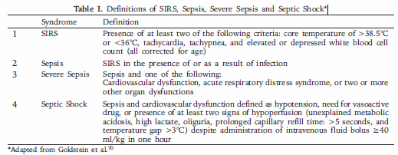
Treatment
Non‐inotropic treatments for shock should always be considered first. These include supplemental oxygen, resuscitation with fluid or blood products, source control and antibiotics for sepsis, and mechanical support (e.g. intra‐aortic balloon pump) or revascularization for cardiogenic shock.
Inoptropes
The ideal inotrope would be one that increased stroke volume without an increase in myocardial oxygen consumption. It would be non‐arrythmogenic, have a short half‐life making it easily titratable and not result in tachyphylaxis. Unfortunately, no such perfect drug exists.
- Noradrenaline
- Dopamine is the second choice in therapy in situations where modest inotropy and pressor support are required. Dopamine is an endogenous catecholamine that stimulates Beta-1, Alpha-1 receptors and dopaminergic receptors (DA1 & DA2) in the heart and circulation.
- Dopamine itself causes release of norepinephrine from nerve terminals, which stimulates Alpha-1 and Beta-1 receptors, thus raising blood pressure. Dopamine is most useful in the treatment of HF patients who have depressed cardiac output with poor tissue perfusion.
- The effects of dopamine are dose dependent:
<2 micrograms/kg/min | 2-4 micrograms/kg/min | ≥5micrograms/kg/min
Low doses of dopamine stimulate the DA1 & DA2 receptors and cause vasodilatation of the splanchnic and renal vasculature. | Moderate doses of dopamine stimulate the Beta-1 receptors and cause an increase in cardiac output with little or no change in heart rate or SVR. | At higher doses, the effects of dopamine on the Alpha-1 receptors overwhelm the dopaminergic receptors and vasoconstriction ensues, leading to an increase in SVR, LV filling pressures and heart rate.
Dopamine Solution Preparation:
- Add 2 ampules (each amp contains 200mg dopamine) i.e. 400mg dopamine to 500ml D5W. Use the microdrip IV set.
- Each ml contains 4/5mg = 0.8 or 800 micrograms of dopamine
- Start dopamine at 2micrograms/Kg/min If patient is 50kg this equals 100microgm/min = 1/8ml = 60/8=7-8drops/min
- Adjust the dopamine drip to keep the blood pressure around 90-100 so that there is urine output of 0.5ml/kg/hr.
Anaphylactic Shock:
- Give IM adrenaline 0.5mg (ie 0.5mL of 1:1000), repeat every five minutes as needed.

1.2 Snake Bites
Introduction: The venom of poisonous snakes may be predominantly neurotoxic (cobras) or predominantly cytolytic (vipers/kraits).
- Neurotoxins cause respiratory paralysis. Neurotoxic envenomation may cause ptosis, dysphagia, diplopia, and respiratory arrest.
- Cytolytic venoms cause tissue destruction by digestion and hemorrhage due to hemolysis and destruction of the endothelial lining of blood vessels. The manifestations include local pain, redness, swelling, extravasation of blood, perioral tingling, metallic taste, vomiting, hypotension, and coagulopathy.
Emergency Measures:
- Wash the bite with soap and water.
- Immobilise the bitten area and keep it lower than the level of the heart.
- Get immediate medical help.
- RIGHT: Reassure Immobilise Get to Hospital Tell the doctor of signs such as bleeding or drooping eyelids that develop on the way to hospital.
- What not to do:
  - Do NOT use ice or other types of cooling measures
  - Do NOT use tourniquets as they may cut off blood supply leading to amputation
  - Do NOT make incisions or perform suction on the wound
  - Do NOT apply alcoholic beverages
- It is VITAL to reassure the patients and keep the patient calm.
  - Not all snakes are poisonous
  - Even fully charged snakes do not always inject a lethal dose
  - Try to identify if the snake is poisonous or non-poisonous if it is brought to it or by using a magnifying glass to see the bite mark. Note that often a bite from a non-poisonous snake can cause an infection or allergic reaction.
  - History - site of the bite, activity at the time of the bite, time of bite, visualization/recognition of the snake.
  - Symptoms suggestive of neuromuscular palsy (ptosis, respiratory difficulty, dysphagia, weakness of limbs, etc.) should be specifically asked for.
  - Initial clinical signs should be noted in detail such as heart rate, blood pressure, respiratory rate, one min counting test, oxygen saturation, bulbar palsy, muscle power, tendon reflexes, pooling of saliva, broken neck sign. These signs to be closely monitored every hour till clinical improvement. ECG should be recorded for arrhythmias. S.electrolytes and renal profile should be done.
  - Give injection tetanus toxoid to all patients provided blood is clotted in 20WBCT.
  - Intramuscular injection to be avoided in viper bite envenoming may result in huge hematoma
Clotting Time- Before the injection of anti-snake-venom (ASV) take 2-3 ml of patients' blood in a new dry glass test tube which is not irrigated by any detergents. Keep the tube undisturbed for 20 minutes and then tip it off, if blood did not clot, it confirms hypofibrinogenemia and that the venom action is persisting. This test should not be repeated before 6 h of the last dose of ASV as the liver takes 6 h for regeneration of clotting factors. In India, we have polyvalent antivenom available which acts against krait, cobra, Russell's viper and Echis. It accelerates the dissociation of the toxin - receptors complexes and reverses the paralysis.
On arrival of the patient, 100 ml (10 vials) ASV is added to 200 cc of normal saline and given to the patient over 30-50 min.

Anti Snake-venom
One should sit by the side of the victim for early diagnosis and treatment of anaphylaxis. Within 30 min after initial dose of ASV if there is no improvement of neurological manifestations one can repeat dose of ASV and no more than total 20 vials of ASV to be administered.

ASV neutralizes circulating venom and it has no action once the venom is attached to the receptor site. In krait bite, its venom destroys receptors thus neurological manifestation may persist for 2 to 3 weeks till there is regeneration of receptors. At this stage, administration of ASV is merely a waste. No amount of antivenom is going to reverse the ptosis or neuroparalysis till regeneration of receptors.
Antivenom should be administered as soon as signs of systemic or severe local swelling are noted.

The mean times between envenoming and death are 8 h (12 min to 120 h) in cobra, 18 h (3-63 h) in Bungarus caeruleus, 3 days (15 min to 264 h) in Russell's viper and 5 days (25-41 days) for Echis cariniatus. The approximate serum half-life of antivenom in envenomed victims ranges from 26 to 95 h. Before discharge, envenomed victims should be closely observed daily for minimum 3-4 days. ^{[6],[9]}
Antivenom Reaction and its Management
No skin test should be performed before giving ASV as it does not give any surety regarding reaction. It is merely killing vital time. Antivenom should not be given intramuscularly. It should be administered by a qualified person who has knowledge of the anaphylaxis reaction and its management. However, snake catchers or trekkers should take with them a few ampoules of ASV in case of an accident, so as to make it readily available to a doctor. ^{[4]}
Reactions of ASV can develop within 10-180 min. The incidence is increased with dose of antivenom and speed of administration. Bolus dose may give rapid reaction. A turbid solution of ASV may precipitate severe reaction and hence should be thrown away
Management of Reaction
Earliest symptoms are hotness in ears, scalp, itching over scalp, urticaria, sudden onset of intractable cough, nausea, vomiting, goose skin, giddiness often complained of uneasiness, suffocation, and irrelevant behavior. Febrile reactions due to contamination of ASV with endotoxin-like compounds may cause fever, rigors, vasodilatation, and hypotension which can occur within 1-2 h of treatment. Children get febrile convulsions.
Systemic anaphylaxis
Sudden onset of projectile profound vomiting, sphincter relaxation, hypotension, bronchospasm, foreign body sensation in throat and angioedema. These reactions are due to complement activation by immune complexes or aggregates of immune globulin.
Delayed reaction serum sickness can develop between 5 and 24 days of ASV therapy. Incidence of this depends upon the dose of ASV but is rare. This delayed reaction is clinically characterized by pyrexia of unknown origin, itching, arthralgia, lymphadenopathy, joint swellings, mononeuritis multiplex, albuminuria, and rarely encephalopathy. Low doses of adrenaline, promethazine, and hydrocortisone can be used as prophylaxis against anaphylaxis reaction. [35]
In case of reaction, injection adrenalin 0.5 ml of 0.1% IM on the lateral aspect of the thigh. Dose can be repeated if not controlled.
In a situation where life is at stake, that is, severe hypotension, bronchospasm, laryngeal edema adrenalin to be given in the dose of 1000 μg (1 ml) diluted in 9 cc of normal saline. A total of 10 cc of this solution can be given 1 ml intravenously every 3-5 min till reaction is reduced.
In addition to this,
- IV aminophylline,
- head low position,
- IV normal saline,
- IVRanitidine
- IV chlorpheniramine maleate,
- IV Hydrocortisone,
- nasal oxygen
Sometimes, patients may require endotracheal intubation and ventilation. Irrespective of due care and when reaction is over; during re-administration of ASV, the patient can develop re-reaction. In such a situation, one can select ASV from another batch and try. Patients should not die of reaction and so also not due to snake bite envenoming. One should not be afraid of administration of ASV in a severe venomous bite provided one is fully prepared to treat any severe reaction. Many victims are referred from PHC to rural or district hospital without giving ASV and succumb on way to the hospital
Emergency Management
Basic cardiopulmonary resuscitation
All patients found unconscious at home and not breathing should start receiving chest compressions and mouth to mouth respiration en-route to the hospital.
Endotracheal intubation and ventilation
Indicated if victim has pooling of saliva, unable to lift the neck from pillow, muscle power <3/5, reduction in oxygen saturation, signs of respiratory failure like abdominal-thoracic respiration, signs of cerebral hypoxia. At the periphery, one can do endotracheal intubation, or if not possible a laryngeal mask can be put directly over larynx and ambu bag ventilation.

- Manage toxic signs/symptoms Anti-venom acts only against circulating toxin, not toxin fixed to tissue. Take supportive measures including blood or plasma transfusion to combat shock, mechanical respiration to combat respiratory distress, antibiotics to prevent secondary infection. Āntihistamines may be given.
- Neurotoxicity:
  - In case of neurologic toxicity, atropine (0.6 mg) subcutaneously should be followed by 5 injections of neostigmine (0.5 mg) intravenously (repeated 2 hourly depending on response) to reverse muscle paralysis.
  - Measure respiratory rate with vigilance
  - If a patient is unable to perform supine neck lift prepare for respiratory support with mechanical ventilation or resuscitation bag with improvised nasopharyngeal tubes by cutting size 5 endotracheal tubes to length of nostril to tragus, lubricate and insert.
- Hemotoxicity:
  - In case of vasculotoxic signs and symptoms, fibrinogen along with heparin may be given, but with extreme caution and constant monitoring, as heparin can intensify bleeding
  - Monitor coagulation on 6 hourly basis and repeat ASV dose if incoagulable
  - Monitor urine output, creatinine, and CBC as there is high risk for renal failure and occult bleeding. If possible, move the patient to a hospital with lab facilities and/or renal support after the first dose of ASV.
  - If severely hypotensive, consider fluid/ blood transfusion after coagulation has been restored.

References:
1) Current Medical Diagnosis and Treatment
2) Manbir online & Angamaly Snake Research Unit (http://www.manbir-online.com/htm2/snake.21.htm)
3) Snake bite poisoning-HS Bawaskar, PH Bawaskar

1.3 Acute Transfusion Reactions

Medical Care
Continuous monitoring of vital signs during generalized anesthesia may prevent acute circulatory (volume) overload, but it may not detect early signs of other reactions (eg, acute hemolytic transfusion reactions).
The onset of red-colored urine in a transfused patient should raise the question of a hemolytic transfusion reaction. When performing checks to confirm that the correct blood was transfused to the correct patient, centrifuge a urine sample to determine whether the red color represents hematuria or hemoglobinuria (see image below).
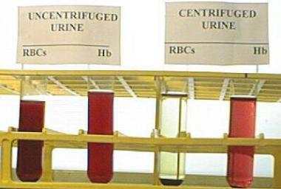
A rapid test is done to distinguish hematuria from hemoglobinuria. The onset of red urine during or shortly after a blood transfusion may represent hemoglobinuria (indicating an acute hemolytic reaction) or hematuria (indicating bleeding in the lower urinary tract). If freshly collected urine from a patient with hematuria is centrifuged, red blood cells settle at the bottom of the tube, leaving clear yellow urine supernatant. If the red color is due to hemoglobinuria, the urine sample remains clear red after centrifugation. In addition, the onset of abnormal bleeding/generalized oozing during surgery in a transfused patient should raise the question of a hemolytic transfusion reaction with DIC.
- Acute hemolytic reactions (antibody mediated)
  - Immediately discontinue the transfusion while maintaining venous access for emergency management.
  - Anticipate hypotension, renal failure, and DIC.
  - Prophylactic measures to reduce the risk of renal failure may include low-dose dopamine (1-5 mcg/kg/min), vigorous hydration with crystalloid solutions (3000 mL/m²/24 h), and osmotic diuresis with 20% mannitol (100 mL/m²/bolus, followed by 30 mL/m²/h for 12 h).
  - If DIC is documented and bleeding requires treatment, transfusions of frozen plasma, pooled cryoprecipitate for fibrinogen, and/or platelet concentrates may be indicated.
- Acute hemolytic reactions (non antibody mediated)
  - The transfusion of serologically compatible, although damaged, RBCs usually does not require rigorous management.
  - Diuresis induced by an infusion of 500 mL of 0.9% sodium chloride per hour, or as tolerated by the patient, until the intense red color of hemoglobinuria ceases is usually adequate treatment.
- Febrile, nonhemolytic reactions: Usually, fever resolves in 15-30 minutes without specific treatment. If fever causes discomfort, oral acetaminophen (325-500 mg) may be administered. Avoid aspirin because of its prolonged adverse effect on platelet function. Allergic reactions: Diphenhydramine is usually effective for relieving pruritus that is associated with hives or a rash. The route (oral or intravenous) and the dose (25-100 mg) depend on the severity of the reaction and the weight of the patient.
- Anaphylactic reactions
  - A subcutaneous injection of epinephrine (0.3-0.5 mL of a 1:1000 aqueous solution) is standard treatment. If the patient is sufficiently hypotensive to raise the question of the efficacy of the subcutaneous route, epinephrine (0.5 mL of a 1:10,000 aqueous solution) may be administered intravenously.
  - Although no documented evidence exists that intravenous corticosteroids are beneficial for the management of acute anaphylactic transfusion reactions, theoretical considerations cause most clinicians to include an infusion of hydrocortisone or prednisolone if an immediate response to epinephrine does not occur.
- TRALI
  - Immediately discontinue the transfusion while preserving venous access.
  - Patients with mild episodes should respond to oxygen administered by nasal catheter or mask. If shortness of breath persists after oxygen administration, transfer the patient to an intensive care setting where mechanical ventilation can be administered.
  - In the absence of signs of acute volume overload or cardiogenic pulmonary edema, diuretics are not indicated.
  - No evidence exists that corticosteroids or antihistamines are beneficial.
  - Treat complications with specific supportive measures.
- Circulatory (volume) overload
  - Move the patient to a sitting position, and administer oxygen to facilitate breathing.
  - The most specific treatment is discontinuing the transfusion and removing the excessive fluid.
  - If practical, the unit of blood component being transfused may be lowered to reverse the flow and to decrease intravascular volume by a controlled phlebotomy.
  - Less urgent situations may be managed by a parenteral or oral diuretic (eg, furosemide).
  - If the patient has symptomatic anemia requiring additional transfusions of RBCs, select concentrated (ie, CPDA-1-anticoagulated) red cells (hematocrit = 80-85%). Avoid red cell components diluted with saline additives (ie, AS-1).
- Bacterial contamination (sepsis)
  - Immediately discontinue the transfusion, including all tubing, filters, and administration sets, and save the transfusion materials for cultures, while preserving venous access.
  - After appropriate blood cultures have been obtained, initiate treatment with intravenous broad-spectrum antibiotics. If a microbiologic stain or a culture of the contents of the transfused product identifies an organism, the initial broad-spectrum antibacterial approach may be modified accordingly.
- The possibility of an acute transfusion reaction should trigger an immediate consultation with the medical director of the hospital's blood bank or a designee (eg, a clinical pathology resident, transfusion medicine fellow). Depending on the findings, the blood bank consultant may arrange for microbiologic stains and cultures of the residual contents of the blood product container, clerical checks for patient and product identification in the laboratory, repeat compatibility testing using a freshly collected blood sample from the recipient, or other pertinent diagnostic studies. The diagnosis of an acute hemolytic transfusion reaction should trigger consultation with a nephrologist to ensure optimal prophylactic measures to prevent renal damage.^{[54]} A hematology consultation is appropriate if a hemolytic transfusion reaction or bacterial contamination precipitated DIC.A clinical diagnosis of bacterial contamination of a transfused blood product should trigger an infectious diseases consultation.

References:
- http://emedicine.medscape.com/article/206885-overview Author: S Gerald Sandler, MD, FACP, FCAP; Updated: Mar 25, 2015

Chapter 2: Pediatrics

2.1: ACUTE DIARRHOEAL DISEASE- in Children

Acute diarrhea: passage of watery stools at least 3 times in a 24-hour period. However, recent change in the consistency of the stools is more important than the frequency.
Persistent diarrhea: diarrhea that starts like acute diarrhea but lasts for 14 days or more.

WHO Low osmolarity ORS composition: Total 245 mmol/L Na 75, Cl 65, Glucose 75, K 20, Citrate 10 mmol/L

Role of Antibiotics in Diarrhea:
Cholera: Syr Doxycycline 10 mg/kg Po stat
Bacillary Dysentery: Causative organisms: Shigella, Salmonella, Enteroinvasive E coli
Rx- Norflox Syr Cefixime 4 mg/kg/dose BD X 5 days

Malnourished children: Empirical antibiotics since they might not manifest with signs of sepsis
There is no role of antibiotics for green colored stools

Home Based Rehydration Therapy: Home based ORS:
Breast feeding, Rice Kanji with salt, Dal water, Coconut water, Buttermilk, Curds, Curd rice
Important instructions to the mother:

- Continue Breastfeeding
- Give one extra meal a day for 2 weeks after diarrheal illness so child regains lost weight
- STOP BOTTLE FEEDS
- Give feeds via paladai or using a tumbler and spoon
When to return / Danger Signs: Requires hospitalization
- Lethargic or unconscious
- Sunken eyes
- Irritable
- Poor feeding
- No urine output for 4-6 hours
- Blood or mucus in stools
- High fever
- Profuse vomiting or diarrhea and child is unable to maintain hydration orally
Dehydration Assessment:

 | No Dehydration | Some Dehydration | Severe Dehydration
Condition | Alert | Rest less, irritable | Lethargic, unconscious & floppy
Eyes | Normal | Sunken | Very sunken and dry
Tears | Present | Absent | Absent
Mouth and tongue | Moist | Dry | Very dry
Thirst | Drinks normally not thirsty | Thirsty drinks eagerly | Drinks poorly unable to drink
Skin turgor | Goes back quickly | Goes back slowly | Goes back very slowly
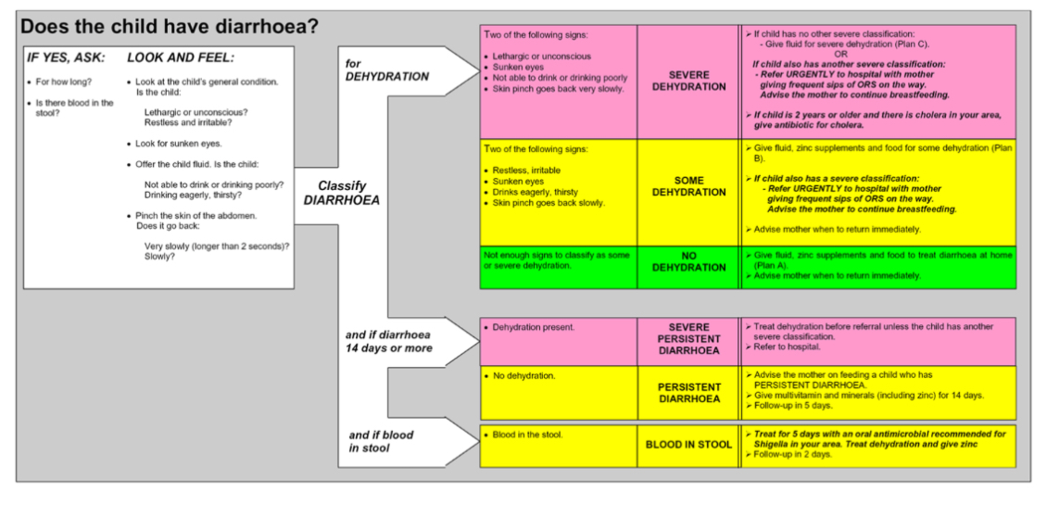

PLAN A (NO DEHYDRATION):
1. Home based Oral Rehydration therapy:
Amount of ORS to be given after each loose stool:
Age | Amount of ORS to be given
< 2 years | 50-100 ml
2-10 years | 100-200 ml
> 10 years | As much as wanted

Breastfeed frequently and for longer at each feed
- If child is exclusively breast fed, then give clear water/ ORS in addition to breast feeds
- If the child is not exclusively breast fed, give one or more of the following ORS, food based fluids (rice water, curd based drinks or soup) or clear water

2. Zinc Supplementation decreases the volume of diarrhoea
Age < 6 month: Syr Zinc Sulphate 10 mg OD for 14 days
Age > 6 months: Syr Zinc Sulphate 20 mg OD for 14 days

PLAN B (SOME DEHYDRATION): Deficit replacement/ Rehydration therapy
WHO: 75 ml/kg over 4 hours oral rehydration
CMCH/CHAD: 50 ml/kg Ringer Lactate over 6 hours
- Give frequent small sips from a cup.
- If the child vomits, wait for 10 minutes. Then continue, but slowly.
- Continue breastfeeding whenever the child wants.

PLAN C (SEVERE DEHYDRATION):At hospital
Intravenous Fluids: Ringer lactate (Preferred) or Normal saline
WHO:
Age | First give 30 ml/kg in: | Then give 70 ml/kg in:
Infants (0-1 year) | 1 hour | 5 hours
Children 1-5 years | 30 min | 2.5 hours

CMCH/CHAD: 100 ml/kg Ringer Lactate over 6 hours irrespective of age.
- Repeat once if radial pulse is feeble or undetectable
- Reassess the child every 1-2 hours. If hydration status is not improving then give the IV drip more rapidly
- Also give ORS (about 5 ml/kg/hr) once the child can drink (about 3-4 hours in infants and 1-2 hours in children).
- Reassess an infant after 6 hours and a child after 3 hours. Reclassify dehydration. Decide on which fluid plan to follow next (plan A, B, C).
- If IV access not possible, start rehydration orally/via NG tube (20 ml/kg/hr) over 6 hours.
- Reassess the child every 1-2 hours
- If persistent vomiting/ increasing abdominal distention then give the fluid more slowly.
- If hydration status is not improving within 3 hours, IV access has to be obtained/ or try inter-osseous line.

2.2: BRONCHIOLITIS

Definition
Viral bronchiolitis is a clinical diagnosis, based on typical history and examination, seen commonly in children aged 0-2 years. Peak severity is usually at around day two to three of the illness with resolution over 7-10 days. The cough may persist for weeks. Bronchiolitis most commonly occurs in the winter months, but can be seen all year round. Bronchilitis is usually self-limiting, often requiring no treatment or interventions.
Bronchiolitis = URTI followed by resp distress and fever with one or more of:

Cough
Tachypneoa
Retractions
Widespread crackles or wheeze

Diagnosis + Investigation
- Diagnosis is clinical and does not require any tests unless there is suspicion of other diagnosis
- CXR, CBC and Creat may be indicated if sepsis is suspected.
- Urine microscopy may be appropriate if febrile and < 2 months old.
Assessment – Only one criteria needs to be met to be classified as moderate or severe.
There is no evidence for the use of:
Regular beta-agonist bronchodilators
Corticosteroids – inhaled or oral/IV
Adrenaline – inhaled or IV (unless peri-arrest)
Hypertonic saline
Antibiotics or antivirals

Management
There should be a very low threshold for admission for all bronchiolitis patients, as Adivasi children often live in smoky environments and have poor nutrition.
- Oxygen therapy to keep sats >92% - humidified if possible via nasal cannula
- NG fluids should be prioritized over IV if child unable to drink due to breathlessness
- Nasal suction and nasal saline can be used at feeding times to improve success.

Referral

GAH does not have a pediatrician or ability to provide NIV so please refer early for children with severe bronchiolitis.

NURSING BRONCHIOLITIS

Definition
Bronchiolitis is a viral infection of the small airways of the lung that commonly follows upper respiratory tract infections. Children between 0-2 years are commonly affected.
Treatment is centred around oxygen therapy and support with feeding and fluid administration.
Bronchilitis is usually self-limiting, often requiring no treatment or interventions.

Immediate Care

(please tick box when complete) | Complete
- Record vitals signs including oxygen saturations
- Encourage good oral fluid intake for all children, if not drinking, NG fluids are preferred.
- For children < 5, contact health animator for under 5 nutrition assessment card details
- Administer paracetamol (15mg/kg) to all children with fever
- If on intravenous fluid therapy, input/output amounts must be recorded

Daily Care

- Record vital signs (resp rate, heart rate, oxygen sats and temperature )
- Administer regular paracetamol (+/- ibuprofen) to children with fever
- Encourage regular fluid intake – if vomiting use oral ondansetron (8-15kg – 2mg, 15-30kg – 4mg)
(see gastroenteritis quick reference guide for oral rehydration therapy guidance)
- If children have oxygen saturations < 92%, please start oxygen therapy via nasal prongs + contact doctor.
- Oxygen therapy can be reduced if saturations <92% slowly. Saturations should be rechecked 30 minutes after any reduction.
- Nasal saline (2-3 drops per nose) and nasal suction should be administered to children <6 months before feeding if struggling.

Contact doctor if:
- If a child has saturations < 92% - please start nasal oxygen to ensure oxygen saturations are above 92%, and contact the doctor to review the patient.
- If the child is not tolerating oral fluid and has not responded to oral ondansetron (as above).
- If child has an increasing respiratory rate or signs of increased work of breathing:
  - Grunting in a baby
  - Chest retractions
  - Tracheal tug

Discharge Advice
- Bronchiolitis can be prevented by not smoking or having wood fires in the child’s home, regularly washing your hands and avoiding other children with upper respiratory infections.
- Please return to hospital if your child:
  - is having difficulty breathing, for example with retractions around ribs and throat
  - has pale or blue-tinged skin
  - has severe coughing fits
  - is unable to feed

2.3: PNEUMONIA IN CHILDREN

Definition

Adivasi children often live in houses with no ventilation and are thus exposed to thick smoke when fires are lit. Treatment of infants should be aggressive and there is a very low threshold for admission.
Bronchiolitis and exacerbations of asthma should not be treated as pneumonia and will expose children to unnecessary antibiotics.
The following children need admission:

<2months with cough and RR >60
2-12 months with RR>50 + chest indrawing
1-5 years with RR >40 + chest indrawing
Grade 3 malnutrition + rapid breathing

Signs of severe pneumonia include:

Shock or toxic appearance
Oxygen sats <85% or difficulty maintaining sats >92%
Severe tachycardia
Severe respiratory distress

Diagnosis + Investigation

- Blood tests not essential, if clinical diagnosis clear. Can help rule out anaemia, will not differentiate viral vs bacterial.
- Chest XRAY only required if diagnosis unclear or atypical presentation.
- Nasal swabs should not be performed
- Creat and s. electrolytes should be performed on any child started on intravenous fluids.
- IV fluids should be prescribed only for shock, NG fluid therapy is the preferred route for infants not drinking.

Management

Antibiotic therapy should be guided by severity of illness and not if patient has been admitted:

Age/Clinical Features | Antibiotic
<1 month | Only IV antibiotics  Under 7 days – Cefotaxime 50 mg/kg 12 hrly + Gentamicin 5mg/kg 24hr*  7 days-1 month – Cefotaxime 50 mg/kg 8 hourly + Ampicillin (see BNF dosing)
>1 month  Mild to moderate pneumonia | Oral abx only appropriate for >3 months  Mild – Oral amoxicillin 30 mg/kg/dose 8hrly (max 1g/dose) - 5 day course  Moderate – IV Amoxicillin 50mg/kg/dose 6 hrly (max 1g/dose) - 5-7 days
1-3 months  Severe pneumonia | IV Cefotaxime 50 mg/kg/dose 6hrly (max 2g/dose) +/-  Anti-staphylococcal agent if suspected (see below)
>3 months  Severe Pneumonia | Co-amoxiclav 30mg/kg/dose (max dose 1.2g/dose) 8hrly  If penicillin allergic cefotaxime 50 mg/kg/dose 6hrly (max 1g/dose)

Ceftriaxone can be substituted for cefotaxime if needed (dose is the same) except in newborns. Gentamicin should be given 36hrly if baby <37/40 birth gestation - please check renal function.
Oral antibiotic switch after IV therapy would normally be Amoxiclav (Amoxicillin dose 50 mg/kg BD).
If penicillin is allergic, azithromycin can be substituted.
Staphylococcus aureus is a cause of severe pneumonia. If suspected, discuss with senior staff. Features include:
Lung abscess or pneumatocoeles, empyema, multisystem infection, very unwell, pneumonia as a consequence of chickenpox, influenza or measles
Treatment is with IV Ampiclox (see ampicillin dosage as per BNF)
Referral-GAH does not have access to any access to non-invasive ventilation or a pediatrician on site.

PNEUMONIA IN CHILDREN NURSING

Definition
Pneumonia is an infection in the chest which causes children to have difficulty breathing.
Babies and infants will often stop eating and drinking if they are struggling with their breathing and therefore fluid intake needs to be prioritized with young patients.

Immediate Care

(please tick box when complete) | Complete
- IV access only required if IV antibiotics
- Record vitals signs including oxygen saturations
- Encourage good oral fluid intake for all children, if not drinking, NG fluids are preferred.
- For children < 5, contact health animator for under 5 nutrition assessment card details
- Administer paracetamol (15mg/kg) to all children with fever
- If on intravenous fluid therapy, input/output amounts must be recorded

Daily Care

- Record vital signs (resp rate, heart rate, oxygen sats and temperature )
- Administer regular paracetamol (+/- ibuprofen) to children with fever
- Encourage regular fluid intake – if vomiting use oral ondansetron (8-15kg – 2mg, 15-30kg – 4mg)
(see gastroenteritis quick reference guide for oral rehydration therapy)
- If children have oxygen saturations < 94%, please start oxygen therapy via nasal prongs + contact doctor.

Contact doctor if:

- If a child has saturations < 94% - please start nasal oxygen to ensure oxygen saturations are above 94%, and contact the doctor to review the patient.
- If the child is not tolerating oral fluid and has not responded to oral ondansetron (as above)
Sepsis risk factors
Maternal
PROM >24hrs (if >37/40 gest)
GBS positive women
Antibiotics given intrapartum
Pre-term birth <37/40
Infant
Respiratory Distress Syndrome > 4hrs post birth
Ventilation required
Apnoea
Evidence of shock
Bradycardia/Tachycardia
Hypoxia
Seizure
Signs of encephalopathy
Altered behaviour/floppy
Early jaundice (>24hrs)
Oliguria >24hrs
Temperature instability

2.4: NEONATOLOGY

- Neonatal Sepsis

Definition
Neonatal sepsis is common but difficult to diagnose due to the nonspecific nature of symptoms.
Kaiser Permanente (US medical facility) has a validated tool for assessing risk and can be accessed at (EOS calculator)
https://neonatalsepsiscalculator.kaiserpermanente.org/
This tool allows for risk stratification, but requires a clinical review of the child to classify them as:

- Well appearing - no persistent physiological abnormalities
- Equivocal - tachycardia (>160), tachypnoea (>60), respiratory distress (not requiring oxygen), temperature instability
One abnormality for over 4 hours, or two abnormalities over 2 hours
- Clinical illness - Haemodynamic instability, O2 requirement over 2 hours, Seizures, Apgar <5 at 5minutes, Ventilation requirement

Diagnosis + Investigation
Please use the above diagnostic tool to assess infants (>34/40) for which there is concern / maternal or fetal risk factors. If EOS calculator suggests blood cultures or antibiotics - follow below guidance.

- CBC, TC, Creat, Bilirubin, ESR??
- Chest blood sugar
- Consider LP ??
- CXR
- Consider eye swabs (for gonorrhoea and chlamydia) if purulent discharge
- Review umbilicus - consider bacterial swab

Unfortunately we are unable to perform blood cultures at GAH at present
If baby is <34/40 gestation, the EOS calculator is not validated and should be used with caution. Sepsis is high risk in this age group.
Calculating maintenance requirements
(Use 5% kidral solution)

Day 1 - 60ml/kg/day
Day 2 - 80ml/kg/day
Day 3 - 100ml/kg/day
Day 4 onwards - 120ml/kg/day

Immediate Management
- Administer – Cefotaxime 50mg/kg 12hrly + Gentamicin 5mg/kg 24hly (if under 37/40 - 36hrly)
- Start IV fluids at maintenance rate, if concerns about haemodynamic instability, poor feeding or low blood sugar (see neonatal hypoglycaemia)
- Ensure 4xday vitals by nursing staff, encourage regular feeding and blood sugar monitoring.

Ongoing management
- 48hrs of antibiotics should be administered to all suspected sepsis neonates.
- At 48hrs - review neonate, if persistent signs of instability - refer to high centre via neonatal ambulance service.
- If baby examines normally, is normoglycaemia and feeding well - antibiotics can be stopped and the baby should be observed for a further 24hrs (4x day vitals)

Referral

If neonate is becoming increasingly unstable refer as soon as possible to Neonatal Ambulance service for transfer to a higher centre.

NURSING NEONATAL SEPSIS

Definition
Neonatal sepsis is common, especially in low weight and pre-term babies (common in Adivasi community). The diagnosis can be difficult as babies do not present with the usual symptoms of fever, cough, urinary symptoms etc. There are many risk factors (which are shown in the clinician guide), but be aware of IUGR and pre-term babes especially.As labour ward nursing staff you are the staff who will first pick up potential sepsis in a baby, so you should always be aware.

Immediate Management

1. Contact doctor for review immediately
2. Ensure full set of vital signs are recorded (including saturations)
3. Check blood sugar for all suspected sepsis babies
4. If antibiotics prescribed please administer immediately - early treatment = better outcome
5. If intravenous fluid started - start input/output monitoring (measure urine volume in bag)

Daily Care
- 4x vitals signs (unless vitals not normal, then should be done 2hourly or as per doctor request)
- Input/output monitoring ( including urine volume ) if on IV fluids
- Ensure regular maternal feeding every 2-3 hours, unless severely unwell. Can cup feed if baby has poor latch/suck.
- After 48hrs of treatment, repeat CBC, TC, Creatinine and Bilirubin should be sent.
- Be aware of hypoglycaemia, if baby is becoming more unwell, check blood sugar. (See hypoglycaemia quick reference guide)

Contact doctor if:
- If baby has worsening signs of sepsis
- Persistent fast heart rate (>160 bpm)
- Persistent fast breathing (>60bpm) or
- new signs of respiratory distress (grunting, retractions)
- Seizure
- Hypoglycaemia
- Poor feeding/lethargy
- If unable to gain intravenous access
- If any other significant nursing concerns, and you have asked the senior nurse.

Discharge advice
Please inform parents to return to hospital for assessment if the baby has any of the following:
New difficulty feeding or tolerating feeds
Unusual behaviour e.g inconsolable crying
Unusually floppy
Fever
Rapid or difficulty breathing (explain about grunting and restriction)

Causes of hypoglycaemia

Common
Lack of nutrition/carbohydrate storage
High insulin levels (due to material diabetes)

Uncommon
Hypopituitarism
Perinatal stress hyperinsulinism
Fatty acid oxidation defects
Gluconeogenesis defects
Ketotic hypoglyceamia
Glycogenosis
GH deficiency
Cortisol deficiency

2.5 NEONATAL HYPOGLYCEMIA

Definition
Neonatal hypoglycaemia is common in underweight (<2kg), preterm and babies of diabetic mothers (see overleaf for common signs)
It can commonly be treated with adequate nutritional intake and sometimes IV glucose administration for a short term.
It is rarely a herald of endocrine or metabolic conditions, but should make the provider strongly consider neonatal sepsis.

Diagnosis + Investigation
Hypoglycaemia should be investigated for pathology if it is :
- Unexpected (no risk factors)
- Severe - glucose < 18mg/dl at any point
- Persistent - 2 measurements > 36mg/do despite adequate nutrition - EBM or formula supplementation (+/- glucose administration)
- Glucose requirement >10mg/kg/min after 48hrs
- Symptomatic

Immediate Management
- IV access, glucose bolus - 2.5ml/kg 10% dextrose (oral glucose if IV access unavailable + IM glucagon 200mcg/kg*)
- Check lab glucose to confirm against glucometer.
- 10% dextrose infusion at 60ml/kg/day
- Encourage mother to establish feeding as soon as possible
- Recheck blood glucose after 30 minutes
  - If blood sugar <18mg/dl - give further bolus (as above) + increase infusion by 2mg/kg/min
Recheck blood glucose after 30 minutes
  - If blood sugar 18 - 44 mg/dl and no clinical signs - increase infusion by 2mg/kg/min
Recheck blood glucose after 30 minutes
  - If blood sugar > 44mg/dl - start to wean IV infusion over 12 to 24hrs + continue enteral feeds
Recheck blood sugar before stopping infusion
Calculating glucose requirements

Rate (ml/min) x % dextrose administration / 6 x weight of baby (in kg) = mg/kg/min
(E.g. 10ml/min of 10% dextrose to a 2kg baby = 8.3mg/kg/minute)

Be aware that dextrose requirements over 12.5% should require a central line (also watch for hyponatraemia)
If glucose infusion <8mg/kg/min then test for hyperinsulinism

Maintenance fluid requirements are as follows (Infusions volumes should not exceed this, % conc can be adjusted)
Day 1 - 60ml/kg/day
Day 2 - 80ml/kg/day
Day 3 - 100ml/kg/day
Day 4 onwards - 120ml/kg/day

Referral
Persistent intravenous glucose requirement despite adequate enteral feeding should require further investigation which should be referred via the neonatal ambulance service

NEONATAL HYPOGLYCEMIA NURSING
Signs of hypoglycaemia

Lethargy
Abnormal feeding behaviour
High pitched cry
Altered level of consciousness
Hypotonia
Seizures
Hypothermia
Cyanosis
Apnoea

Definition
Neonates are easily susceptible it low blood sugars as they have very little carbohydrate stores to rely on if not getting adequate feeds.
At risk babies are:
- Less than 37 weeks gestation
- IUGR babies (<2kg)
- Babies of diabetic mothers
Babies of mothers taking beta blocker medication
- Babies being treated for sepsis or NPO

Treatment protocol
All babies which fit in the at risk category above should be managed as follows:
- Keep baby warm and dry with blanket as per usual cares.
- Encourage and support early breast feeding within 1 hour after birth.
- Check pre-feed blood sugar before the second feed (2-4 hours after birth)

If blood sugar is <36mg/dl treat as per protocol A
If blood sugar is >36mg/dl treat as per protocolIf blood sugar is >18mg/dl treat as per protocol C
Protocol B
Continue to encourage 2 hourly feeding
No further glucose monitoring required
Watch out for signs of hypoglycaemia

Note: All babies should be offered 2-3hrly breastfeeding, even if on IV glucose supplementation.

Contact doctor if:
- If baby has persistent low blood sugar (<36mg/dl) despite regular feeding (as above)
Protocol C
Administer oral glucose immediately (or EBM)
IV Access
Contact doctor, get 10% dextrose infusion ready
Record vitals
- If baby has low blood sugar and signs of hypoglycaemia
- Baby has potential signs of sepsis - rapid breathing, grunting, fever, lethargy, poor feeding
Protocol A

Administer glucose powder
Encourage breastfeed, if poor suck encourage hand express and cup feed atleast 10mls per feed.
Can substitute with formula 10-15ml/kg

Check blood sugar before third feed

If <36mg/dl - repeat protocol A and contact doctor
If >36mg/dl - continue to encourage regular feeds and keep aware of signs of hypoglycaemia

2.6 NEONATAL JAUNDICE

Definition
Neonatal jaundice is common and is a physiological response after 24hrs (peaking at day 3-7) in breastfed babies. It is commonly mild and can be treated with phototherapy, but care must be taken to not miss neonatal sepsis or other sinister causes of jaundice (see box opposite)
CAUSES

<24hrs of age
Haemolytic disease
Sepsis
>24hrs of age
Physiological
Sepsis
>3 weeks (breastfed) >2weeks (formula)
Conjugated Jaundice
Cholestatic, multiple causes, significant pathology
Unconjugated Jaundice
Heamolysis or sepsis.

Diagnosis + Investigation

> 24hrs of age
- SBR, CBC, Blood film, Blood group + Coombs test
- Evaluate maternal blood group - high risk if Rh-ve
- If their is no evidence of haemolysis - have low threshold for treatment for sepsis if any concern.

>24hrs of age
- SBR; Nurses will plot on treatment graph and initiate phototherapy if required.
- Assess neonate for sepsis if nurses are concerned (see QRF Neonatal Sepsis)
- Use treatment algorithm overleaf for phototherapy treatment

>3 weeks of age (breastfed), > 2 weeks of age (formula fed)
- Check SBR + conjugated fraction
- If conjugated fraction > 20% —> cholestatic jaundice. Urgent referral for paediatric opinion.
- If conjugated fraction < 20%. —> check maternal and baby blood group. CBC and Coombs test. Blood film. Consider need for phototherapy.

Management
<24hrs of age
- Initiate phototherapy immediately. Consider need for transfer if significant haemolytic disease - if SBR high or Hb dropping.
- Repeat SBR at 4 hrs of age to see trend, if rising will need referral for IVIg +/- exchange transfusion.
- Start IV fluids therapy at maintenance level + 30mls/kg/day for insensible losses due to phototherapy.

>24hrs of age
- Phototherapy is first line therapy for all jaundice in the first 2-3 weeks of life. GAH has a single phototherapy unit - we are unable to provide high dose therapy or exchange transfusion.
- Nursing staff will take repeat SBR samples every 12hrs and adjust treatment - you will be contacted to review if the SBR is rising despite phototherapy - referral will be required, consider sepsis and heamolysis

>3 weeks of age (breastfed), > 2 weeks of age (formula fed)
- Initiate phototherapy for unconjugated hyperbilirubinaemia immediately if above treatment line. Consider sepsis and heamolysis - treat as appropriate
- Urgent referral for conjugated hyperbilirubinaemia - do not not delay by further testing at GAH.

Referral - NEONATAL JAUNDICE NURSING

Definition
Neonatal jaundice is common, occurring in 50-60% of babies. Some babies will treatment with phototherapy to prevent bilirubin overload leading to risk of seizures. This is very effective treatment and rarely requires any further intervention. There is a small percentage of babies with another cause of their jaundice and this should be investigated by the doctor if the jaundice presents before 24hrs of age or not responding to phototherapy.
GAH Quick Reference Guide:
NEONATAL JAUNDICE

Immediate Care

- If jaundice is suspected - send a serum bilirubin sample. Also record a full set of vitals, jaundice can be a sign of sepsis - if concerned contact the doctor.
- If baby’s age < 24hrs and serum bilirubin >10- contact doctor for review
- If baby’s age >24hrs then plot bilirubin level on jaundice graph
- If above phototherapy treatment line - start phototherapy (ensure phototherapy standard operating procedure is followed) then make medical staff aware.
- Repeat SBR needs to be sent after 12hrs of phototherapy. (See below)

Follow up serum bilirubin:
Serum bilirubin rising rapidly despite phototherapy
Serum bilirubin stable or <50 below treatment line
Serum bilirubin >50 below treatment line

Doctor review immediately
Stop phototherapy
Continue phototherapy.
Recheck SBR in 12hrs

Daily Care

- Babies having phototherapy are at high risk of dehydration and regular feeding should be encouraged, but please minimise time away from phototherapy.
- Monitoring of stool and urine output is mandatory.
- Vitals should be recorded 4x day.
- Daily weight

Contact doctor if:

- Jaundice in first 24hrs of life
- Serum bilirubin rising despite phototherapy
- Baby has potential signs of sepsis - rapid breathing, grunting, fever, lethargy, poor feeding

Discharge Information

Please tell all parents to return to hospital for assessment if they notice new onset of jaundice in their baby, especially if feeding is poor.

Chapter 3: Infectious Diseases

3.1 Antibiotic Primer
3.2 Urinary Tract Infections

3.3 Soft Tissue and Bone Infections
3.4 Varicella Zoster

3.5 Bacterial Endocarditis
3.6 Tuberculosis
3.7 HIV/AIDS

3.8 Typhoid Fever
3.9 Leptospirosis
3.10 Measles

3.11 Animal Bites
3.12 Parasitic Infections
3.13 Needle-stick Injuries

3.14 Clostridium Difficile
3.15 Fever of Unknown Origin

3.1 Antibiotic Primer
Penicillins
Generation | Names | Properties | Spectrum
Natural Penicillins | Penicillin G (IV)  Penicillin V (PO) | Some Gram+ Cocci, GPR, GNC, most anaerobes | Group A Strep  Enterococci  Listeria  Pasteurella  Syphilis
Anti-Staphylococcal | Amoxycillin- Clavulanic acid  Linezolid | Treats MSSA,Little Gram – activity  Treats MRSA | Streptococcus, Staphylococcus with PCNase
Aminopenicillins | Ampicillin (IV)  Amoxicillin (PO)  Ampiclox IV(Ampicillin plus Cloxacillin)  Amoxicillin+Clavulanate (amoxyclav) | Penetrates porin channel of Gram negatives. Not stable against PCNases.  Ampiclox useful against PCN-resistant staphy | Enterococcus, Listeria, H. Flu, Shigella, Salmonella, Proteus
Anti-Pseudomonal Penicillins | Piperacillin +Tazobactam | Penetrates porins of Gram negatives, more resistant to PCNases | Most GNR including Enterobacter, Pseudomonas
Piperacillin + tazobactam-Beta-lactam/beta-lactamase inhibitor -Anti bacterial spectrum - Staphylococcus aureus (methicillin susceptible), Coagulase negative Staphylococci, Streptococcus pneumoniae (penicillin susceptible), Streptococcus spp., Haemophilus influenzae, Moraxella catarrhalis, Neisseria meningitides, Neisseria gonorrhoeae, Enterobacteriaceae, E. coli, Pseudomonas aeruginosa
Renal impairment - CrCl >40 mL/min: Dose adjustment not necessary ---- CrCl 20-40 mL/min: 2.25 g IV q6hr, OR 3 g/0.375 g IV q6hr (for nosocomial pneumonia), OR extended infusion of 3.375 g IV over 4 hr q12hr (off-label) - CrCl <20 mL/min: 2.25 g IV q8hr, OR 2.25 g IV q6hr (for nosocomial pneumonia)
Dosage in Elderly
The most important alteration that occurs in the elderly is the age-associated decline in normal renal function. The creatinine clearance is a very useful measure of renal function in elderly patients and can be estimated by the Cockroft-Gault equation in which the creatinine clearance (in milliliters per minute) is assumed to equal the percentage of normal renal function.
The dose may be adjusted upward or downward to compensate for increased or decreased extracellular fluid volume. The maintenance dose should be estimated using ideal body weight and percentage of normal renal function.
Cephalosporins
Generation | Names | Properties | Spectrum
1st Gen | Cephalexin (PO)  Cefazolin (not available) | Most GPC (Staph and Strep, not MRSA), Some GNR (E. coli, Proteus, Klebsiella) | Used for surgical prophylaxis and skin infections
2nd Gen | Cefuroxime (not available) | Decreased activity against GPC, increased GNR activity | PNA/COPD flare  Abdominal Infections
3rd Gen | Cefixime (PO)  Cefotaxime (IV)  Ceftriaxone (IV) | Broad activity against GNR and some anaerobes. | PNA, sepsis, meningitis
4th Gen | Cefepime | Increased resistance to B-lactamases | Monotherapy for febrile neutropenia
Other Antibiotics
Type | Names | Spectrum | Notes
Aminoglycosides | Amikacin (IV)  Gentamycin (IV) | GPC, some respiratory Gram negatives, atypical, Pseudomonas | S/E: Ototoxicity (irreversible)  Nephrotoxicity (reversible)  Amp and Gent together treat Enterococcus
Tetracyclines | Doxycycline | Ricketssia, Ehdlichia, Chlamydia, Mycoplasma, Nocardia, and Lyme
Fluoroquinolones | Ciprofloxacin  Norfloxacin | Enteric GNR and atypical.  UTI: Cystitis, Pyelonephritis  Prostatitis/Epididymitis  Gastroenteritis  Pseudomonal Osteomyelitis  Nosocomial pneumonia | S/E: potentiates coumadin  Teratogen: CartilageAbnormalities  CNS dizziness, NSAIDS potentiate CNS toxicity, Hepatotoxicity  Prolongs QT interval
Metronidazole |  | - Used to treat anaerobes  -CNS penetration – treats brain abscesses  -Secreted into GI tract  -Combine with quinolones for intra-abdominal infections | S/E: Disulfaram Alcohol Effect  Nervous system Toxicity  Metallic Taste  Reversible Neutropenia  Dark/Red Urine
Chloramphenicol |  | Salmonella Typhi | S/E: Gray Baby Syndrome, Aplastic Anemia, Bone Marrow Suppression
Macrolides | Azithromycin | GPC, some respiratory Gram negatives, atypicals
.

3.2 Urinary Tract Infections
Introduction
Lower urinary tract: Urethritis, cystitis
Upper urinary tract: Pyelonephritis, renal or perinephric abscess, and prostatitis
Uncomplicated: Also known as simple UTIs or cystitis
- Usually affect the lower urinary tract, including the bladder
- More common and easier to treat than complicated UTIs
- Symptoms typically last 2 to 4 days
- Treatment typically lasts 3 to 10 days
Complicated:
- More likely to cause symptomatic illness or death
- Can involve the kidneys, stones, sepsis, urinary obstruction, or catheters
- Can be caused by drug-resistant bacteria
- Treatment typically lasts 10 to 14 days
Risk factors for complicated UTIs
- Pregnancy
- Immunocompromised state
- Structural abnormalities
- Comorbidities that increase infection risk, like diabetes mellitus
- Recent surgery or device use
- Metabolic disorders
- Unusual pathogens, like yeast
Microbiology
Always send urine for C&S before starting antibiotics
Uncomplicated UTI: E. coli (~80%), Proteus, Klebsiella, S. saphrophyticus
Complicated UTI: E. coli (~30%), enterococci (20%), Pseudomonas (20%), S. epidermidis (15%), other GNB
Urethritis: Chlamydia trachomatis, Neisseria gonorrhoeae, Ureaplasma urealyticum, Trichomonas vaginalis, Mycoplasma genitalium, HSV
.
Clinical Manifestations
- Cystitis: dysuria, urgency, frequence, hematuria, change in urine color/odor, suprapubic pain, fever generally absent
- Urethritis: may be identical to cystitis except urethral discharge may be present
- Prostatitis: Chronic prostatitis similar to cystitis except symptoms of obstruction (hesitancy, weak stream). Acute prostatitis presents with perineal pain, fever, tenderness on prostate exam.
- Pyelonephritis: fever, chills, flank or back pain, nausea, vomiting, diarrhea.
- Renal abscess: identical to pyelonephritis except persistent fever despite appropriate antibiotics.

Diagnostic Studies:
Urinalysis: Normal urine - WBCs < 2-5/hpf and Blood < 2 RBC/hpf, bacteria none, casts hyaline/casts hpf nitrites
Urine Culture: clean-catch midstream. Significant levels are:
  - ≥ 10⁵ CFU/ml in asymptomatic women
  - ≥ 10³ CFU/ml in men
  - ≥ 10² CFU/ml in symptomatic patients
Sterile pyuria (pyuria with negative culture) can be caused by urethritis, nephritis, renal TB, or foreign body (calculus).
Pregnant women should be screened for asymptomatic bacteriuria.
Prostatitis: Do first void and midstream urine collection, prostatic expressage, and post-prostatic massage urine specimens.
Ultrasound
Do renal ultrasound for
- all male patients with UTIs to pick up anatomical abnormalities
- all females who are pregnant & with recurrent UTIs
- For older males with BPH also do post-void residual (normal >100ml)

Treatment at GAH
Clinical Scenario | Empiric Treatment Guidelines
Uncomplicated Cystitis | First line:  - Nitrofurantoin 100mg PO BD for 5 days(minimal resistance and propensity for collateral damage. Take it with a full glass of water and with meals)*  - Cotrimoxazole 160mg/800mg PO BD for 3 days  Second line:  - Ciprofloxacin 250 mg PO BD for 3 days  - Levofloxacin 250 mg PO OD for 3 days  Alternative therapy:  - Amoxy-clav 625 mg PO BD for 3-7 days
Complicated Cystits | - Ciprofloxacin 400mg IV Q12H for 7-14 days  - Ampicillin 1-2 g IV Q6H + Gentamicin 2 mg/kg IV Q8H for 7-14 days  - Ceftriaxone 2g IV OD for 7-14 days  - Piptaz 4.5g IV Q8H for 7-14 days  - Meropenem 1g IV Q8H for 7-14 days
Urethritis | Treat for both Neisseria and Chlamydia  Neisseria: Ceftriaxone 125 mg IM x 1 dose  Chlamydia: Doxycycline 100mg PO BID for 7 days or Azithromycin 1g PO x 1 dose
Prostatitis | Ciprofloxacin 500 PO bid x 10 days and then 250 mg PO bid for 10 days (total 3 weeks) for acute prostatitis and 4 -6weeks for chronic
Pyelonephritis | - IV Aminoglycoside (Gent/Amikacin) +/- ampicillin  - Ceftriaxone 2g IV OD or BD  - Piptaz 4.5g IV Q6H  - Meropenem 1g IV Q8H  Change IV to PO antibiotic based on urine C&S when patient improved clinically and afebrile for 24-48 hours and complete a 14 day PO course in total, inc. initial IV therapy.
Treatment in Pregnancy | Cystitis:  - 1st line: Nitrofurantoin 100mg PO BD for 7 days (Class B, contraindicated at term*)  - 2nd line: Trimethoprim 200mg PO BD for 7 days *  - 3rd line: Cephalexin 500mg PO BD for 7 days  If symptoms persist despite initial treatment give Amoxicillin 250 mg PO TDS for 7 days or treat according to sensitivities.
Children | 1st line:Nitrofurantoin 5-7mg/kg/day for 7 days  2nd Co- trimoxazole 5-12 mg/kg/day divided BD (only >2 months)  3nd line: Ciprofloxacin 15mg/kg/day divided BD  4th line: Cephalexin 50mg/kg/day divided QID
Note there are high rates of Ciprofloxacin and Co-trimoxazole resistance at GAH.
*Nitrofurantoin should not be used in the 3rd trimester as it causes hemolytic anemia in the newborn
* With Trimethoprim in pregnancy: give folic acid 5 mg daily if it is the first trimester of pregnancy. Do not give trimethoprim if the woman is folate deficient, taking a folate antagonist, or has been treated with trimethoprim in the past year.
.
Urinary Tract Infections in Elderly Persons
Asymptomatic Bacteriuria(ASB)
Because of physiologic changes related to aging and comorbid illnesses, ASB is a common occurrence in older adults. Neither short-term nor long-term adverse outcomes attributable to the high incidence and prevalence of ASB have been shown in this population.
1. Diagnosis:
The diagnosis of ASB is based on the result of a urine culture from a urine specimen with isolation of the same bacterial strain in quantitative counts 100,000 colony forming units (cfu)/ml

2. Prevalence:
Population studies throughout the world have shown a rise in the prevalence of asymptomatic bacteriuria with age.
- Young women have a prevalence of ASB of 1 to 2%.
- For women 65 - 90 yr, 6 to 16%. >90yr 22 - 43%
- ASB is very uncommon in young men, but for men > 65, prevalence is 5 - 21% and is highest in men over the age of 90.
- Among the institutionalized elderly, 25 to 50% of women and15 to 35% of men have ASB.
- The prevalence is highest among those most severely disabled.
- Up to 90% of institutionalized adults also have asymptomatic pyuria (i.e., white blood cells in the urine in the absence of urinary tract–specific symptoms).
- For those residents with long-term indwelling catheters, 100% have ASB.
- Elderly persons with condom catheters have a lower incidence ofASB or urinary tract infections (UTIs) than those with catheters.

3. Management for elderly persons with ASB:
Routine screening and treatment for ASB are not recommended for the following persons: (1) diabetic women; (2) older persons living in the community or institutionalized; (3) persons with spinal cord injury; and (4) catheterized patients while the catheter remains in situ.
Although a 3-d course of antibiotic therapy has been shown to decrease the prevalence of bacteriuria at 6 mo. no benefits in morbidity, mortality, and chronic urinary incontinence have been shown to date.
Screening and treatment of ASB in older persons is only recommended in the following two circumstances:(1) before transurethral resection of the prostate and (2) before urologic procedures in which mucosal bleeding is anticipated.

4. Prevention:
Cranberry juice reduced the frequency of bacteriuria plus pyuria in the elderly population. However, because of several study design issues in this trial, the use of cranberry juice has not been fully advocated for the prevention ofASB.
In a controlled trial of intravaginal estriol therapy in postmenopausal women with recurrent UTI, the estriol group had fewer episodes of ASB than the placebo group. However, this study was conducted specifically among women with a history of recurrent UTI. Intravaginal estriol therapy is not recommended for all postmenopausal women.
In men, changes in the bactericidal activity of prostate secretions has been reported and proposed as one factor contributing to bacteriuria.
Lastly, avoiding long-term indwelling catheter use is optimal. If possible, using a condom catheter provides more comfort to the patient and fewer adverse outcomes.

3.3 Soft Tissue and Bone Infections
Cellulitis
- Refers to infection of the superficial/deep dermis and subcutaneous fat.
- Primarily caused by Streptococcus and Staphylococcus, including MRSA. The infection is often polymicrobial in diabetics/immunosuppressed.
- Special cases:
  - Cat bite 🡪 Pastuerella multocida
  - Dog bite 🡪 Pastuerella multocida, Capnocytophaga canimorsus (C. canimorsus can cause a fulminant sepsis with symmetrical peripheral gangrene in splenectomized patients)
  - Penetrating injury 🡪 Pseudomonas
  - Gardening 🡪 Sporothrix (causes ulcerating nodules)
- Clinical Manifestations: Erythema, edema, warmth, pain, sometimes regional lymphadenopathy
- Toxic Shock Syndrome can be seen with Staph or Strep infection. Causes fever, headache, vomiting, myalgias, pharyngitis, diarrhea, diffuse rash with desquamation, hypotension, and shock.
- Treatment:
  - Antibiotics: Amoxyclav 625 mg TID for 5-10 days. Most cellulitis can be treated with PO antibiotics. IV antibiotics are indicated for signs of systemic toxicity or rapidly progressing erythema. Duration of treatment is 5-10 days, but depends on clinical response. MRSA is not common at GAH, but if suspected consider using clindamycin or linezolid. Diabetic foot ulcers require more aggressive treatment.
  - Supportive therapy:
    - Limb elevation
    - Magnesium sulphate paste for local application every 4 hours
    - Paracetamol and NSAIDs for pain
    - Optimisation of sugars
  - Surgery: Cellulitis often resolves with medical management. Surgical treatment including fasciotomy/ debridement is considered in case of non-resolution with medical management, compartment syndrome, or development of necrotic patches over the skin.

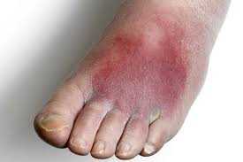

Other Cutaneous Infections
- Impetigo: Superficial purulent lesions, usually on face/extremities, bullae, gold crusting. Usually caused by Strep or Staph species. Topical mupirocin or other topical antibacterial is usually sufficient for treatment. If extensive treat with amoxicillin or amoxyclav
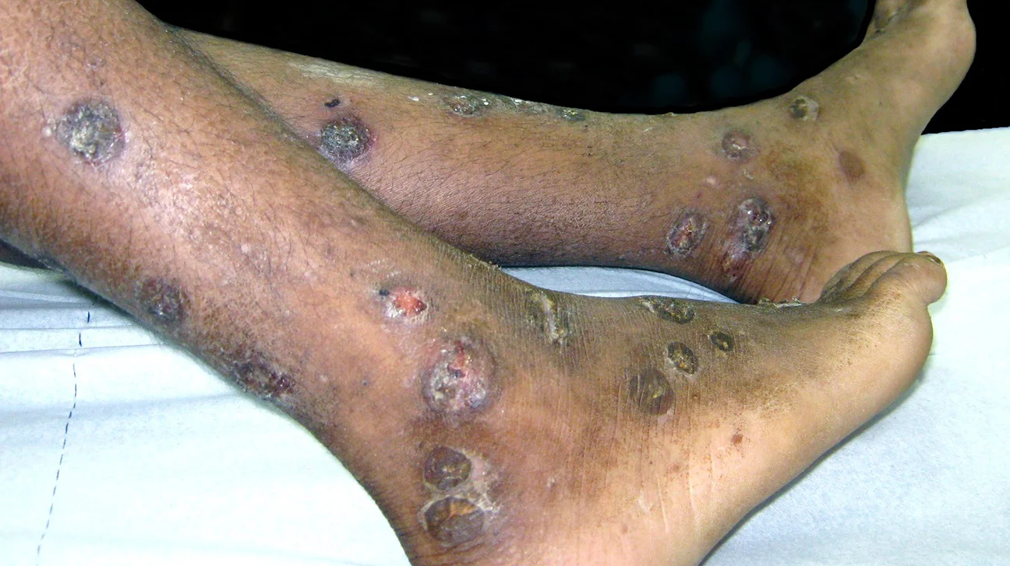
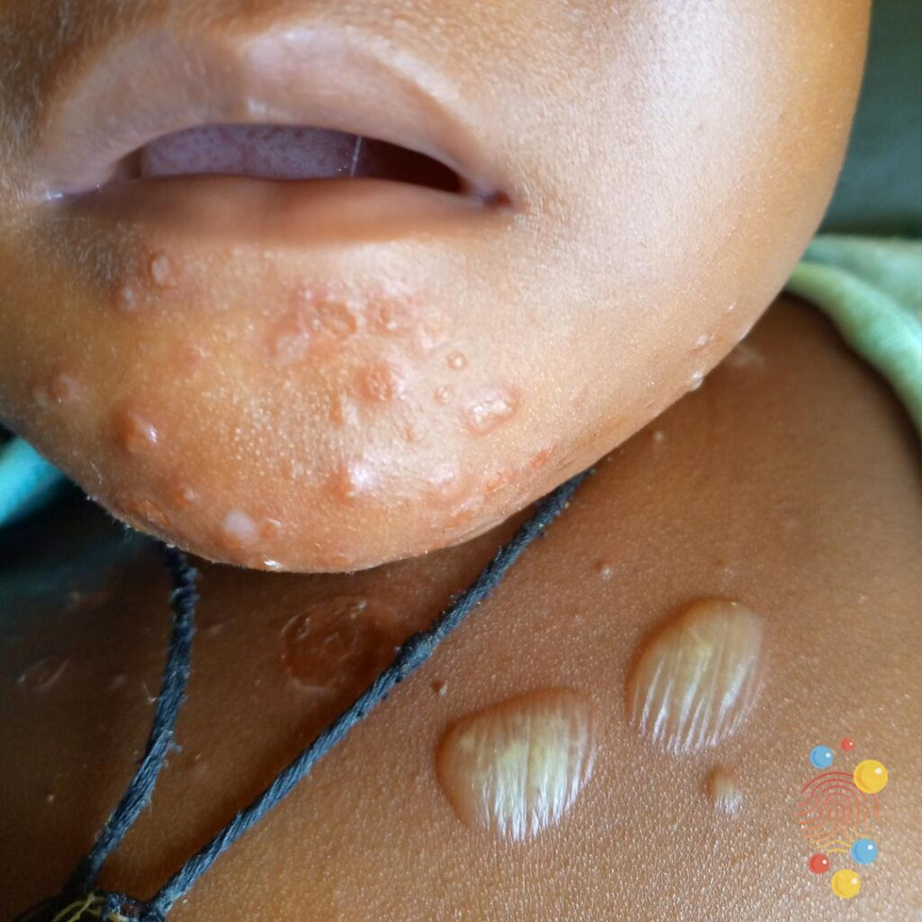

- Erysipelas: Raised erythematous lesions with clear demarcation from normal skin. Mainly caused by Group A streptococcus. Treat with amoxicillin or amoxyclav. If admitted then treat with Crystalline penicillin.
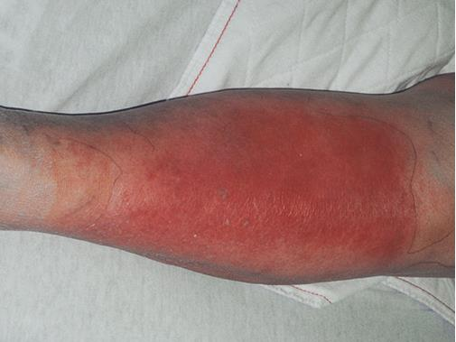
- Folliculitis/Furunculosis: Folliculitis is superficial inflammation of hair follicles, limited to epidermis. Furunculosis is an infection of the follicle extending to the dermis (multiple coalescent furuncles are called carbuncles). Usually caused by Staph aureus or Pseudomonas. Treat with antibiotics, warm compresses +/- incision and drainage/ debridement.


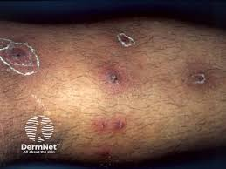

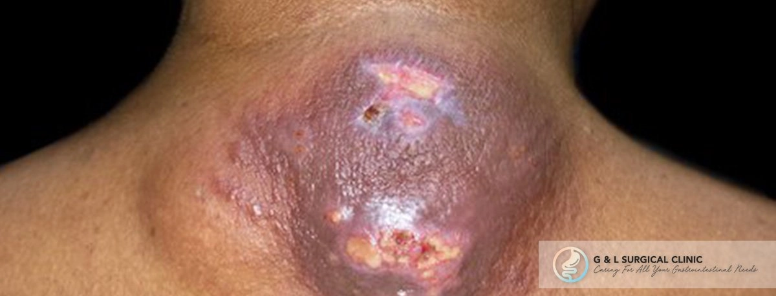

- Recurrent furunculosis: Get pus culture. Antibiotics
  - Amoxyclav for 2-4 weeks
  - Linezolid (if MRSA)
  - Clindamycin 300 mg PO BD for 5-7 days along with Amoxyclav
  - Topical mupirocin ointment

Necrotizing Fasciitis
- Infection and necrosis of the superficial fascia, subcutaneous fat, and deep fascia. Necrosis of arteries and nerves in the subcutaneous fat is called gangrene.
- Fournier’s gangrene is necrotizing fasciitis of the perineum
- Clinical manifestations include necrotic skin changes with blebs, rapid spread, and systemic toxicity. Pain is out of proportion to apparent cellulitis. Hemorrhagic bullae, darkening of skin, cutaneous gangrene +/- crepitus present.
Treatment is surgical debridement. Treat aggressively with IV antibiotics.- Piperacillin /tazobactam. Generally fatal if untreated.
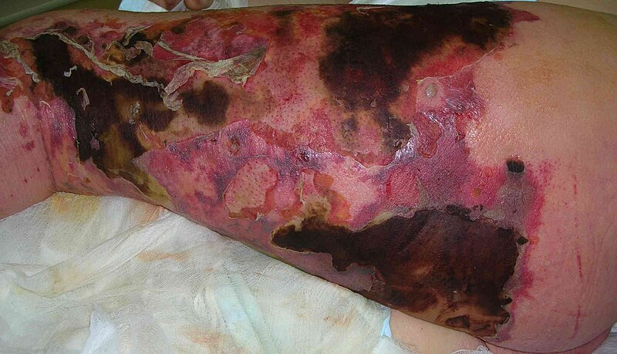

Clostridial Myonecrosis (Gas Gangrene)
- Life-threatening, fulminant clostridial infection of skeletal muscle
- Usually muscle trauma (penetrating wound or crush injury) + wound contamination with clostridial spores
- Most commonly caused by C. perfringens
- Incubation period is 6 hours to 2-3 days
- Bronze skin discoloration, tense bullae, necrotic areas
- Crepitus present but not prominent (gas is in muscle)
Treatment is surgical exploration with debridement, fasciotomies, and amputation if necessary. Antibiotic treatment with high dose Penicillin G (24 MU IV divided q2-3hours + Clindamycin 900mg IV q8h).
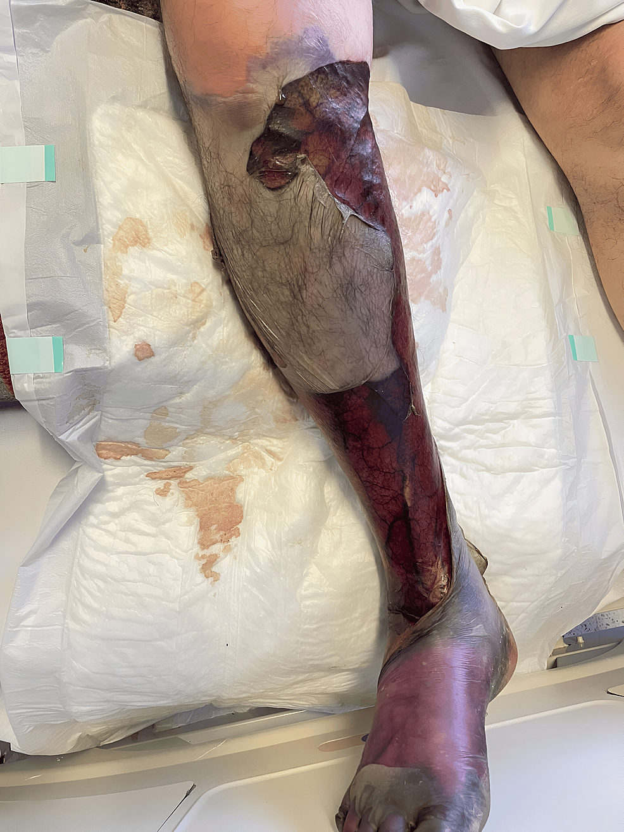

Necrotising Soft Tissue Infection (NSTI):
Necrotizing soft tissue infections (NSTIs) rank among the more difficult disease processes encountered by physicians and surgeons. NSTIs can arise primarily in the dermis and epidermis, but they more commonly affect the deeper layers of adipose tissue, fascia, or muscle. NSTIs are typically caused by toxin-producing bacteria and are characterized clinically by very rapid progression of disease with significant local tissue destruction. Varying amounts of early or late systemic toxicity depend on the strain of bacteria and toxins produced. Once symptomatic, the progression of disease is typically measured in hours; early diagnosis and treatment are crucial to survival.

Diagnosis is hindered by the fact that the disease progresses below the surface, and the cutaneous manifestations belie the severity of disease. As the infection disseminates, patients develop pain and signs of systemic toxicity disproportionate to the findings of skin examination, and physicians must maintain a high index of suspicion to rapidly diagnose NSTIs.

The standard treatment consists of broad-spectrum antibiotics, wide surgical debridement, and supportive care. Most patients require multiple surgical debridements, and survivors often have large and complex wounds requiring soft tissue coverage and prolonged hospitalizations.

Even with optimal treatment, NSTIs portend significant morbidity and have mortality rates of 25%-35% in recent series.

Risk factors:
- Obesity
- Diabetes mellitus
- Immunocompromised patients
- Alcoholics
- Peripheral vascular disease

Etiology:
- Trauma to the skin
- IV drugs
- Insulin injection site
- Animal or insect bites
- Surgical complications

Classification:
- Type 1: Polymicrobial (gram-positive cocci, gram-negative rods, anaerobes, clostridial species)
- Type 2: Group A beta hemolytic streptococci either alone or with staphylococcal species
- Type 3: Gram negative marine organisms- Vibrio vulnificus
- Type 4: Fungal

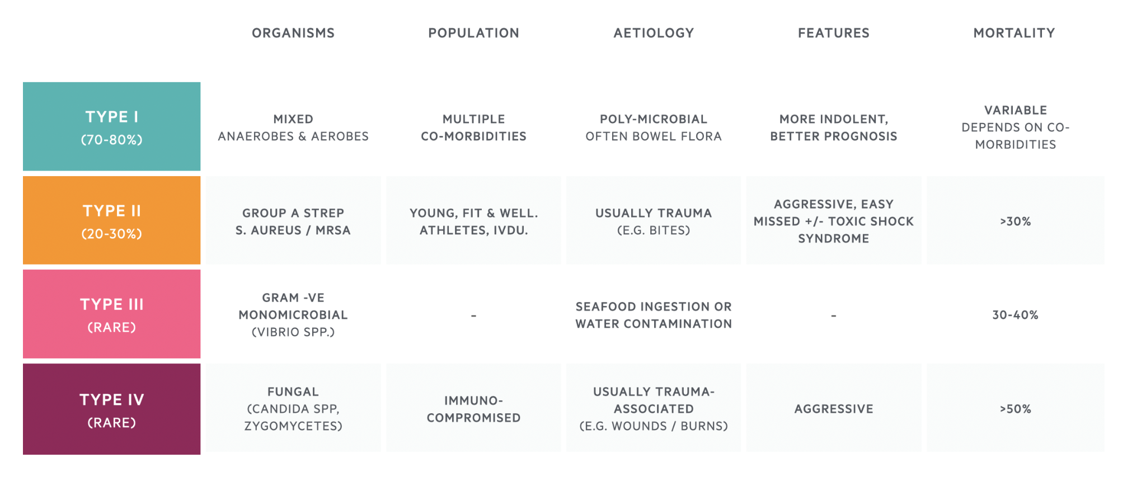

Treatment:
- Early and aggressive surgical debridement is the mainstay of treatment (may often require amputation)
- Broad spectrum IV antibiotics based on culture sensitivity
- Supportive therapy

Osteomyelitis
- Infection of bone due to hematogenous seeding or dirce spread from contiguous flora
- Hematogenous infection usually due to Staph aureus.
- Mycobacterial infection of vertebral body is called Pott’s disease.
- Contiguous focus of infection can be caused by Staph aureus, Strep, or polymicrobial.
- Blood cultures to evaluate microbial source
- ESR > 70 greatly increases likelihood of osteomyelitis
- Imaging: Plain radiographs can be normal early in disease. Lytic lesions seen after 2-6 weeks. MRI can detect very early changes. CT can demonstrate periosteal reaction and cortical/medullary destruction.
- Treatment: IV Antibiotics for 4-6 weeks.

Staphylococcus Abscess
- Approximately 25% of people are symptomatic nasal carriers of Staph aureus, which is spread by direct contact
- For a staph abscess, incision and drainage must be done. Then give Cephalexin 250-500mg QID or Amoxyclav 1000mg PO bid for 7-10 days.
- If MRSA present, treat with Doxycycline 100mg PO BID, cotrimoxazole DS BID, clindamycin 300mg PO BID or linezolid 600mg bid
References- Adapted from Pocket Medicine, Sabatine, 2011, 6-6

3.4 Chicken Pox
Acyclovir 800 mg p.o. five times / day x 7 days to be started within 24 hours of onset of rash. (CMC HIC)
Herpes(Varicella) Zoster(Shingles)
Introduction
- . Causes acute, unilateral, painful dertmatomal skin eruption.
- VZV reactivation in peripheral nerve distribution is from latency in dorsal root ganglion
Clinical Manifestations
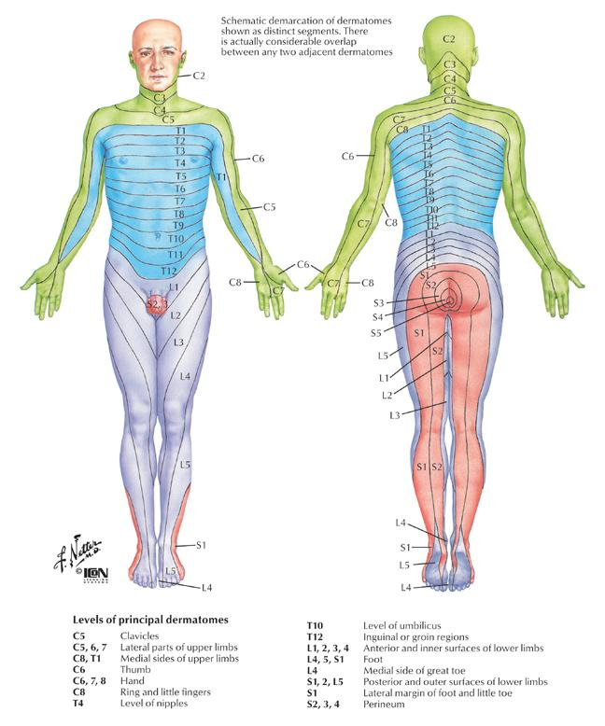
- Neuritic pain in a dermatomal distribution, THEN acute dermatomal eruption of clustered rash (vesicles > papules/pustules > macules) in varying stages of evolution
- Lesions in V1 distribution of trigeminal nerve require urgent ophthalmologic evaluation
- Post-herpetic neuralgia is severe pain lasting > 90 days after episode, may last months to years, more frequent with increasing age and with delay of antiviral treatment. Can treat with Amytriptyline or Gabapentin.
Treatment
- Treat if can initiate within 72 hours of skin lesions in normal host or at any time diagnosed in an immunosuppressed patient.
- Acyclovir 800mg 5 times a day for 7 days (Davidson)
- Prednisolone 60mg od for 2 weeks may be given ( CMDT)
- Acyclovir 10mg/kg IV q8hr if disseminated or high risk patient
- Prevention: Vaccine approved for patients > 60 years
References:Netter’s Anatomy
3.5 Bacterial Endocarditis
Definitions
- Infection of the endothelium of heart (including but not limited to the valves
- Acute (ABE) is infection of normal valves with a virulent organism (S. aureus, group A or other beta-hemolytic strep, Strep pneumoniae)
- Subacute (SBE) is indolent infection of abnormal valves with less virulent organisms (Strep viridians)
Modified Duke Criteria
- Must have 2 Major OR 1 Major + 3 Minor OR 5 Minor Criteria
- Major Criteria:
  - Sustained bacteremia (by organism known to cause endocarditis)
  - Endocardial involvement (+ echo or new valvular regurgitation murmur)
- Minor Criteria:
  - Predisposing Condition (abnormal valve or abnormal risk of bacteremia)
  - Fever
  - Vascular Phenomena (septic arterial or pulmonary embolism, mycotic aneurysms, ICH, Janeway lesions)
  - Immune Phenomena (Osler nodes, Roth spots, +Rheumatoid factor, Glomerulonephritis)
  - Positive blood culture not meeting major criteria

Physical Exam
- Janeway lesions: septic emboli, nontender, hemorrhagic macules on palms and soles
- Osler’s nodes: immune complexes, tender nodules on pads of digits
- Splinter hemorrhages: proximal nail bed
- Roth Spots: retinal hemorrhages with a pale center
Diagnosis
- Blood cultures prior to antibiotics
- CBC with diff
- EKG to assess for new conduction abnormalities
- Transthoracic echocardiogram

Empiric Therapy Suggestions
- Native valve acute bacterial endocarditis: Vancomycin +/- Gentamicin
- Native valve subacute bacterial endocarditis: Ceftriaxone (or Ampicillin if concern for enterococcus) + Gentamicin
- Prosthetic Valve Endocarditis: Vancomycin + Cefepime + Gentamicin
- Repeat daily blood cultures until patient defervesces and blood cultures negative
- Fever may persist up to one week after appropriate antibiotic therapy instituted
- Duration of Treatment: Usually 4-6 weeks

References
Adapted from Pocket Medicine, Sabatine, 2011, 6-14

3.6 Tuberculosis
Background
- Transmission of Mycobacterium tuberculosis is via small-particle aerosols (particularly coughing and singing)
- 90% of infected normal hosts will never develop clinically evident disease
- Tuberculosis kills more adults in India than any other infection
- Mycobacteria multiply very slowly leading to chronic manifestations

Clinical Manifestations
- Primary TB pneumonia: middle or lower lobe consolidation, +/- effusion, +/- cavitation
- TB pleurisy: Can occur with primary or reactivation TB. Due to breakdown of granulomas with spilling of contets into pleural cavity and local inflammation. Pulmonary effusion +/- pericardial and peritoneal effusions
- Reactivation TB pulmonary disease: apical infiltrates +/- volume loss +/- cavitation
- Miliary TB: Acute or insidious. Due to widespread hematogenous dissemination. Usually in immunosuppressed patients, diabetics, alcoholics, elderly, or malnourished. Constitutional symptoms prominent. Pulmonary disease with small millet seed-like lesions on CXR, present in 60-80% of people with miliary TB.
- Extrapulmonary TB: lymphadenitis, pericarditis, peritonitis, meningitis, nephritis, osteomyelitis, Pott’s disease, hepatitis, splenitis, cutaneous, arthritis
Tuberculous lymphadenitis: Known as scrofula when present in the cervical region.Usual presentation is isolated chronic nontender lymphadenopathy in a young adult without systemic manifestations. Physical exam reveals a firm discrete or matted nodes fixed to surrounding structures.
Skeletal tuberculosis: TB spondylitis is called Pott’s disease. It generally affects the lower thoracic and upper lumbar spine. The diagnosis is often delayed as a result of the subacute course. Patients with skeletal TB are at risk for compression fractures and cord compression or nerve root entrapment if not treated.
- TB and HIV: Increased risk of progressive primary infection and reactivation.
- Multidrug resistant (MDR) TB: resistant to isoniazid (INH) and rifampin (RIF)
- Extensively durg resistant (XDR) TB: resistant to INH, RIF, quinolone, and 2nd line injectables

Diagnostic Studies for Active TB
- Sputum PCR testing: This is the gold standard diagnostic test and is confirmatory for pulmonary TB
- Acid Fast Smear (rapid diagnosis) and culture (increased sensitivity and allow sensitivity testing) of sputum. Sputum AFB x 3 is the critical investigation. Ideally collect early morning samples on three consecutive days.
- CXR: classically fibrocavitary apical disease in reactivation versus middle and lower lob consolidation in primary TB. A diagnostic thoracentesis can be done for pleural effusions in the 5th intercostal space in the midaxillary line.
- CT Thorax: Can be performed at the government hospital and the images to be discussed with Dr. Harshad (CMC Vellore). If the imaging features are typical of pulmonary TB, ATT can be started
- ESR may be elevated
- PPD: However often negative in immunocompromised or malnourished patients.
- Biopsy or FNA: Needed for extrapulmonary TB diagnosis
- Miliary TB can present with pancytopenia.

Contacts of Smear-positive patients
- Any contact person of an AFB smear-positive case who has a productive cough should have 3 sputum examinations as soon as possible for diagnosis.
- If sputum examinations are negative and symptoms are present despite treatment with broad-spectrum antibiotics, Chest X-ray should be done and the patient evaluated clinically.
- Children who have symptoms should undergo CXR and clinical examination. Tuberculin (PPD) testing can be helpful in evaluating TB in children, but a positive tuberculin test does not confirm disease, and a negative test does not rule it out. Hence, clinical correlation needs to be done along with the screening tests

BCG Vaccination
- Most people who have received BCG vaccine have a tuberculin reaction of 3-19 mm in size at 2-3 months following vaccination.
- The reaction wanes with time; at more than 10 years after vaccination it is generally <10mm. However with repeated tuberculin testing, this may rise to >10mm. Childhood BCG vaccine is not a common cause of a positive tuberculin skin test in adulthood (8%).
- BCG prevents serious forms of TB in children. The present policy of the Government of India is to administer BCG at birth to newborns if they are born in an institution, and between the ages of 6 weeks and 9 months otherwise under the Expanded Programme on Immunization.

Treatment
- Patients are generally admitted.
- Dosages are titrated up to the recommended daily dose, while monitoring BP and symptoms.
- Once treatment is started, the patient becomes non-infective within 2 weeks.
- As TB mycobacteria multiply very slowly, many months of therapy are required. The Indian Revised National TB Conrol Programme (RNTCP) DOTS (Directly Observed Treatment, Short–course chemotherapy) is used. Thrice a week, alternate day treatment is used – this is as effective as daily treatment. DOTS ensures compliance and is available free of cost through government programs.
- Drugs are supplied in patient-wise boxes containing the full course of treatment, and packaged in blister packs. For the intensive phase, each blister pack contains medications for one day. For the continuation phase, each blister pack contains one week’s supply of medication. The combipack drugs for extension of the intensive phase are supplied separately

Side effects of Anti-TB Drugs (instructions for health animators)
Symptom | Drug | Action to be Taken
Sleepy | Isoniazid (H) | Reassure patient
Reddish/orange urine/tears | Rifampicin (R) | Reassure patient
Nausea, diarrhoea, vomiting | Any | Reassure patient.  Give drugs with less water and over a longer period
Burning sensation hands or feet | Isoniazid (H) | Give pyridoxine (Vit B6) 100mg/day until symptoms stop
Joint pains | Pyrazinamide (Z ) | If severe refer patient for evaluation
Decreased vision | Ethambutol (E) | STOP treatment and refer patient for evaluation
Jaundice | Isoniazid (H)  Rifampicin ( R)  Pyrazinamide (Z) | STOP treatment and refer patient for evaluation immediately
Ringing in the ears  Dizziness, loss of balance | Streptomycin (S) | STOP treatment and refer the patient for evaluation

RNTCP Treatment Categories
Category I | Category II
New cases who are sputum-positive, or patients with sputum-negative or extra-pulmonary disease | Retreatment cases including patients with relapse, failure and those who return to treatment after default. Such patients are generally sputum positive.
2 months: H₃R₃Z₃E_{3B6}  4 months: H₃R_{3B6} | 2months:H₃R₃Z₃ E₃S_{3B6}  1 month: H₃R₃Z₃E_{3B6}  5 months: H₃R₃E_{3B6}
Treatment is given in two phases. The Intensive Phase consists of isoniazid, rifampicin, pyrazinamide and ethambutol given under direct observation thrice weekly on alternate days and lasts for 2 months (24 doses). This is immediately followed by the Continuation Phase, which consists of 4 months (18 weeks, 54 doses) of isoniazid and rifampicin given thrice weekly on alternate days, the first dose each week being directly observed. If the sputum smear is positive after 2 months of treatment, the 4 intensive Phase drugs are continued for another one month (12 doses) before starting the 4-month Continuation Phase. | Treatment is given in two phases. The Intensive Phase consists of two months (24 doses) of isoniazid, rifampicin, pyrazinamide, ethambutol and streptomycin, followed by one month of isoniazid, rifampicin, pyrazinamide and enthambutol, all given under direct observation thrice weekly on alternate days. This is immediately followed by the Continuation Phase, which consists of 5 months (22 weeks, 66 doses) of isoniazid, rifampicin and ethambutol given thrice weekly on alternate days, the first dose each week being directly observed. If the sputum smear is positive after 3 months of treatment, the 4 Intensive Phase drugs are continued for another one month (12 doses) before starting the 5 month Continuation Phase.
(E)ethambutol, (H)isoniazid, (R)rifampicin, (Z)pyrazinamide, (S)streptomycin, (X₃), Vitamin B6 (B6)three times per week
Dosage Information
 | Body weight | Intensive Phase |  |  |  |  | Continuation Phase
 | Body weight | E₃* | H₃ | R₃ | Z₃ | S₃** | H₃ | R₃
Peds | 5-10 kg | 200 | 150 | 75 | 500 |  | 150 | 75
Peds | 11-20 kg | 400 | 200 | 150 | 750 |  | 200 | 150
Peds | 21-30 kg | 600 | 300 | 300 | 1000 |  | 300 | 300
Adult | <33 kg | 800 | 500 | 300 | 1000 | 750/500 | 500 | 300
Adult | 33-50 kg | 1200 | 600 | 450 | 1500 | 750/500 | 600 | 450
Adult | >51 kg | 1600 | 700 | 600 | 2000 | 750/500 | 700 | 600
All doses in milligrams.
(E) ethambutol, (H) isoniazid, (R) rifampicin, (Z) pyrazinamide, (S) streptomycin, (X₃)three times per week
* Ethambutol should not be given to children below 6 years of age
** Patients over 50 years of age are given streptomycin 500 mg instead of 750 mg

Tuberculous meningitis
- Patients should be referred to the hospital for immediate ATT treatment.
- The patient should be put on Category I treatment, with the continuation phase lasting for 6-7 months.
- Steroids should be given initially to reduce meningeal inflammation and reduced gradually over 6-8 weeks.
Treatment of Tuberculosis during pregnancy
- Streptomycin should not be given during pregnancy; other drugs used in the RNTCP are safe during pregnancy.
- Breast-feeding should continue regardless of the mother’s TB status.
Child Under 5yrs
- All children <5 years of age in contact with smear-positive household members should be given chemoprophylaxis for 6 months. Isoniazid 5mg/Kg daily dose or 10mg/Kg alternate day dose with 5mg Vit B6

3.7 HIV/AIDS
Background
- AIDS is defined as a positive HIV test with: CD4 count less than 200/mm³ or opportunistic infection or malignancy.
- Acute retroviral syndrome occurs in 40-90% of patients 2-6 weeks after infection
- HIV/AIDS prevalence in the Gudalur area is low
Diagnosis
- ELISA for HIV-1 antibody is positive 1-12 weeks after acute infection (99% sensitive), used as a primary screening test
- Western Blot is used as confirmatory test (99% specific)
CD4 Counts and Complications
- CD4 < 500: Constitutional symptoms, mucocutaneous disorders, recurrent bacterial infections, TB
- CD4 < 200: PCP pneumonia, Toxoplasma, Bartonella, Cryptococcus, Histoplasma, Coccidioides
- CD4 < 100: CMV, MAC, invasive aspergillosis, bacillary angiomatosis, CNS lymphoma, PML
Treatment
- Patients are referred to the Govt Hospital . Please inform the COUNSELLING team and they will organise further treatment
- We have almost no HIV + patients among our tribal population.
The following is for your information only
- Indications for initiation of ARVs typically includes AIDS-defining illnesses, CD4 < 350mm3, pregnancy, HIV associated nephropathy, HBV co-infection requiring treatment, or HIV-associated symptoms (system, cognitive, mucocutaneous).
- Regimens for naïve patients may include: (NNRTI + 2 NRTIs) OR (PI +/- low-dose Ritonavir + 2 NRTI) or (integrase inhibitor + 2 NRTIs)
- Prophylaxis
  - Tuberculosis (PPD ≥5mm): INH +Vitamin B6 for 9 months
  - Pneumocysis jiroveci (CD4<200): TMP-SMX DS or Dapsone 100mg qd
  - Toxoplasmosis (CD4 < 100 and positive Toxo serology): TMP-SMX DS qd
  - MAC (CD4 < 50): Azithromycin 1200mg qweek

3.8 Typhoid Fever
Background
Fever that has lasted longer than one week is an indication for workup for typhoid. Step wise pattern of fever, characteristically seen in adults, is not seen in children, i.e., onset can be sudden. Constipation is frequent, but diarrhea or abdominal pain may be present instead. Chills, myalgias, anorexia, cough, vomiting, headache, loose motions, arthralgias, neurological manifestations can be seen.

Clinical Signs
Abdomen may be distended and a 1-2 cm spleen is often palpable. Rales are often heard in lung bases. If toxemia is severe, delirium will be present. Hemorrhage and perforation of the intestine is sometimes seen in the 2nd or 3rd week of the illness. This can manifest in an acute surgical emergency with patients having signs of generalised peritonitis and shock. Other complications include pneumonia, encephalitis or meningitis.
Diagnosis
- Total counts are often normal or low.
- Widal test provides some guidance, although its limitations are acknowledged. O antigen titre > 1:320 is highly suggestive of an active infection. A rising O titre helps in the diagnosis. High H antigen positivity is an indication of an old infection.
- Blood culture is diagnostic but cannot be performed at GAH
Treatment
Is continued for 3 days after patient is afebrile or below whichever is later
1 st line: Ceftriaxone 2 g IV OD or BD X 10-14 days
2nd line: Cefixime 200 mg BD X 7-14 days(WHO)
3rd line: Azithromycin 1 g once then 500 mg OD for 5 to 7 days
4th line: Ciprofloxacin 500 mg BD X 7-10 days (ci: children)
In ill patients, start with IV ceftriaxone and when pt is ready for discharge change to cefixime PO
Treatment of Carriers
Ciprofloxacin, 750 mg orally twice a day for 4 weeks, has proved to be highly effective in eradicating the carrier state. Cholecystectomy may also achieve this goal.

3.9 Leptospirosis
Leptospirosis is a zoonosis with protean manifestations caused by a spirochete. Leptospirosis presents with the abrupt onset of high fever, rigors, myalgias especially calf tenderness, and headache in over 75% of patients. Conjunctival suffusion or haemorrhage +/-mild jaundice in a patient with a nonspecific febrile illness should raise suspicion for this disease.
While most cases of leptospirosis are mild to moderate, the course may be complicated by renal failure, uveitis, hemorrhage, acute respiratory distress syndrome, myocarditis and rhabdomyolysis.(Weil's disease)
Diagnosis:
WBC count may be normal or as high as 50,000/ml (0.05/L), with neutrophils predominating.
The urine may contain bile, protein, casts, and red cells.
Elevated bilirubin and aminotransferases are seen in 75%,
and elevated creatinine (greater than 1.5 mg/dL) is seen in 50% of cases.
Serum creatine kinase is usually elevated in persons with leptospirosis and normal in persons with hepatitis.. Diagnosis is usually made by means of serologic tests, including the microscopic agglutination test (considered the gold standard but not widely available), and enzyme-linked immunosorbent assay (ELISA). PCR molecular diagnostics are not widely available but appear to be sensitive, specific, positive early in disease, and able to detect leptospiral DNA in blood, urine, CSF, and aqueous humor. (Current diagnosis 2019)
Because the clinical features and routine laboratory findings of leptospirosis are not specific, a high index of suspicion must be maintained for the diagnosis.
Treatment:
Inpatient:
1st Line: Ceftriaxone 2 g OD IV
2nd Line: Penicillin 250,000 units/kg/ divided into 4 doses to max of 6 million units
3rd Line: Azithro PO 10 mg/kg 1st day, 5 mg/kg OD for 6 days
Once patient is afebrile and ready to go home give Doxy 100mg bid x 7days
Prevention
The mainstay of prevention is avoidance of potentially contaminated food and water.
Prophylaxis with doxycycline has been effective – Doxy 100mg od .

3.10 Measles
Measles is a vaccine-preventable illness caused by inhalation of droplets infected with paramyxovirus. There have been two outbreaks in our patient population, likely secondary to inappropriate storage of the live vaccine prior to administration. Measles presents with severe URI symptoms, conjunctivitis, cough, high fever for 4- 5- days, followed by maculopapular rash at height of fever, which begins behind the ears, on the face and proceeds downward and outward, affecting the palms and soles (seldom). Koplik spots (image below) are pathognomonic of measles (tiny “table salt crystals” on mucous membranes,esp. opposite lower molars, occurring during prodroma only). Mortality can be up to 10% secondary to CNS complications, viral bronchopneumonia, gastroenteritis, or generalized immunosuppression and secondary bacterial infections. Treatment is supportive care and Vitamin A (which may work by boosting the immune system and maintaining GI and respiratory epithelium). Antibiotics are given in our malnourished patients because secondary bacterial infections is high.

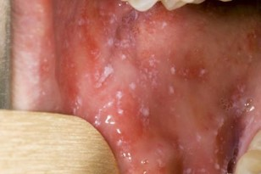
Diagnostic tests: None, based on clinical diagnosis
Treatment
- All children below 5 with measles and
  - Fast breathing (> 50/min upto 12 months, and > 40/min. in those 1 to 5 years)
  - Chest indrawing (retraction)
  - Gr.2 or more malnutrition
  - Any danger sign like drowsiness, inability to feed
  - High fever persisting more than 6 days
should be admitted to hospital.
Patients with measles should be isolated for 4 days after rash onset. In the hospital setting, patients with measles should be placed under air-borne precautions.
Treatment is symptomatic, including antipyretics and fluids as needed.
- Older (>5 years) children with measles, who are ambulatory and have fast breathing alone, can be treated at home with co-trimoxazole or amoxycillin for 5 days (and instructed to come to hospital if symptoms worsen).
- All children with measles, whether in hospital or at home, receive a stat dose of Vitamin A orally (2L IU for > 1 year, 1 L IU for 6 months to 12 months) & a repeat dose the next day. Vitamin A supplementation for children reduces pediatric morbidity and measles-associated mor tality. All patients also get B complex.
- Patients with eye lesions get a repeat dose of Vitamin A 4 weeks later. They should also be prescribed gentamicin eye drops tid daily for 7 days & a follow-up for eye involvement.
- Zinc has a role in the maintenance of normal immune functions, but insufficient data are avail- able to recommend zinc supplementation to children with measles.
- Of those admitted, the more severe cases get Inj CP + Genta or Ampi + Genta (for 10 days). Those who do not respond get Inj. Cefotaxime + Genta.
- Measles virus is susceptible to ribavirin and other anti- virals in vitro. Ribavirin is used in selected severe cases of pneumonitis, but there is not enough evidence to recom- mend antiviral use.
- All children with measles will need a follow-up within 10 days of discharge/ stopping of treatment at home, and then monthly checks for three months & after another three months. They will remain immunocompromised for at least 6 weeks& will be prone to diarrhoeal disease, ARI & TB.
- Cough persisting > 1 week can be treated with addition of salbutamol 2mg morning & evening.
- Cough persisting > 3 weeks with persisting weight loss may need investigation for TB. The Mantoux test for TB would remain negative for ~ 6 weeks following an attack of measles. (Note that ALL children with measles will lose some weight).
- All children during measles would need frequent small feeds & an extra, enhanced feed/ day for a month following an attack.
References: CMDT 2019

Animal & Human Bites
Management In Hospital
- Clean wound with 1% providine and then thoroughly irrigate with normal saline using a syringe. Avoid irritants like Alcohol, Hydrogen Peroxide
- Give Tetanus toxoid 0.5 ml IM
- Closure of wounds - animal bites with suspected rabies exposure - once adequate local Immunoglobulin infiltration is given - it is safe to perform sharp debridement of devitalized tissue and primary closure. Local may be preferably given by nerve blocks rather than local infiltration to avoid tissue distortion especially in facial bites. Primary closure gives better scar outcome with no added infection rates.
- Cat bites in any location
- hand bites by any animal, including humans, .
- Individuals with certain comorbidities (diabetes, liver disease)
- patients without functional spleens who are at increased risk for over- whelming sepsis (primarily with Capnocytophaga species)
- deep puncture wounds, and
- if medical care is sought more than 24 hours after injury. .
For OPD pts give Amoxicillin-clavulanate (Augmentin) 500 mg orally three times daily for 5–7 days is the regimen of choice. - For patients with serious allergy to penicillin, a combination of clindamycin 300 mg orally three times daily + doxycycline 100 mg orally twice daily, or double-strength TMP-SMZ orally twice daily, or a fluoroquinolone (ciprofloxacin 500 mg orally twice daily or levofloxacin 500–750 mg orally once daily).. Agents such as dicloxacillin, cephalexin, macrolides, and clindamycin should not be used alone because they lack activity against Pasteurella species. TMP- SMZ has poor activity against anaerobes and should only be used in combination with clindamycin.
If wound is large or infected Admit and treat with Ampiclox + Gent if infection severe
- If rat-bite fever suspected (in Asia Spirillum minus is causative and associated with an ulcerated or indurated area), usually 14-18 days after bite tx use penicillin G (400,000 to 1.2 million units/day divided 4 doses for at least 7 days).
- When pt is ready for discharge send home on Cephalexin 50 mg/kg divided 4 doses.or Amoxy-clav
- If the patient is at high risk for rabies then follow above procedure and refer to Gov’t hospital for rabies vaccine (usually given at 0,7,14,21,28 days). No immunoglobulin is available.
- Because the risk of HIV transmission is so low following a bite, routine postexposure prophylaxis is not recommended.
- Each case should be evaluated individually and consideration for prophylaxis should be given to those who present within 72 hours of the incident, the source is known to be HIV infected, and the exposure is high risk. (CMDT 019)
Dog Bites & Rabies- 1If the dog is behaving normally keep it under observation for 10days – if there are no changes in behaviour then the dog is not rabid and no treatment for rabies indicated
2. If the dog cannot be observed ( eg stray dog) patient needs to be referred to Gudalur GH for antirabies vaccine.Usually a 5 dose regimen ( 1ml or 0.5ml IM) on days 0,3,7,14 and 28 days

3.12 Parasitic Infections
Roundworms
Given living conditions, it is asssumed that all patients are repeatedly infected with worms. All children between 2-5 years old are routinely dewormed every 6 months. Adults should be dewormed if they are anemic.
Treatment
1)Albendazole 400 mg X 1 can be used, repeat in 2 weeks (half dose of albendazole under 2 yrs).
2)Mebendazole 100 mg bd x 3 days, repeat in 2 weeks (Do not use under 2 yrs)
3)Piperazine 150 mg/kg = 1 mL/Kg of syrup (150 mg/ml) QHS x 2 days (Used in a patient with abdominal pain – paralytic agent, therefore, risk of worm ball obstruction lower - suspected to be due to ascaris)

3.13 Needle-Stick Injuries
- No risk on exposure to intact skin
- The risk of HIV transmission after a percutaneous exposure to HIV-infected blood is approximately 0.3% (1 in 300) and after mucous membrane exposure 0.09% (1 in 1000)
- HBV: Rate of HBV transmission ranges from 6% to 30% after a single needlestick exposure to an HBV-infected patient
- HCV: The incidence of acute HCV seroconversion averages 1.8% (from 0% to 7% per injury)

What should be done after exposure?
Immediately following exposure:
1. Wash area with soap and water; eyes to be irrigated; pricked finger not to be reflexively put in mouth
2. Start PEP drugs
Decision of PEP by the doctor will be made based on:
- Degree of exposure to HIV
- HIV status of source
Provide standard pre-test counselling focus on immediate concerns.
Rationale of PEP Information about primary HIV infection indicates that systemic infection does not occur immediately, leaving a brief period within a ‘window of opportunity’ during which post-exposure antiretroviral (ARV) intervention may modify viral replication.
PEP should be given to
- health-care personnel
- relatives looking after HIV-positive persons
- victims of sexual assault
Drugs for PEP
- Basic regimen: Zidovudine 300 mg b.d. + Lamivudine 150 mg b.d.
- Expanded regimen: Zidovudine + lamivudine + Indinavir 800 mg t.d.s
- Or any other protease inhibitor
Duration of PEP: 28 days
- Start as early as possible, preferably within 2 hours & Continue for 4 weeks (28 days)
- PEP started after 72 hours is not recommended
Efficacy of ARV for PEP
- PEP provides definite prevention of infection
- Early initiation of PEP and small inoculum size are correlates of successful PEP
- Delaying initiation, shortening the duration or reducing the antiretroviral (ARV) dose of PEP individually or in combination decreases efficacy
- Zidovudine (NRTI) is the only agent shown to prevent HIV transmission in humans
- Failure of Zidovudine PEP to prevent HIV infection has been reported in at least 14 instances.

3.14 Clostridium Difficile
Background -Changes in colonic flora by antibiotics or chemotherapy can lead to colonization by C. difficile spores. There is release of A/B toxin causing colonic mucosal necrosis and inflammation
Clinical Manifestations
- Acute water diarrhea, often with lower abdominal pain, fever, and very elevated WBC
- Pseudomembranous colitis leads to bowel wall thickening
- Fulminant colitis can lead to toxic megacolon (≥6cm on KUB) and bowel perforation
Diagnosis- Consider sig if diagnosis uncertain
Treatment- Discontinue antibiotics if possible, stop antimotility agents
Mild: Metronidazole 500mg PO TID for 10-14 days (can use IV if PO not possible or ileus present)
- Moderate: Vancomycin* 125-500mg PO QID for 10-14 days
- Severe: PO Vancomycin* + IV Metronidazole
Recurrent Infection: 1st relapse: Repeat 14 day course of metronidazole
2ndrelapse:Vancomyn* taper for 6 weeks ( *Not available at GAH)

3.15 Influenza A H1N1
Adult patients with H1N1 infection will present to a clinician in either of the following groups. All patients should confine themselves at home and avoid mixing with public and high risk members in the family.
- Patients with mild fever (less than 38C) plus cough / sore throat with or without bodyache, headache, diarrhoea and vomiting.
Treat for the symptoms mentioned above. Oseltamivir 75 mg bid x 5 days indicated for the following
- *Children with mild illness but with predisposing risk factors.
- Pregnant women;
- Persons >65 years ;
- Patients with lung diseases, heart disease, liver disease, Kidney disease, blood disorders, diabetes, neurological disorders, cancer and HIV/AIDS;
- Patients on long term cortisone therapy.

- Upper respiratory tract infection alone.
These patients are to be differentiated from common cold by presence of high fever, severe myalgia and less rhinorrhoea . Patients should be treated with Cap. Oseltamivir 75 mg twice a day for 5 days and if symptoms persist after 5 days, extend therapy till 10 days

- Upper respiratory tract infection with lower respiratory tract involvement without tachypnoea / hypoxia. .
As for 2 above + Broad Spectrum antibiotics as per the Guideline for Community-acquired pneumonia (CAP) may be prescribed – Inj Ceftrioxone+ Azithromycin + brochodilators and mucolytic agents as required.

- URTI plus LRTI with Tachypnoea but no hypoxia
In addition to above, these patients will require oxygen by nasal prongs or mask.to keep o2 sat >95%

- URTI with LRTI with hypoxia
hPatients will require Cap. Oseltamivir 150 mg twice daily + antibiotics +with bronchodilators and mucolytic agents. Such patients should be looked at for the presence of ARDS.
If Sao2 is > 90, these patients can be managed with nasal prongs and oxygen masks with high flow of 10 to 12 liters per min to keep Sao2 around 95.
If Sao2 is 85- 90 then these patients should be put on noninvasive ventilation.-CPAP
Patients with SaO2 < 85, a trial of noninvasive ventilation should be given. If O2 stat stays <95 refer pt to higher centre

3.16 Fever of Unknown Origin
The definition of FUO derived by Petersdorf and Beeson from a prospective analysis of 100 cases has become the clinical standard:
- Fever higher than 38.3ºC (100.9ºF) on several occasions,
- Duration of fever for at least three weeks,
- Uncertain diagnosis after one week of study in the hospital.
Three general categories of illness account for the majority of “classic” FUO cases and have been consistent through the decades. These categories are:
- Infections,
- Malignancies,
- Collagen-vascular diseases (eg, vasculitis, rheumatoid arthritis).
After a thorough history and examination, evaluation might consist of some or all of the following tests: urine microscopy, ESR, TC/DC, platelets, PPD, Widal (might consider repeating after 3-4 days to see if titer is going up), HIV, SGPT (ALT), alk phos, T. Bili, D. Bili, HbsAg, , malaria thick and thin smears, RF, ANA, and possible a lumbar puncture.
Chest xray, ultrasound of abdomen/pelvis, CT abd
Outpatient or prophylactic:
1)Doxy 2 mg/kg/d bid (in children 8 years of age and pregnant women; max 200 mg/d). (Note that doxy also covers rickettsia). or
2)Amox 50 mg/kg divided tid in children under 8 or pregnant women use
Total duration of tx: 7 days

3.17 Prevention of Mother to Child Transmission of Hepatitis B Infection
5% of the world’s population is chronically infected with hepatitis B [1,2]. With a prevalence rate for HBsAg seropositivity 2-7 %, India has an intermediate endemicity, and a projected burden of 50 million carriers, the second largest in the world [3,4].
In India, the HBsAg prevalence rate among pregnant women varies between 0.9% and 11.2% [5-7].
Hepatitis B e-antigen (HBeAg) status, which indicates high replicative activity of the virus in the liver, was less than 30% in most earlier studies on pregnant women, though a recent study revealed HBeAg seropositivity of 56.8% [6].
Without immune prophylaxis, in mothers who are both HBsAg and HBeAg +, the risk for transmission to the baby is 70 - 90% by 6 months of age, The increased risk of transmission with HBeAg positive status is due to high titres of HBV in these women [8
Whereas in the case of mothers who are HBsAg +, but HBeAg -, it is less than 10% [8-11].
The risk for development of chronic hepatitis B infection varies inversely with the age at which infection occurs,
- 90% of affected infants develop chronic infection as opposed to
- 30-50% of < five children and
- 6% of children > five years of age [13,14].
Chronic hepatitis B infection acquired in childhood carries a 25% risk for development of chronic liver disease, cirrhosis or hepatocellular carcinoma [15]. Hence, it is imperative to prevent mother to child transmission.

Preventive Strategies –Immunoprophylaxis - A combination of active and passive immune prophylaxis is the optimum strategy to prevent HBV infection in all babies( including low birth wt) of HBsAg positive mothers and in mothers with an unknown HBsAg positivity status at delivery.
A combination of hepatitis B immune globulin (HBIG)* and
hepatitis B vaccination initiated within 24 hours of delivery, followed by
a three dose immunization schedule initiated at 1-2 months of age, has been shown to protect about 90% of babies whose mothers were + for both HBsAg and HBeAg
Hepatitis B vaccination is carried out using the monovalent vaccine for the birth dose.
Further three doses may be administered as a combination vaccine with other infant vaccines like DPT, DTaP and Hib vaccines at 6,10 and 14 weeks since interference with the immunogenicity of these vaccines does not occur.

In mothers with an unknown HBsAg positivity status at delivery, the birth dose of hepatitis B vaccine is administered within 24 hours of birth, and HBIG *is administered as soon as possible if the mother tests positive, ideally within 72 hours of delivery.
HBIG provides temporary protection that lasts for 3 to 6 months. A combination of HBIG with HBV is slightly more effective than HBV alone in prevention of transmission of hepatitis B. Studies have shown that HBIG is effective when administered as late as 72 hours after birth

Vaccination alone - administration of a 4 dose series of hepatitis B vaccine to the newborn starting within 12 hours after birth without passive HBIG (HBIG being unavailable ) has shown to have a protective efficacy and prevent vertical transmission to babies in about 85% of mothers who were both HBsAg and HBeAg + [27-30].
This is highly pertinent in settings like ours where financial constraints and inconvenience often preclude the use of HBIG. HBIG is available only in Ooty. Most tribal pts will not travel to Ooty with their newborns so immunisation must be done at GAH and the 2nd and 3rd doses taken in the PHCs.

Chapter 4: Cardiovascular Diseases

4.1 Acute Pulmonary Edema
4.2 Acute Myocardial Infarction
4.3 Congestive Heart Failure

4.4 Hypertension
4.5 Rheumatic Heart Disease
4.6 Peripheral Arterial Disease

4.1 Acute Pulmonary Edema
In full-blown pulmonary edema, the patient should be:
- Placed in a sitting position with legs hanging over the side of the bed; this facilitates respiration and reduces venous return. If a patient is unable to sit, place them in an upright position on the bed (semi Fowler’s) with the head end of bed elevated 30-45 degrees.
- Oxygen is delivered by mask to obtain an O2 sat of >95% . CPAP ventilation may improve oxygenation and prevent severe CO₂ retention in conscious patients while pharmacologic interventions take effect. However, if respiratory distress remains severe, pt may need to be referred for endotracheal intubation and mechanical ventilation .
- Morphine is highly effective in pulmonary edema. The initial dosage is 2–8 mg IV (subcutaneous administration is effective in milder cases) and may be repeated after 2–4 hours. Morphine increases venous capacitance, lowering LA pressure, and relieves anxiety. However, morphine may lead to CO2 retention by reducing the ventilatory drive. It should be avoided in patients with opioid-induced pulmonary edema, who may improve with opioid-antagonists, and in those with neurogenic pulmonary edema.
- Intravenous diuretic therapy- furosemide, 20-40 mg IV,( or 2 1/2 times the prior daily dose if the patient has been receiving long-term diuretic therapy) is usually indicated even if the patient has not exhibited prior fluid retention. These agents produce venodilation prior to the onset of diuresis.
- Sublingual nitroglycerin or isosorbide dinitrate, will ameliorate dyspnea rapidly prior to the onset of diuresis, and they are particularly valuable in patients with accompanying hypertension. It accelerates clinical improvement by reducing BP and LV filling pressures. Due to its hypotensive action, it should not be given in patients with hypotension ( Systolic BP ,90mmHg, or 30mmHg below baseline). Any intake of phosphodiesterase inhibitors (Sildenafil, Tadalafil- for erectile dysfunction) within the past 48hours is a contraindication to NTG.
- In patients with low-output states—particularly when hypotension is present— use positive inotropic agents - Noradrenaline infusion (2-10mcg/min)
- Bronchospasm may occur in response to pulmonary edema and may itself exacerbate hypoxemia and dyspnea.
Treatment with inhaled beta-adrenergic agonists or intravenous aminophylline may be helpful, but both may also provoke tachycardia and supraventricular arrhythmias.
- Patients with acute decompensation of chronic heart failure should be treated to achieve an euvolemic state and have their medical regimen optimized.
Generally, an oral diuretic and an ACE inhibitor should be initiated, with efficacy and tolerability confirmed prior to discharge. In selected patients, early but careful initiation of beta -blockers in low doses should be considered.
In most cases, pulmonary edema responds rapidly to therapy.
When the patient has improved, the cause or precipitating factor should be ascertained. 12lead ECG should be taken to rule out an MI precipitating pulmonary oedema. In patients without prior heart failure, evaluation should include echocardiography and in many cases cardiac catheterization and coronary angiography.
Renal function test can also be done as pulmonary oedema can occur in CKD patients, especially if they have missed their due medicines or dialysis.

4.2 Acute Myocardial Infarction
Diagnostic tests
- 12 lead electrocardiogram. (Serum cardiac enzymes / troponin levels are not available).
- Chest Xray- to rule out chest pain due to pneumothorax, aortic dissection, cardiac tamponade
- Complete blood count- to get baseline values, rule out thrombocytopenia
- Serum Troponin I or T- marker of MI
- PT-INR, aPTT- to rule out pre-existing coagulopathy
A patient is diagnosed to have acute MI if he presents with
- chest pain and
- there is ST-segment elevation in two or more contiguous leads
  - Threshold values for ST segment elevation-
  - Males more than 40yrs- more than 2mm in leads V2-V3
  - Males less than 40yrs- more than 2.5mm in V2-V3
  - Women- more than 1.5mm in V2-V3
  - More than 1mm in all other leads, or
- a new onset left bundle branch block.
Treatment
- Aspirin 300 mg - chew tablet (4 tablets of 75 mg each)
- Clopidogrel 300 mg PO (4 tablets of 75 mg each)
- Atorvastatin 80 mg PO
- Supplemental oxygen, target SpO2- 90%
- Isosorbide dinitrate 5mg SL q5min prn or glyceryl trinitrate 0.3mg SL q5min prn (will cause fall in BP)
- Morphine- if pain not relieved by nitrates
- Buprenorphine in small doses 0.2ml IV (analgesia, in lieu of morphine)
- Pantoprazole 40mg bd
- Ondansetron 4mg IV(anti-nausea) if needed
- Midazolam 1-2 mg IV or Diazepam 5 mg po/IV prn (sedative)

Continuous pulse-oximetry, cardiac and BP monitoring
- Target SpO2- 90%
- Target BP- less than or equal to 180/110 in potential thrombolysis candidates; less than or equal to 220/110mmHg in patients not being considered for lysis
Ideal treatment for any STEMI is percutaneous coronary intervention( balloon angioplasty). In patients not suitable for PCI, thrombolysis is the next best option.

Thrombolysis:
Inj. streptokinase 1.5 million units diluted in 50-100ml of normal saline over 1hr, with half of the dose given in 20 min followed by the rest in 40 min .
Inclusion criteria:
1. ST elevation myocardial infarction.
2. Patient presents within 12 hours of onset of chest pain.
3. Patient presents after 12 hours but he still has severe chest pain and there is ST elevation on ECG.

Contraindications to thrombolysis:
Absolute contraindications | Relative contraindications
1.Past h/o h’agic stroke  2. h/o non h'agic stroke in the past 1 year  3. BP>180/110  4. Aortic dissection  5. Active internal bleeding(excluding menses)  6. H/O GI bleed in past 3 months  7. h/o spine surgery in past 3 months  6. Do not give SK if it has been given from 5 days to 2 years before as it can cause allergic reactions and is not as effective. | 1. Current use of anticoagulants with INR>2  2. Recent surgery within 2 weeks  3. Prolonged CPR>10min  4. Known bleeding diathesis  5. Pregnancy

Points to note:
- SK can cause allergic reactions like fever, chills and hypotension.
- If a patient has inferior wall MI, RV leads have to be taken to exclude RV MI which presents with hypotension and requires fluid resuscitation.
- Early use of ACE inhibitors (enalapril) esp if BP is high and
B blockers (metoprolol) - if pt tachycardic and BP is high also help prolong survival. However use them carefully as they can cause hypotension.
- Be vigilant, as patients with MI can present with atypical symptoms. MI should be ruled out in any elderly individual presenting with acute onset breathlessness.
Note: Non-Tribal patients may consider transfer to a private hospital or med college.
4.3 Congestive Heart Failure
Discussion
ACE-inhibitors (eg, enalapril) are the drugs that have made the biggest difference to outcome in heart failure and should be the mainstay of therapy. Furosemide is used for reducing peripheral or pulmonary edema. Once volume status is stable, furosemide should be weaned off if possible.
Beta-blockers (atenolol/metoprolol XL) improve prognosis in heart failure but should be started very slowly and increased very slowly in those with stable and well-controlled heart failure.
Patients with ischemic cardiomyopathy ( e.g. after MI) should be considered for additional medications such as aspirin and isosorbide.
Patients with atrial fibrillation should be considered for digoxin (for ventricular rate control) and warfarin (to prevent thromboembolic events).
Diagnostic tests
Congestive heart failure is a clinical diagnosis. Chest x-ray to document pulmonary edema is not routinely obtained. Echocardiography to assess LV function is not routinely obtained but should be considered if there is a murmur.
Serum electrolytes are not routinely followed unless: 1) patient is on Enalapril > 5mg/day, 2) there is concurrent renal dysfunction, or 3) the patient’s clinical condition warrants. If serum electrolytes are being followed, obtain Na, K, and Creatinine 2 weeks after initiating enalapril, and then 1 month after reaching a stable dose.
Patients on furosemide do not need serum potassium checked if they are also on enalapril or spironolactone
Treatment
- Furosemide 20-40 mg po od + Spiranolactone 25mg od– and increase dose as needed. Add HCTZ for refractory edema http://accessmedicine.mhmedical.com.lb-proxy2.touro.edu/data/books/2224/m_elmocardio_ch11_f011.png
- Enalapril 2.5 mg po od, usual maintenance dose 10-15 mg/day, (may be divided bid) for all cases with left ventricular systolic dysfunction.
- Metoprolol XL 12.5 mg po od, increase dose every 2-4 weeks gradually to a maximum for all cases with left ventricular systolic dysfunction.
Or Atenolol 25-50mg/day (goal: Resting heart rate 50-60)

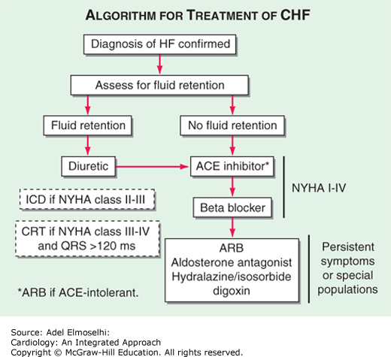

4.4 Hypertension
Discussion
Essential hypertension is very common in patients seen at GAH. Secondary hypertension should be considered in younger patients. In the pediatric age group, consider post-infectious glomerulonephritis. In patients < 40 years, consider coarctation of the aorta (examine for symmetry of pulses and BP in limbs). Other causes of secondary hypertension are infrequently seen
Diagnosis

Blood pressure | Classification
<120/80 | Normal
120-139/80-89 | Prehypertensive
>140/90 | Hypertensive
A patient is diagnosed to have hypertension if BP is >140/90 (for patients >60 years BP >150/90) on at least 2 visits or
a single BP reading with hypertensive changes (Loud S2 on clinical examination, ECG with LVH, fundus showing retinopathy).
Workup
All patients require blood sugar, creatinine and urine tests (albumin/sugar/microscopy).
Hb (for polycythemia), electrolytes, calcium, uric acid, fasting lipid, ECG, CXR
Renal ultrasound should be performed if urine albumin/serum creatinine is elevated or if it is a young hypertensive(<40yrs). The yield from further tests in an asymptomatic patient may not be worth the money so you may need to restrict the tests and just treat.
Echocardiography may be of value for certain patients to assess cardiac function or detection of left ventricular hypertrophy (LVH)(Wash Manual)
Treatment
All prehypertensives should be advised lifestyle modifications (wt reduction, exercise, low salt DASH diet, stop smoking, control blood sugar &lipids and decrease alcohol intake. Physical activity -Moderate-to-vigorous activity 3-4 days a week averaging 40 min per session Antihypertensive drugs are not indicated in this group.
Indications:
- Hypertensive without any co-morbidity: Amlodipine
- Diabetes mellitus: Enalapril/Losartan. Add amlodipine/HCTZ/betblocker if BP not controlled
- Angina/IHD: Beta blocker + Enalapril/losartan
- Bronchial asthma/COPD/PAD: Avoid beta blocker
- PAD: Enalapril/amlodipine
- Stroke history: Enalapril or Losartan. Add amlodipine/HCTZ
- Heart Failure: Enalapril or Losartan + Betablocker+ Furosemide + Aldactone
- Elderly: Amlodipine
- Pregnancy: Labetalol/Amlodipine
- Hypertensive urgency: Increase oral antihypertensives patient is on.
- Hypertensive emergency: IV Labetalol

Dosing:
- Amlodipine: 2.5-10mg od or 5mg bid
- Enalapril: 2.5mg od -20mg bd
- Losartan: 25-100mg od
- Atenolol: 25-100mg od
- HCTZ: 12.5 mg od

Remember
- ACE inhibitors and ARBs should not be used in the same patient simultaneously.
- Because patients with diabetes are at increased risk of nephropathy, coronary artery disease, and heart failure, conditions known to benefit from ACEIs and ARBs, it makes sense to choose one of them firstline for hypertension in patients with diabetes.
- Beta-1 Selective Beta-blockers – possibly safer in patients with COPD, asthma, diabetes, and peripheral vascular disease- Metoprolol.
- Increase dose or add another drug after 2 weeks if target BP not achieved.
- Thiazides and CCBs reduce systolic BP more than diastolic BP.
- HCTZ causes hypokalemia/hyponatremia and can also precipitate gout and increase blood sugar. Avoid in >50year olds
- Enalapril should not be given in renal artery stenosis and in pregnancy. At high doses beware of hyperkalemia. Use cautiously if s.creat is elevated
- Amlodipine is a common cause of pedal edema and constipation that may be discomforting for patients.
- Beta-blockers can cause severe bradycardia, monitor heart rate in patients receiving them.

 | Drug | Dose (mg/d) | Comments
 | Aldosterone antagonists  Spironolactone | 25–50 | Most effective when combined w/ ACEI  CNS effects (drowsiness, lethargy, headache, fatigue), GI disturbances, hyperkalemia, menstrual irregularities, gynecomastia, mastodynia.  Contraindicated in patients at high risk for hyperkalemia
 | Alpha₂-agonists  Clonidine tablets | 0.1–0.6 | Dry mouth, dizziness, drowsiness, constipation  Rebound hypertension with abrupt discontinuation
 | ACE inhibitors  Enalapril | 2.5–40 | Cough, angioedema,  Contraindicated in patients with bilateral renal artery stenosis. And in pregnancy. To check S. Creat before initating as it can cause hyperkalemia. Produces tall T wave in ECG.
 | Angiotensin II receptor antagonists  Losartan | 25–100 | Contraindicated in patients with bilateral renal artery stenosis. To check S. Creat before initating as it can cause hyperkalemia. Produces tall T wave in ECG.
 | Beta-blockers  Atenolol  Metoprolol  Propranolol | 25–100  50–100  40–120 | Bradycardia, hypotension, GI disturbances, dizziness, fatigue, insomnia, heart failure, reduced peripheral circulation, impotence, depression, nightmares, bronchospasm in patients with asthma, masks symptoms of or potentiates hypoglycemia in patients with diabetes, hypertriglyceridemia
 | Calcium channel blockers  Amlodipine  Nifedipine | 2.5–10  30–60 | Peripheral edema, palpitations, headache, dizziness, fatigue, nausea
Diuretics  Furosemide  Hydrochlorothiazide |  | 20–80  12.5 | Hyperuricemia, hypokalemia, hyperglycemia, hypocalcemia, increased urination at onset of therapy, dizziness, weakness, muscle cramps, photosensitivity, hypotension

Strategy

A | Start one drug, titrate to maximum dose, and then add a second drug.
B | Start one drug, then add a second drug before achieving max dose of first
C | Begin 2 drugs at same time, as separate pills or combination pill. Initial combination therapy is recommended if BP is greater than 20/10mm Hg above goal

Hypertensive crisis includes hypertensive emergencies and uncontrolled HT. It usually develops in patients with a previous history of elevated BP but may arise in those who were previously normotensive. The severity of a hypertensive crisis correlates not only with the absolute level of BP elevation but also with the rapidity of development because autoregulatory mechanisms have not had sufficient time to adapt.
.In both excessive or rapid decreases in BP should be avoided especially in the elderly, volume depleted, and on antihypertensive agents to minimize the risk of cerebral hypoperfusion or coronary insufficiency.
Hypertensive uncontrolled is defined as a systolic BP> 180 mmHg or a diastolic BP >=110 mm Hg or greater without the acute signs of end-organ damage.
Treatment-. Normal BP can be attained gradually over several days as tolerated by the individual patient.
• Need intensification of their antihypertensive drug therapy.
• Counsel the patient regarding compliance of medications and life style and diet modifications

Hypertensive emergencies are diagnosed if there is a systolic BP> 180 mmHg or a diastolic > 120 mmHg with the presence of acute target organ damage. Patient may be asymptomatic.
Cardiopulmonary - Myocardial ischemia/infarction, acute LV failure with pulmonary edema, acute aortic dissection, unstable angina
Central Nervous system -Hypertensive encephalopathy, cerebral infarction, intracranial haemorrhage
Renal -Acute renal failure
Malignant hypertension requires the presence of papilledema.

Treatment of Hypertensive Emergencies
IV antihypertensive- IV Labetalol, 5 mg every 15min max dose 300mg
Goal time BP target
- First hour - Reduce SBP by 25% (while maintaining goal DBP ≥ 100 mm Hg)
- Hours 2–6 -SBP 160 mm Hg and/or DBP 100–110 mm Hg
- Hours 6–24 -Maintain goal for hours 2–6 during first 24 hr
- 24–48 hr Outpatient BP goals

4.5 Rheumatic Heart Disease
Discussion
Acute rheumatic fever occurs in upto 3% of children who have had Group A ß-hemolytic (GAS)Streptococcal Pharyngitis or tonsillitis 1-3 weeks before. It occurs in children of school age (4 to 18 years) who are poor, malnourished & live in overcrowded houses. It is related to infection with GAS possibly on the basis of an antigen common to the heart. Rheumatic Heart Disease (RHD) is the most serious complication of Rheumatic Fever (RF).
More than 1/3rd of patients with acute rheumatic fever may develop heart problems - valve leaks, heart failure and even death. Recurrences of rheumatic fever are quite common and cause increasing and permanent damage to the heart valves. This results in increasing disability, repeated hospitalizations and premature death. Luckily, RHD is one of the preventable chronic disorders of the heart.
Primary prevention of RHD involves detection of streptococcal pharyngitis in children in the age group of 5-15, followed by adequate treatment with an appropriate antibiotic (as discussed under the heading URTI / Streptococcal Pharyngitis above).
Secondary prevention of RHD is recommended to any patient with a previous diagnosis of RF. It involves the administration of prophylactic antibiotic to prevent possible heart damage with every attack of sore throat or tonsillitis.
The Jones Criteria (last updated in 1992) is used to assist the clinician in standardizing the diagnosis of RF. The presence of two major criteria, or one major and two minor criteria, establishes the diagnosis.

MAJOR CRITERIA | MINOR CRITERIA
Carditis  Migratory polyarthritis  Sydenham’s Chorea  Subcutaneous Nodules  Erythema Marginatum | CLINICAL  Fever  Arthralgia  LABORATORY  Elevated acute phase reactants (ESR,CRP)  Prolonged PR interval
PLUS
Supporting evidence of a recent Group A streptococcal infection (e.g. + throat culture or rapid antigen detection test; and/or elevated or increasing streptococcal antibody test (ASO titre).

A. Carditis is the most serious consequence of rheumatic fever and varies from minimal to life-threatening HF. The term carditis implies pancardiac inflammation, but it may be limited to valves, myocardium, or pericardium. Valvulitis is frequently seen, with the mitral valve most commonly affected. Mitral insufficiency is the most common valvular residua of acute rheumatic carditis. Mitral stenosis after acute rheumatic fever is rarely encountered until 5– 10 years after the first episode. Thus, mitral stenosis is much more commonly seen in adults than in childree ( Lange 22-2014)

B.Polyarthritis The large joints (knees, hips, wrists, elbows, and shoulders) are most commonly involved and the arthritis is typically migratory. Joint swelling and associated limitation of movement should be present. This is one of the more common major criteria, occurring in 80% of patients. Arthralgia alone is not a major criterion.(Lange 22,2014)

C Sydenham chorea is characterized by involuntary and purposeless movements and is often associated with emotional lability. These symptoms become progressively worse and may be accompanied by ataxia and slurring of speech. Muscular weakness becomes apparent following the onset of the involuntary movements. Chorea is self-limiting, although it may last up to 3 months. Chorea may not be apparent for months to years after the acute episode of rheumatic fever

Lab Tests
1 ESR 2 ASO titre 3 CXR for cardiomegaly and CCF 4. ECG & 5.ECHO
Treatment – Acute rheumatic fever with carditis
1.Bed Rest until temp, resting pulse rate, ESR and ECG all return to normal
2. Aspirin markedly reduces fever and relieve joint pain and swelling. It has no effect on the natural course of the disease. Start with aspirin at 100 mg/kg/day.and monitor the ESR at 5-7 days interval. Once the fever and the joint inflammation are completely settled and the ESR returns to normal, reduce aspirin to 75mg/kg/day and then slowly start tapering the dose of aspirin over about 4 weeks with close monitoring of the ESR at regular intervals. If the ESR rises as you reduce the dose of aspirin, then go up on the dose and start again after a week or 10 days.
3. . Penicillin is used to eradicate streptococcal infection if present. - Inj Penidure 50,000U/kg to a max of 1,200,000 units IM at admission. Azithromycin may be substituted (10 mg/kg/day).
4. In the presence of cardiomegaly /congestive cardiac failure or poor response with aspirin-There is no proof that cardiac damage is prevented or minimized by corticosteroids. A short course of corticosteroids added to aspirin (prednisone,1- 2 mg / kg / day for 2 weeks, after which it is tapered ) usually causes rapid improvement of the joint symptoms and is indicated when response to aspirin has been inadequate. (CMDT 2019)

RHD Prophylaxis
All patients who have had RF without carditis are given Inj Benzathene penicillin once in 4 weeks to prevent streptococcal infection until they are 21 years old, or up to 5 years after last attack, whichever is later.
All patients who have had carditis without any heart damage are given Inj Benzathene penicillin once in 4 weeks t until they are 21 years old, or up to 10years after the last attack, whichever is later.
All patients who have had RF with heart damage are given Inj Benzathene penicillin once in 4 weeks lifelong. For those who don’t want injections, phenoxymethyl penicillin (PenVK) tablets can be given.
Dosage: Inj Benzathene penicillin 50,000 units/kg to a max of 1,200,000 units monthly
Alternative : Pen VK 250mg po bid, or azithromycin 250 mg od In children 5mg,kg to a max of 250mg od CMDT 2019 UpToDate 2019

4.6 Peripheral Arterial Disease
Almost all PAD is due to atherosclerosis, Vasculitis, or TAO
The most important risk factors are: Smoking, Tobacco chewing, Diabetes, Hyperlipidemia, Hypertension, Atrial fibrillation, and Infective endocarditis
Plaque rupture is responsible for the most serious features of PAD and often occurs in an asymptomatic plaque. 20% of middle-aged people (55-75) have PAD of whom only 5% have symptomatic PAD.
PAD affects the legs 8 times more often than the upper limbs. The lower limb arterial tree comprises the aorto-iliac (inflow), femoro-popliteal and infra-popliteal (outflow) segments. One or more segments may be affected in a variable and asymmetric manner.
The clinical features depend on:
- The anatomical site
- Presence or absence of collaterals
- Speed of onset
- Mechanism of injury
Factors Influencing the Clinical Manifestations of Peripheral Arterial Disease
- Anatomical site
  - Cerebral circulation: Transient ischaemic attack (TIA), amaurosis fugax, vertebrobasilar insufficiency
  - Renal arteries: Hypertension and renal failure
  - Mesenteric arteries: Mesenteric angina, acute intestinal ischaemia
  - Limbs (legs » arms): Intermittent claudication, critical limb ischaemia, acute limb ischaemia
- Collateral supply
  - In a patient with a complete circle of Willis, occlusion of one carotid artery may be asymptomatic
  - In a patient without cross-circulation, stroke is likely
- Speed of onset
  - Where PAD develops slowly, a collateral supply will develop
  - Sudden occlusion of a previously normal artery is likely to cause severe distal ischaemia
Mechanism of injury
1. Haemodynamic: Plaque must reduce arterial diameter by 70% ('critical stenosis') to reduce flow and pressure at rest. On exertion (e.g. walking), a much lesser stenosis may become 'critical'. This mechanism tends to have a relatively benign course due to collateralisation
2.Thrombotic: Occlusion of a long-standing critical stenosis may be asymptomatic due to collateralisation. However, acute rupture and thrombosis of a non-hemodynamically significant plaque usually has severe consequences
3. Atheroembolic: Symptoms depend upon embolic load and size; carotid (TIA, amaurosis fugax or stroke) and peripheral arterial (blue toe/finger syndrome) plaque are common examples
4.Thromboembolic: Usually secondary to atrial fibrillation. The clinical consequences are usually dramatic as the thrombus load is often large and tends to occlude a major, previously healthy, non-collateralised artery suddenly and completely.
Lower limb ischaemia presents as 2 distinct clinical entities: intermittent claudication (IC) and critical limb ischaemia.(CLI)
The presence and severity of ischaemia can be determined by clinical examination and measurement of the ankle:brachial pressure index (ABI) = highest systolic ankle BP
brachial BP.
In health the ABPI is > 1.0, in IC typically 0.5-0.9, and in CLI usually < 0.5.
Intermittent claudication(IC)
Ischaemic pain of the leg muscles precipitated by walking and relieved by rest is known as intermittent claudication. Typically, the pain comes on after a reasonably constant ‘claudication distance’, and rapidly and completely subsides on stopping walking. Resumption of walking leads to a return of the pain. Most patients describe a cyclical pattern of exacerbation and resolution due to the progression of disease and the subsequent development of collaterals.The pain is usually felt in the calf muscles because the disease tends to affect the superficial femoral artery. However, the pain may be felt in the thigh or buttock if the iliac arteries are involved. Approximately 5% of middle-aged men report IC. Provided patients comply with ‘best medical therapy only 1-2% per year will deteriorate to a point where amputation and/or revascularisation are required. However, the annual mortality rate exceeds 5%, which is 2-3 times higher than an equivalent non-claudicant population.
This excess mortality is due to the fact that IC is nearly always found in association with widespread atherosclerosis.
Features of Chronic Lower Limb Ischaemia
- Pulses: diminished or absent
- Bruits: denote turbulent flow but bear no relationship to the severity of the underlying disease
- Reduced skin temperature
- Pallor on elevation and rubor on dependency (Buerger’s sign)
- Superficial veins that fill sluggishly and empty (‘gutter’) upon minimal elevation
- Muscle-wasting
- Skin and nails: dry, thin and brittle
- Loss of hair
Severe limb ischaemia (SLI) can be Critical or Subcritical limb ischaemia
Critical limb ischaemia (CLI) is defined as
1.Rest (night) pain
2 Requiring opiate analgesia
3 And/or tissue gangrene
4 Present for more than 2 weeks
5 An ankle blood pressure of less than 50
Subcritical limb ischemia (SCLI) is
1 Rest pain
2.No tissue loss
3.Ankle BP at 50 mmHg
Whereas IC to single-segment plaque, CLI is always due to multi-level disease.
Many patients with CLI have not previously sought medical advice for IC, principally because they have other comorbidity that prevents them from walking to a point where claudication pain might develop
Treatment
All patients with any manifestation of PAD should be considered candidates for best medical therapy
- Cessation of smoking
- Regular exercise (in a typical claudicant this would entail 30 minutes of walking three times per week)
- Antiplatelet agent (aspirin 75 mg daily or clopidogrel 75 mg daily)
- Reduction of cholesterol LDL < 100mg % (diet + statin therapy)
- Peripheral vasodilators like as cilostazol can improve symptoms in patients with IC.
- Diagnosis and treatment of diabetes mellitus (all should have fasting glucose measured)
- Diagnosis and treatment of frequently associated conditions (e.g. hypertension- with ACE I as they stabilize plaques, anaemia, heart failure).
Vascular surgery is covered under CMCHIS , so advise angio and surgery as needed. Dr Shivananda can do the Surgery at GAH
Indeed, most claudicants succumb to MI or stroke.General measures to reduce cardiovascular mortality will improve the functional status of the limb.
Intervention (angioplasty endarterectomy or bypass) is usually considered only when best medical therapy has been instituted and given at least 6 months to effect symptomatic improvement, and then only in those patients who are severely disabled or whose livelihood is threatened by their disability.

Chapter 5: Respiratory Diseases

5.1 Streptococcal Pharyngitis & Tonsillitis

5.2 Acute Otitis Media

5.3 Sinusitis

5.4 Bronchitis

5. 5 Pneumonia

5.6 Chronic Obstructive Pulmonary Disease

5.7 Asthma

5.1 Streptococcal Pharyngitis& Tonsillitis
Introduction:
Most URTI’s are secondary to viral infections and require supportive care only. The exception is streptococcal pharyngitis or tonsillitis, which should be treated with antibiotics. Up to 3% of cases of untreated streptococcal pharyngitis can be complicated by rheumatic fever, and up to 40% cases of rheumatic fever are subsequently complicated by rheumatic heart disease. The chances of rheumatic fever are highest for patients in between the ages of 5-15 years old.
Clinical criteria can be used to distinguish between viral URTI and streptococcal pharyngitis (see table). Any patient with suspected streptococcal pharyngitis should be treated with antibiotics. If you cannot distinguish between the two conditions, you should have a low threshold for treating patients 5-15 years old with antibiotics (rationale: we see rheumatic heart disease not infrequently in our patient population, and treatment constitutes primary prevention of this condition). Where compliance is in doubt, use intravenous injection of depot penicillin (Bp).
Diagnosis
Clinical diagnosis. ASO titers are available, although they are not routinely ordered.

CHARACTERISTIC OF STREPTOCOCCAL PHARYNGITIS | NOT CHARACTERISTIC
- Temperature > 38º C  - Soreness of throat, acute at onset  - Tenderness of Anterior cervical lymph nodes  - Redness (hyperemia) of the pharynx  - Exudates  - Petechiae on palate  - Scabbed erosions on edges of nostrils  - Scarlet Fever. | - Cough  - Hoarseness  - Watery nasal discharge  - Conjunctivitis

Treatment
- Acetominophen (10-15/kg /dose qid)
- Saline gargle
- Amoxycillin 250 mg po tid x 5-7days if suspect streptococcal pharyngitis (40-50mg/kg in 3 divided doses)
If allergic to penicillin – Azithromycin – Adults-500mg od for 3 days. Children 10mg/kg on day 1( to a max of 500mg) then 5mg/kg /day for next 2 days

5.2 Acute Otitis Media
All febrile children, especially with vomiting, diarrhea, URI, should be examined with an otoscope, even if they do not complain of ear pain.
Treatment
Amox 50 mg/kg divided 2-3 times daily x 5 days (use 80 mg/kg/ day in treatment failures or in patients with underlying malnutrition or sickle cell disease) or
If severe amoxy-clav
For those sensitive to Amoxycillin use Azithromycin

5.3 Sinusitis
Diagnosis
Clinical diagnosis based on h/o URI followed by headache with tenderness over the frontal, ethmoidal or maxillary sinus.
Sinus x-rays /CT rarely required.
Treatment
- Doxycycline 100mg od x 7 days or Amoxy 50 mg/kg/day divided bid-tid
- Chlorpheneramine 4mg po hs x 7 days with Certrizine 5 to 10 mg daily (daytime)
- Steam inhalation tid
- Acetominophen
- Oxymetalazone (Otrivine) nasal drops 1-2 drops bid (if significant rhinorrhea) for 2 days – avoid in hypertensives
5.4 Bronchitis
Treatment
Antibiotic choices of Acute Exacerbation of Chronic Bronchitis (AECB)
- Amox 500 tid, or Doxy 100 mg bid,or Septran DS bid, or Cipro 500 bid. Duration: 7 days
5.5 Pneumonia & Bronchopneumonia
Definition
Bacterial pneumonia is common. The differential diagnosis of pulmonary tuberculosis should be considered in any patient with symptoms greater than 2 weeks.
CURB65 SCORE (to assess pneumonia severity)

C - Confusion (present =1, not present = 0)
U - Urea (creatinine at GAH if >1.2mg% =1)
R - Resp rate (if over 30 = 1)
B - Blood pressure (if systolic < 90mmHg =1)
A - Age (if age over 65 = 1)

Score 0 -1 = 30d mortality 1.5% = Mild, OP treatment
Score 2 = 30d mortality 9.2% = Moderate,admit HDU
Score 3-5 = 30d mortality 22% = Severe, admit HDU

Exacerbation of COPD should be considered differently, it requires use of steroids and bacterial infection is commonly with different flora (see separate guidance)

Diagnosis + Investigation
- Routine CXR is not required for all patients.
- CBC, ESR, blood sugar creatinine requested in all patients.
- Check on all patients
- Sputum for AFB (x2) and GeneXpert (send to GH if 2 sputum AFB are neg) if TB is suspected
- CURB 65 score to guide antibiotic therapy
- Any patients with O2 saturation <95% should be admitted (excluding COPD) to HDU.

Management
Care should be guided by severity of illness (use CURB65 score) and psychosocial factors which may also lead to admission.
If there is any doubt of H1N1 infection add Oseltamivir(Tamiflu) 75mg PO q12h for 5 days
Patients do not need intravenous antibiotics just because they are admitted to hospital.

CURB SCORE | 1st line antibiotic | 2nd line antibiotic | If penicillin allergic
Score 0-1 | Amoxicillin PO 500mg TID 5 days | Azithromycin PO 500mg OD 5 days | Azithromycin PO 500mg OD 5 days
Score 2 | Ampicillin IV 1g QID | Amoxiclav PO 625mg BD | Doxycycline 200mg stat, then 100mg OD
Score 3 | Ceftriaxone IV 2g q24h + Azithromycin 500mg OD | Ampicillin IV 500mg Q6h+ Gentamycin IV 3-5mg/kg OD | Ceftriaxone IV 2g q24h +  Azithromycin 500mg OD
If clinical improvement after 48hrs of intravenous treatment, then step down to oral abx :
Amoxiclav or (Doxycycline or Azithromycin – if concerned about atypical pathogens)
There is rarely need to extend treatment past 7 days, unless clinically indicated.
If patients are not responding to antibiotic therapy, consider broadening the coverage to antibiotics to cover:
- Pseudomonas 🡪 Piperacillin + tazobactam (Piptaz) IV 4.5 gm q6h + gentamycin or amikacin
- Atypical organisms 🡪 add macrolide (e.g. azithromycin) or gentamycin + penicillin.
MRSA is uncommon in the Adivasi community and should not be routinely covered, only if very strong suspicion or risk factors (e.g. recent long hospital admission in referral centre).

Referral - to Calicut Medical College should be sought as early if the patient is deteriorating despite antibiotics, oxygen therapy and non-invasive ventilation ( C-PAP available at GAH )..

NURSING GUIDELINES
Definition
Pneumonia is an infection in the lung which leads to difficulty breathing, productive sputum and low oxygen levels. It can commonly be a complication of patients with chronic lung diseases. E.g. COPD, Asthma. It can have varying severity which is calculated by using the CURB65 score (see on other side) and this should guide our treatment.

Immediate care

(Please tick box when complete) | Complete
1.Wear a face mask for your protection and give patient one also
2. IV access (if required for IV antibiotics)
3.Record vital signs: if oxygen saturations < 94% give 2L oxygen via nasal cannula
4.Blood tests - CBC, Creatinine, ESR, RBS
5.Sit patients upright if having trouble breathing
6.If severe pneumonia – start input/output monitoring
7.Contact health animator to inform them of admission and ask screening questions ( for TB and deaths in the family due to breathing problems in the past few days).
8.If doctor concerned about TB – perform PPD and collect sputum samples x2 (Patients should also be isolated if possible)

Daily Care
- Vital signs including saturations four times/day
- Sputum samples x 2 if doctor concerned about TB (send for AFB staining)
- Monitor blood sugar of diabetic patients before breakfast, lunch and dinner.
- Encourage patients to mobilize to help with coughing up sputum and breathe deeply to get air down into the base of their lungs
- Physiotherapist should be consulted if breathing deteriorating despite antibiotic treatment.

Contact doctor if:
- If patient needs increasing amounts of oxygen to keep saturations above 94%
- If blood sugar <70mg or >200mg
- If blood pressure is under 90mmHg systolic or dropping rapidly.
- If patient’s level of consciousness is dropping or is looking increasingly tired (from breathing hard)

Referral
- Inform the patient's relatives to stay with the patient if condition worsening.
- Inform area HA if patient worsening
- Female patients who are referred to Calicut Med College must be accompanied by a female and a male relative

Discharge Information
Please return to the hospital if you feel your breathing is getting worse, you are having high fevers or rigors.
Please complete the course of antibiotics as prescribed
Discussion
Bacterial pneumonia is common. The differential diagnosis of pulmonary tuberculosis should be considered in any patient with symptoms greater than 2 weeks.In children, especially infants, this should be treated aggressively. Many of them live in houses with no ventilation and are thus exposed to thick smoke in the evenings, when fires are lit. There is a low threshold for admitting young children and especially babies.
The following children require admission:
- <2 months with cough & respiratory rate (RR) more than 60/min
- children 2-12 months with RR > 50/ min. with chest indrawing
- children 1 year to 5 years with RR > 40/ min. & chest indrawing
- children with Gr. III malnutrition & fast breathing
With the absence of microbiology testing, our choice of antibiotics at GAH is empiric.
Diagnostic tests
Obtain urine albumin, sugar, microscopy to exclude urinary tract infection. Chest X-ray usually not required. Blood tests are usually not required. A simple screening test for pulmonary TB is ESR, an investigation which is quickly available in the outpatient department and which is usually elevated (>20) in tuberculosis.
Treatment
Ambulatory treatment:
1st line: Amoxycillin or Azithromycin
2nd line: Cefixime

Inpatient treatment:
1st line: Inj Ampi + Gent or Inj Ceft + Azithromycin

5.7 Bronchial Asthma
Discussion
This is a relatively common disorder. The weather or high pollen count may account for this. The cost of inhaled bronchodilators prohibits their use in most of our patients. Nebulized therapy with salbutamol is available in hospitals for acute asthma exacerbations. Smokers are strongly advised to stop
Diagnostic tests
Clinical diagnosis and Peak Expiratory Flow Meter (PEFR)
Treatment
The first step in management is to classify the severity of disease as it influences management decisions.
Classification | Intermittent | Persistent
Classification | Intermittent | Mild | Moderate | Severe
Symptoms | ≤2 days/wk | >2 days/wk but not daily | Daily | Throughout the day
Night time awakenings | ≤2/month | 3-4/month | >1/wk but not every night | Every night
Treatment is then initiated in a stepwise manner as shown below:
Drugs available
Oral:
- Salbutamol (asthalin): 2mg/4mg bid to tid
- Sustained release theophylline (Deriphylline Retard): 150mg/300mg HS to bid.
- Steroids (Prednisolone): 0.5 to 1 mg/kg Po with Aerocort RC: Beclomethasone/Salbutamol tid
Nebulisation:
- Salbutamol:2.5mg to 5mg 6 to 8 hourly
- Ipratropium: 0.5mg 6 to 8 hourly
Assess the patient's capacity to use a rotahaler which older tribals find difficult to do. So start them on oral salbutamol and Dhheriphyllin retard titrating to the highest dose. Salbutamol nebulisation and steroids are given for acute exacerbations. For those affording rotahalers, steroid+salbutamol rotacaps with deriphyllin.
Dosages:
Salbutamol< 2 years: 100mcg/kg qid 2-5 years: 0.1 mg/kg po tid, not to exceed 2mg po tid
6-12 years: 2 mg po tid or qid 13-64 years: 2 - 4mg po tid or qid, max 8mg po qid
65 years: 2 mg po tid or qid
- Deriphylline retard 150-300 mg po bid
- Prednisolone 1 mg/kg po od x 3 days

5.8 COPD Exacerbation
Definition
Points to consider

Consider heart failure in elderly with breathlessness and wheeze.
Clubbing is not a feature of COPD and if present - consider malignancy etc.
TB should always be suspected
Asthma is uncommon in the elderly, if saturations <94% for asthmatics this would be a severe/life-threatening exacerbation.
Pt compliance to inhalers is very poor and so is generally not used as OP therapy.
COPD is common in the Adivasi community and current outpatient therapy consists of oral salbutamol and theophylline with some use of inhaled steroids. Smoking and poorly ventilated houses are the most common risk factors.
Exacerbation of COPD can commonly be precipitated by viral illness or smoke irritation rather than bacterial infection (commonly different pathogens to classical pneumonia), therefore antibiotics need to be used prudently. jn

Diagnosis + Investigation
- CBC, ESR, Creat are essential tests
- Consider ECG if diagnostic uncertainty
- Spirometers not available at GAH, diagnosis is clinical.
- CXR can be diagnostic for features of COPD and look for consolidation/pneumothorax.
- Consider TB testing if risk factor are present and high ESR - send 2x sputum for AFB . If neg send to government hospital for GeneXpert)

Management
- Purulent sputum production, fevers and elevated leukocyte count should guide antibiotic use, not level of breathlessness.
- An aggressive initial response to wheeze and breathlessness is often required, with ongoing tapering of therapy.
- Bronchodilators and steroids have been shown to reduce mortality and morbidity in acute attacks with judicious use of oxygen therapy to keep sats over 88%.

Bronchodilators | Salbutamol nebuliser 5mg - Max every 15-60mins, give back to back in acute SOB, decrease frequency to TID as tolerated  Ipratropium bromide 0.5mg - Max 3 doses acutely, regular dosing TID
Steroids | Prednisone 1mg/kg (max 40mg) OD - 5-7 day course  (Or Dexamethasone 0.2mg/kg IV OD)
Antibiotics | Severe - IV Ceftriaxone 1g OD  Mild/moderate - Doxycycline 200mg stat, then 100mg BD or  Augmentin 625mg BD or  Azithromycin 500mg OD (5-7 days total course)
Oxygen therapy | Use oxygen therapy carefully, GAH cannot measure blood gas  2l/min oxygen to keep saturations >88% <92%

Patient in Extremis
- SC Inj.Adrenaline 1:10,000 (0.01ml/Kg) subcutaneous + repeated doses as needed (if no IV access) may be tried rarely in an extreme situation where all other modalities have failed.
- IV Adrenaline - 50-100 micrograms boluses as required.

Referral - BIPAP therapy is available at GAH hospital but not blood gases and mechanical ventilation
If patients are deteriorating/desaturating with maximal bronchodilators and steroid therapy then early consideration for referral to Calicut Medical College is essential.

Chronic:
- Salbutamol 2-4 mg tid.as tolerated
- Theophylline retard (sustained release) 150-300 mg bid.
- Aerocort ( salbutamol + beclomethasone ) rotacaps bid or tid
- Prednisone 1 mg/kg OD for 5 to 7 days in severe cases. If need to use more than 7-14 days then tapering is required.
- Home oxygen is not options in this setting
COPD NURSING
GAH Quick Reference Guide:
EXACERBATION OF COPD/BRONCHITIS

Definition
Chronic Obstructive Pulmonary Disease (COPD) is a lung disease which is almost exclusively caused by smoking. Our patients are also affected by poor-ventilation and smoke filled houses.
These patients can get worsening shortness of breath when exposed to excessive smoke, viral or bacterial infections, changes in weather and continued smoking.
It is important to stress to patients that stopping smoking and improving home-ventilation is essential to have less exacerbation of COPD.

Immediate Care

1. IV access ( only required for IV antibiotics )
2. CBC, Creat, ESR
3. Administer nebulisers as prescribed, inform doctor if pt not getting improvement.
4. Oxygen therapy @ 2L/min if oxygen saturations < 88%
5. Sit patients upright to help with their breathing
6. Contact health animator to find out: Any TB contacts, open fires at home, who is looking after patients/family at home, smoking and alcohol use.

Daily Care
- Record vitals 4 x day (including oxygen saturations)
- Reduce O2 administration by 1L/min if saturations >94%, recheck after 30 mins
- Encourage pts to mobilise to improve lung ventilation
- Physiotherapist should be contacted if pt struggling to cough up sputum
- If patient has fever give 500mg paracetamol and contact doctor if not on antibiotics.

Contact doctor if:
- If oxygen saturations are below 88% despite 2l/min O2 therapy.
- If patient’s respiratory rate >30 or <12
- If patients level of consciousness has reduced
- If spiking fever and patient is not taking antibiotics

Discharge advice
Please inform patients that they should take the complete course of their medications.
They need to be counselled to stop smoking if they still smoke.
They can also help reduce worsening of their breathlessness by avoiding smoky environments and avoiding people with coughs and fevers.
Patients should return to hospital is their breathing gets worse or they have fevers.

Chapter 6: Renal Diseases

6.1 Post-Streptococcal Glomerulonephritis
6.2 Benign Prostatic Hypertrophy
6.3 Difficulty Urinating

6.4 Urinary Tract Stones
6.5 Epididmo-orchitis
6.6 Prostatitis

6.7 Pyelonephritis
6.8 Cystitis
6.9 Chronic Kidney Disease
6.10 Nonspecific Urethritis

6.1 Post-Streptococcal Glomerulonephritis (PSGN)
Clinical Features
- History of preceding skin infections or sore throat about 10-14 days (sometimes less) ago.
- PSGN is very uncommon below 2 years of age
- Oliguria
- Hematuria.
- Hypertension.
- Oedema, usually sudden onset, first noticed over the eyelids. Clinically detectable ascites is unlikely in AGN.
- Rarely, the initial presentation of AGN itself may be
  - As altered sensorium (due to hypertensive encephalopathy) or
  - Respiratory difficulty (due to pulmonary oedema) or
  - Renal failure, without the classical features of AGN
Pathophisiology
Functional changes include proteinuria, hematuria, reduction in GFR (ie, oligoanuria), and active urine sediment with RBCs and RBC casts. The decreased GFR and avid distal nephron salt and water retention result in expansion of intravascular volume, edema, and, frequently, systemic hypertension.
Investigations
Urine: + or ++ proteinuria; RBCs and WBCs and corresponding casts. WBCs may exceed the number of RBCs at times and it only indicates a glomerular inflammation, and not necessarily urinary infection. Transient heavy proteinuria may be present occasionally in the early phase and then the whole picture may look like a nephrotic syndrome. Followup of the child for a few days will settle the diagnostic confusion.
Blood: Serum creatinine and potassium may be elevated.
They usually get normalized within a few days, latest by 4 weeks. If they do not normalize or show rapid deterioration, patient will need to be referred for nephrology consultationas it may be the early stage of the dangerous “crescentic” nephritis. Crescentic nephritis requires diagnostic biopsy and immunosuppressive therapy.
Optional Investigations
- ESR may be elevated, which possibly indicates inflammation and need not be interpreted as due to a collagen vascular disease without other supportive evidence.
- ASO titer and throat culture for evidence of recent streptococcal disease. ,
- X-ray of the chest for pulmonary oedema, cardiomegaly, etc.
- ECG: Tall peaked T waves, depressed ST segment, prolonged PR interval, disappearance of P wave, widening of QRS complex, etc., indicates progressively severe-to-fatal hyperkalaemia

Treatment:
Diet
- No added salt till diuresis begins. Avoid salty items like salted fish, pickles, papad, etc.
- Restriction of potassium-rich foods like fruits, green leafy vegetables, meat and fish, chocolates, nuts, etc.
- The child can take rice or wheat based preparations with saltless side dishes. For example, appam or dosai with sweetened milk as a side dish, rice with curd, payasam, etc
- Calories need not be restricted.Tolerable fat is allowed.
- Restriction of protein is needed only in case of renal failure (high creatinine).
Activity
Bedrest is needed till hypertension is controlled and restriction of activity is needed till gross haematuria subsides.
Fluids
- Fluids are to be restricted to 400 mL/M2/day till diuresis begins. Insensible loss can be taken as 15 mL/kg/day for a school-aged child and up to 30 mL/kg/day for an infant.
- If patient is edematous restrict intake to less than previous days urine output.
- If oral intake is not good, insensible waterloss can be replaced IV as 10% glucose. The actual urine output can be replaced as 0.2% saline.
- In case of abnormal losses like vomiting, diarrhoea, etc., electrolyte replacement may be done, but only after determining the serum electrolytes (saline and 10% glucose in 1:4 ratio is a good initial guess).
Antibiotic
Amoxycillin or azithromycin for 10 days.
Diuretics
Furosemide (1-2 mg/kg/dose orally). If not effective give Frusemide 2- 5 mg/kg/dose IV till the urine output is satisfactory. The frequency of diuretic administration depends on urine output; usually will require twice daily administration.
Monitoring
- Blood pressure q6h or more if hypertensive,
- Daily intake-output,
- Daily weight.

Complications and Their Management (Manual of Ped Practice - Santhosh Kumar 2nd ed p369)
Hypertension
The upper limit of normal systolic BP for a child may be taken as 90 + (2 x age in years).
While measuring the BP, use a cuff whose inflatable bladdercovers 2/3rd length of the arm and is long enough to completely encircle the arm.
Headache, vomiting, drowsiness, visual disturbances and seizures indicate hypertensive encephalopathy
Hypertension in the early stages of illness is usually due to volume overload.
Drug doses need to be titrated according to effect.
Treatment
- Salt and water restriction.(400ml/m2/day). Daily weight
- Furosemide (2 mg/kg/dose orally). If not effective give Furosemide 2- 5 mg/kg/dose IV till the urine output is satisfactory - (reduces the vol overload and hence the HT). Give IV over 1-2 minutes( Hearing loss is most common after rapid or high-dose IV administration in patients with decreased renal function or those taking other ototoxic drugs-Davis); Double the dose if there is no adequate response within 1 hour.
ROUTE | ONSET | PEAK | DURATION
PO | 30–60 min | 1–2 hr | 6–8 hr
IM | 10–30 min | unknown | 4–8 hr
IV | 5 min | 30 min | 2 hr
Davis Drug Guide

- Nifedipine 0.25-0.5 mg/kg/ dose PO (sublingually for immediate effect), 3 or 4 times a day.The mechanism by which nifedipine reduces arterial blood pressure by peripheral arterial vasodilator by acting directly on vascular smooth muscle and, consequently, a reduction in peripheral vascular resistance. ... Nifedipine is a http://www.rxlist.com/adalat-drug/clinical-pharmacology.htm
Add Amlodipine (0.1 mg/kg/dose) for longer acion or
Betablockers -propranolol 1 mg/kg/day,maximum 4 mg/kg/day or atenolol 1 mg/kg/day, maximum 4 mg/kg/day
Moniter weight daily and serum sodium daily,
if pt drowsysuspect encephalopathy or hyponatremia
Patients with severe hypertension and encephalopathy
Admit to ICU and managed with IV antihypertensive drug:
IV Labetalol: Bolus of 0.2 - 1 mg/kg,
Followed by a constant infusion (1 mg / ml in 0.9% NaCl) if needed.
Begin infusion at 1 mg/kg/hour. Increase the infusion rate at 10 -15 min intervals until there is an effect. If there is no effect at a dose of 2.5 mg/kg/hour, choose another agent
If BP falls too rapidly, give boluses of normal saline.
Time course to resolution of APSGN
Clincial and laboratory features
- Gross Haematuria – 2wk
- Hypertension – 4 wk
- Persistent proteinuria – 2 mo
- Intermittent proteinuria – 1 yr
- Microhaematuria – 2yr
Indications for Renal Biopsy(refer to Calicut Medical College)
• Persistent heavy proteinuria after 6 months
• Atypical presentation – nephrotic syndrome, severe acute renal failure with estimated GFR <30ml/min/1.73m2
• Atypical course – failure of renal function to improve after initial improvement during theacute phase which usually last no more than 2 weeks
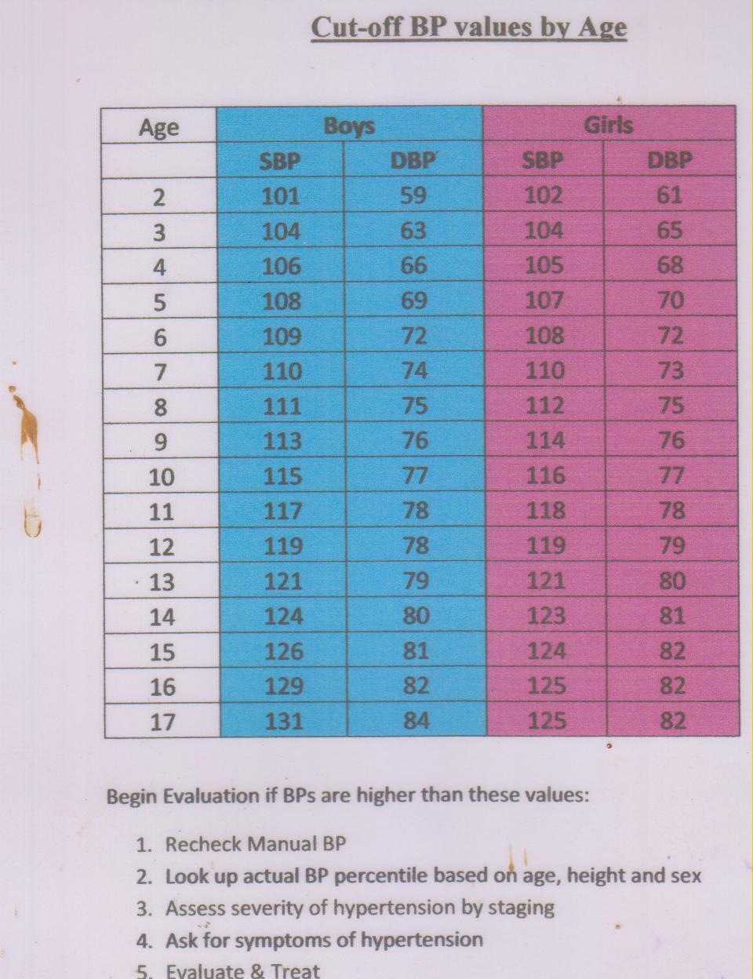

6.2 Benign Prostatic Hypertrophy
Common symptoms of BPH are increased frequency of urination, nocturia (>2 times/night), hesitancy, urgency, and weak urinary stream. These symptoms typically appear slowly and progress gradually over a period of years. Keep in mind that age, CCF, renal disease, diabetes mellitus and insipidus can all cause nocturia and many patients have multiple etiologies. Examine genitalia and prostate

DDx includes urethral stricture, bladder neck contracture, CA or prostate or bladder, bladder stones, UTI, neurogenic bladder.

Tests- Check urine micro, sugar, serum creatinine and PSA.
Ultrasound Abdomen to R/O hydronephrosis and to measure residual urine.( normal< 100ml)

Treatment- Conservative measures such as advising patients not to drink water after 6pm, avoiding caffeine/alcohol, and double voiding to empty bladder more completely (Double voiding involves passing urine more than once each time that you go to the toilet. This makes sure that the bladder is completely empty)

Drug tx: -Mild to mod symptoms-Tamsulosin 0.2-0.4 mg HS(10 tabs 0.2 mg cost Rs.42,0.4 mg 15 tabs Rs. 88)
If alpha blocker ineffective, severe symptoms or prostate very enlarged add Finasteride 5mg OD (10 tabs Rs 95)
If no improvement consider TURP

BPH Management in GAH- The aims are to reduce symptoms and improve quality of life, prevent complications, minimize adverse effects of treatment and manage patients “close to home”. BPH arises from the nodular proliferation of glandular epithelium, stroma and smooth muscle, and is the coexistence of lower urinary tract symptoms, bladder outflow obstruction and benign prostatic enlargement. BPH affects men > 45 and increases with age. 90% of men >70 years have BPH. The mean age for symptomatic development is 65 years.

Most men with urinary tract outflow symptoms can be managed at GAH

Pathway

Symptomatic presentation to primary care
Obstructive |  |  | Irritative
Hesitancy in initiating voiding | Weak urinary stream,prolonged voiding | Sensation of incomplete emptying | Dysuria
Nocturia | Overflow incontinence | Acute urinary retention | Frequency
Nocturnal incontinence |  |  | Urgency

Symptoms may be exacerbated by otc medications and those with antimuscarinic effects.

Assessment and Investigations to be undertaken in GAH
History, examination, DRE, U&Es, glucose (to eliminate diabetes), urinalysis, MSU. PSA should not be routinely undertaken. It is indicated if there is an abnormal DRE, family history, strong patient request and must accompanied with thorough counselling.
Completion of frequency volume chart by patient

Results collated, and treatment plan discussed and agreed with patient

Mild symptoms - IPPS score 0-8
(or those with severe symptoms unwilling for other intervention) –
Watchful waiting Lifestyle advice: fluid manipulation/bladder retraining

Discussion -An understanding of symptoms and natural history of BPH reduces anxiety and increases tolerability for extended periods of time.
Watchful waiting is safe for those with mild/mod symptoms.
Review-Monitor annually by reassessing symptoms using clinical examination and discussion of preferences.

Moderate symptoms- PPS score 9-24
(or those with severe symptoms unwilling to have surgery) –
Drug therapy with alpha-blocker or/and 5 alpha reductase inhibitor.

Severe symptoms in those willing to have surgery – IPPS score 25-41
Referral for surgery
Flow studies Cystometrography to be done before surgery

Abnormal results
Raised PSA, abnormal DRE, retention, evidence of renal failure (acute/ chronic) macro/microscopic haematuria, culture negative dysuria, recurrent UTIs and if symptoms fail to respond to treatment in 8-10weeks refer for
urgent surgery

Medications

1.Alpha blockers
Alpha-blockers ease symptoms by relaxing muscle of the prostate. Work within a few days with full effect being achieved in 6 weeks.
There is little evidence that one alpha-blocker is more effective or better tolerated than another
Tamsulosin: 0.4mg daily at night. Side effects include drowsiness, abnormal ejaculation.
2. 5-alpha reductase inhibitors
5 alpha reductase inhibitors work by shrinking the prostate and are indicated if there are intolerable adverse effects from an alpha-blocker. Most effective in men with larger prostates.Take up to six months to see benefits. Side effects are uncommon.
Finasteride – daily 5mgs.
Dutasteride – 0.5mg daily. Side effects include impotence, decreased libido, breast enlargement or tenderness, ejaculation disorder. Note: Effect on reducing PSA results by 50%.

For further detail see PRODIGY Guidance – prostate – benign hyperplasia www.prodigy.nhs.uk

6.3Difficulty Urinating
Ask the following questions:
1. Is there pain on urination? The presence of pain on urination should suggest cystitis, urethritis, urethral caruncle, vesicular calculus, urethral stricture, and acute prostatitis.
2. if painless urination look for focal neurologic signs? The presence of focal neurologic signs should suggest multiple sclerosis, poliomyelitis, cauda equina tumor, acute spinal cord injury, tabes dorsalis, and diabetic neuropathy,
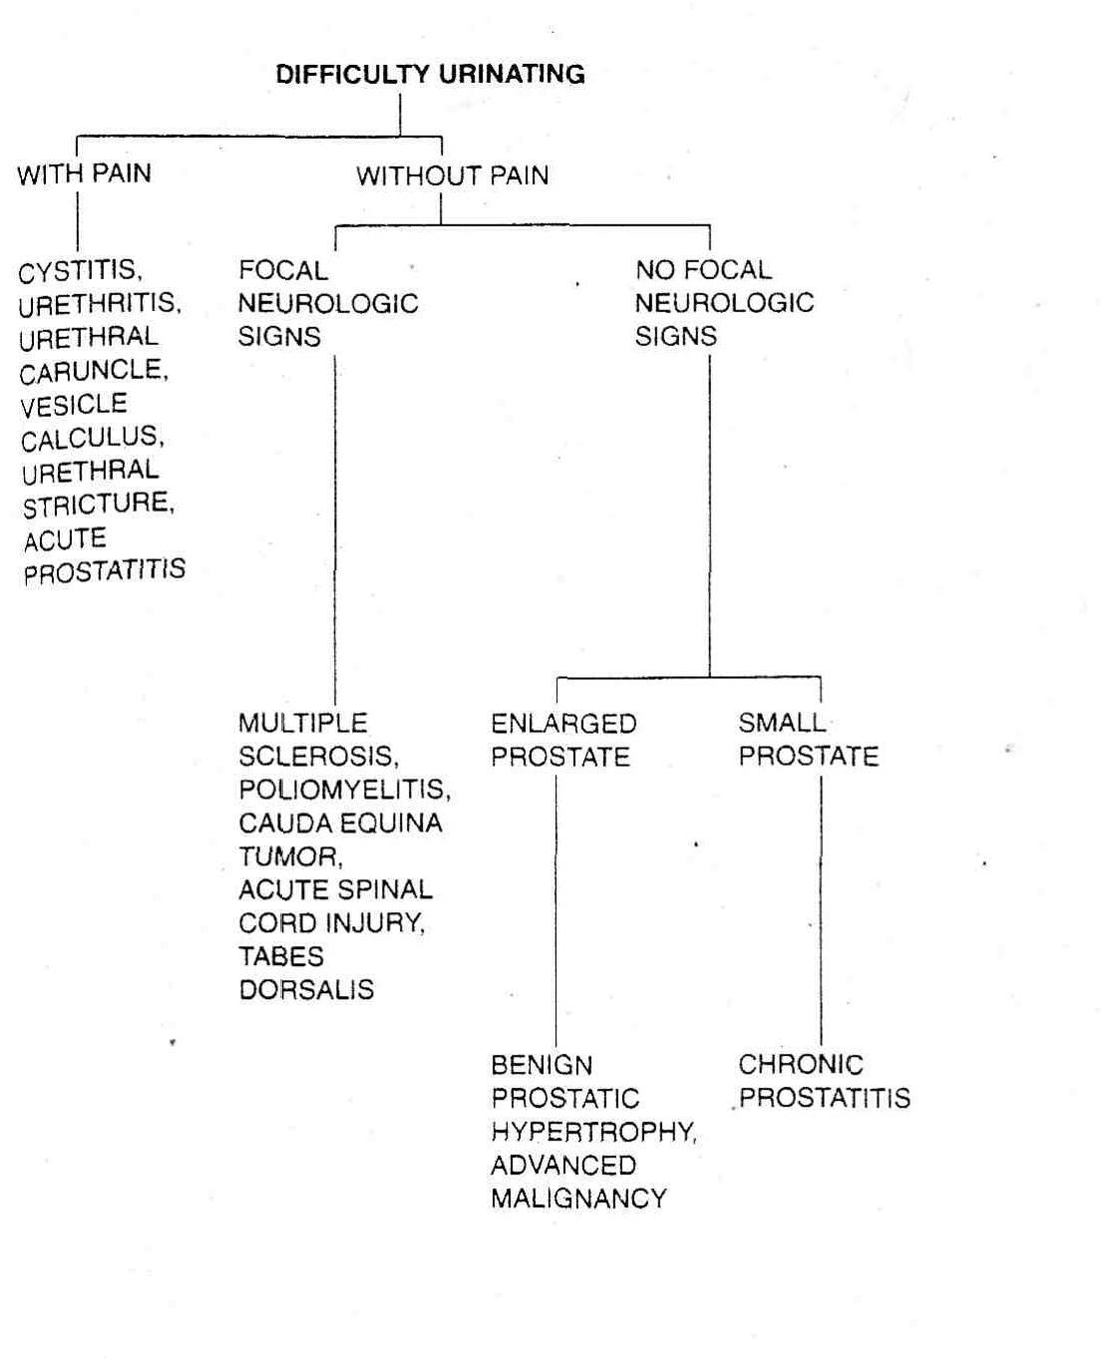
3. If painless urination without neurological signs check if the prostate enlarged? The presence of an enlarged prostate would suggest benign prostatic hypertrophy or an advanced malignancy. A small nodular prostate may suggest an early carcinoma of the prostate. Chronic prostatitis would present with a normal sized or small sized prostate that is firm.

Diagnostic Workup
Routine laboratory tests include:
- CBC, ESR, urinalysis,VDRL test, urine culture, and sensitivity.
- If there is an urethial discharge, a Gram stain and culture for gonococcus* should be done. If this is negative,
- Ultra-sonography may be done to demonstrate residual urine. If there is a significant amount of residual urine ( >100ml), referral to a urologist for cystoscopy and cystometric testing.
- If there are focal neurologic signs, a neurologist consulted.
- An enlarged prostate or a nodular prostate should be an indication for a consultation with a urologist and ordering a PSA titer

6.4 Urinary Tract Stones
Discussion
Urinary tract stones are the most common causes of hematuria and pain in the flank or groin region. The incidence is more common in men and is related to decreased urine volume or increased excretion of stone-forming components like calcium, oxalate, uric acid, cystine, xanthine, and phosphate. They can form anywhere in the urinary tract, but usually in the kidney.
- 80% of all stones contain calcium (as oxalate, sometimes as phosphate). The causes include hyperparathyroidism, renal calcium leak, absorptive or idiopathic hypercalciuria, hyperoxaluria, hypomagnesemia, and hypocitraturia
- Struvite stones contain calcium, ammonia and phosphate, and are formed by Gram-negative, urease-producing organisms like Pseudomonas, Proteus and Klebsiella.
- Uric acid stones are associated with the intake of purine-rich foods like fish, legumes, or meat. They are also seen in patients with cancers and patients with gout.
- Cystine stones occur in the inherited condition cystinuria and are rare.

Clinical features
Most renal stones are asymptomatic. Ureteric obstruction by stone causes:
- Renal colic which is an acute, severe, flank pain that radiates to the groin, testis or labia. It is often associated with nausea and vomiting. The pain peaks within 90 to 120 mins and can wake the patient up from sleep, and is intermittent in the first phase which then becomes constant characterising the second phase lasting up to 3 to 4 hours.
- Increased frequency, dysuria, and haematuria.
- On examination there may be costovertebral tenderness and sluggish bowel sounds. The testis and suprapubic area may be tender on palpation. Fever is rarely seen but when present, can suggest pyelonephritis
Diagnostic tests
- Urinalysis: shows red cells and urinary crystals. Nitrates, leukocytes and bacteria indicate UTI
- Bloods: White cell count (look for infection), Creatinine (usually normal unless bilateral stones causing obstructive uropathy). Check Parathyroid hormone levels, Calcium, Phosphorus and Uric acid (in case of recurrent stones (look for underlying cause).
- X-ray KUB: radio opaque calculi are seen. However, small stones can be missed and features of obstruction cannot be seen
- USG Abdomen and Pelvis: Useful in assessing obstruction and resultant hydronephrosis and in pregnancy where X-ray cannot be performed. Identification of stones <5mm especially in the ureters can be difficult on USG.
- Combining X Ray KUB with USG is an effective and a reasonable alternative to CT scans as these show hydronephrosis, demonstrate both calcified and non-calcified calculi with lower radiation exposure
- Non-Contrast Abdominal and Pelvic CT: This is considered the ‘gold standard’ as it is the most reliable test to diagnose urolithiasis. This is reserved in patients where the X ray KUB and USG abdomen fail to identify the stones and there is high clinical suspicion of urolithiasis.

Management
All patients do not require admission. Patients with mild symptoms, without severe infection and without obstruction can be managed on an outpatient basis and followed up.
Criteria for hospitalisation:
- Inadequate pain relief with oral analgesics
- Obstructed pyelonephritis
- Sepsis
- Intractable nausea and vomiting

Inpatient treatment:
- Analgesia: Diclofenac 75 mg IM/ IV stat followed by repeated doses every 12 hours. Paracetamol 500mg to 1000mg every 6 hours.
- Antiemetics and rehydration therapy are often required.
- Tamsulosin 0.4 mg od especially for stones larger than 5mm
- Oral fluids 4 litres/day

Discharge with tab diclofenac, pantoprazole, and tamsulosin (for ureteric and bladder neck muscle relaxation)
Advise patient to:
- Drink 3L of water daily of which 1 litre is at night. Lime juice makes the urine alkaline.
- Control dietary factors: healthy diet which contains calcium (binds oxalate in the gut) but avoid additional calcium supplements, avoid excess salt, eat more vegetables and less meat as vegetable proteins make the urine less acidic.
- Sleep on the side opposite to the stone to allow gravity to assist in stone removal.

Criteria for urgent referral for Urology consult:
- Obstructing stone in a patient with UTI and sepsis including pyelonephritis (requires urgent surgical decompression)
- Intractable nausea and uncontrolled pain despite IV analgesics
- Obstructing stone in a solitary kidney
- Bilateral ureteric obstruction
- Any degree of obstruction with raising creatinine.

At 4 weeks there is a 20% risk of complications, including deterioration of renal function, sepsis and ureteric stricture.
If stone has not passed by 4 weeks, advise Ureteroscopy with stenting (Double J or DJ) of the ureter to dilate the ureter and also protect the kidney by allowing the kidney to drain.
4-6 weeks after DJ stenting patient is readmitted to undergo ureteroscopy and lithotripsy
As the urologist visits only once in 3 months patient may need to be referred to a higher center

Further intervention includes:
-Lithotripsy (breaks down stones so they can pass).
-Percutaneous nephrolithotomy (PCNL) - used for large stones (>2 cm), staghorn calculi and also cystine stones.
-Ureteroscopy (generally reserved if lithotripsy is unavailable or unsuccessful).
-Open surgery rarely used, reserved for bladder stones, complicated cases, or failure with all other methods.

Preventative measures for recurrent stones:
- Hydration
- Alkalinize urine
- Treat underlying cause
- Thiazide diuretics (hydroxychlorothiazide) for all calcium stones and add calcium citrate for oxalate stones.
- Allopurinol (for uric acid stones)’;.’

6.5 Epididmo-orchitis
Acute Epididmo-orchitis
Discussion --In men <35 years old:
- Most common aetiology in this population is reflux of sterile urine through the ejaculatory ducts.
- Worldwide the most likely aetiology is sexually transmitted infection eg Chlamydia trachomatis and Neisseria gonorrhoeae
Testicular torsion is an important differential and may be difficult to differentiate on examination. A painful swollen testicle in an adolescent boy or a young man should be managed as torsion until proven otherwise.
- Differentiate via Doppler ultrasound
- If still unclear surgical exploration.
In men over >35 years old:
Infection due to Gram-negative enteric organism causing urinary tract infections - eg, Escherichia coli, Pseudomonas spp. Often due to bladder outlet obstruction (eg in BPH).
Other important causes include:
- Extrapulmonary TB
- Mumps
- Behcets
- Side effect of amiodarone (dose >200mg).
Rarer infectious causes include:
Candidiasis, Brucellosis, Coccidioidomycosis, Blastomycos, Cytomegalovirus

Chronic epididymitis is characterized by a ≥six-week history of symptoms of discomfort and/or pain in the scrotum, testicle, or epididymis.
- Most commonly due to TB
- Rare non infectious causes include: trauma, cancer, autoimmune and idiopathic causes.
Clinical features
- Usually acute or sub-acute onset.
- Unilateral swelling and tenderness of epididymis +/- testes,
- Beginning in the tail of the epididymis and spreading to involve the whole of the epididymis and testes.
- May have symptoms of urethritis or UTI.
- Other signs may include: urethral discharge, secondary hydrocele, erythema and/or oedema of the scrotum on the affected side and pyrexia.
Diagnostic tests
Clinical diagnosis based on symptoms and signs.
Further tests:
- Urinalysis
- MSU for microscopy and culture: microscopy may show pus cells or bacteria
- Gram stain of any urethral secretions.
If TB infection suspected:- Mantoux test, ESR,3 early morning urine samples, for acid fast bacilli (AFB), Renal Ultrasound & CXR to explore co-existing respiratory involvement
Management
Treat as you would UTI
- Start on ciprofloxacin 500mg PO, BD, for 10-14 days.
- Adapt treatment based on urine C&S
Additional measures
- Bed rest
- Scrotal elevation
- NSAID’s until fever and local inflammation subsides.
High fever indicates complicated infection, in these cases hospital admission is advised.
If after therapy signs and symptoms of epididymitis do not subside within 3 days, this requires re-evaluation:
- TB
- Rare or Resistant organism
- Alternative diagnosis

6.6Prostatitis
Discussion
Inflammation of the prostate gland. 4 clinical syndromes:
- Acute bacterial
- Chronic bacterial
- Chronic prostatitis/chronic pelvic pain syndrome
- Asymptomatic inflammation.
Chronic prostatitis is more common than Acute and Non-bacterial is more common than bacterial.
However bacterial prostatitis more likely if patient is <35 and has more severe symptoms.
In acute bacterial prognosis is good, however 1 in 10 go on to develop chronic prostatitis.
Chronic prostatitis can prove difficult to treat but most men gradually recover with treatment (may take years) and relapses are relatively common.
Prostatitis does not increase the risk of prostate cancer.
Bacterial aetiology:
- Usually Gram-negative organisms: Escherichia coli, Enterobacter, Serratia, Pseudomonas, Proteus.
- STI’s: Neisseria gonorrhoeae and Chlamydia trachomatis.
- Rarer causes: Mycobacterium tuberculosis.
Non-bacterial aetiology:
- Elevated prostatic pressures
- Pelvic floor myalgia
- Emotional disorders.
Risks factors:
- Sexually transmitted infections (STIs).
- Urinary tract infections (UTIs).
- Indwelling catheters.
- Following manipulation of the gland - eg, post-biopsy.
- Increasing age.
Clinical Features
Acute bacterial: Usually severe symptoms that start fairly suddenly.
- Urinary symptoms: frequency, urgency, dysuria, nocturia, hesitancy, incomplete voiding.
- Pain in pelvis, lower back or lower abdomen.
- May be toxic (fever, nausea, dehydration, tachycardia etc)
- O/E Prostate will be tender, may feel hot, nodular, boggy or possibly normal.
- Patient may have inguinal lymphadenopathy and/or urethral discharge.
Chronic bacterial:
- Symptoms similar to acute bacterial prostatitis, but less severe and can fluctuate in intensity over several months.
- May have a history of UTI.
- O/E Prostate may feel normal or may be hard from calcification.
Non-bacterial chronic prostatitis:
- Urinary and genital pain for at least three of the past six months.
- Symptoms generally vary over time.
- O/E Prostate may feel normal or may be hard from calcification.
Diagnostic tests
Clinically diagnosed by a tender prostate on rectal exam (donot perform vigorous or repeated rectal exams due to risk of seeding infection) and h/o dysuria.
- Confirmed by urine culture and microscopy
- If toxic CBC, Creatinine, .
Non-bacterial chronic prostatitis diagnostic criteria:
- Symptoms suggestive of prostatitis lasting for more than three months.
- Negative cultures of urine and prostatic fluid.
- Leukocytes may be present in prostatic fluid in the inflammatory type and absent in the non-inflammatory type.
Management
Acute bacterial:
- 1st line ciprofloxacin 500mg PO, BD for 28 days.
- 2nd line doxycycline 100mg PO, BD for 14 days.
- IV antibiotics for: Toxic, severely ill, unable to tolerate oral or deteriorating on oral. If severely may require IV aminoglycosides in addition to flouroquinolones.
- If inadequate response to antibiotics:
- prostatic abscess (investigate by transrectal ultrasound examination or CT scan of the prostate, requires surgical drainage).

Additional points:
- Avoid repeated rectal examination for fear of seeding infection.
- Acute urinary retention requires suprapubic catheterisation, as insertion of a urethral catheter may damage the prostate.
- After recovering all men require referral for investigation of their urinary tract, to exclude structural abnormalities.

Chronic bacterial:
- Prescribe same Antibiotics as acute
- Usually requires 4-6 week course
- Repeat courses may be necessary.
- Stool softeners and analgesia also beneficial
.
Non-bacterial chronic prostatitis:
- Paracetamol or NSAIDs for analgesia.

Antibiotics may help occult infection

6.7 Pyelonephritis
Discussion
Renal infection due to ascending infection from the bladder.
Clinical features
- Acute onset loin pain (may be unilateral or bilateral), may radiate to iliac fossa or suprapubic area.
- Lumbar tenderness and guarding
- Symptoms of cystitis (in 30%).
- Fever with rigors, vomiting and hypotension.
Complications include renal or perinephric abscess and papillary necrosis.
Perinephric abscess will produce marked loin pain and tenderness, may have bulging of the loin. Patients appear very ill with fever leucocytosis and +ve blood cultures. Urinary symptoms are absent and urine will not contain pus cells or organisms.
In TB infection of kidney and urinary tract patient will demonstrate
- Bladder symptoms, haematuria, malaise, fever, night sweats, loin pain.
- May have CKD as a result of urinary tract obstruction or destruction of renal tissue
- May show renal calcification and ureteric strictures.
Diagnostic tests
- Mid stream sample of urine for culture and microscopy. Urine will show neutrophils and bacteria (with typical clinical features confirms diagnosis) may also show red cells and tubular epithelial cells. In TB urine will show neutrophils but will be negative on routine culture, early morning urine cultures should be sent to identify tubercle bacilli.
- Renal tract USS (or CT) to exclude perinephric abscess, or obstruction (as predisposing factor)
- Additional tests for TB: cystoscopy (if bladder involvement), USS (or CT) urinary tract, CXR.
Management
Patient is generally admitted, urine analysis and C&S taken and started on IV antibioticsit. Once culture report is obtained antibiotic can be modified as needed
- 1st line Cephalosporins (Inj Ceftriaxone 2gm IV od).
- 2nd line Severe cases initially require IV therapy with a amicillin + gentamicin or amikacin

6.8 Cystitis
Discussion
Bacterial infection of the bladder; most common infection seen in primary care. Usually due to E.coli (75%) other causative organisms include Klebsiella, proteus, pseudomonas spp., Steptococci, Staphylococcus epidermis.
Clinical features
- Abrupt onset urinary frequency and urgency.
- Burning urethral pain during micturition.
- Suprapubic pain during and after voiding.
- Cloudy or foul smelling urine.
- Visible or microscopic haematuria.
Systemic features usually slight or absent. Fever, rigors and loin tenderness suggest pyelonephritis.
Diagnostic tests
- Urinalysis: Blood, protein, nitrite, glucose.
- Mid stream urine sample for microscopy, culture & sensitivity.
- Blood tests: CBC, s.creatinine
Further investigations
- Pelvic examination in women with recurrent UTI
- Rectal exam in men to examine prostate
- Renal USS/CT in acute pyelonephritis, recurrent UTI despite antibiotics, UTI in pregnancy
- Cystoscopy if significant haematuria or suspected bladder lesion.
Management
Antibiotics can be commenced while awaiting results of urine culture.
- 1st line: oral Nitrofurantoin 50-100 mg four times daily for 5 days (however resistance is increasing) or oral Septran DS two times daily for 5 days
- Other effective agents: Norfloxacin, Ciprofloxacin or Cephalexin.
5–10-day antibiotic course for women who have:
- Impaired renal function.
- An abnormal urinary tract (for example renal calculus, vesicoureteric reflux, reflux nephropathy, neurogenic bladder, urinary obstruction, or recent instrumentation).
- Immunosuppression (eg poorly controlled diabetes mellitus or are receiving immunosuppressive treatment).
In Pregnancy:
- 1st line: Nitrofurantoin 50-100 mg four times daily for 7 days
- 2nd line: Cefalexin 500 mg twice daily, or 250 mg 6-hourly, for 7 days
- Repeat urine culture after 7 days.
- If symptoms persist despite initial treatment adjust according to sensitivities.
Symptom relief:
- Paracetamol or NSAIDs
Advise women to seek medical attention if symptoms persist despite initial treatment or they develop fever with loin tenderness (suggestive of pyelonephritis).

6.9Acute Kidney Injury
Defined as a sudden dectrease in kidney function , resulting in an inability to maintain acid base balance , fluid and electrolyte balance, and to excrete nitrogenous wastes associated with sudden increase in serum creatinine,
and often associated with oliguria

Causes
Prerenal- dehydration,haemorrhage, heart failure,NSAIDS, ACE inhibitors, renal artery stenosis
Renal: AGN- immune complex disease
ATN – ischemia, NSAIDS, antibiotica, radiographic contrast,chemo, multiple myeloma
Vasuular- malignant hypertension,embolus
Acute interstitial nepritis- drugs- allopurinol,rifampicin, diuretics,sulpha, infections
Postrenal- BPH, bladder tumour

Lab tests
  - S. creatinine,
  - Electrolytes – hyperkalemia, hyperphosphatemia, hypocalcemia, acidosis
  - Urine sodium- low in prerenal, high in renal causes
  - Ultrasound to exclude obstruction
  - ECG- peaked T waves, widening QRS
Treatment
1 Prerenal – maintain euvolemia, treat cause, monitor electrolytes, avoid nephrotoxins
2. Post renal – relieve obstruction with catheter or stent
3. Renal- Refer for hemodialysis / peritoneal dialysis if pt has
- Uremic symptoms like pericarditis, encephalopathy, coagulopathy, seizures, neuropathy
- Fluid overload not responsice to diuretics
- Refractory hyperkalemia
- Severe metabolic acidosis

6.9 Chronic kidney disease
Discussion
Also known as chronic renal failure, a state in which there is an irreversible reduction in renal function. Can be caused by a number of reasons including:
- Circulatory problems such as renal artery stenosis
- Inflammation within the kidneys - interstitial nephritis or glomerulonephritis
- Diabetes is very important cause - diabetic kidney disease also affects glomeruli
- Urinary tract obstruction - in ureters, bladder, or below - more on obstruction
- Inherited diseases - more info on inherited/congenital diseases.
It is also common for renal impairment to worsen gradually with time, even if the cause of damage is removed. There are various theories for this, including hyperfiltration stress on residual nephrons, and direct toxicity from proteinuria to the renal tubules.
The following markers identify patients at greater risk of deterioration of renal function:
- Worse renal function - higher serum creatinine
- Proteinuria - the higher, the greater the risk of progression
- Hypertension - the higher, the greater the risk
- Renal biopsy shows fibrosis, or continuing inflammation
- Young age - they have longer for trouble to develop
CKD can be categorized into 5 stages depending on eGFR (estimated glomerular filtration rate).
To calculate eGFR visit: http://egfrcalc.renal.org/
Stage | GFR | Description | Management, comments
1 | 90+ | Normal kidney function but urine or other abnormalities point to kidney disease | Stages 1-3 (5-10% of the population?)  Need assessment, long term monitoring, control of blood pressure and CV risk factors
2 | 60-89 | Mildly reduced kidney function; but must also have urine or other abnormalities (e.g. anatomical, genetic) to be classified as CKD
3 | 30-59 | Moderately reduced kidney function | Few or no symptoms still
4 | 15-29 | Severely reduced kidney function | Planning for endstage renal failure if progressive. Increasing symptoms.
5 | 14 or less | Very severe, or endstage kidney failure (ESRF or ESRD) | Renal failure
CKD can also be classified depending on the urinary Albumin Creatinine Ratio.
Despite the poor prognosis treatment can prevent or delay the progression of CKD, reduce or prevent the development of complications, and reduce the risk of cardiovascular disease.
Clinical features
Initially asymptomatic until stage 3 or 4, symptoms then start to develop due to widespread effects of renal failure.
- General symptoms: appear ill. Nocturia common (decreased concentrating ability). Fatigue, breathlessness, anorexia, nausea. In ESRF: pruritis, vomiting, muscular twitching, fits, drowsiness, coma.
- Immune dysfunction, leading to infections (2nd most common cause of death in dialysis patients after cardiovascular disease)
- Haematological: Impaired platelet function (bleeding tendency), Anemia (related to deficiency in EPO) contributes to many nonspecific symptoms of CKD.
- Fluid and electrolyte abnormalities: Fluid retention (can cause episodic pulmonary oedema, particularly associated with renal artery stenosis). Some patients (with tubule-interstital disease) develop salt wasting disease. Metabolic acidosis.
- Endocrine function: Hyperparathyroidism, Hyperprolactinemia, insulin resistance.
- Myopathy and neuropathy: Myopathy dues to poor nutrition, hyperparathyroidism, vit D deficiency and electrolyte disorders. Muscle cramps and “restless legs” are common. Neuropathy occurs late in ESRF but may improve with dialysis.
- Cardiovascular disease LVH due to hypertension may predispose to arrhythmias. Vascular calcification associated with increased phosphate levels (due to decreased excretion) can cause limb ischemia. Pericarditis common in ESR, can cause pericardial tamponade and constrictive pericarditis.
- Metabolic bone disease: Osteomalacia, Hyperparathyroid bone disease and osteoporosis due to disturbances in calcium and phosphate metabolism.
Diagnostic tests
Diagnose and monitor via estimated glomerular filtration rate (eGFR) and urinary albumin:creatinine ratio (ACR).
Primary concerns
- Identifying the underlying cause
- Addressing reversible factors which make renal function worse (e.g. hypertension, UTI, Urinary obstruction, neophrotoxic medication)
- Screen for complications (e.ganemia or osteodystrophy)
- Screen for cardiovascular risk factors.
Initial tests to consider:
- U+E, creatinine, calcium and phosphate
- Albumin
- CBC
- CRP
- Urinalysis
- Urine microscopy
- Renal USS
- Cultures
- CXR
- Serology
- ECG
Continuing monitoring:
- eGFR based on blood creatinine.
- Urinary ACR
- CBC to exclude renal anaemia for people with stage 3b,4, and 5 CKD.
- Serum calcium, phosphate, vitamin D, and parathyroid hormone to monitor bone metabolism for people with stages 4 or 5 CKD.
Monitoring based on clinical judgement and patients’ individual risk factors adjust according to:
- The underlying cause of CKD.
- Past patterns of eGFR and ACR
- Comorbidities
- Changes to drug treatment
- Intercurrent illness
Management
Management priorities are aimed towards preventing further deterioration in renal function and limiting metabolic and cardiovascular complications.
- Antihypertensive therapy: target BP 130/80 in uncomplicated CKD, 125/7 in CKD with proteinuria >1g per day. The most important aspect is that the blood pressure is lowered, which agent is used is of secondary importance. Based on numerous sources a combination of the following are recommended:
1st line: ACE inhibitor OR ARB (don’t combine as this can worsen kidney function)
2nd line: Calcium channel blockers (Diltiazem and Verapamil help reduce proteinuria so are preferred over Amlodipine and Nifedipine)
3rd line: Aldosterone antagonsists (Spironalactone, however risk of Hyperkalemia)
4th line: Beta blockers
Diuretics:used in most patients.Thiazide diuretics (CKD stage 1-3) Loop diuretics (CKD stage 4-5)
- Reduction of proteinuria: ACE inhibitors or ARBs. May cause initial drop in GFR but continue provided the drop is not >20% or progressive.
- Dietary and lifestyle modifications: Smoking cessation, exercise and weight loss if appropriate. Restricting protein is of limited benefit in early stages, in CKD stage 4/5 avoid excess protein but maintain sufficient calories. Avoid excess potassium and phosphate.
- Lipid lowering therapy: Statins, Atorvastatin 20mg daily.
- Treatment of Anemia: Erythropoeitin. Target Hb 100-120 g/L. Iron deficiency, active inflammation or malignancy should be treated before EPO treatment. Deworm patients.
- Maintenance of fluid and electrolyte balance:
If fluid retention limit dietary sodium to 100mmol/day loop diuretics may be used to treat fluid overload. Hyperkalemia requires
- restriction of intake to <70mmol/day and
- withdrawal of potassium sparing diuretics, ACE inhibitors and ARBs.
- Calcium resonium may work in the short term to bind potassium.
- Acidosis can be corrected using sodium bicarbonate to keep plasma bicarbonate >22mmol/L,
- if the sodium load causes oedema use calcium carbonate as alternative.
- Renal bone disease: Treat hypocalcemia with 1alpha-hydroxylated synthetic analogues of vitamin D, which will normally prevent or control osteomalacia.
Control hyperphosphatemia with dietary restriction of phosphate rich foods (milk, cheese, eggs) and the use of phosphate binding drugs eg calcium carbonate.
Secondary hyperparathyroidism is usually controlled with these measures, however if it isn’t do parathyroidectomy.
Suspected AKI needs to be managed urgently.
Avoid NSAIDs!
Renal replacement therapy
Required temporarily in AKI or permanently in CKD. Aim is to replace the excretory function of the kidney and maintain normal water and electrolyte balance.
1 year survival 84%, 5 year survival 50%.
Patients with progressive CKD should be identified and prepared for RRT at least 12 months before the predicted start date.
Types of RRT:
- Haemodialysis: Most common RRT, for AKI or CKD. Vascular access gained via central venous catheter or arteriovenous shunt. Works through diffusion of solutes from blood to dialysate across a semi permeable membrane down a concentration gradient. Patient is anticoagulated with heparin during treatment, typically takes 3-5 hrs 3 x weekly. Complications include: hypotension during dialysis, cardiac arrhythmias, haemorrhage, air embolism, and dialyser hypersensitivity.
- Haemofiltration: Principally used for AKI. Intermittent or continuous, allows for control of intravascular volume by adjusting rate of fluid replacement. Works by water and solutes being filtered across semi-permeable membrane by a pressure gradient. Replacement fluid is added to filtered blood before it is returned to patient.
- Peritoneal dialysis: Principally for CKD. Useful in children and adults with residual renal function. In continuous ambulatory dialysis 2 L of sterile isotonic fluid is introduced and left in the abdomen for 4-6 hrs. In Automated peritoneal dialysis fluid exchanges are performed by a pump overnight. Complications include: CAPD peritonitis, catheter exit site infection, ultrafiltration failure, peritoneal membrane failure, sclerosing peritonitis.
- Transplantation: Best chance of long term survival in CKD. Can restore normal kidney function and correct all metabolic abnormalities associated with CKD. All patients should be considered unless contraindications ( see below). Graft rejections are the most common cause for failure. All transplant patients require lifetime clinic follow up to monitor renal function and immunosuppression (common regimens include prednisolone with ciclosporin or tacrolimus with azathioprine). Treatment is associated with increased risk of infection and malignancy (particularly skin cancers).
Renal transplant Contraindications
Absolute: - Active malignancy. 2 years remission recommended.
- Active vasculitis or and – GBM disease with +ve serology. At least 1 year remission recommended before transplant.
- Severe heart disease
- Severe occlusive aorto-illiac vascular disease.
Relative: 1.Age. Generally not offered to <1 or >75 2. High risk of disease recurrence in transplanted kidney.
3 Disease of lower urinary tract. In impaired bladder function an ileal conduit may be considered.
4.Significant comorbidity.
Referral--Nephrologist:
- An estimated glomerular filtration rate (eGFR) of less than 30 mL/min/1.73 m2. These people are usually under specialist care, but monitoring of blood tests may take place in primary care as part of shared care arrangements.
- A sustained decrease in eGFR of 25% or more within 12 months and a change in eGFR category.
- A sustained decrease in eGFR of 15 mL/min/1.73 m2 or more within 12 months.
- A urinary albumin:creatinine ratio (ACR) of 70 mg/mmol or more, unless known to be caused by diabetes and already appropriately treated.
- A urinary ACR of 30 mg/mmol or more, together with persistent haematuria (two out of three dipstick tests show 1+ or more of blood) after exclusion of a urinary tract infection.
- A rare or genetic cause of chronic kidney disease (CKD), or the suspicion of one (such as polycystic kidney disease).
- Suspected renal artery stenosis (suggested by refractory hypertension, recurrent pulmonary oedema with normal left ventricular function, or an increase in serum creatinine of 20% or more when started on an angiotensin-converting enzyme [ACE] inhibitor ).
- Complications of CKD, such as renal anaemia (haemoglobin less than 11 g/dL) and renal bone disease (for example abnormal serum calcium, phosphate, or raised parathyroid hormone).
- Hypertension that remains poorly controlled despite the use of at least 4 antihypertensive drugs at therapeutic doses.
Urologist:
- Urinary tract obstruction (for example the bladder is palpable) — emergency admission may be required for people with hyperkalaemia (potassium greater than 6 mmol/L) or fluid overload.
- Isolated persistent haematuria (no decrease in eGFR and no proteinuria).
In people under 50 years of age a non-urgent referral to a urologist should be made.
In people 50 years of age and older an urgent referral should be made.
6.10 Non-gonococcal urethritis.
Non-gonococcal urethritis (NGU), or inflammation of the urethra, is the most common treatable sexually transmitted syndrome in men, caused by infection with 1.Chlamydia trachomatis 20-50 % and 2. Mycoplasma genitalium. 10-30 %
Other causes are Ureaplasma urealyticum, Trichomonas vaginalis, anaerobes,Herpes simplex virus (HSV) and Adenovirus. Up to half of the cases are non-specific.
Symptoms-Urethritis is characterized by discharge, dysuria &/or urethral discomfort but may be asymptomatic.
Diagnosis - The diagnosis of urethritis is confirmed by demonstrating an excess of polymorpho-nuclear leucocytes (PMNLs) in a stained smear.
An excess of mononuclear leucocytes in the smear indicates a viral etiology.
In patients presenting with symptoms of urethritis, the diagnosis should be confirmed by microscopy of a stained smear, ruling out gonorrhea.
Treatment - If marked symptoms and urethritis is confirmed, syndromic treatment should be given at the first appointment without waiting for the laboratory results. Treatment options are
- doxycycline 100 mg bid for one week followed by azithromycin 500mg od x five days + metronidazole 400 mg bid for 5 days should be given. or
- azithromycin 1gm single dose followed by doxycycline 100 mg bid + metronidazole 400mg bid for one week
Current partner(s) should be tested and treated with the same regimen. They should abstain from intercourse until both have completed treatment.
Persistent or recurrent NGU must be confirmed with microscopy. Reinfection and compliance must be considered.

Chapter 7: Gastrointestinal Diseases

7.1 Acute Gastroenteritis
7.2 Acid Peptic Disease
7.3 Abdominal Ascites

7.4 Guidelines for Endoscopy
7.5 Cholelitiasis (Gallstones)
7.6 Hemorrhoids
7.7 Anorectal Abscess
7.8 Fistula in ano
7.9 Acute Appendicitis

7.1Acute Gastroenteritis
Gastritis / Vomiting:
This is characterized by upper abdominal discomfort often described as a burning type of pain related to food intake. The common causes include peptic ulcer disease and gastro esophageal reflux. More serious causes include gastric or pancreatic cancers, and chronic pancreatitis.
Differentials include
- Functional dyspepsia : up to 60 %
- Organic causes:
  - Peptic ulcer disease : 15 to 25 %
  - Reflux esophagitis: 5 to 15 %
  - CA esophagus/ stomach: <2 %
  - Biliary tract disease
  - Gastroparesis
  - Pancreatitis
  - Carbohydrate malabsorption (lactose, sorbitol, fructose, mannitol)
  - Medications (Aspirin, NSAIDs, Alcohol, Iron, Metformin, Oral Antibiotics, Steroids, Deriphyllin)
  - Ischemic bowel disease
  - Metabolic disturbances (hypercalcemia, hyperkalemia)
  - Hepatoma
  - Intestinal parasites (giardia, strongyloides)

Management:
- Endoscopy is recommended for all patients with new onset Gastritis lasting for > 2 weeks
- Trial of PPIs can be considered in patients when there is no clinical suspicion of upper GI malignancy. This includes Tab. Pantoprazole 40 mg once daily for 10-14 days followed by symptoms reassessment. B complex tablets are also given.
- In patients with severe gastritis or intractable symptoms- Syp. Sucralfate 10ml TID is added in addition to PPI
- Non-pharmacological treatment: This remains the cornerstone in preventing the recurrence of symptoms. All patients should be advised to stop smoking, chewing betel nut/ tobacco and consuming alcohol. Spicy foods should be avoided and GERD precautions must be given in addition to weight loss.

Red-Flag Signs: These patients definitely warrant an upper GI scopy despite clinical improvement. These include,
- Weight loss
- Hematemesis or melena
- Recurrent symptoms
- Early satiety
- Significant risk factors (Smoking, Tobacco consumption)
- Dysphagia
- No response to pharmacological therapy

In patients with Gastritis and Vomiting, consider admission/ observation and the following medications
- IV hydration with DNS/ RL
- Inj. Ondansetron 8mg IV
- Inj. Pantoprazole 40mg IV
- Inj. Phenergan (Promethazine) 25mg IV (in case of no response to Ondansetron)
- Inj. Dexamethasone (refractory vomiting and in patients with hyperemesis gravidarum)

Diarrheal Illness
Assess amount of fluid loss
- BP -systolic pressure
- > 90 pt not dizzy on sitting – oral fluids- Kanji water + salt or ORS
- >90 but pt is dizzy on sitting/ standing- IV hydration with NS/ RL, ORS, monitor vitals and urine output
- <90 – hypotension- IV NS/ RL, admit in HDU, catheterize if indicated, evaluate for sepsis

- Urine output should be > 1ml/kg/hr

Is it diarrhoea or dysentery? A useful way of classifying diarrhea in clinical practice is as follows:
- If diarrhea is with mucus +/- blood it is dysentery
- If not it is diarrhea

So for all pts ask for stool microscopy – if it shows WBCs it is dysentery. Management comprises of Antibiotics and hydration
- Tab. Norflox 800 mg twice daily if not sick (vitals stable, no fever or leukocytosis)
- Inj. Ceftriaxone and Inj. Metronidazole if sick (fever, abdominal tenderness,tenesmus, leukocytosis).
- If stool has no pus cells and cholera suspected give doxy 300mg stat

- Patient not vomiting - Give kanji with salt or ORS
- Patient vomiting/drowsy - Do serum electrolytes in addition to CBC and Creatinine

Acute diarrhea without fever and without blood
Main causes: Viral
Treatment: ORS and reassurance

Acute watery diarrhea, cholera suspected
Main causeVibrio cholera
Treatment :Doxycycline 300 mg p.o. x 1 dose or Azithromycin 1 g p.o. x 1 dose or Cipro 500mg bid x 3 days
Prompt rehydration essential

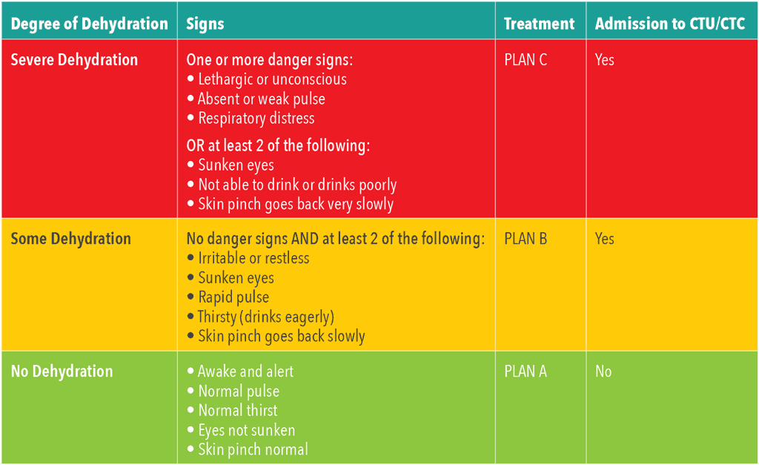

Dysentery: Bacillary dysentery (acute onset fever and bloody diarrhea)

Main causes: Shigella, campylobacter, invasive E.Coli, Salmonella
Treatment: Mild
- Norfloxacin 400 mg 2 tabs bid x 2 days (above 6 yrs of age)
- Ciprofloxacin 500 mg p.o.BIDx3 days
- Azithromycin 500 mg p.o.ODx3 days
- Septran 6-12 mg TMP/kg/day in divided doses every 12 hours (use only in children greater than 2 months)
Severe: If a patient has high fever, abdominal tenderness and looks sick, start IV ceftriaxone. Septic shock possible Add IV metrogyl and if patient is worsening start Inj. Piptaz 4.5g IV Q6h- Q8h

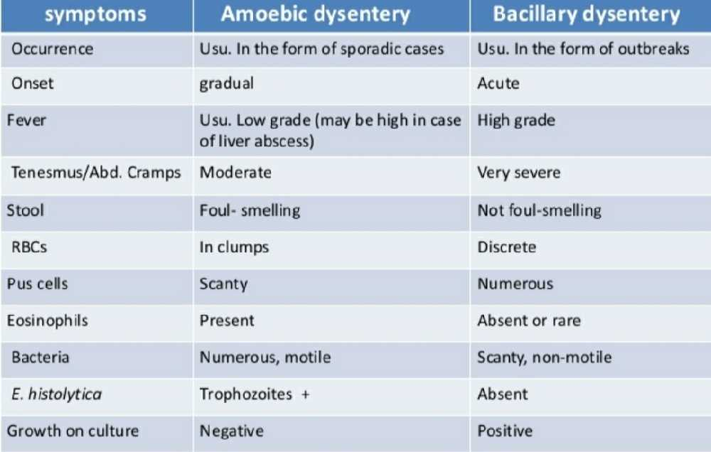

Acute diarrhea without fever, with blood
Main causes: Amebic dysentery
Treatment: Metronidazole 400mg tid x 5 days

Persistent diarrhea - that continues although at a lesser severity following an attack of acute diarrhea
Main causes: giardiasis, amebiasis, lactose intolerance, inflammatory bowel disease, ca colon

Evaluation: All patients with persistent diarrhea, new onset altered bowel habits, bleeding per rectum associated with weight loss, or with family history of colorectal cancers must undergo a Colonoscopy

Treatment: Metronidazole or trial of withholding milk products x 2wks

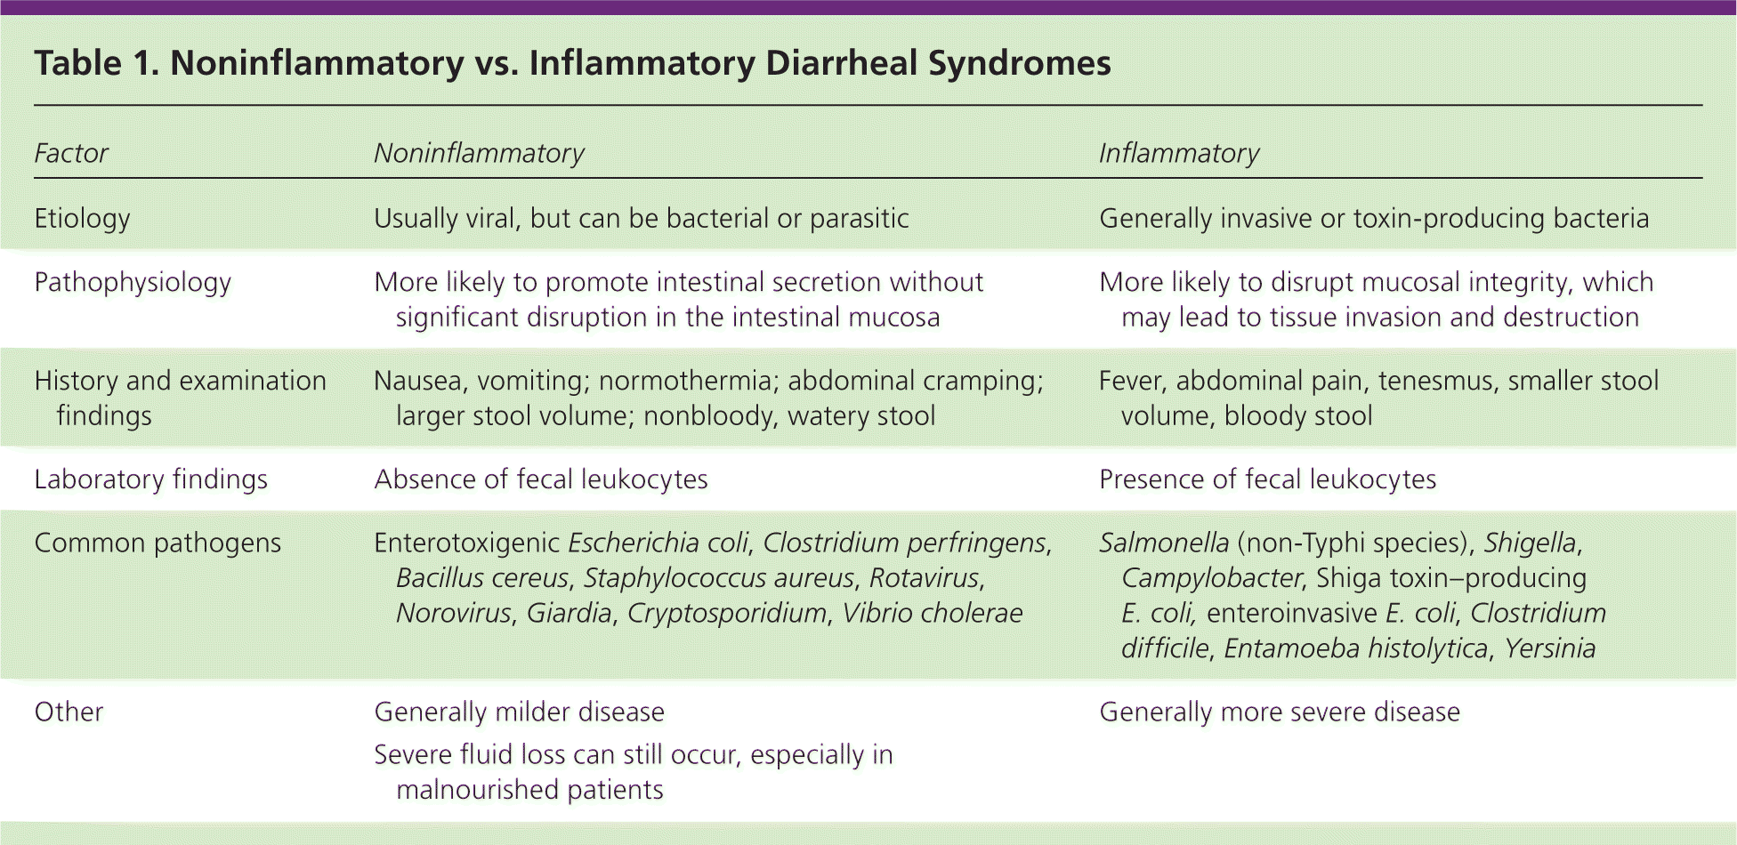

Chronic diarrhea with fever
Main causes: TB Enteritis, AIDS
Treatment:tx underlying cause

Chronic diarrhea with blood, without fever
Main causes: Amebiasis, parasitic disease (trichuriasis)
Treatment: Metronidazole or Albendazole

Chronic diarrhea without fever or blood
Main causes: Giardiasis, tropical sprue (check MCV), Strongylodiasis (upper abdominal pain and eosinophilia are clues), lymphoma of small bowel
In Giardiasis pt has postprandial hurry
Treatment: underlying cause In Giardiasis Metrogyl 400mg tid x 5 days

7.2 Acid Peptic Disease (APD)

Treatment
- Stop chewing betel, stop smoking & alcohol, eat regular meals, avoid gastric irritants like aspirin/ NSAIDs
- Antacid as needed
- Tab. Pantoprazole 40mg once daily for 2 weeks
- Syp Sucralfate
- Anti H.pylori regimen used in GAH
Amoxicillin 1000 mg po bid x 2 weeks
Metronidazole 800 mg po bid x 2 weeks
Pantoprazole 40 mg po BD for 6 weeks
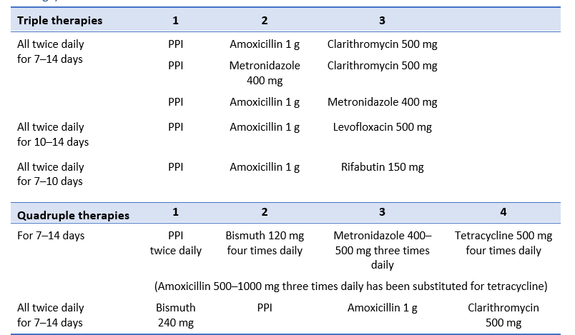

7.3 Guidelines for Endoscopy

Dyspepsia with no alarm symptoms: Consider trial of PPI and reassessment first
- age less than 35 years
- duration of symptoms <2 weeks
- No other Red-flag (Alarm) symptoms

Alarm symptoms include: Endoscopy is mandatory
- new onset of symptoms in someone >45
- family history of upper-GI malignancy
- unintended weight loss
- GI bleeding or iron deficiency anemia,
- progressive dysphagia
- Odynophagia
- Persistent vomiting
.

OGD is done at GAH and biopsies are taken and sent to GKNM Hospital. H.pylori breath test is not done. If biopsy shows H.pylori treat as in 7.2

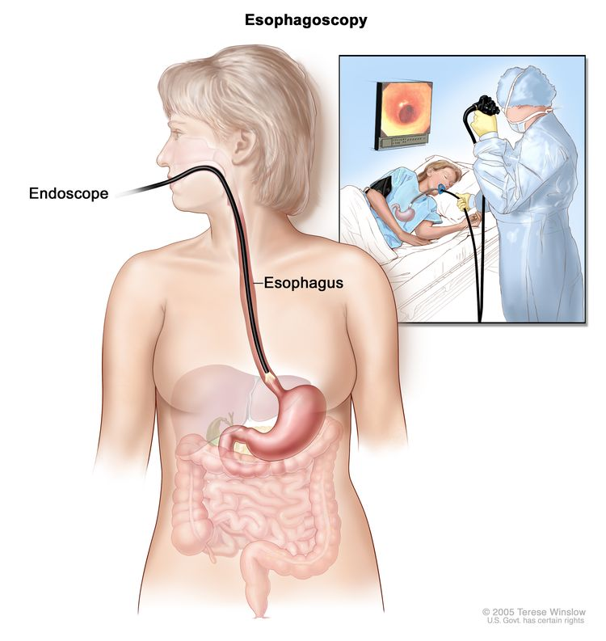

If gallstones are suspected, do USG abdomen first, followed by OGD as this causes increased abdominal gas shadows making USG difficult. Even if patient has gallstones do OGD as many patients have significant APD which needs treatment

7.4 Abdominal Ascites

The term “ascites” denotes the pathologic accumulation of fluid in the peritoneal cavity. Healthy men have little or no intraperitoneal fluid, but women normally may have 20 mL depending on the phase of the menstrual cycle.

Causes
- Cirrhosis (Over 80% of ascites are caused by portal hypertension secondary to chronic liver disease.)
- Infections (TB, peritonitis)
- Mixed ascites (cirrhosis+another disease)
- Cardiac ascites
- Pancreatitis
- Renal disease
- Massive liver metastasis
- Peritoneal carcinomatosis
- Hypothyroidism

Diagnosis:
Physical examination is relatively insensitive for detecting ascitic fluid. requiring at least 1500 mL of fluid to be detected. Abdominal ultrasound establishes the diagnosis.

Abdominal Paracentesis is performed in all patients with new onset of ascites to help determine the cause
And also in patients with known ascites with clinical deterioration (fever,abdominal pain,/tenderness, worsening of renal function ,change in mental status, ileus,hypotension, leukocytosis,or GI bleeding)

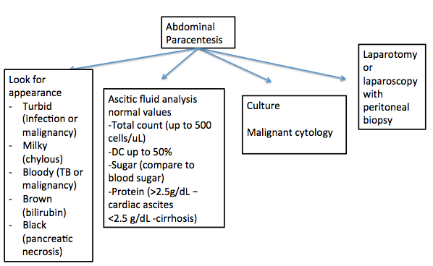

Ideally the following four tests should also be done (not available at GAH) -
- SAAG Calculation
Serum-to-ascites albumin gradient (SAAG) is calculated by subtracting the AF albumin value from the serum albumin value, which should be obtained the same day. If serum albumin – AF albumin .= ≥1.1 g/dL (≥11 g/L) predicts that the patient has portal hypertension with 97% accuracy. A gradient <1.1 g/dL (<11 g/L) indicates that the patient does not have portal hypertension.
- LDH - if elevated, suggests peritonitis
- Ascitic amylase - for pancreatic duct rupture
- ADA, Smear for AFB - to rule out abdominal TB

Management:

Cirrhotic ascites: REFER BELOW
Malignant ascites: Serial large volume paracentesis
TB peritonitis: ATT

7.4 A Cirrhotic ascites

CIRRHOTIC ASCITES
In individuals with ascites, the urinary Na concentration is often <10 mEq/L (10 mmol/L). Free water excretion is also impaired in cirrhosis, and hyponatremia may develop.

Management is as follows:

- Record daily weight. The goal of weight loss in the ascitic patient without associated peripheral edema should be no more than 0.5–0.7 kg/day.
- Bed rest.
- Restrict dietary Na intake initially to 2g/day; after diuresis ensues, the intake of Na may be liberalized slightly.
Note: In some patients, ascites diminishes promptly with bed rest and dietary Na restriction alone.
- Restrict fluid intake (to 800–1000 mL/day) in patients with hyponatremia.
- Long-term IV albumin has been reported to improve 18-month survival in patients with cirrhotic ascites.
- DIURETICS—Spironolactone, generally in combination with furosemide, should be used in patients who do not respond to salt restriction alone.
The dose of spironolactone is initially 100 mg PO daily and may be increased by 100 mg every 3–5 days (up to a max daily dose of 400 mg/day, although higher doses have been used) until diuresis is achieved, typically preceded by a rise in the urinary sodium concentration.
In patients who cannot tolerate spironolactone because of side effects, such as painful gynecomastia, amiloride (another potassium-sparing diuretic) may be used in a starting dose of 5–10 mg orally daily.
Diuresis is augmented by the addition of a loop diuretic such as furosemide. This potent diuretic, however, will maintain its effect even with a falling glomerular filtration rate, with resulting prerenal azotemia. The dose of oral furosemide ranges from 40 - 160 mg/day, and blood pressure, urinary output, mental status, and serum electrolytes (especially potassium) should be monitored in patients taking the drug.
- Avoid NSAIDs, ACE inhibitors and angiotensin II antagonists
- Large volume paracentesis (more than 5 L) - In patients with massive ascites and respiratory compromise, ascites refractory to diuretics (“diuretic resistant”), or intolerable diuretic side effects (“diuretic intractable”), large-volume paracentesis is effective. Large-volume paracentesis can be repeated daily until ascites is largely resolved and may decrease the need for hospitalization. If possible, diuretics should be continued in the hope of preventing recurrent ascites (CMDT2019 p1805).

7.5 Cholelithiasis (Gallstones)
Management- The treatment of gallstones is as follow
Asymptomatic gallstones (single stone < 10mm) – Expectant management except in patients with type 2 diabetes
Symptomatic gallstones (Biliary colic, cholecystitis, biliary pancreatitis, sickle cell disease) – Elective laparoscopic cholecystectomy



Medical treatment: Is rarely indicated and may be considered in some cases :
- Oral bile salt therapy (ursodeoxycholic acid)
- Contact dissolution
- Extracorporeal shockwave lithotripsy
Cholecystectomy for asymptomatic gallstones may be indicated in the following patients:
- Those with large (>2 cm) gallstones
- Those who have a nonfunctional or calcified (porcelain) gallbladder on imaging studies and who are at high risk of gallbladder carcinoma
- Those with spinal cord injuries or sensory neuropathies affecting the abdomen
- Those with sickle cell anemia in whom the distinction between painful crisis and cholecystitis may be difficult
- Diabetes with minor symptoms

Acute Cholecystitis

Symptoms include sudden onset abdominal pain in the right upper quadrant, associated with fever, nausea and vomiting. On examination, the patient will have tenderness over the right hypochondrium exaggerated on deep inspiration (Murphy’s sign). Presence of jaundice and hypotension should raise the suspicion of Cholangitis.

Investigations:
- CBC (elevated WBC counts)
- Total and direct bilirubin (to rule out cholangitis/ obstructive jaundice)
- SGOT, SGPT (may be elevated)
- USG abdomen is the gold standard diagnostic test (look for gallbladder wall edema, stones, and pericholecystic fluid collection, and for evidence of GB rupture)

Management:
All patients with acute cholecystitis should be admitted.
- Nil per oral for first 24 to 48 hours followed by graded oral feeds
- IV fluids
- IV analgesics (Paracetamol and Diclofenac)
- IV antibiotics (Ceftriaxone is the first line, upgrade to Piptaz or Ertapenem in case of severe infection and unstable patient). Antibiotics are administered for 5-7 days followed by oral antibiotics for another 5-7 days
Interval Elective Cholecystectomy is done in 6 weeks once the inflammation has subsided

Criteria for Referral:
- Severe sepsis with hypotension and shock requiring ventilatory or inotropic supports
- Choledocolithiasis (often seen as dilated CBD, and will require ERCP and CBD clearance)
- Acalculous cholecystitis requiring percutaneous cholecystostomy
- Failed conservative treatment
- Suspected GB carcinoma

7.6 HEMORRHOIDS
Patient complains of bleeding during defecation which may be associated with a mass protruding from the anal canal
Internal hemorrhoids are traditionally graded from I to IV based on the extent of prolapse which are diagnosed on proctoscopy
1st degree – painless bleeding without any mass
2nd degree – mass coming out and going back spontaneously
3rd degree – mass needs to be pushed in manually
4th degree – mass stays out
Proctoscopy must be done to confirm that the source of bleeding and identify the hemorrhoids

It is crucial to make an appropriate diagnosis and more importantly to rule out other dangerous conditions like carcinoma rectum, inflammatory bowel disease (Ulcerative colitis) or tuberculous fistula in ano. For this, a thorough history and examination is critical. Ask for red flag signs (which indicate more serious problems and will require a colonoscopy). These signs include
- Weight loss
- Low hemoglobin (bleeding from hemorrhoids almost never causes low hemoglobin)
- Abdominal pain
- Altered bowel habits
- Tenesmus
- Spurious diarrhea
- Passage of mucus with blood
- Family history of colorectal cancers
- Age >45 years

Treatment:
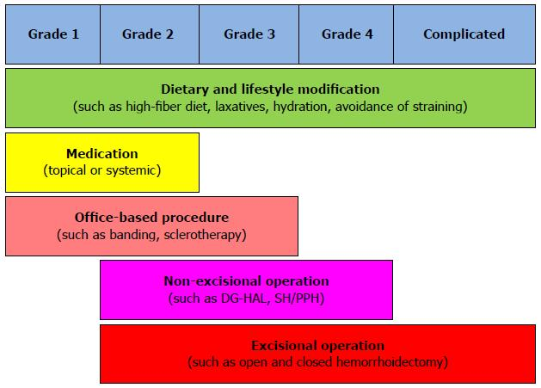

Management of Prolapsed Hemorrhoids
Sometimes the hemorrhoids prolapses out and becomes painful as the anal skin gets inflamed. Admit patient and
- Apply xylocaine jelly give IV sedation and gently reduce the prolapsed mass.
- Teach patient to reduce the mass if it prolapses out again
- Apply 25% dextrose soaked gauze pad over the prolapsed component to reduce the edema
- Antibiotics if indicated (excoriation of the skin over the external component of the hemorrhoidal tissue/ pus discharge/ elevated counts)
- Keep foot end of bed elevated
- Analgesics
- High fibre diet and liq paraffin 30ml/ Lactulose/ Cremaffin to produce soft stool and avoid straining
- Emergency surgery is not warranted in case of prolapsed hemorrhoids as it can lead to increased post op morbidity and fecal incontinence. Surgery should be planned electively after 10-14 days once the edema and infection subsides
7.7 Anorectal Abscess
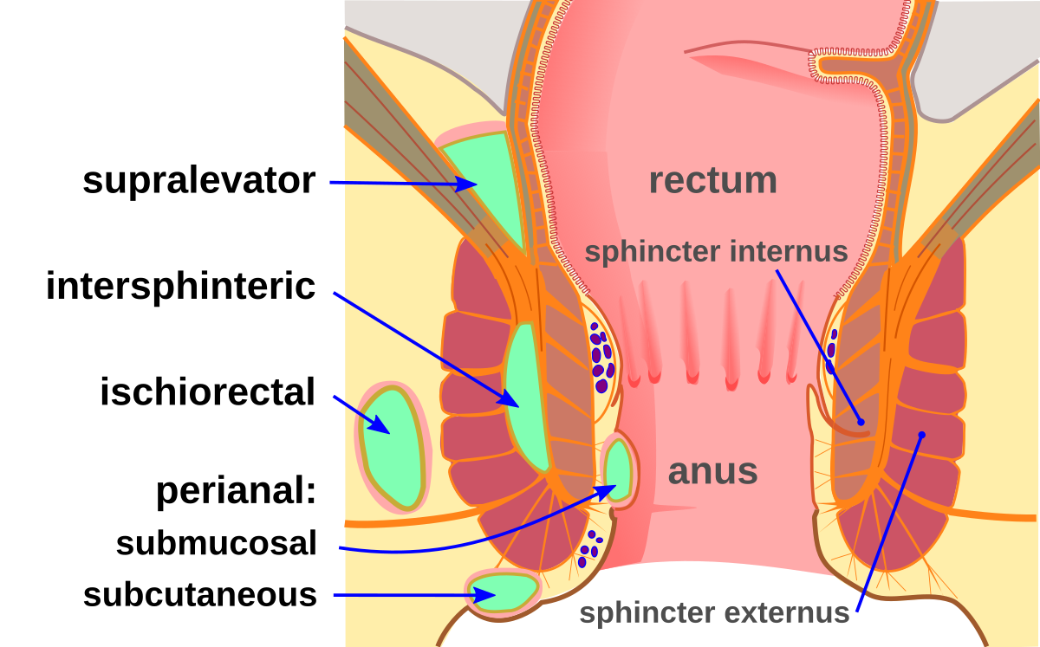

- Fistula in ano is the most common cause of anorectal abscesses (intersphincteric/ perianal and ischiorectal)
- Patients present with perianal pain which is of acute onset, associated with fever and occasionally pus discharge (in case of rupture of abscess)
- The diagnosis is clinical- digital rectal examination to identify the internal opening, perianal, and perineal examination
- Treatment is always surgical and there is no role for conservative treatment for anorectal abscesses
- Surgery comprises Examination under anesthesia and drainage of abscess. It is important to identify if there is an internal opening and document it in the operation record. However, fistulotomy or fistulectomy should not be performed concomitantly as this can lead to higher postoperative morbidity and incontinence
- Antibiotics can be discontinued 24 to 48 hours after the operation
- Post op care: Instruct the patient to do sitz baths thrice daily, teach wound digitation using lignocaine gel and measures to avoid constipation.


7.8 Fistula in ano
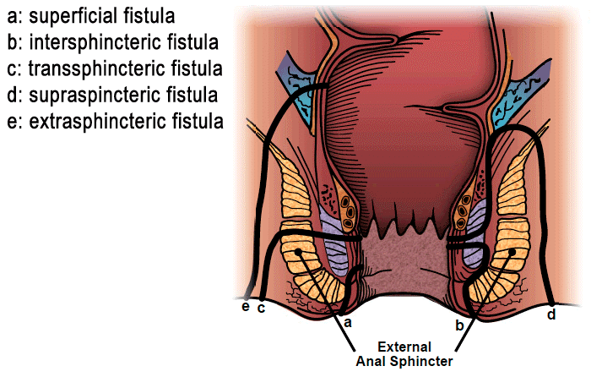
Clinically, fistula in ano can be classified as simple and complex fistulae
Simple fistula in ano:
- Intersphincteric
- Low transsphincteric
- Single external opening
- External opening < 4 cm from the anal verge
- Absence of TB, Crohn’s disease or anal canal malignancy
Complex fistula in ano:
- High trans sphincter
- Supra sphincteric
- Extra sphincteric
- Recurrent fistula
- Multiple external openings
- Long tracts (External opening > 4 cm from the anal verge)
- Anterior fistula in women
- Fistula due to TB, Crohn’s disease or anal canal malignancy

Evaluation:
- History to rule out red flag signs (refer to the section on Hemorrhoids), advise colonoscopy if there are any red flag signs.
- Perianal and digital rectal examination
- Assess the anal sphincter tone on digital rectal examination (this will aid in planning the type of operation)
- MRI pelvis for complex fistula in ano
- Anorectal manometry for patients with poor sphincter tone/ incontinence (to document the sphincter function as there will be some deterioration of the same post operatively)

Treatment:
- There is no role for conservative management
- Antibiotics are ineffective
- Simple fistula: EUA and fistulotomy
- Complex fistula: EUA and staged fistulotomy by seton insertion/ fistulotomy and sphincter reconstruction/ Endorectal advancement flap/ LIFT

7.9 Acute Apendicitis

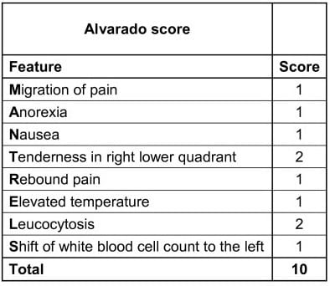

Score <5: Diagnosis of appendicitis less likely
Score 5-6: Equivocal of appendicitis, correlate clinically, consider admission and observation
Score 7-8: Probable appendicitis, consider treating as appendicitis
Score >9: Highly suggestive of acute appendicitis, treat as the same

- Appendicitis is a clinical diagnosis and hence ultrasound is not required to support the diagnosis.
- Consider USG only in the following patients
  - Young females (to rule out ectopic pregnancy/ tubo ovarian pathologies). Also do a UPT
  - Patients >40 years of age (to rule out secondary appendicitis- CA colon/ IBD/ TB)
  - Atypical presentation
  - Appendicular mass on clinical examination
  - For CMCHIS purposes

Treatment:
- Laparoscopic appendicectomy is the treatment of choice for acute appendicitis.
- Patients with appendicular mass- conservative treatment (Ochsner-Sherren regimen) followed by interval appendicectomy after 6 weeks
- Intra op:
  - If appendix appears normal- perform appendicectomy (chances of microscopic appendicitis and to avoid diagnostic dilemma during successive episodes of pain)
  - If appendix appears normal and there is another pathology (ovarian torsion/ ectopic pregnancy)- address only the pathology and leave the appendix behind, document in the operation record
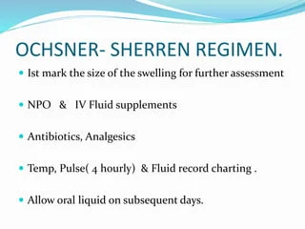
7.10 Inguinal hernia

Inguinal hernia is the most common surgical condition encountered and managed at GAH. The presentation can range from asymptomatic cough impulse in the inguinal region to strangulated hernia with bowel perforation presenting with peritonitis and septic shock. History should include the etiological factors (chronic cough/ constipation. voiding lower urinary tract symptoms/ lifting heavy objects/ smoking), and complications of hernia (pain, irreducibility, obstruction, or strangulation).

Diagnosis: Inguinal hernia is a clinical diagnosis. USG is reserved for recurrent and irreducible hernias only and in patients with BPE to measure prostate size and post void residue.

Treatment:
Always surgical. However, in patients with no symptoms without significant risk factors, expectant management can be considered on a case to case basis.

Surgical options:
- Open mesh repair
- Laparoscopic repair (TEP/ TAPP): this is currently offered only during specialist visits once every 2-3 months
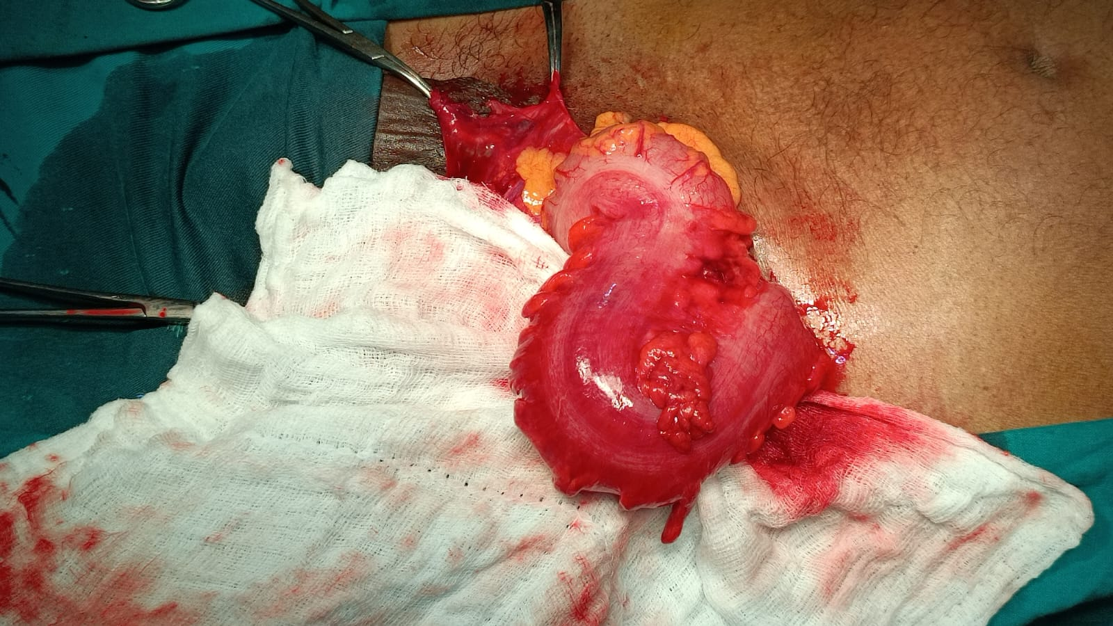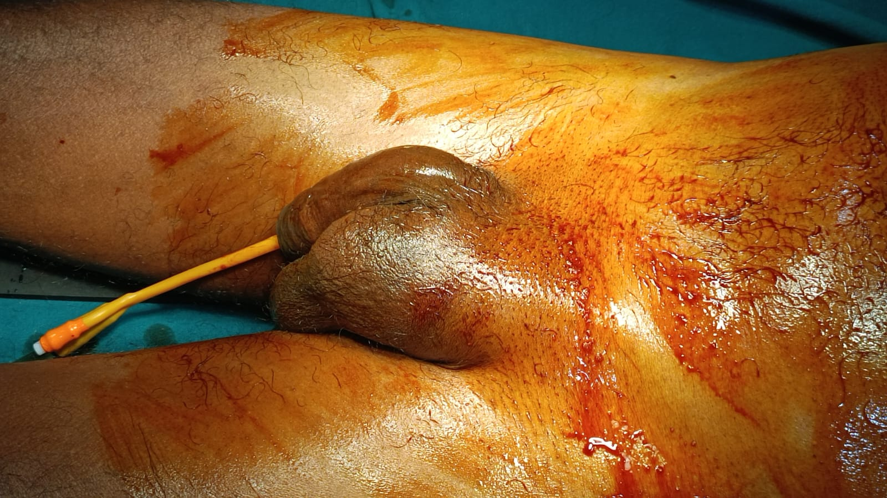

7.11 Umbilical. Paraumbilical, or Incisional hernia

Symptoms are similar to inguinal hernia and can present with complications such as pain, irreducibility, obstruction, or strangulation.

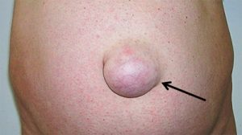
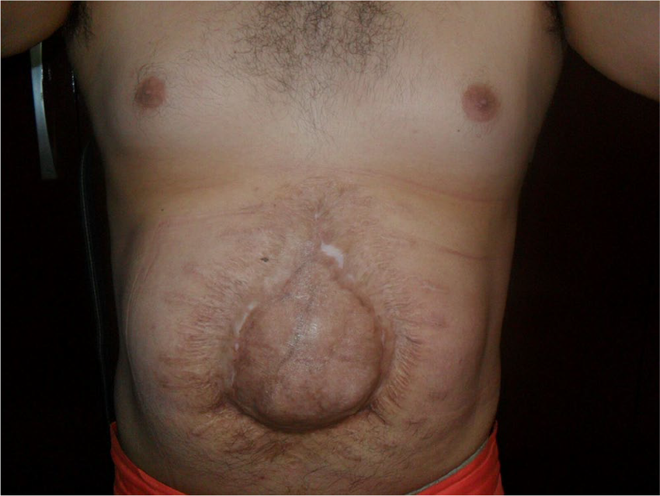
Diagnosis: Clinical and USG to look for contents, size and number of defects (to plan the type of surgery), and for CMCHIS purposes.

Treatment:
- Primary closure (for defect size <2cm)
- Open mesh repair (sublay) for defect >2cm
- Laparoscopic intraperitoneal onlay mesh repair (IPOM)- consider in patients with multiple defects, obesity and recurrent hernias

7.12 Acute Pancreatitis:

Acute pancreatitis is a sterile inflammation of the pancreas which invokes systemic inflammatory response syndrome (SIRS). Approximately 80% of the patients have mild symptoms which only require supportive therapy like fluid resuscitation, dietary modification, and analgesics. The severe forms of pancreatitis however require intensive care. Most admissions of acute pancreatitis in GAH are due to alcohol abuse. The other etiologies include,
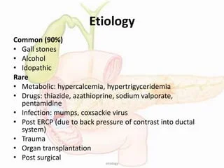

Assessment of severity:
Atlanta classification and the modified Marshall score are used to assess the severity of pancreatitis

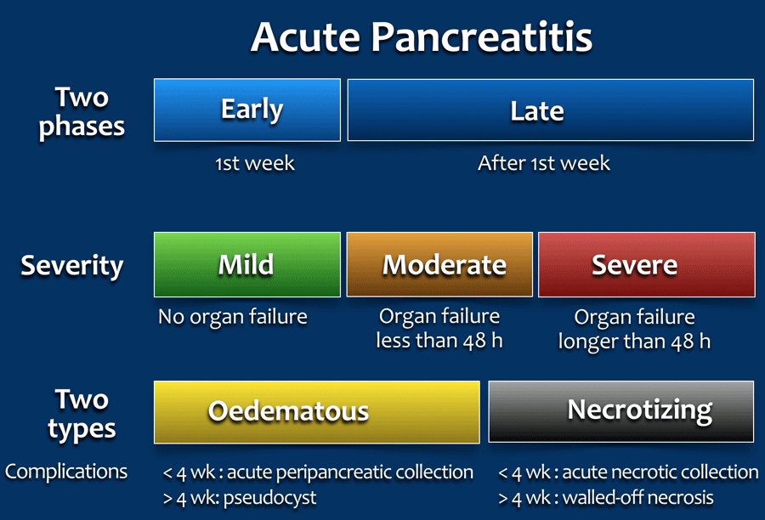

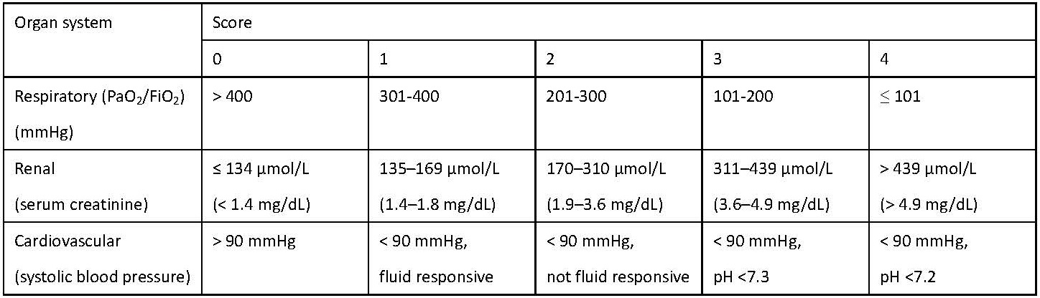
Management:

Early management
Fluids | Administer a moderate fluid resuscitation (10 ml/kg bolus in case of hypovolemia, followed by 1.5 ml/kg/h) using Ringers lactate
Nutrition | Resume an on-demand diet as soon as tolerated. Consider feeding tube placement if diet has not been resumed after three days
Pain management | Multimodal approach that combines paracetamol, metamizole and simple opiates. When insufficient consider epidural analgesia
Prophylaxis | Prophylactic antibiotics, pre, pro- and postbiotics can currently not being recommended

Management of complications
Antibiotics | Carbapemens remains the first choice of empirical antibiotics for treatment of infected necrosis, although robust evidence is lacking  Procalcitonin may be used as guidance when antibiotic therapy is considered to reduce unnecessary antibiotic use
Infected necrosis | Drainage of infected necrotic collections should be delayed and treated with antibiotics alone if possible  Modality of drainage (percutaneous, transgastric plastic of lumen-apposing metal stents) should be discussed interdisciplinary and depends on the location and extent of the collections, and local availability and expertise
Intra-abdominal hypertension | Neostigmine treatment should be considered for patients admitted to the ICU with intra-abdominal hypertension
Biliary necrotizing pancreatitis | Patients with biliary necrotizing pancreatitis should be closely monitored following discharge and offered cholecystectomy when collections have been resolved
Persistent organ failure | Extracorporeal cytokine removal might be considered as last resort for persistent organ failure in selected cases

7.13 Acute Hepatitis:

Acute viral hepatitis is a systemic infective condition predominantly affecting the liver. It is mostly caused by the hepatotropic viruses (A,B,C,D,E). The others include Cytomegalovirus, Coxsackievirus, and Adenovirus. Hepatitis A and E are acute and self limiting, whereas the others can have a chronic sequelae.

Hepatitis A:

Hepatitis A is usually an acute and self limiting condition. The chance of fulminant hepatitis is extremely rare. There can be relapses after 6-9 months in some patients. > 90% of the children in developing countries like India acquire this infection and have a life-long immunity.
Risk factors include poor hygiene and sanitation since the transmission is feco-oral through contaminated food.

The symptoms are:
- Jaundice (yellowing of the skin and eyes)
- Fatigue
- Abdominal pain
- Loss of appetite
- Nausea
- Diarrhea
- Fever
- Dark urine
- Relapse with cholestasis or serum sickness
Treatment: The treatment is largely supportive as the illness is self limiting. Antibiotics, analgesics, vitamin supplements are not warranted. Patients do not mandate admission unless there is a risk of fulminant hepatic failure (elderly, and immunocompromised). OCPs should be avoided in patients who have recovered from Acute hepatitis as there can be cholestasis. Alcohol use should be discouraged.
Hepatitis B:
Hepatitis B infection is endemic in the adivasi population catered by GAH. The modes of transmission include vertical (mother to child), sexual contact, through blood (blood transfusion, needle stick injury, bites and scratches). The sequelae and chronicity depends on the age at which disease is acquired and the immunity of the patient.
- Vertical transmission and in infancy: 80-80% develop chronic infection
- Children at 1-5 years: 30-50% develop chronic infection
- Adults: Only 2-6% develop chronic infection although 30-50% are symptomatic during the acute phase
Symptoms:
- Principal symptoms:
  - Fatigue and tiredness
  - Malaise
  - Jaundice
  - Fever
  - Muscle and joint aches
- Less common symptoms:
  - Weight loss
  - Depression
  - Anxiety, irritability
  - Headaches
  - Sleep disturbance
  - Discomfort in the abdomen on the right side
  - Itching
  - Nausea and diarrhea
  - Appetite loss
Diagnosis:
HBsAg serological test is performed at GAH. This test however cannot differentiate between acute or chronic infection. Fulminant hepatitis is diagnosed clinically and with liver function tests that show features of acute liver failure.
Treatment:
Antiviral therapy with Lamivudine is not recommended in most patients since 90-95% of them have a complete clinical recovery. It is however used in patients with complications of Heptatits B such as polyarteritis nodosa, and in patients who are immunocompromised.
In patients with fulminant hepatitis, orthotopic liver transplantation is the only possible treatment option.
Prevention:
Pre- exposure prophylaxis- the national immunisation schedule makes Hepatitis B vaccine mandatory for all newborns.
In high-risk groups (healthworkers): further doses of vaccination are necessary to offer protection.

Acute Hepatitis sequence of testing:

- HBc IgM and HBsAg
- HAV IgM
- Anti-HCV
- HCV RNA
- Anti-HEV (only if the above are negative)

7.14 Liver Abscess:

Liver abscess is a suppurative space occupying lesion in the liver caused either by bacteria or Entamoeba histolytica. Amoebic liver abscess in seen in middle-aged individuals with risk factors of chronic alcohol consumption, diabetes, liver cirrhosis, and HIV infection. The clinical features include fever, abdominal pain, and anorexia. Jaundice is seen in less than 15% of the patients depending on the location, size and number of lobes.
Pyogenic liver abscess is seen in elderly, immunocompromised patients who have more acute presentation with fever, severe abdominal pain, and sepsis.

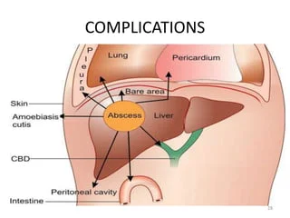
Poor prognostic factors:
- Clinical:
  - Encephalopathy
  - Jaundice
- Biochemical:
  - Serum bilirubin >3.5mg/dL
  - Serum albumin <2.5g/dL
- Ultrasound:
  - Large volume abscess
  - Multiple abscesses
- Underlying chronic liver disease

Management:
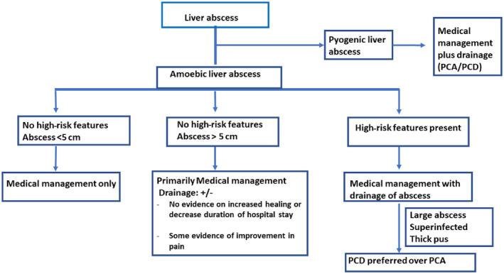

Medical management:

Amoebic liver abscess:
- Tissue amoebicidal agents: Metronidazole: 800 mg three times a day PO or 500 mg IV three times a day for 7‐10 days
- Luminal amoebicidal agents: Diloxanide furoate: 500 mg three times a day for 20 days
Pyogenic liver abscess:
- First line: Inj. Ceftriaxone 2g IV OD and nj. Metronidazole 500mg IV Q8H
- Seconda line: Inj. Piptaz 4.5g IV Q6H
- Third line: Inj. Meropenem/ Inj. Ertapenem IV

Drainage of abscess (for size >3cm):
- left lobe liver abscess
- abscess with thin rim of hepatic parenchyma (<10 mm) around it
- multiple liver abscesses
- impending rupture recognized on imaging
- nonresponse to medical therapy after 3 to 5 days.

Routes of drainage:
- USG guided aspiration/ drainage (>3 cm size)
- Open drainage (not amenable for radiological drainage)

7.15: Breast Lump:

Fibroadenoma is the most common lesion in the breast which is seen in females in young age (as early as 12-15 years of age) and in the reproductive age group. There are no specific risk factors for the same. The aim of evaluation is to rule out carcinoma of the breast. Benign lesions are often insidious in onset and do not show a rapid increase in size. Benign lesions are often painful whereas malignant lesions are almost always painless (resulting in patients neglecting the lump until advanced stages). On examination, benign lesions are soft to firm in consistency, and mobile. The skin over the lump is normal and there will be no associated nipple discharge, or axillary lymphadenopathy. For complete evaluation, the opposite breast and axilla should be examined, along with abdominal examination to rule out hepatomegaly (liver mets), and pelvic mass (krukenberg’s tumor).

Investigations:
- USG of the breast is a crucial investigation to characterize the lesion and diagnose the lesions that are clinically not palpable.
- Mammogram is ordered only in older patients (> 40 years), and if the USG is inconclusive
- FNAC/ Core biopsy can be considered if there is a clinical and radiological dilemma in diagnosis, and for CMCHIS eligible patients

Management:

- Surgical excision is the mainstay of treatment

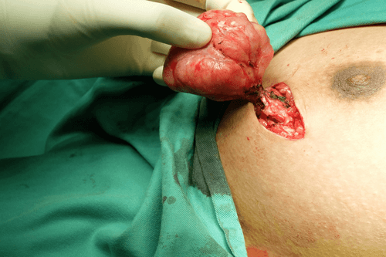

- Consider hormonal therapy (Ormeloxifene) only in the following patients:
  - Large lesions, clinically benign for downsizing prior to surgery (for cosmetic reasons)
  - Multiple lumps
  - Patient unwilling for surgery (after explaining that the chance of harboring malignancy being 1-2%)

Chapter 8: Orthopedics & Rheumatology
8.1 Arthritis
8.2 Acute Osteomyelitis
8.3 Rheumatoid Arthritis
8.4. Osteoarthritis
8.5 Gout
8.6 Backpain
8.7 Dermatomes

8.1Arthritis
The ddx of an acute monoarthritis overlaps with causes of oligoarthritis and polyarthritis since virtually any arthritic disorder can initially present as one swollen joint.
In this context its helpful to categorize the causes of arthritis as follows: infectious (bacterial, viral, TB), post-infectious (rheumatic, reactive), crystalline, neoplastic, traumatic, degenerative, or due to systemic rheumatic disease (RA, SLE). If a septic arthritis is suspected tap immediately. If rheumatic fever is suspected one would expect migratory polyarthritis. If reactive arthritis a history of diarrhoea
Articular TB most often involves a single joint, but multifocal lesions can occur. Involvement of the hip joint is the most common, and the most difficult to diagnose. Important clinical features are swelling, pain, and/or loss of joint function that progresses over weeks to months, rather than days. Erythema, warmth, and other signs of acute infection are usually absent in such so-called “cold joints.”.
If crystalline disease (gout) is suspected , then a tap is often not performed due to concerns of introducing infection. Serum Uric acid estimation is not done in house but sent out to Thyrocare ; remember that it can be normal during a gouty attack. A response to NSAIDs is usually suggestive of diagnosis.
If a hemarthrosis is suspected then tap.
If a flare of an existing osteoarthritis suspected then treat with NSAIDs and then paracetamol symptomatically.
Rhematoid factor can be done in house but note high false positive rate. ANAs has to be sent out and generally not performed due to expense. ESRs are used instead, along with other clinical criteria to determine if SLE.

8.2Acute Osteomyelitis
Acute hematogenous osteomyelitis occurs predominantly in children, usually in he metaphysis of long bones. Patients usually present within several days to one week after the onset of symptoms including fever, irritability and lethargy. Typical clinical findings include tenderness over the involved bone and decreased range of motion in adjacent joints and diagnosis is based on*

- Pus on aspiration
- Positive bacterial culture from bone/blood
- Presence of classic signs and symptoms
- Radiographic changes typical of osteomyelitis

Leukocytosis and elevations in the ESR rate may be noted
The palpation of bone in the depths of infected pedal ulcers in patients with diabetes mellitus is strongly correlated with the presence of underlying osteomyelitis . If bone is palpated, the evaluation may proceed directly to microbiologic and histologic confirmation of osteomyelitis, and thereafter to treatment. Further diagnostic studies are unnecessary.
In osteomyelitis of the extremities, plain film radiography remains the primary investigative tools. Radiographic evidence of bone destruction by osteomyelitis may not appear until approximately two weeks after the onset of infection . The radiographs may reveal osteolysis, periosteal reaction and sequestra (segments of necrotic bone separated from living bone by granulation tissue). A bone abscess found during the subacute or chronic stage of hematogenous osteomyelitis is known as a Brodie's abscess.
Ultrasonography and computed tomographic (CT) scanning may be helpful in the evaluation of suspected osteomyelitis. An ultrasound examination can detect fluid collections (e.g., an abscess) and surface abnormalities of bone (e.g., periostitis), whereas the CT scan can reveal small areas of osteolysis in cortical bone, small foci of gas and minute foreign bodies. CT scan ( bone window to be requested ) is available in Govt Hosp in Gudalur.
Magnetic resonance imaging (MRI) is particularly useful in unclear cases when a patient is suspected of having osteomyelitis, discitis or septic arthritis involving the axial skeleton and pelvis. Compared with XRay, MRI has equivalent or greater sensitivity, specificity, accuracy for the detection of osteomyelitis. and also provides greater spatial resolution in delineating the anatomic extension of infection. They need to be sent to Coonoor Govt Hosppital WIMS, Meppady or to a hospital in Perinthelmanna.
Organisms Commonly Isolated in Osteomyelitis Based on Patient Age
Infants (< 1 year) | Children (1 to 16 years) | Adults (> 16 years)
Group B streptococci | S. aureus | Staphylococcus epidermidis
Staphylococcus aureus | Streptococcus pyogenes | S. aureus
Escherichia coli | Haemophilus influenzae | Pseudomonas aeruginosa
 |  | Serratia marcescens
 |  | E. coli
In pts with SCD S.typhi is commonly involved
Antibiotic Therapy - After cultures have been obtained, an empiric IV Ampiclox + either cefotaxime or ceftriaxone is initiated to cover clinically suspected organisms.
When the culture results are known, the antibiotic regimen is revised and a four- to six-week course of appropriate antibiotic therapy is given
Surgical debridement is rarely required when the diagnosis of hematogenous osteomyelitis is made early. However, if antibiotic therapy fails, debridement (or repeated debridement) and another four- to six-week course of parenteral antibiotic therapy is essential.
Children with acute osteomyelitis should get 2 wks of initial IV antibiotic Rx then given an oral agent.
In GAH if pus is not obtd the initial treatment is IV ampiclox + ceftriaxone for 10-14 days based on the WBC count and ESR followed by 1 mo of oral amoxyclav oe cephalexin.
Ref Diagnosis and Management of Osteomyelitis - CAREK,et al, Medical University of South Carolina, Charleston, Am Fam Physician. 2001 Jun 15;63(12):2413-2421.

8.3Rheumatoid Arthritis (RA)
Diagnosis:The diagnosis is essentially clinical & is made when 4 of 7 qualifying criteria established by the American Rheumatism Association are met. These qualifying criteria are as follows:
- Morning stiffness lasting longer than 1 hour before improvement.
- Arthritis involving 3 or more joints.
- Arthritis of the hand, particularly involvement of the proximal interphalangeal (PIP) joints, metacarpophalangeal (MCP) joints, or wrist joints.
- Bilateral symmetrical involvement of joint areas (e.g. both wrists).
- Rheumatoid nodules
- Positive serum rheumatoid factor (RF)
- Radiology: X-rays may show soft tissue swelling, periarticular osteopenia (subchondral bone porotic rather than sclerotic, loss of joint space, erosions and deformity.
Other history that can aid in the diagnosis include: generalised malaise, weakness & PUO
Investigations are important in assessment and exclusion of other possible diagnoses.
- ESR: usually raised but may be normal.
- CBC: normochromic, normocytic anaemia and reactive thrombocytosis common in active disease.
- Liver function tests: mild elevation of alkaline phosphatase and gamma GT( send out to Thyrocare)
- Uric acid/synovial fluid analysis: excludes polyarticular gout (no crystals). (send out to Thyrocare)
- Urinalysis: microscopic haematuria/proteinuria may suggest connective tissue disease.
- Rheumatoid Factor: positive in 60-70% of patients (and in 5% of normal population).
- Radiology

Treatment
A.Pain relief:
Start patient on an NSAID - diclofenac 25- 50 mg tid after food or ibuprofen 200-400mg tid AF unless these are contraindicated. These have no effect on long-term disability but provide symptomatic relief. Paracetamol and tramadol, Intra-articular steroid injections or low-dose oral prednisolone (5 -7.5 mg per day) may be added..
B. Preventing deformity;
RA causes significant morbidity and should be treated aggressively from the time of diagnosis. This is especially true for symmetrical seropositive erosive systemic polyarthritis. This means that disease-modifying antirheumatic drugs (DMARDs) should be used early. They may need to be given for 4-6 months for full response. They should be monitored closely for toxicity and include:
1. Methotrexate (use first; it can act within 4 weeks whereas most other DMARDs take up to 3 months).
The starting dose is 2.5 - 5 mg once a week, increased every 4 weeks in 2.5 mg increments to a max of 20 mg per week. Methotrexate is an anticancer drug and has severe hepatotoxicity (most important), as well as hematological, pulmonary, & gastro-intestinal toxic side effects. Folic acid is given to decrease the hematological side effects as follows. If pt is getting 15 mg Mtx on Monday give folic acid 5mg on Wed,Thur and Fri.
2. Chloroquine/Hydroxychloroquine - relatively safe, and less likely than other DMARDs to cause side effects. It may be used early in patients with established RA - usually as combination therapy. Chloroquine 250mg od/ Hydroxychloroquine 200mg od - bid.
3. Sulfasalazine *(the second most used DMRA). The starting dose is 500 mg od for 1 week, increased by 500 mg daily each week in divided doses until 10 g bd.( not in the pharmacy so prescription needs to be given)
4. Splints can help prevent deformity. Pl refer pt for physiotherapy
Monitoring requirements for antirheumatic drugs:
DRUG | MONITOR | HOW OFTEN
Methotrexate | Total WBC count, sGPT | Fortnightly for 1 month, then monthly.
Chloroquine / hydroxychloroquine | Eye check | Every 6 months
Sulfasalazine | Total WBC count, SGPT | Monthly for the first 3 mo, then every 6 mos
Prognosis:Patients with rapid onset of disease may show better remission than those with insidious onset. Prognosis is worse with large joint involvement.

8.4 Osteoarthritis (OA)
OA is a chronic disease process affecting large weight bearing synovial joints. Osteoarthritis usually does not affect the wrists, elbows or shoulders.
The high incidence of Acid Peptic Disease in the tribals prohibits widespread use of NSAIDs. NSAID use should be restricted to patients with clearly defined soft tissue / bony injury not responding to paracetamol. Avoid NSAIDs for non-specific body pains.
Differential diagnosis of thoracic or lumbar spine pain includes Pott’s disease (TB) or metastatic cancer.
If multiple joints or small joints are involved, consider rheumatoid arthritis.
Diagnostic Tests
X Ray: Because bone demineralization is not a radiographic feature of osteoarthritis, its presence strongly suggests an inflammatory condition such as rheumatoid arthritis.
If RA is suspected, ESR and Rheumatoid Factor may be obtained. To rule out Pott’s disease, obtain ESR. If still not ruled out, thoracic or lumbar spine x-ray are indicated, along with PPD.
Most routine blood tests are normal in patients with uncomplicated osteoarthritis. Analysis of synovial fluid usually reveals a white blood cell count of less than 2,000/ml.

Treatment
Medical management - Nonpharmacologic therapy
- Patient education.
- Weight loss (if overweight, BMI>23).
- Range of motion exercises.
- Muscle strengthening exercises – e.g. for quadriceps for knee osteoarthritis.
- Assistive devices for ambulation.
Many patients with OA of the hip and knee are more comfortable wearing shoes with good shock-absorbing properties or orthoses. The use of an appropriately selected cane can reduce hip loading by 20 to 30 percent. Attention must be given to the length of the cane and how it is to be used. The top of the cane’s handle should reach the patient’s proximal wrist crease when the patient is standing with arms at the side. The cane is usually held on the unaffected side of the body.
In addition, patients may benefit from shoe inserts to correct abnormal biomechanics due to angular deformities of the knees.
Physiotherapy & Occupational therapy. An occupational therapist can determine whether the patient needs assistive devices such as a raised toilet seat. In addition, special splints can be designed to stabilize or reduce inflammation of particular joints, such as the first carpometacarpal joint or the base of the thumb.
The physical therapist can provide an individualized exercise program and teach the patient how to use therapeutic heat and massage.
Pharmacological Therapy
Non-opioid analgesics (e.g. Paracetamol).
Topical analgesics. Diclofenac gel 1% or 0.025 % capsaicin cream* applied qid has been found effective in the management of pain caused by OA of the knee, ankle, wrist and shoulder
NSAIDS: Diclofenac sodium 25-50 mg thrice daily or Ibuprofen 400-600 mg thrice daily. Give along with omeprazole to prevent peptic ulcer. Not recommended for prolonged use due to development of side effects such as GI bleed and renal failure.
Opioid analgesics (e.g. codeine, tramadol): They can be used for short periods to treat exacerbations of pain. These agents are not recommended for prolonged use because they cause constipation and increase the risk of falling, particularly in the elderly.
Intra-articular steroid injections. Intra-articular Corticosteroid Injections - Patients with a painful flare of osteoarthritis of the knee may benefit from intra-articular injection of a corticosteroid such as triamcinolone. When a joint is painful and swollen, short-term pain relief can be achieved with aspiration of joint fluid followed by intra-articular injection of a corticosteroid. It may be combined with a local anaesthetic. A joint should not be injected more than three or four times in one year because of the possibility of cartilage damage from repeated injections.
If the patient remains quite immobile in spite of the medical therapy, he should be referred to an orthopedic surgeon for surgical interventions. Available options include: Arthroscopic debridement, joint lavage, osteotomy & joint replacement.

8.5Gout
Definition - Deposition of microcrystals in joints and periarticular tissues results in gout
Etiology
Primary gouty arthritis is characterized by hyperuricemia that is usually because of underexcretion of uric acid (90% of cases) rather than its overproduction. Urate crystals may be deposited in the joints, subcutaneous tissues (tophi), and kidneys.
Secondary gout, like primary gout, can be caused by either defective renal excretion or overproduction of uric acid producing. Intrinsic renal disease, diuretic therapy, low-dose aspirin, cyclosporine, and ethanol all interfere with renal excretion of uric acid. Starvation, lactic acidosis,dehydration, preeclampsia, and diabetic ketoacidosis also can induce hyperuricemia. Overproduction of uric acid occurs in myeloproliferative and lymphoproliferative disorders, hemolytic anemia, polycythemia, and cyanotic heart disease.
Classification
Clinical phases of gout can be divided into
1 Asymptomatic hyperuricemia, 2 acute gouty arthritis, and 3 chronic arthritis.

Asymptomatic hyperuricemia is defined as serum uric acid (UA) levels >7 mg/dL.
It is not routinely treated because of expense and the potential drug toxicity. However, patients should be monitored closely for the development of complications
If serum UA level is >/ 12 mg/dL in men or 10 mg/dL in women antihyperuricemic Rx should be considered.
Aspirin (uricoretentive), diuretics, high alcohol intake, and foods high in purines ( shellfish, sardines, liver, and kidney) should be avoided. Weight loss should be encouraged.
- Acute gouty arthritis
Acute gouty arthritis attacks can be precipitated by surgery, dehydration, fasting, binge eating,
or heavy ingestion of alcohol. Although the acute gouty attack will subside spontaneously over several days, prompt treatment can abort the attack within hours.
The serum uric acid level is normal in 30% of patients with acute gout and, if elevated, should not be manipulated until an attack has resolved.
a)NSAIDs are the treatment of choice due to ease of administration .Clinical response may require 12 to 24 hours, and initial doses should be high, followed by rapid tapering over 2 to 8 days. Give diclofenac, 50 mg PO q8h for 2 days, followed by 25 mg PO q8h for 3 to 7 days.
b)Glucocorticoids are useful when NSAIDs are contraindicated. An intra-articular injection of glucocorticoids produces rapid dramatic relief. Alternatively, prednisone, 40 to 60 mg PO daily, can be given until a response is obtained and then should be tapered rapidly
c)Colchicine is not commonly used to treat gout but is useful when NSAIDs or glucocorticoids are contraindicated or not tolerated.Often associated with severe GI toxicity. The dosage varies but is usually 1.2 mg at onset of symptoms and 0.6 mg taken 1 hour after the initial dose (1.8 mg over 1 hour) is effective therapy.
- Chronic gouty arthritis
Frequent gout attacks, (>2/yr), tophi, evidence of joint damage, and urate nephropathy are indications for urate-lowering therapy.
Allopurinol, a xanthine oxidase inhibitor, is effective therapy for hyperuricemia in most patients.
Colchicine,0.6 mg PO daily or bid, should be given for a few days before manipulation of the uric acid level to prevent precipitation of an acute attack. In renal insufficiency.colchicine 0.6 mg every other day or every 3 days should be considered in patients with a creatinine clearance between 10 and 34 mL/min.
The initial dose of allopurinol is 100mg/day It can be increased by 100 mg every 2 to 4 weeks to achieve the minimum maintenance dosage that will keep the uric acid level < 6 mg/dL, which is below the limit of solubility of monosodium urate in serum.
In patients with impaired renal function, the starting daily dose should be reduced by 50 mg for each 20 mL/min decrease in the creatinine clearance. For patients with a creatinine clearance below 20 mL/min, the starting dosage is 100 mg every other or every third day.
The daily dose should also be decreased in patients with hepatic impairment.
The concomitant use of a uricosuric agent may hasten the mobilization of tophi.
If an acute attack occurs during treatment with allopurinol, it should be continued at the same dosage while other agents are used to treat the attack.
Side effects of Allopurinol: Hypersensitivity reactions from a minor skin rash to a diffuse exfoliative dermatitis associated with fever, eosinophilia, and a combination of renal and hepatic injury occur in up to 5% of patients. Patients who have mild renal insufficiency and are receiving diuretics are at greatest risk.
Severe cases are potentially fatal and usually require glucocorticoid therapy. Allopurinol may potentiate the effect of oral anticoagulants and blocks metabolism of azathioprine and 6-mercaptopurine, necessitating a 60% to 75% reduction in dosage of these cytotoxic drugs.
In patients without tophi, prophylactic colchicine can be discontinued 6 months after the target serum urate levels have been obtained and no acute attacks have been documented by the patient.
In patients with tophi, duration of prophylaxis is uncertain but consider discontinuation 6 months after resolution of tophi.
Febuxostat is a nonpurine selective inhibitor of the xanthine oxidase It is more expensive than allopurinol. The starting dose is 40 mg/d, with titration to 80 mg/d if needed. It is used in patients with renal impairment
Management of secondary gout includes treatment of the underlying disorder and urate-lowering therapy.
acute gouty arthritis attacks as
Urcosuric drug therapy should not be started until an acute attack of gouty arthritis has ended, because of the risk of increased mobilization of uric acid stores.
Uricosuric Drugs. These agents decrease the serum uric acid level by increasing renal excretion.Probenecid*, in a dosage of 1 to 2 g per day, achieves satisfactory control in 60 to 85 percent of patients. Sulfinpyrazone is a uricosuric agent and since it can act as an antiplatelet drug, it should be used cautiously in patients who are anticoagulated or have bleeding problems. Sulfinpyrazone* can also cause gastrointestinal problems. Thus, caution should also be exercised in giving this drug to patients with peptic ulcer disease. Dosage is 100 mgm thrice daily.
Reference: WASH MANUAL 34th ed 2014

8.6 Back Pain

Causes of low back pain
Congenital causes
• Spina biflda
• Lumbar scoliosis
• Spondylolysis
Spondylolisthesis
• Transitional vertebra
• Facet tropism

Traumatic causes
• Sprain, strain
• Vertebral fractures
• Prolapsed disc
Inflammatory causes
• Tuberculosis
• Ankylosing spondylitis
• Seronegatlve spond-arthritis (SSA)
Degenerative
• Osteoarthritis

Neoplastic
Benign
Osteoid osteoma*
Eosinophilic granuloma
Malignant
Primary: Multiple myeloma,lymphoma
Secondaries from other sites

Metabolic causes
• Osteoporosis
• Osteomalacla

Pain referred from viscera*
Genito-urinary diseases
Gynaecological diseases
Abdominal dosease

Miscellaneous causes
Functional back pain
Postural back pain
Protuberant abdomen
Occupational bad posture
Habitual bad posture

HISTORY
Backpain is of
1.Sudden onset-
- With fever
Pyelonephritis, Epidural abscess
- Without fever
H/O Trauma – IVDP, compression fracture,spondylolisthesis, sacroilitis, facet syndrome
No H/o trauma - Renal /ureteric calculi, Herpes zoster,Dissecting aneurysm
2. Gradual Onset
- Tumour of spinal cord/cauda equina,
- Abd tenderness – pancreatitis, post penetrating duodenal ulcer
- Pelvic tumour
- Prostatis
- Vascular – Abdominal aneurysm
- Spine- Osteoarthritis,Rheumatoid/ankylosing spondylitis
Radiation of pain
Yes- IVDP, tumor of spinal cord, epidural abscess
No – Osteoarthritis,Rheumatoid/ankylosing spondylitis, prostatis
Bladder symptoms associated with pain
Yes- Tumour of spinal cord/cauda equine, kidney disease

EXAMINATION
Skin – Herpes vesicles
Spine- Scoliosis, tenderness, mobility
- Straight leg raise test , FABER(Flexion,ABduction,External Rotation), Hip movements
- Wasting
- Reflexes – Inc in cord compression, Dec in nerve compression
-Sensation
Abdomen
-loin tenderness -abd mass, -abd tenderness
TESTS
- CBC
- ESR
- Urine analysis
- Rheumatoid factor
- Amylase/lipase
- HLA B27 antigen
- PSA
- Serum protein electrophoresis

- XRay- thoracic/lumbar spine AP & Lat
- XRay abd for pancreatic calcification, kidney stones
- Abdominal Ultrasound
- OGD
- CT spine
- MRI

Treatment
Most backpain is from intervertebral is from Intervertebral disc prolapse(IVPD)
Patient is advised bed rest- a firm mattress or a blanket over a wooden bed
Analgesics- paracetemal,diclofenac or tramadol
Muscle relaxants like diazepamwhich will also produce sleep.

If above have not relieved pain admit pt and place on traction
Skin traction as described in the Green book pg220, Max wt 5Kg withvft end of bed elevated 4 cm for each kg ( max 8”)

I

8.7Dermtomes
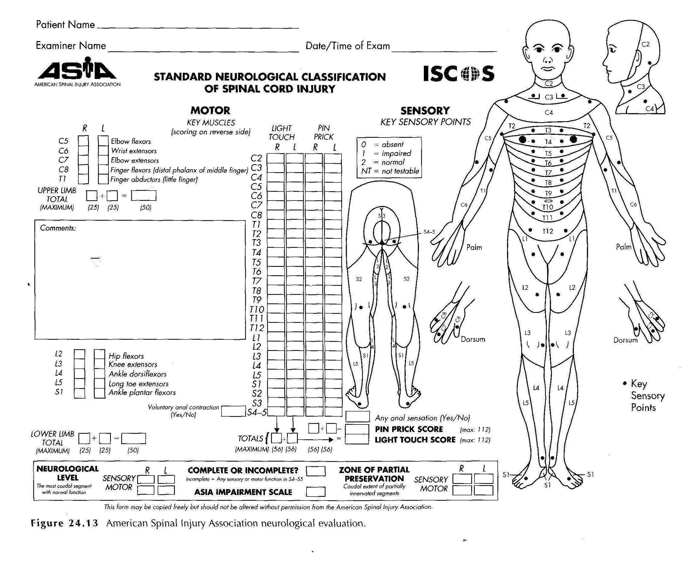

Chapter 9: Hematology & Oncology

9.1 Approach to anemia, Iron Deficiency Anemia
9.2 Sickle Cell Anemia
9.3 Thalassemia
9.3 Lymphadenopathy

9.1 Iron Deficiency Anemia
Discussion
- Iron deficiency anemia in our patients is usually multifactorial. Causes include:
- Nutritional –inadequate intake of iron in the diet - rice and wheat are both poor in iron and also contain phytates which bind iron and prevent absorption
- Increased need for iron (infants and babies, adolescents, menstruating and pregnant women)
- Increased losses- excessive bleeding (hookworms, menorrhagia, piles, peptic ulcer)
Diagnostic tests
CBC (hypochromic,microcyctic anemia) & Sickle cell prep.
Treatment Iron Deificiency state can increase absorption Availability for absorption in foods (Red meat 50%), Eggs(12.5%), Vegetables(5%)
1) Dietary supplementation with foods rich (> 5mg/100g) or intermediate (1-5mg/100g) in iron:
- Animal foods like meats, liver, egg yolk
- Legumes and pulses
- Green leafy vegetables
- Jaggery (as made in large iron vats)
- Cooking in iron pots increases iron content of food
Milk and milk products and most non-green vegetables are poor in iron
2) Deworm with albendazole 400mg 1 tab stat and repeat in 1 week
3) Give iron folic acid & B12 - Adults: MFI(iron folic acid) one tablet each od, increase to
one tablet tid + B1,6,12,Zn od for 3-6mo till Hb >12gm%
- Children < 20kg: Iron syrup (10mg/ml) -6 mg / kg of elemental iron / day for treatment
4) IV iron is indicated for the treatment of iron deficiency in the following situations;
- Demonstrated intolerance to oral iron preparations
- A clinical need to deliver iron rapidly to replenish iron stores
- Active inflammatory bowel disease where oral iron preparations not tolerated or contraindicated
- Patient non-compliance with oral iron therapy
Oral iron must not be administered concomitantly with a course of IV iron. Allow a period of 5 days after the final dose of iv iron.
Contraindications to IM/IV iron
- Anaemia not attributable to Fe deficiency
- A history of hypersensitivity to IV iron
- First trimester of pregnancy
- Acute or chronic infection
- Iron overload
- History of cirrhosis of the liver
- Acute renal failure
- Patients with a history of severe asthma, eczema or other atopic allergy
Preparations
IM- Inj iron-dextran (Imferon, 100mg iron/2ml).
IV - There are two preparations of IV iron available;
- IV iron sucrose (Venofer®) given as a divided dose, and
- low molecular weight iron dextran (CosmoFer®) this can be given as a total dose infusion (CosmoFer ® may also be given intramuscularly).
Choice of preparation is dependent on how immediate the requirement to complete the dose i.e. iron dextran (CosmoFer ®) can be given as a total dose infusion, iron sucrose (Venofer ®) is given as divided doses.
Response
Due to iron metabolic pathways, a rise in reticulocyte count will occur during the 2nd week and thereafter, provided bleeding is not excessive, one can expect a rise in Hb of approx 1.5g/week.

Protocol for IV iron sucrose – Venofer
Dosage
The total cumulative dose of Venofer® should be calculated using the table below. Venofer® can be given as a maximum of 200mg not more than 3 times per week; doses must be 24 hours apart.
Total cumulative Venofer® dose = number of 100mg ampoules for Hb increase.
Dose includes 500mg to replenish iron stores.

Increase in Hb required (g/dL) ie Target Hb minus Actual Hb
 |  | 1g | 2g | 3g | 4g | 5g | 6g | 7g
 | 40 | 6 | 7 | 8 | 9 | 10 | 11 | 12
 | 45 | 6 | 7 | 8 | 9 | 10 | 11 | 12
 | 50 | 6 | 7 | 9 | 10 | 11 | 12 | 13
 | 55 | 6 | 8 | 9 | 10 | 12 | 13 | 14
 | 60 | 6 | 8 | 9 | 11 | 13 | 14 | 16
 | 65 | 7 | 8 | 10 | 11 | 13 | 14 | 16
 | 70 | 7 | 8 | 10 | 12 | 13 | 15 | 17
 | 75 | 7 | 9 | 10 | 12 | 14 | 16 | 18
 | 80 | 7 | 9 | 11 | 13 | 15 | 17 | 18
 | 85 | 7 | 9 | 11 | 13 | 15 | 17 | 19
 | 90 | 7 | 9 | 11 | 14 | 16 | 18 | 20
 | 95 | 7 | 10 | 12 | 14 | 16 | 19 | 21

\
Drug to diluent concentration | Test dose | Remainder of first dose
100mg Venofer® in  100mL Sodium Chloride 0.9% | 25mg in 25mL over 15 mins.  (IV pump set 100mls/hr, VTBI 25mL) | 75mg in 75mL to be infused.  Max infusion rate 200mL/hr
200mg Venofer® in  100mL Sodium Chloride 0.9% | 25mg in 12.5mL over 15 mins.  (IV pump set 50mL/hr, VTBI 12.5mL) | 175mg in 75mL to be infused.  Max infusion rate 200mL/hr
200mg Venofer® in  200mL Sodium Chloride 0.9% | 25mg in 25mL over 15 mins.  (IV pump set 100mL/hr, VTBI 25mL) | 175mg in 175mL to be infused.  Max infusion rate 200mL/hr

Test dose -The first infusion of Venofer® must include a test dose; facilities for CPRcardiopulmonary should be available. 25mg of Venofer® should be infused over a period of 15 minutes. If no adverse events occur during the test dose, the remainder of the dose should be given at an IV rate of not more than 50ml in 15 minute.
Subsequent doses -Subsequent doses may be given over 15minutes (100mg) or 30 minutes (200mg).

Administration
IV infusion | Rate of administration
100mg in 100mL Sodium Chloride 0.9% | Administer over at least 15 minutes  (maximum pump rate 400mL/hr)
200mg in 100mL or 200mL of Sodium Chloride 0.9% | Administer over at least 30 minutes  (maximum pump rate 200mL/hr for 100mL bag, 400mL/hr for 200mL bag)
The initial test dose of 0.5 ml is given intramuscularly in the hospital, as there is a risk of anaphylaxis. If no adverse reactions are observed, the injection can be given according to the schedule until the calculated total amount required has been reached. Generally 2ml is injected daily for 5 days and the remainder is given in the area centre.
Total iron needed (mg) = 0.66 x body weight in Kg x (100 – patients Hb in g/dl x 100)
14.8
Blood transfusion (packed cells) is reserved for those with severe anemia < 5g/dl in cardiac failure dyspnoea, pedal oedema) or with severe infection. 1ml of blood contains 0.5mg iron.(Goodman & Gilman 9th Ed)

9.2 Sickle Cell Disease (SCD)
Every adivasi &Chetty should be screened with a metabisulfite sickle cell prep screen(SCP). If this is positive a serum Hb electrophoresis is done to separate trait from disease. Those who have sickle cell trait need genetic counseling only as they are otherwise normal.
Every SCD patient has a blue sickle cell book which is kept at GAH an taken to the field duing doctor’sfield visits.
Sickle cell patients have chronic anemia (Hb 8-10) and alternate between periods of good health and crises.
4 types of crises can be expected :
- vaso-occlusive (VOC) which is the commonest
- aplastic anemia (often due to parvovirus B-19),
- sequestration (look for a large spleen, especially in children), and
- hemolysis.
Infection, cold weather, dehydration are precipitating events.
Signs of VOC include : severe achy bone pain, low grade fever, icterus.
Treatment
Sickle Cell Disease patients should be counseled and encouraged to
- drink plenty of fluids – adults 3litres/day so that the urine is not yellow
- take a nutritious diet
- avoid strenuous work
- avoid getting wet and cold
- be properly clothed to avoid cold
All patients are given folic acid 5mg/day, B complex with B12 daily and paracetamol tablets as needed. Iron tablets are to menstruating females. It is avoided in pts who have received blood transfusions to avoid iron overload
In addition:
Children 0-2:
Administer penicillin (Kaypen), 125 mg twice a day, folic acid and B complex with B12
DO NOT ADMINISTER HYDROXYUREA.
Children 2-5:
Administer a single dose of Pneumo-23 vaccine 0.5ml intramuscularly or subcutaneously (preferably in the deltoid or mid lateral thigh) and stop oral penicillin.
5-Hydroxyurea(5HU) 10mg/kg /day in patient who have episodes of crisis or are staying at home because of aches and pains.
Increase 5HU dosage to a max of 15mg/kg/day if there is no improvement in the pain.
For doses less than 500 mg/day, the correct amount of powder is taken from the capsule and given to the patient in a little honey.

Patients 5 and above:
Administer Pneumo-23 vaccine via intramuscular/subcutaneous route if not given previously.
Administer hydroxyurea 10mg/kg by weight
Increase to 750 mg 5HU daily (1.5 capsule) if there is no response.

Monitoring of all patients on 5HU:
Check WBC count seven days after first administration of 5HU.
If normal, check WBC count monthly.
If the total WBC count falls below 3500/mm, stop hydroxyurea for seven days and recheck count.
If the total WBC count goes up after seven days, restart hydroxyurea at reduced dose or frequency (3-5 days per week).
Adjust hydroxyurea dosage only after consulting the doctor
5HU can be increased to 15 mg/kg if patient has recurrent crises or a persistently high white count

Hyroxyurea Pregnancy Warning
5HU has been assigned to pregnancy category D by FDA .Animal studies have revealed that the drug crosses the placenta. Its use has associated with embryotoxicity, fetal malformations, growth retardation, and impaired learning disability. There are no controlled data in human pregnancy. If HU is used during pregnancy or if the patient becomes pregnant while taking this drug, the patient should be apprised of the potential harm to the fetus. Women of childbearing potential should be advised to avoid becoming pregnant while on 5HU.
Hydroxuurea Breast feeding Warning
HU is excreted into human milk. Because of the potential for serious adverse reactions with HU a decision should be made either to discontinue nursing or to discontinue the drug, taking into importance of the drug to the mother
Management of Crises in SCD
Standard patient monitoring of patients with SCD admitted with acute pain crisis should include at least 4-hourly SpO2 monitoring, heart rate monitoring and blood pressure monitoring.
SpO2 should be measured on room air to enhance the sensitivity and specificity of the test to detect significant hypoxia and this is particularly helpful if the patient is located in a general ward environment.
Daily clinical examination is also required, which should be more frequent if there is clinical concern.
1.Severe pain – Vaso occlusive crisis(VAO)- Most common cause for admission is pain in the long bones, back or chest. The area may be swollen and the pain is caused by bone infarction.
Pain Scale

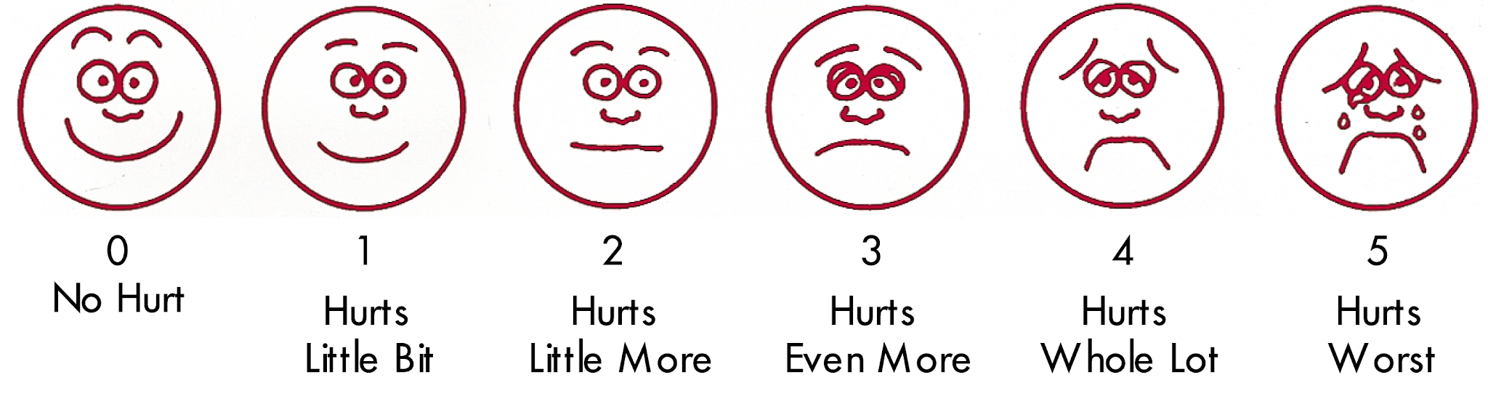Scale:
- Mild to moderate pain is treated with paracetamol, diclofenac ( after food and with omeparazole 20mg bid to avoid gastritis), tramadol.
- Severe pain is treated with Narcotics – buprenorphine drip is started and titrated to control pain. Initiate vigorous analgesia to break the pain cycle

2 Hydration as patient is often too sick to drink fluids
- Blood transfusion if pain and anemia is worsening
- Antibiotics- it is difficult to decide initially if patient needs antibiotics as pain is often accompanied by low grade fever. If fever persists >3 days, or is increasing with patients condition worsening or if the painful area is tender and there is increase in the swelling with Inc WBC count start IV ampiclox (for S.aureus) + Ceftrioxone (for S.typhi)-
- Continue or increase 5 HU dosage (to 15mg/kg/day), and vitamins. With hold iron to avoid gastritis
2.Acute Chest Syndrome
Patient presents with fever, pleuritic chest pain suggestive of pneumonia, and increasing respiratory distress
( dec o2 sats). Chest Xray may or may not show an infiltrate.
Start
- IV hydration
- O2 by mask or canula to keep O2 sat >95%
- PO azithromycin 500mg od + IV ceftrioxone1-2 gm od
- Blood transfusion is the most important treatment if patient is worsening. Ideally exchange transfusion is advised

3. Severe anemia and jaundice- hemolysis
- Blood transfusion
- USS abdomen to diagnose gallstones and obstructive jaundice

9.3 Lymphadenopathy

Fluctuant cervical nodes that develop over weeks to months without significant inflammation or tenderness (cold abscess) suggest TB until proven otherwise
Hard cervical nodes, particularly in older patients and in smokers, suggest metastatic cancer.
Left side drains the abdomen/pelvis (Virchow’s node) and the right side drains lungs, mediastinum, and esophagus.

Differential diagnosis
Location | Lymphatic drainage | Causes
Submandibular | Tongue, submaxillary gland, lips and mouth, conjunctivae | Infections of head and neck, sinuses, ears, eyes, scalp, pharynx
Submental | Lower lip, floor of mouth, tip of tongue, skin of cheek | Mononucleosis, EBV, CMV, toxoplasmosis
Jugular | Tongue, tonsil, pinna, parotid | Pharyngitis, rubella
Posterior cervical | Scalp and neck, skin of arms and pectorals, thorax, cervical and axillary nodes | TB, lymphoma, head and neck cancers
Suboccipital | Scalp and head | Local infection
Postauricular | External auditory meatus, pinna, scalp | Local infection
Preauricular | Eyelids and conjunctiva, temporal region, pinna | External auditory canal
Right supraclavicular node | Mediastinum, lungs, esophagus | Cancers of lung, retroperitoneum of GIT
Left supraclavicular node | Thorax, abdomen via thoracic duct | Lymphoma, thoracic or retroperitoneal cancer, bacterial or fungal infections
Axillary | Arm, thoracic wall, breast | Infections, cat scratch disease, lymphoma, breast cancer, brucellosis
Epitrochlear | Ulnar aspect of forearm and hand | Infections, lymphoma, sarcoidosis, syphilis
Inguinal | Penis, scrotum, vulva, vagina, perineum, gluteal region, lower abdominal wall, lower anal canal | Infections of leg, foot, STD, lymphoma, pelvic cancers, plague

Diagnosis:
Blood tests to confirm infectious causes
Lymph node biopsy if there is a suspicion of TB or malignancy

Management:
Based on the cause

9.4 Carcinoma Esophagus

Esophageal cancer is the most common cancer among the patients treated at GAH (tribal and non-tribal population). The risk factors include smoking, tobacco chewing, consumption of alcohol, Barrett's esophagus, and Fanconi’s anemia. Patients often present with dysphagia, odynophagia, and loss of weight.

Pathologically, there are two types:
- Squamous cell carcinoma: this is more common in developing countries (and in our population)
- Adenocarcinoma: begins at the gastro esophageal junction and is seen more commonly in patients with obesity and GERD

Diagnosis:
Upper GI endoscopy and biopsy is the gold standard test for diagnosis of upper GI cancers
For staging: CT of the thorax and abdomen/ PET CT can be done, USG to look for liver metastasis in all patients prior to CT (indicates poor prognosis and further diagnostic tests can be deferred and palliative treatment offered).

Prognosis depends on the stage, pathological type (well/ moderately/ poorly differentiated), operability, and patient’s general condition

Treatment:
- Upfront surgery (Stage 1 cancers only)
- Chemoradiation therapy
- Immunotherapy and Targeted therapy
- Esophageal stenting: as a palliative option but is expensive and without significant benefits, hence not offered at GAH

9.5 Carcinoma stomach:

Carcinoma stomach is the third most common cancer seen at GAH. The incidence is more common in men and has been associated with H. pylori infection, alcohol use, high salt intake and low consumption of fruits. The presentation includes early satiety, vomiting, dyspepsia, loss of weight, hematemesis, and melena. Iron deficiency anemia may be sometimes the only clinical finding in a patient with carcinoma stomach. Approximately 60% of the patients with CA stomach are not eligible for a curative treatment due to late presentation or being unfit for therapy.

Pathologically, the most common type is adenocarcinoma with or without the presence of signet ring cells. Gastrointestinal stromal tumour (GIST) is another malignancy that can affect the stomach but is rarely encountered at GAH.

Diagnosis is based on upper GI scopy and biopsy, the staging evaluation includes CT thorax and abdomen, or a PET CT

Management:
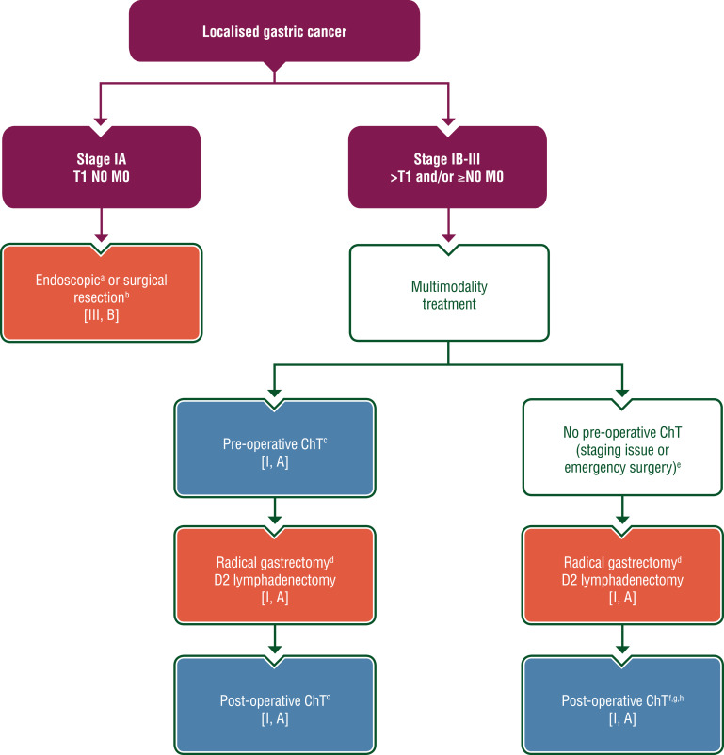

- Management of advanced/ unresectable/ metastatic carcinoma stomach
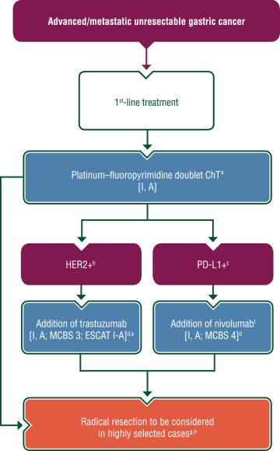

9.6Carcinoma Breast:

Breast cancer is the most common cause of cancer-related death worldwide in women. The risk factors include advanced age, family history of breast cancer, early menarche and late menopause, dense breast tissue, exposure to radiation, and sedentary lifestyle.

The clinical presentation can range from asymptomatic breast lump that is incidentally detected on examination to an ulcerative growth over the breast with foul smelling discharge and sepsis.

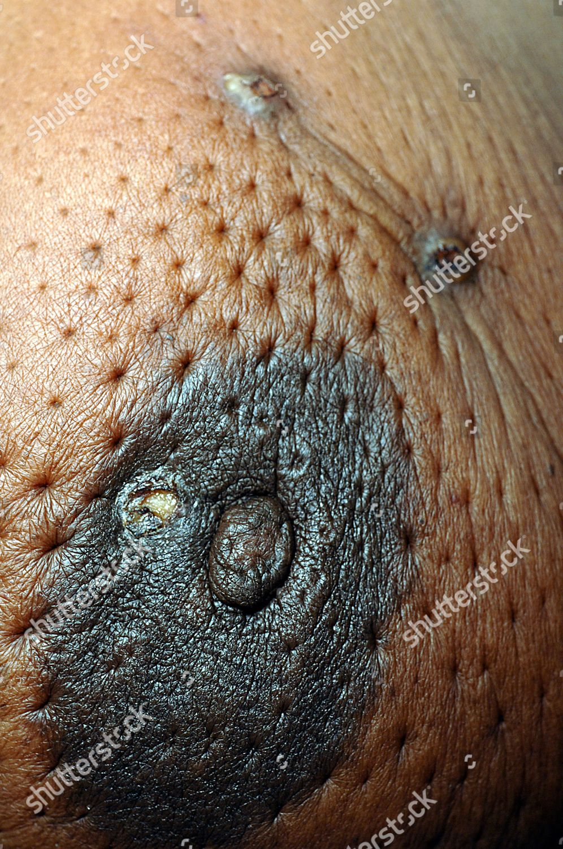

Diagnosis: Triple assessment which includes
- Clinical (history and examination)
- Radiology (USG and Mammogram)
- Pathology (FNAC/ Core biopsy including hormone receptor status)
Other investigations:
- Bone scan in patients who are symptomatic and with node positivity
- CT scan of the chest in patients with fixed tumors and bulky nodal disease
- Liver function tests
- USG abdomen to look for liver metastasis and krukenberg’s tumor
- MRI breast for patients with familial breast cancer (as a screening investigation)

Management:
Surgery remains the cornerstone in the management of carcinoma breast in GAH. The options include
- Breast-conservation surgery (BCS): Small tumours involving single quadrant, without involvement of nipple-areola complex and without axillary lymphadenopathy on clinical and USG. The patient should be counseled and willing for adjuvant radiation therapy and need for mastectomy in case of margin positivity and recurrence. Regional lymph node metastasis is the strongest prognostic factor of long-term outcome in breast cancer. Hence, sentinel lymph node biopsy or axillary lymph node dissection should be performed in all patients undergoing BCS
- Neoadjuvant chemotherapy and surgery: For patients with locally advanced breast cancers (>cT2,cN+). Patients will be referred to Ramakrishna hospital, or Ashwin hospital for the same. Chemotherapy can also be given at GAH under CMCHIS after obtaining the opinion from the medical oncologist.
- Modified radical mastectomy (MRM): For patients with operable breast cancers and without bulky axillary lymph nodes.
- Adjuvant chemotherapy: For patients with positive lymph nodes after MRM and tumour size >cT2
- Adjuvant hormonal therapy:
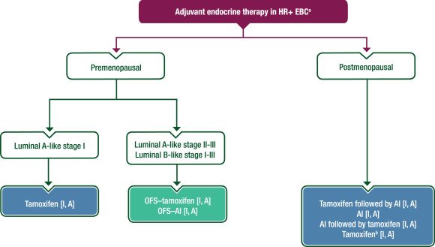

Chapter 10: Endocrinology and Metabolism

10.1 Hypothyroidism
10.2 Hyperthyroidism
10.3 Eurthyroid Goiter

10.4 Diabetes and DKA Management
10.5 Diabetes Ketoacidosis
10.6 Dyslipidemia

10.7Hypokalemia
10.8 Hyperkalemia

10.1 Hypothyroidism
Diagnosis: If pt is suspected to be hypothyroid ask for TSH only ( Thyrocare)
Management of primary hypothyroidism:
Patients should be started on levothyroxine.
The dose of levothyroxine (eltroxin) in adults is 1-2µg/kg/d. Children require a higher dose. Start at a lower dose in the elderly and in those with heart disease. (Tablets available in GAH have strength of 50 and100 µg.)
Monitoring TSH:
Primary target: to achieve a serum TSH that is within the reference range.
The minimum period to achieve stable concentrations of TSH after a change in dose of thyroxine is two months and therefore TFT should be repeated only 2 months after starting/changing dose. .
Once stable levels have been achieved annual follow-up is sufficient.
Special situations
Subclinical hypothyroidism: T4 normal, TSH mildly elevated. Treatment is indicated if patient is symptomatic, is pregnant or is positive for TPO antibodies. Start with a lower dose of eltroxin.
Pregnancy: Daily requirement is higher. Dose may have to be increased by 25-50 µg.
Myxoedema coma: Mortality high. Give loading dose of eltroxin(400 µg) followed by maintenance dose daily. Steroids should be given because of impaired adrenal reserve. Empirical antibiotics to be started. Do not give hypotonic fluids like D5W as they have imapaired renal secretion.
Congenital hypothyroidism: Suspect hypothyroidism in an infant if the child has the following features-constipation, large anterior fontanelle, macroglossia, hypotonia, umbilical hernia, poor weight gain, etc.
Infants require higher doses of eltroxin(10-15 µg/d).

10.2 Hyperthyroidism
Diagnosis: ↑T3/T4, ↓TSH (If TSH ↑ consider secondary hyperthyroidism)
Causes:
Diffuse goiter -Graves’ disease
Solitary nodule -Toxic nodular goiter
Multiple nodules -Toxic multinodular goiter
Transient -Thyroiditis (Hasimoto’s, postpartum…)
Others -Thyroxine overdose, 2*hyperthyroidism, ectopic thyroxine secretion (struma ovarii)

Treatment:
Graves’ disease: Antithyroid drugs for 1- 2 years. About 50% show remission. For those who relapse consider radioiodine if pt does nor want any more children.
Toxic nodular goiter: Radioiodine/surgery
Toxic MNG: Generally poor response with antithyroid drugs. Surgery advised (after rendering euthyroid with antithyroid drugs)
Thyroiditis: is transient. Antithyroid drugs not to be used. Manage symptoms with β blockers.
Thyroxine overdose:Reduce dose by 25µg decrements while repeating TFTs.
Drugs:
Carbimazole (Neomercazole):
- Dose: Start with 5-10mg three times a day. Most people require a lower dose once TFTs have stabilized. Therefore dose may be lowered appropriately.
Side effects: rash, pruritus, rarely agranulocytosis. WBC to be repeated monthly initially and then a month after increase in dose.

Monitoring TFT:
Repeat TFTs 4-6 weeks after starting treatment. TSH tends to remain suppressed for a few months and is not useful for monitoring treatment. Rather the target is to bring the T4 to within normal range.
Special situations:
Pregnancy: Use the lowest effective dose to avoid fetal hypothyroidism. Propylthiouracil is preferred as it has less placental transfer. Repeat TFT at least every 2 months.
Thyrotoxic crisis: Steroids to be used along with neomercazole and propranolol.
T3 thyrotoxicosis: Isolated elevation of T3 with normal T4. May be seen in early Graves’ disease.
Apathetic hyperthyroidism: Elderly individuals may present with minimal symptoms of hyperthyroidism.

10.3 Euthyroid Goiter

Thyroid Nodules:
Thyroid nodules can be solitary or multinodular. Most multinodular goitres are benign. However, all thyroid nodules need to be evaluated clinically (history and examination), radiologically (USG thyroid), pathologically (if needed) and biochemically (TFT).

Factors suggesting a malignant diagnosis include the following:
-Age < 20 years or > 70 years
-Male sex
-Associated dysphagia or dysphonia

-History of neck irradiation
-Prior history of thyroid carcinoma
-Firm, hard, or immobile nodule
-Presence of cervical lymphadenopathy

Factors suggesting a benign diagnosis include the following:
-Family history of goitre or autoimmune disease (Hashimoto thyroiditis)
-Presence of thyroid hormonal dysfunction (hypothyroidism, hyperthyroidism)
-Pain or tenderness associated with nodule
-Soft, smooth, and mobile nodule

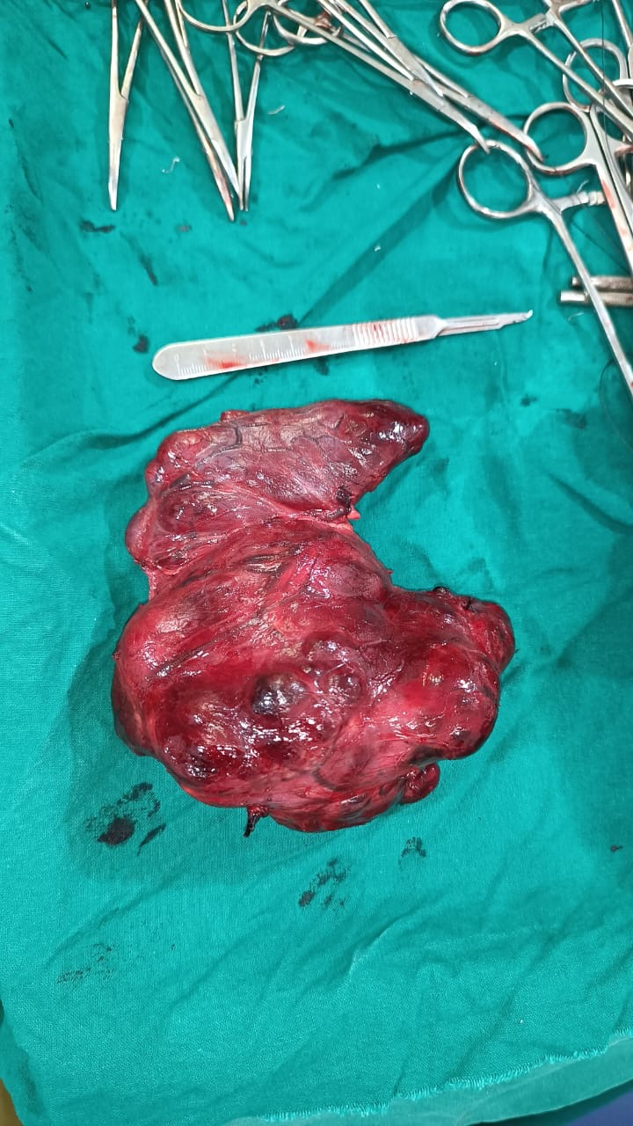

Approach to Thyroid Nodule
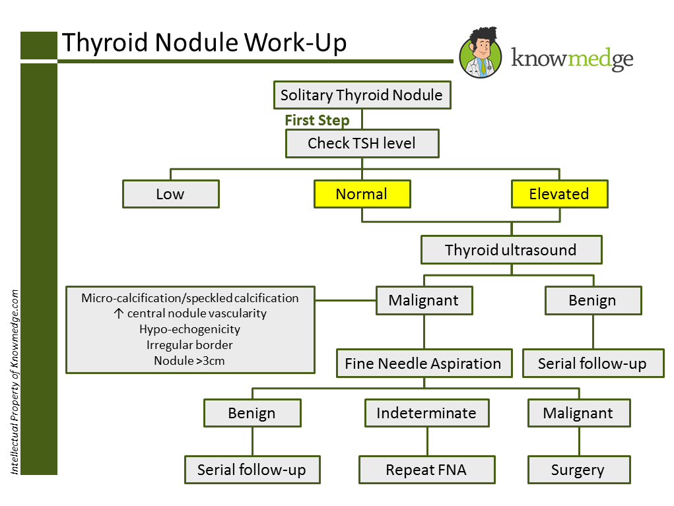
Surgery for thyroid nodules:

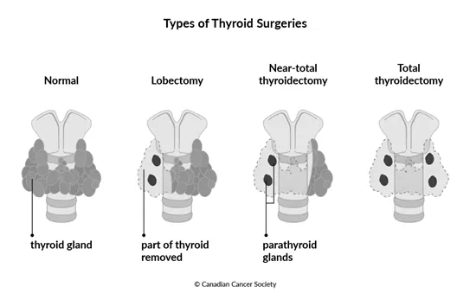
Complications following total thyroidectomy:

- Recurrent laryngeal nerve injury causing Vocal Cord Palsy
- Injury to the parathyroid hormones causing Hypocalcemia and tetany
- Reactionary and secondary hemorrhage
- Surgical site infection (rare)

10.4 Diabetes Mellitus
The prevalence of diabetes is on the rise in the tribal community because of the change in life style. It is a challenge to detect the disease early and especially to ensure long term compliance. There is also a high prevalence of diabetes in the local non-tribal community
Diagnostic criteria for diabetes mellitus
- Fasting Blood Sugar (FBS) ≥126 mg/dl. (Fasting is deﬁned as no caloric intake for at least 8 hours) or
- 2-h post prandial blood sugar (PPBS)≥200 mg/dl during an OGTT.(The test should be performed using a glucose load containing the equivalent of 75 g anhydrous glucose dissolved in water) or
- In a patient with classic symptoms of hyperglycemia or hyperglycemic crisis, a random plasma glucose ≥200 mg/dl or
- HbA1C ≥6.5%.
- blood glucose levels taken in the fasting state and 2 hours after a meal are high.
Oral glucose tolerance test – OGTT Give 75 grams of glucose in 300ml of water to a person fasting overnight.The subject must have received at least 150 - 200 mg of carbohydrate in the previous 3 days.
Prediabetics have a 40% risk of developing diabetes over the next 5 years
 | Diabetes | Pre-diabetes (IFTor IGT)
Fasting | .>/= 126mg % | 110-125mg%
2 hrs post prandial | >/= 200mg% | >140 but<200 mg%
IFT= Impaired Fasting Glucose, IGT =Impaired Glucose Tolerance)

Physical examination
- Height, weight, BMI. Ideal body weight = (height in cm -100) x 0.9
- BP determination, including orthostatic measurements when indicated
- Pulses - Palpability of the peripheral pulses; bruit over the carotid artery.
- Skin examination (for infections like furuncles, abscesses)
- Comprehensive foot examination with documentation:
Inspection- 1 Dry skin 2 Hair loss 3 Callosities 4 Cracks& fissures 5 Web space infection 6 Nail exam
Palpation of dorsalis pedis and posterior tibial pulses
Presence/absence of knee and ankle reflexes
Determination of sensation, proprioception and vibration
- Fundoscopic examination (annually)
- Having an “apple shape” (carrying extra weight around the stomach) carries a greater risk of lifestyle related diseases such as heart disease, diabetes, lipid disorders and atherosclerosis, leading to strokes and myocardial infarction, than having a “pear shape” (carrying extra weight around hips or thighs).. It is also an indicator of high visceral obesity and thus insulin resistance.

Ankle-brachial index (ABI): This test is done by measuring systolic BP at the ankle (cuff wrapped around the calf and the dorsalis pedis is palpated) and in the arm (cuff wrapped around he arm and the brachial artery is palpated) while a person is at rest.
Measurements are then repeated at both sites after 5 minutes of walking.
By dividing the highest ankle systolic BP by the highest recorded systolic BP in either arm, the ABI can be calculated The ABI result is used to predict the severity of peripheral arterial disease (PAD) that may be present. A decrease in the ABI result with exercise is a sensitive indicator that significant PAD is probably present.
A normal resting ABI is 1 or 1.1 indicates that anteskle systolic BP is the same or greater than the arm BPand there is no significant narrowing or blockage of blood flow,
A resting ABI < 1 is abnormal,
ABI of <0.95, indicates significant narrowing of one or more blood vessels in the legs
< 0.8, pain in the foot, leg, or buttock may occur during exercise (intermittent claudication).
<0.4, symptoms may occur even when at rest.
If 0.25 or below, severe limb-threatening PAD is probably present.

Management of Diabetic Patient
1 Educate the patient about control of blood glucose by diet counselling, exercise and medicines
2 Educate the patient regarding proper foot care
3 Perform good neuro and vascular exam of foot and document it
4. Get Xray and pus c& S for diabetic foot patients & inform early re chance of amputation
Laboratory evaluation
- Monthly FBS /2hrs PPBS to alternate
- 6 monthly s. creatinine and urine exam
- Yearly Fasting lipid profile,including total, LDL,HDL cholesterol and triglycerides,TFT,sGPT,ECG
- USS abd, if not done to R/O gallstone
Medicines
If blood sugar is not controlled with food & exercise start on metformin if s. creatinine is WNL. Gradually increase to 1500mg metformin SR bid.
If BS still uncontrolled in
Pts <40 yrs add glibenclamide -start at 2.5 mg and go up to 10mg od or glimepiride 0.5mg to 8mg in divided doses
>40 yrs – add glipizide – start at 2.5mg to max of 5mg tid. If still uncontrolled add pioglitazone 15-45mg od
If still uncontrolled continue metformin stop the other medicines and add insulin

Generally, to correct a high blood sugar, one unit of insulin is needed to drop the blood glucose by 50 mg/dl. This drop in blood sugar can range from 30-100 mg/dl or more, depending on individual insulin sensitivities, and other circumstances.
To calculate Total Daily Insulin (TDI) Requirement (in units of insulin)
TDI= Weight in Pounds ÷ 4 (of which Basal/background insulin dose = 50% of TDI)
Ideally patient is admitted and switched over to insulin and taught to administer it
Glycemic goals
FBS: 70–130 mg%. PPBS ≤180 mg%. HbA1C ≤7.0%.
Sulfonylureas
Because sulfonylureas (glimeperide,glipizide,glibenclamide)release insulin, they can cause hypoglycemia; the risk is greatest with the long-acting glibenclamide. Hypoglycemia can be particularly hazardous in elderly patients living alone. Use a short-acting sulfonylurea(glipizide) or an alternative drug for these patients.
Sulfonylureas will work only when there is adequate pancreatic beta cell function.They will not work for
patients with Type I diabetes mellitus.Some patients with Type II diabetes mellitus no longer have any significant pancreatic beta cell function. These drugs will not work for them.
Sulfonylureas are metabolized by the liver. Do not give them to patients with severe hepatic insufficiency These drugs contain a sulfonamide group. Do not give them to patients with severe hypersensitivity to sulphonamides Avoid sulfonylureas in pregnancy. Pregnant women with diabetes, or who develop diabetes during pregnancy, should be treated with insulin.
Insulin is almost always required for adequate, safe control of diabetes in medical or surgical emergency.
The effect of sulfonylureas is reduced by the actions of corticosteroids and thiazide diuretics.
The metabolism of sulfonylurea drugs is inhibited by the antifungal drugs itraconazole and fluconazole. Avoid these combinations as they increase the risk of hypoglycemia.

Oral hypoglycemic agents
Metformin | 500-2500mg two to three times a day with meals. 1500mg SR bid
Glimeperide | 1-8 mg in 2 divided doses
Glibenclamide | 2.5-10 mg od
Glipizide | 2.5 to 5 mg twice /thrice a day 30 min before meals
Pioglitazone | 15-45 mg once a day
Insulin
Mixtard(70/30- NPH/regular insulin)
Regular(plain insulin)

Management of Co-morbidities
1. Hypertension
- Target BP < 130/80 mmHg
- Drug of choice: ACEI/ARBs
- Add CCB/ β blocker to reach target
2.Dyslipidemia
Statins to be started irrespective of baseline lipid levels for diabetic patients-Atorvastatin 2.5 -10 mg hs od
- With overt CVD
- Without CVD who are above 40 yrs and have ≥1 risk factor for CVD.
- In others, start statins if LDL>100mg/dl.
3.Antiplatelet agents
- Consider aspirin (75mg/150mg) as a primary prevention strategy in men >50 years of age or women >60 years of age who have at least one additional major risk factor.
*(Major risk factors: family history of CVD, hypertension, smoking, dyslipidemia,or albuminuria)

10.5 Hypoglycaemia
Commonest endocrine emergency. Prompt diagnosis and treatment essential—brain damage & death can occur if severe or prolonged.
Definition - Plasma glucose < 50mg%(3mmol/L). Threshold for symptoms varies. Symptoms –
- Autonomic: Sweating, anxiety, hunger, tremor, palpitations, dizziness.
- Neuroglycopenic: Confusion, drowsiness, visual trouble, seizures, coma. Rarely focal symptoms, eg transient hemiplegia. Mutism, personality change, odd behaviour, restlessness, and incoherence may lead to misdiagnosis of alcohol intoxication or even psychosis.
Fasting hypoglycaemia Causes: The chief cause is insulin or sulfonylurea treatment in a diabetic, eg increased activity, missed meal, accidental or non-accidental overdose.
In non-diabetics you must EXPLAIN mechanism: Exogenous drugs, eg insulin, oral hypoglycaemics?, access through diabetic in the family?, alcohol, eg a binge with no food; aspirin poisoning; ACE-inhibitors, beta-blockers;
Pituitary insufficiency.
Liver failure, plus some rare inherited enzyme defects.
Addison’s disease.
Islet cell tumours (insulinoma) and immune hypoglycaemia (eg anti-insulin receptor antibodies in Hodgkin’s disease).
Non-pancreatic neoplasms, eg fibrosarcomas and haem angiopericytomas.
When to investigate:
1.Whipple answered this (Whipple’s triad): symptoms or signs of hypoglycemia + low plasma glucose + resolution of symptoms or signs post glucose rise.
2.Document symptoms during attack and lab glucose ( glucometers often not reliable at low readings).
3.Take a drug history and exclude liver failure.
4.72h fasting may be needed (monitor closely).
Bloods: glucose, insulin, C-peptide, and plasma ketones if symptomatic.
If endogenous hyperinsulinism suspected, do insulin, C-peptide, proinsulin, hydroxybutyrate. Interpreting results:
1. Hypoglycaemic hyperinsulinaemia (HH): Causes: insulinoma, sulfonylureas, insulin injection (no detectable C-peptide—only released with endogenous insulin);
Noninsulinoma pancreatogenous hypoglycaemia syndrome, mutation in the insulin-receptor gene. Congenital HH follows mutations in genes involved in insulin secretion .
2 Insulin low or undetectable, no excess ketones. Causes: non-pancreatic neoplasm; anti-insulin receptor antibodies.
3. Decreased Insulin, decreased ketones. Causes: alcohol, pituitary insufficiency, Addison’s disease.
The brain stops working if plasma glucose levels get too low, so we are nervous of levels < 50mg%. But some are asymptomatic at this level. So what is definitely abnormal? The answer may be 70 mg%(4mmol/L), allowing for inaccuracies in fingerprick BS (NB: whole blood glucose is 10–15% < plasma glucose.) Think: ‘In this ill patient when can I be sure that a low glucose is not contributing to their illness?’ If BS < 70mg% it is wise to treat

Management:
- If conscious, orientated, and able to swallow, give 15–20g of quick-acting carbohydrate snack (eg 200mL sugar water) and recheck blood glucose after 10–15mins (repeat snack up to 3 times).
- If conscious but uncooperative, squirt glucose solution between teeth and gums.
- In unconscious patients, or those not responding to these measures, give glucose IV bolus (eg 100ml 25% glucose over 15mins ), and start 500ml DNS at 200 ml/hr. Expect prompt recovery. Once blood glucose >70mg% and patient has recovered, give long-acting carbohydrate (eg kanji, ragi, biscuit ).
- In alcoholic hypoglycaemia the IV glucose should be preceded by 100 mg IV thiamine to avoid Wernicke- Korsakoff psychosis.

Post-prandial hypoglycaemia- May occur after gastric/bariatric surgery (‘dumping’), and in type 2 DM. Investigation: Prolonged OGTT .
Treatment -If episodes are often, advise many small high-starch meals. If post-prandial low glucose, give slowly absorbed carbohydrate (high fibre). In diabetics, rationalise insulin therapy.(Oxford Handbook pg214)

10.6 Diabetic Ketoacidosis (DKA)
DKA occurs as a result of severe insulin insufficiency and an excess of counter regulatory hormones (e.g., glucagon).The predisposition to DKA is characteristic of Type I Diabetes and may be a presenting manifestation. However, DKA may occur in any patient with diabetes who is sufficiently stressed.
Treatment:
The therapy for DKA should include
- restoration of volume,-DEHYDRATION IS MORE LIFE THREATENING THAN HYPERGLYCEMIA-so its correction takes precedence
- appropriate electrolyte management,
- reversal of acidosis and ketogenesis, and
- control of blood glucose.
A. Diagnosis. Common symptoms- vomiting and vague abdominal pain without localizing signs. Severe acidosis promotes hyperventilation. Shock or coma may occur.
Laboratory evaluation. BS is almost always elevated. Other laboratory features may include hyponatremia, hyperkalemia, increased creatinine and an elevation of serum amylase unrelated to abdominal pathology, urine shows ketones
B. Precipitating factors. 1.insufficient or interrupted insulin therapy and 2. infection or other stress. Because infection often is occult, cultures of blood and urine, examination of the skin and feet, and a chest radiograph are indicated. 3.Myocardial infarction may precipitate DKA, and an EGG is useful both for cardiac assessment and for the evaluation of hyperkalemia. 4.Pregnancy may precipitate DKA.
C. Supportive measures. For patients in shock or coma, supportive measures should proceed without delay- pressors, O2
D. Monitoring of therapy. Frequent measurements of glucose and electrolytes are essential to assess response to therapy in DKA. A safe approach is to measure BS q30-60m(using glucometer)and to measure plasma electrolytes ql-2h as needed.
Ketonuria can persist after correction of acidosis, and urine ketones are of only limited use in following therapy. Pertinent clinical and laboratory data should be recorded on an organized flowchart to aid management.
E. Fluid management. Restoration of intravascular volume should be prompt, guided by cardiac and renal function. Initial fluids should include NS or LR . Patients with normal cardiac function should receive the first liter of fluid rapidly.An osmotic diuresis is common once fluids are started and may slowly progress toward a positive fluid balance. Typically give 1L NS stat, then 1L over the next hr, the 1L over 2hrs, 1L over 4hr, then 1L over 6hr (Oxford handbook)
1. Monitoring of volume. Frequent assessment of the heart rate, BP and urine output, auscultation of lung bases for crackles is important to guide volume replacement. Suspected heart failure, myocardial infarction, or renal failure may warrant the monitoring of central venous pressure.
2. Correction of free water deficit. Ringer’s lactate, may be used as an alternative to isotonic saline to restore intracellular volume when the serum sodium level is >155mEq/L
3. Maintenance fluids. When the intravascular volume has been restored a maintenance infusion of RL at a rate of 150-250 ml/hour is appropriate for most patients with normal cardiac and renal function.
F. Bicarbonate therapy. Bicarbonate therapy should be considered initially when
DKA is accompanied by shock or coma, severe acidosis or severe hyperkalemia.
Bolus infusion of bicarbonate should be avoided except as an emergency resuscitation measure. A solution of sodium bicarbonate, 80-100 mEq (two ampoules) or 1ml/kg of 8.4%over 1hr is used. Use RL instead of NS to reduce hyperchloremia seen with administration of NaCl solutionsfor maintainence.
G. Potassium replacement. Replacement of K+ is a fundamental part of therapy for DKA. Although hyperkalemia due to metabolic acidosis may be observed initially, patients with DKA usually are deficient in K+, and life -threatening hypokalemia can develop during insulin treatment.
When the s. creatinine is WNL urine output is adequate, start K+ at 10 mEq/hr. When K+ is < 4 mEq/l increase infusion of K+ to 15-20 mEq/hr. Measurement of K+ levels is used to guide K+ administration.In patients with oliguria or renal failure, K+ levels must be monitored meticulously with continuous EGG monitoring.
H. Insulin treatment. In DKA, insulin Rx reverses ketogenesis and restores glicose utilization. Although insulin acts to lower the blood glucose level, the resolution of acidosis and ketone production is the objective & a D5W infusion often is needed to avoid hypoglycemia while this objective is being met.
1. The initial dose should be 10-15U of regular (plain)insulin or 0.15U/kg IV, as a bolus.
2. Continuous IV insulin infusion is the treatment of choice in DKA. Administration of 10 units/hour (or 0.1 units/kg/hour) is appropriate initially.
3. IM insulin injections provide an alternative to IV infusion. The IM route should be avoided in hypotensive patients, as absorption is unpredictable . An initial dosage of 10 units (or 0.1 units/kg) IM qlh should be give
4. Adjustments of insulin dosage should be guided initially by blood glucose levels. After the first hour of treatment, the glucose levels should fail by at least 50 mg/dl/hour; a slower response may be indicative of insulin resistance, inadequate fluid administration, or improper insulin delivery.If insulin resistance is suspected, the dosage of IV insulin should be increased by 50-100% in hourly increments.
Insulin can be tapered, with care to maintain the basal requirement ( 1-2U/hr),. Subsequently, when oral intake is resumed, SC insulin may be given and the IV or IM insulin discontinued.
I. Dextrose administration Because the fall in the blood glucose level caused by insulin treatment usually is more prompt than is the resolution of ketoacidosis, dextrose administration may be necessary during therapy. Normalization of glucose is not advised during initial therapy of DKA because of the risk of serious hypoglycemia. A reasonable goal is to maintain blood glucose at 200-300 mg/dl. When the initial blood glucose level is less than 400 mg/dl Dextrose containing fluids are appropriate as part of the initial regimen.
J. Phosphate administration. Insulin treatment promotes cellular uptake of phosphate and hypophosphatemia. Because complications of hypophosphatemia in DKA are rare and IV phosphate administration can compromise renal function, routine use of phosphate should be avoided. In patients with hypophosphatemia and a prolonged inability to resume dietary intake, the use of potassium phosphate in maintenance IV fluids 9 total dose <20mEq K+ might be considered.
K. Initiation of oral intake. Nausea, vomiting,& abdominal pain usually resolve during the first few hrs of Rxt. Patients may eat when they can tolerate food, but ketoacidosis should be corrected before a full diet is resumed.
L. Prevention of recurrent DKA. If precipitating factors are corrected and uninterrupted insulin therapy is maintained, DKA should not recur. Delay in the SC admin of insulin after IV therapy in DKA should be avoided, and care should be taken to maintain the admin of insulin in doses sufficient to meet requirements. Intermediate-acting or a combination of short- and long-acting insulin should be given SC before the IV insulin is discontinued, so that continuous insulin activity is maintained and basal needs are met.
Electrolytes should be measured at q4h intervals until stability is demonstrated.
M. Complications of DKA. These should be recognized and addressed.
1. Lactic acidosis may accompany ketoacidosis, particularly when shock, sepsis, or necrotizing inflammation also are present or when metformin is administered.It is suspected when acidosis does not respond to insulin.Its responds to volume replacement, but bicarbonate may be required.
2. Cerebral edema may occur during therapy for DKA, manifested by headache, altered mental status, and papilledema. A CT scan can establish the diagnosis.It can be avoided by preventing sudden drop in BS levels and keeping it > 300mg% 3. Arterial thrombosis is a complication of DKA that may present as stroke, myocardial or other organ infarction, or limb ischemia. Acute management is specific to affected areas of the body. Thrombectomy or anticoagulation may be appropriate.
Reference: (Wash Manual 29th Ed pg 405)

10.7 Diabetic Foot

DIABETIC FOOT EXAM

Pulse* | Sensation | Interdigital ulcers | Skin/nail changes  (callus, hair loss) | Foot deformity
DP  PT  Femoral | Pain |  | Skin dry  Fissures  Absent hair  Nail fungus  Nail cut wrong
*If absent do Doppler study
Rx-Toe nail fungal infection – Terbinafine 250 mg od x 12 weeks
Hand nail fungal infection – Terbinafine 250 mg od X 6 weeks
If patient has foot ulcer get XRay
Earliest changes are swelling & loss of soft tissue plane between bone & muscles. Then
- decreased bone density with poor margins
- bone moth eaten , fracture

Reasons for Hospitalisation
- Signs of systemic infection-fever, chills, confusion, uncontrolled hyperglycemia, leucocytosis
- Ascending cellulitis
- Deep infection or abscess
- Gas in soft tissue
- Osteomyelitis,
- Absent pedal pulses
- Need for repeated debridement
- No improvement with oral antibiotics with in 48-72 hrs

TREATMENT OF INFECTION
- Mild – Cephalexin 500 mg q6h,
- Moderate - Amoxy- clav, 875/128 q12h, levofloxacin 750 mg od
- Severe – Pipercillin+tazobactam IV 3.375 q6h or 4.5 q6h if pseudomonas suspected,
+ Linezolid 600mg q12h ( if MRSA suspected)
- If allergic to penicillin Cipro 500mg iv q12h + Metronidazole 500 mg iv Q8h

10.8 Dyslipidemia
Hypercholesterolemia Management
1. Obtain fasting lipid levels
Primary target – LDL Cholesterol
< 100 Optimal, 100- 129, Near optimal, 130-159, Borderline high,160-189 High, > 190 Very high
Total cholesterol
<200 Desirable
200 – 239 Border line
>240 High
Triglycerides
< 150 Normal
150 – 199 Border line
200 – 499 High
> 500 Very high
HDL Cholesterol
< 40 low
>60 high

2. Identify presence of coronary heart disease (CHD) or CHD risk equivalent
CHD- Myocardial infection, unstable angina, stable angina, clinical significant myocardial schema
CHD risk equivalent – peripheral arterial disease, abdominal aortic aneurysm, caritid artery disease, diabetes mellitus.
3. Determine presence of major risk factors
- Cigarette smoking
- Hypertension (BP > 140/90 mm)
- Low HDL Cholesterol (<40 mg / dl)
- Family history of premature CHD (Male 1st degree relatives < 55 yrs) ,(Female 1st degree relative < 65 yrs)
- Age (male> 45 yrs, female > 55 yrs)
4. Categorise patient into risk group
High risk - CHD / CHD risk equivalent
Moderate risk - 2 risk factors
Low risk - 0 – 1 risk factor
5. Treatment of LDL Cholesterol goals
Risk category LDL – Cholesterol goal
High risk <70 mg/dl
Moderate risk <100 mg / dl
Low risk < 130 mg / dl
6. Treatment of elevated Triglycerides
150 – 199 mg/dl - primary aim: to reach LDL goal
If LDL goal already achieved ; secondary aim : is to reach non HDL goal (total cholesterol-HDL), which is 30 mg / dl higher than LDL goal
200 – 499 mg / dl - do –
> 500 mg/dl: Primary aim to lower Triglycerides as it can cause pancreatitis. ( ie to treat even if LDL is normal)
7. Treatment of low HDL (<40mg/dl)
Primary aim: to reach LDL goal
If TG 200 – 499 mg/dl: to achieve non HDL Goal
If TG< 200 MG/DL (Isolated low HDL) in CHD or CHD equivalent consider nicotinic acid or fibrate.
Drugs used
Class | Drug | Lipid effects | Side effects | Contraindication
HMG CoA Reductive inhibition | Atorvastatin 5 – 80 mg | LDL ↓18-55%  HDL ↑5 –15%  TG ↓ 7 – 30% | Myopathy, increased liver enzymes | Absolute: active or chronic liver disease
Fibric acids | Fenofibrate (200 mg)  Genfibrozil*(600mg bd) | LDL↓ 5 – 20 %  HDL↑10 – 20 %  TG ↓ 20– 50 % | Dyspepsia,  Gallstone | Absolute: severe renal disease.  Severe hepatic disease
Nicotinic acid | Extended release NA*  Niespen 1-2 g | LDL↓ 5 – 25 %  HDL↑15 – 35 %  TG ↓ 20 – 50 % |  | Absolute: chronic liver disease, severe gout  Relative:Diabetes, Peptic ulcer
Bile acid reques trants | Cholestyramine 4 – 16 * | LDL↓ 15 – 30 %  HDL ↑3 – 5 %  TG - no change or increase | GI distress constipation | Absolute  DysbetalipoprotinaemiaTG>400m%  Relative TG>200mg/dl
Atorvastatin-Myopathies have occurred in patients taking atorvastatin, including muscle aches, muscle tenderness, or muscle weakness, with elevated CPK > ten times normal. Rhabdomyolysis has been reported in patients esp in pts with impaired renal functio s. Using atorvastatin in combination with other medications that increase atorvastatin levels increases the risk for myopathies and rhabdomyolysis. Management of statin-induced myopathies includes temporarily holding therapy, switching to an alternative statin, or reducing the dose. Atorvastatin can cause liver function test abnormalities. Check SGPT 6weeks after starting atorva If normal check once in 6-12 mos.Patients starting atorvastatin should have sGPT & FLP performed at baseline, & after 6 weeks. Once the patient is stable, lipids and sGPT can be checked every 6 - 12 months.If GPT > three times normal, atorvastatin should be dose reduced or discontinued.Contraindications- Patients with active liver disease, pregnancy, who may become pregnant or breastfeeding.

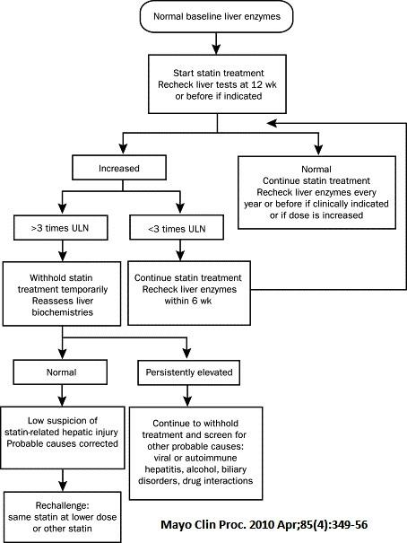

10.9 Hypokalemia
Mild hypokalemia [K⁺>3 mmol/L (11.7 mg/dL)] is generally asymptomatic.
With severe K⁺ deficiency [K⁺<3 mmol/L (11.7 mg/dL)] the symptoms are primarily cardiovascular.
Early ECG manifestations include ectopy, T-wave depression, and prominent U waves.
Severe depletion increases susceptibility to reentrant arrhythmias.
Treatment
In mild hypokalemia, oral replacement is suitable. 1ml Syrup KCL contains 2 mEq K+.
Adults: Initial doses range from 40-100 mEq/day in 2-5 divided doses: limit doses to 40 mEq per dose. Total daily dose should not exceed 200 mEq
• Pediatric patients aged birth to 16 years old: 2-4 mEq/kg/day in divided doses; not to exceed 1 mEq/kg as a single dose or 40 mEq whichever is lower; if deficits are severe or ongoing losses are great, consider intravenous therapy. Total daily dose should not exceed 100 mEq
Parenteral therapy is indicated in the presence of severe depletion, significant symptoms,or oral intolerance.
K⁺ concentrations (administered as chloride) in peripherally administered IV fluids should not exceed 40 mmol/L (156 mg/dL), and therate of administration should not exceed 20 mmol (78 mg)/hour.
The IV KCl soln in GAH has 20mmol/10ml KCl so adding ½ amp to 500ml NS makes a 20mmol/l soln
However, higher K⁺ concentrations [60 to 80 mmol/L (234 to 312 mg/dL)] administered more rapidly (with cardiac monitoring) are indicated in cases of severe hypokalemia, for cardiac arrhythmias, and in the management of diabetic ketoacidosis.
Administration of high K⁺ concentrations via subclavian, jugular, or right atrial catheters should be avoided because local K⁺ concentrations may be cardiotoxic. Hypomagnesemia frequently accompanies hypokalemia and generally must be corrected to successfully replenish K⁺. Gelusil MPS contains 250mg Magnesium hydroxide/tablet of which 15% (approx. 40mg)gets absorbed

10.10 Hyperkalemia

Def-Serum potassium level greater than 5.0 mEq/L (5.0 mmol/L).

Causes of hyperkalemia.

1.Spurious/pseudohyperkalemia-

Leakage from erythrocytes when separation of serum from clot is delayed (plasma K⁺ normal)

-Marked thrombocytosis or leukocytosis with release of intracellular K⁺ (plasma K⁺ normal)

-Repeated fist clenching during phlebotomy, with release of K⁺ from forearm muscles

-Specimen drawn from arm with intravenous K⁺ infusion
2.Decreased K+ excretion
Kidney disease, acute and chronic
Renal secretory defects (may or may not have reduced kidney function): kidney transplant, interstitial nephritis, systemic lupus erythematosus, sickle cell disease, amyloidosis, obstructive nephropathy
Hypoaldosteronism,Addison disease
Type IV renal tubular acidosis ,Heparin
Drugs that inhibit potassium excretion: spironolactone, eplerenone, drospirenone, NSAIDs, ACE inhibitors, angiotensin II receptor blockers, triamterene, amiloride, trimethoprim, pentamidine, cyclosporine, tacrolimus 3.Shift of K⁺ from within the cell
Massive release of intracellular K⁺ in burns, rhabdomyolysis, hemolysis, severe infection, internal bleeding, vigorous exercise
Metabolic acidosis (in the case of organic acid accumulation— eg, lactic acidosis—a shift of K⁺ does not occur since organic acid can easily move across the cell membrane)
Hypertonicity (solvent drag)
Insulin deficiency (metabolic acidosis may not be apparent)
Hyperkalemic periodic paralysis
Drugs: succinylcholine, arginine, digitalis toxicity, beta-adrenergic antagonists Alpha-adrenergic stimulation?
4. Excessive intake of K⁺
Especially in patients taking medications that decrease potassium secretion (see above)
Clinical Features- Hyperkalemia impairs neuromuscular transmission, causing muscle weakness, flaccid paralysis, and ileus.
ECG is not a sensitive method for detecting hyperkalemia, since nearly half of patients with a serum K+ > 6.5 mEq/L will not manifest ECG changes.
ECG changes in hyperkalemia include bradycardia, PR interval prolongation, peaked T waves, QRS widening, and biphasic QRS–T complexes. Conduction disturbances, such as bundle branch block and atrioventricular block, may occur. Ventricular fibrillation and cardiac arrest are terminal events.
Treatment The diagnosis should be confirmed by repeat laboratory testing to rule out spurious hyperkalemia, especially in the absence of medications that cause hyperkalemia or in patients without kidney disease or a previous history of hyperkalemia.
Plasma potassium concentration can be measured to avoid spurious hyperkalemia due to potassium leakage out of red cells, white cells, and platelets.
Kidney dysfunction should be ruled out at the initial assessment.
Treatment consists of
-withholding exogenous potassium,
-identifying the cause,
-reviewing the patient’s medications and dietary potassium intake, and
-correcting the hyperkalemia.

Emergent treatment is indicated when cardiac toxicity, muscle paralysis, or severe hyperkalemia (K+> 6.5 mEq/L) is present, even in the absence of ECG changes. Insulin, bicarbonate, and beta- agonists shift potassium intracellularly within minutes of administration (seeTable below). Intravenous calcium may be given to antagonize the cell membrane effects of K+, but its use should be restricted to life-threatening hyperkalemia in patients taking digitalis because hypercalcemia may cause digitalis toxicity. Hemodialysis may be required to remove potassium in patients with acute or chronic kidney injury. Neither agent has been studied in acute hyperkalemia or in patients with end-stage renal disease. Sodium polystyrene* has been widely used for decades although its efficacy and safety have been questioned. It may not increase potassium excretion above laxatives alone and has been associated with colonic necrosis, both with and without sorbitol coad- ministration. The FDA has recommended that sodium polystyrene should not be administered in sorbitol, but the mixture remains commonly available. Its use should be restricted to patients with life-threatening hyperkalemia when dialysis is not available and other therapies (eg, diuretics) have failed. Sodium polystyrene is contraindicated in patients with risk factors for colonic necrosis, such as bowel obstruction, ileus, and postoperative state.

Treatment of hyperkalemia. MDT 2019 909
Immediate
Modality | Mechanism of Action | Onset | Duration | prescription | K⁺ Removed From Body
Calcium | Antagonizes cardiac conduction abnormalities | 0–5 minutes | 1 hour | Calcium gluconate 10%, 5–30 mL IV; or calcium chloride 5%, 5–30 mL IV | None
Bicarbonate | Distributes K⁺ into cells | 15–30 minutes | 1–2 hours | NaHCO₃, 50–100 mEq intravenously Note: Sodium bicarbonate may not be effective in end-stage kidney disease patients; dialysis is more expedient and effective. Some patients may not tolerate the additional Na load of HCO3 therapy. | None
Plain Insulin IV | Distributes K⁺ into cells | 15–60 minutes | 4–6 hours | Regular insulin, 5–10 units IV + glucose 50%, 25 g IV | None
Albuterol nebuliser | Distributes K⁺ into cells | 15–30 minutes | 2–4 hours | Nebulized albuterol, 10–20 mg in 4 mL normal saline, inhaled over 10 minutes Note: Much higher doses are necessary for hyperkalemia therapy (10–20 mg) than for airway disease (2.5 mg). | None
Urgent
Loop diuretic | Renal K⁺ excretion | 0.5–2 hours |  | Furosemide, 40–160 mg IV Note: Diuretics may not be effec- tive in patients with acute and chronic kidney diseases. | Variable
Sodium polystyrene sulfonate (eg, Kayexalate) * | Ion-exchange resin binds K⁺ | 1–3 hours |  | Oral: 15–60 g in 20% sorbitol (60–240 mL)Rectal: 30–60 g in 20% sorbitol Note: Resins with sorbitol may cause bowel necrosis &intestinal perforation, esp in pts with abnormal bowel function. | 0.5–1 mEq/g resin
Hemodialysis^{1 *} | Extracorporeal K⁺ removal | 1–8 hours |  | Dialysate [K⁺] 0–1 mEq/L  Note: A fast and effective therapy for hyperkalemia, Serum K can be rapidly corrected within minutes, but post-dialysis rebound can occur. | 25–50 mEq/h  Note: Serum K can be rapidly and effectively corrected within min- utes; post-dialysis rebound can occur.
Peritoneal dialysis * | Peritoneal K⁺ removal | 1–4 hours |  | Frequent exchanges | 200–300 mEq

Chapter 11: Neurology

11.1 Febrile Fits
11.2 Epilepsy
11.3 Status Epilepticus

11.4 Meningitis
11.5 Stroke
11.6 Migraine

11.1 Febrile Fits
Discussion- Seizures occurring in association with fever affect approximately 4% of all children (and is the commonest neurological disorder in Britain and USA).
Definition: Generalized convulsions in neurologically healthy child
- Usually within 24 hours of onset of fever
- Age group of 6 mo to 5 years
- Lasting < 15 minutes
- Only 1 convulsion in 24 hours
- Is associated with a sudden rise in temperature
- Usually with reversion to normal sensorium, and no neurologic deficit

Diagnostic tests
Clinical diagnosis. The risk of meningitis in a child with febrile fits with a normal history and physical examination is very small (0 – 4%). Meningitis is suspected and lumbar puncture performed for patients with any of the following signs:
- Complex, partial, focal or multiple seizures in 24 hours
- Nuchal rigidity (Kernig’s sign +) or full anterior fontanel
- Drowsy, stuporous or comatose
- Petechiae
- Shock or fall in blood pressure
- Any feature not consistent with desciption of febrile fits (above)

Treatment
Inj Diazepam 0.2 mg/Kg slow IV stat (or rectal, same preparation, if IV not obtained) to stop convulsions
Tepid sponging for temperature > 101ºF
Paracetamol 15 mg/kg stat and 10 mg/kg q6h to alternate with Ibuprofen 10mg/kg q6h
Oral diazepam 0.33 mg/kg q8h till patient is discharged (hold if altered sensorium)
Find the cause for the fever and treat it
Long term anticonvulsants are not advocated in typical febrile fits
(BMJ Vol 323 Nov 10,2001)

11.2 Epilepsy
Classifications
Seizures are classified as partial and general.
- Partial seizures are further classified as simple partial (SPS) or complex partial (CPS).
  - SPS does not cause alteration of consiousness and has motor, sensory, psychic, and autonomic symptoms.
  - CPS usually involves alteration but no loss of consciousness.
- Generalized seizures can be tonic clonic, absence or atonic. There is loss of consciousness.
Investigations
Check SUGAR ( for hypoglycaemia), electrolytes (for hyponatremia), TC/DC ( for meningitis), HIV.
DD- Keep TIAs, migraine, TB brain , cysticercosis, CNS metastasis in mind.
Treatment
If correctable causes such as hypo/hyperglycemia, hyponatremia, hypotension, meds, or fever are causative do not start Anti Epileptic Drug (AED) right away.
Start AED right away if there is history of
- severe head injury (prolonged LOC, head injury with deficits),
- neuro exam with deficits,
- mental retardation,
- 1st seizure is a partial seizure,
- family history of epilepsy.
- brain lesions on CT,
General principles of choosing an AED are :
- use monotherapy,
- start low dose and go slow.
- Combo therapy should be attempted only if at least two adequate sequential trials of single agents have failed.
Phenytoin, Carbamezapine, Valproate can all be used for both partial and generalized seizures.
Phenobarb is reserved for generalized seizures.
1) Phenytoin:Loading dose 15 mg/kg IV(over 15 minutes); maintanence 5 mg/kg od or divided bid. Remember that phenytoin follows second order kinetics, so be especially careful beyond 300 mg/day.
Avoid using in adolescent girls as it cause acne, hirsutism and gingival hyperplasia.
2) Phenobarbitone (PB):5-8 mg/kg/day divided in 1-2 doses, indicated in tx of generalized seizures in infants but should be avoided in toddlers beyond 1 year of age as it is associated with hyperactivity and learning disability in 20% of children.
3) Carbamezapine:2 to 3 mg/kg per day given 2-4 times and can be increased every five days to max of 10 mg/kg daily.
4) Valproate (VPA):initial dose 15 mg/kg per day in three divided doses. May be increased by 5 to 10 mg/kg per day every week as needed. Max of 30 mg/kg.
Withdrawing AEDs in a complicated issue and there are no hard fast rules.
Generally a 2 year seizure free interval is used as a guide to stopping treatment. Gradually taper off over a period of 6 months.
Reference:Up To Date, OP Ghai 14th Edition,CMC PGD
CHOICE OF DRUGS IN EPILEPSY IN CHILDREN (AED) (CMC PGD)
Always start with a single anti epileptic drug(i.e. Monotherapy). If the max dose of one drug does not control seizures add a 2nd drug and increase dose till seizures are controlled. The 1st drug is then tapered and stopped.
Polypharmacy should be discouraged as it increases the side effects and cost for the patient and long term compliance is decreased.
“Intractable Epilepsy” in India is often due to polypharmacy and inadequate doses. Switching to monotherapy at correct dosage ensures adequate control in most cases.
If control is not achieved with 2 drugs refer to a neurologist.Compliance is affected by the cost of the medicine. Poor patients cannot afford Carbamazepine & Valproate, so use Phenobarb and Phenytoin for generalised seizures.

Type of Epilepsy | Drug of Choice | Second line drug
Generalised | Carbamazepine | Phenobarbitone  Phenytoin  Sodium valproate
Complex partial | Carbamazepine | Phenytoin  Sodium valproate  Phenobarbitone
Absence | Ethosuxemide | Sodium valproate or  Clonazepam
Myoclonus | Sodium valproate and  Clonazepam
Infantile spasm | Prednisolone

11.3

Status Epilepticus
- Place patient in lateral position (recovery)
- Administer inj. diazepam 0.2mg/kg i.v. stat. slowly over a minute. The dose can be repeated upto 20mg but be careful of respiratory depression.
- Next give loading dose of phenytoin 20mg/kg i.v. diluted in normal saline(avoid dextrose as phenytoin precipitates in it) over 15-20 minutes. Monitor blood pressure and heart rate as it can cause hypotension and heart block.
- If seizures continue, patient will require referral to higher centre.

11.4 Meningitis
Acute Bacterial Meningitis
Acute bacterial meningitis is infection of the subarachnoid space.
Microbiology of Adult Meningitis
Etiology | Comments
Strep.pneumoniae (30-60%) | Look for distant infection (Osler’s triad = meningitis, endocarditis, pneumonia)
N. meningitidis(10-35%) | Primarily in children & young adults, may be associated with petechiae/purpura.
H. influenzae(<5%) | Predisposing factors include CSF leak, trauma, post neurosurgery, mastoiditis
L. monocytogenes(5-10%) | Seen in elderly, alcoholics, or patients with malignancy, immunosuppression, iron overload. Outbreaks associated with contaminated milk, cheese, raw vegetables. Often associated with a poly-predominant pleocytosis.
Gram - rods (1-10%) | Usually nosocomial, elderly, immunocompromised patients
Staphylococci(5%) | Seen with indwelling CSF shunts or after head trauma
Work-up
- Check for nuchal rigidity (sensitivity 30%), Kernig’s sign, Brudzinski’s sign, stiff neck, photosensitivity, focal neurologic findings, papilledema, rash
- WBC is > 10,000 in 83% of bacterial meningitis
- Lumbar puncture - Rule of 2s: CSF WBC > 2,000, Glucose < 20, Total protein > 200 has 98% specificity for bacterial meningitis
Typical CSF Findings in Meningitis
Condition | Appearance | Pressure  (cm H₂0) | WBC/mm³ | Glucose  (mg/dL) | Total Protein  (mg/dL)
Normal | Clear | 9-18 | 0-5 Lymphs | 50-75 | 15-40
Bacterial | Cloudy | 18-30 | 100-10,000 Polys | <45 | 100-1000
TB | Cloudy | 18-30 | <500 Lymphs | <45 | 100-22
Fungal | Cloudy | 18-30 | <300 Lymphs | <45 | 40-300
Aseptic | Clear | 9-18 | <300 polys 🡪 lymphs | 50-100 | 50-100
Treatment of Acute Bacterial Meningitis at GAH
Normal Adult: Ceftriaxone 2g IV q12h + Vancomycin *15-20mg/kg IV q12h + Dexamethasone
- Corticosteroids: Dexamethasone 10mg IV q6hr x 4 days. Shown to decrease neurologic diability and mortality by 50% with Strep pneumonia meningitis. Consider steroids in all bacterial meningitis prior to organism detection. Must start before or with first dose of antibiotics.
- If > 50 years of age or alcoholic: Add Ampicillin 2 g IV q4hr for Listeria coverage
- Immunosuppresed: Ampicillin + Ceftazadime *2g IV q8hr + Vancomycin* + Acyclovir
Prophylaxis for close contacts of patients with meningococcal meningitis: Rifampin 600mg PO BID x 2 days OR Ciprofloxacin 500mg PO x 1dose OR Ceftriaxone 250mg IM x 1
.
Aseptic Meningitis
Defined as negative bacterial microbiologic data
- CSF pleocytosis with negative blood and CSF cultures
Etiologies:
  - Viral (enterovirus most common, HIV, HSV (Type 2 > 1),VZV, mumps, adenovirus, polio, CMV, EBV
  - Parameningeal focus of infection
  - TB, fungal, spirochetal, rickettsial, Coxiella, Ehrlichia
  - Medications: Bactrim, NSAIDS, Penicillin, INH
  - Systemic Illness: SLE, sarcoidosis, Behcet’s, Sjogren’s syndrome, Rheumatoid Arthritis
  - Neoplasma
- No antibiotic if suspect viral etiology
- If Mycobacterium tuberculosis, start ATT and dexamethasone
- Fungal Treatment: Amphotericin B

Viral Encephalitis
Viral infection of the brain parenchyma with evidence of neurologic dysfunction
- Etiologies: HSV-1 (~9%, MRI shows temporal lobe lesions), VZV (primary or reactivation, vesicular rash)
Dx: Lumbar puncture

Treatment
- HSV/VZV: Give acyclovir 10mg/kg IV q8h (often given empirically)
- CMV treatment: Ganciclovir +/- Foscarnet
- Supportive care for most other etiologyes

LP findings
 | Bacterial | Viral | TB
Appearance | Often turbid | Usually clear | Often fibrin web
WBC count | 90-1000+ | 50-1000 | 10-1000
Cell type | Neutrophils | Lymphocytes | Lymphocytes
Protein (g/l) | >1.5 | <1 | 1-5
Glucose | <1/2 plasma | >1/2 plasma | <1/2 plasma
Opening pressure | Markedly elevated | Slightly elevated | Mod elevated
Organisms | In smear and culture | Not in smear or culture | Often absent in smear

Empirical treatment of Meningitis
< 3 months
IV Cefotaxime + ampicillin +/- anti TB treatment+/- antiviral
(Can use Ceftriaxone instead of cefotaxime if not premature, jaundiced or acidotic)

>3 months
IV Ceftriaxone. +/- anti TB treatment +/- antivirals
For over 3 months can add Dexamethasone 0.15mg/kg (max 10mg) for 4 days if LP shows: purulent CSF, WCC >100/ml, Raised WCC plus protein >1g/l
- Start dexa no longer than 12 hours after starting antibiotics
- NB/ evidence of effectiveness limited, also little evidence of harm
- Must rule out TB

Confirmed by LP
Under 3 months
- Group B strep: IV cefotaxime 14days
- Listeria: IV amoxicillin or Ampicillin 21days plus Gentamicin 7days
- Gram –ve bacilli: IV cefotaxime 21days
- Meningococcus: IV Ceftriaxone 7days
Over 3 months
- Haemophilus influenzae type B: IV ceftraixone 10days
- Strep pneumoniae: IV Ceftriaxone 14days
- Meningococcus: IV Ceftriaxone 7days
References:NICE Guideline UK 2010; Lancet 2008; Adapted from Pocket Medicine, Sabatine, 2011, 6-10

11.5 Stroke Stroke is a medical emergency that requires rapid diagnosis and treatment. The hallmark of stroke is the abrupt interruption of cerebral blood flow to a specific brain region resulting in neurologic deficits. Fluctuation of functional deficits after stroke onset or a brief deficit known as transient ischemic attack (TIA) suggests tissue at risk for infarction that may be rescued by reestablishing perfusion.

Ask about progression or fluctuation of symptoms and when the patient was last normal. Prior TIA symptoms (e.g., transient monocular loss of vision, aphasia, dysarthria, paresis, or sensory disturbance) suggest atherosclerotic vascular disease, the most common cause for stroke. Inquire about cardiac arrhythmias and atherosclerotic risk factors.A history of neck trauma or recent chiropractic maneuvers warrants evaluation for arterial dissection

Ischemic stroke History Time of onset is critical if thrombolytic therapy is to be administered. Time of onset is when the patient was last seen normal and NOT when the patient was found with their deficit Risk Factors -hypertension, TIA, prior stroke, carotid stenosis, diabetes mellitus (DM), dyslipidemia, cigarette smoking, alcohol consumption, oral contraceptive use, obesity, genetics, and age. Ischemic stroke is subclassified into atherothrombotic, embolic, hypoperfusion, or hypercoagulable state (though relatively rare). –

- Atherothrombosis results from reduced flow within an artery or embolism of thrombus into the distal segment of an artery. Atherosclerosis is the most common etiology of thrombus formation in large vessels. Less common etiologies include dissection, fibromuscular dysplasia, Moyamoya, giant cell arteritis. Lipohyalinosis, usually due to hypertension, is the most common etiology of small-vessel disease.

- Cardioembolic strokes account for about 20% of all ischemic strokes. High-risk cardiac sources include atrial fibrillation, sustained atrial flutter, rheumatic valve disease, atrial or ventricular thrombus, dilated cardiomyopathy, prosthetic valve,bacterial endocarditis, nonbacterial endocarditis (antiphospholipid antibody syndrome, marantic endocarditis, Libman–Sachs endocarditis), sick sinus syndrome, and coronary artery bypass graft (CABG) surgery

-Hypoperfusion occurs due to general circulatory problems and often results in bilateral symptoms. Infarction commonly occurs in border zones between large vessels, resulting in watershed infarcts.

- Hypercoagulable states can cause venous or arterial thrombosis.

Cerebral venous sinus thrombosis is the occlusion of a venous sinus(es) by a thrombus. Occurs in hypercoagulable states such as late pregnancy, postpartum, cancer, and thrombophilias, trauma and adjacent inflammation/ infection. Anti-thrombin (AT)-III deficiency typically result in venous, not arterial infarcts.

May manifest with ischemic infarcts and/or hemorrhage. Venous sinus thrombosis often presents with signs and symptoms of elevated intracranial pressure, such as headache, bilateral sixth nerve palsies, blurred vision, and papilledema.

Hypercoagulable states may predispose to arterial thrombosis. These include sickle cell disease, polycythemia vera, essential thrombocythemia, thrombotic thrombocytopenic purpura (TTP), antiphospholipid antibody syndrome, hyper-homocysteinemia, Factor V Leiden, protein C and S deficiency.
Hemorrhagic stroke occurs in about 20% of all cases. The location of an intraparenchymal hemorrhage (IPH) may suggest its etiology. Hemorrhage in basal ganglia, thalamus, or pons is often due to chronic systemic hypertension. Amyloid angiopathy typically causes lobar hemorrhages and is a common etiology in the elderly. Head trauma, anticoagulants, drugs (cocaine or amphetamines), arteriovenous malformation (AVM), tumor, blood dyscrasia, hemorrhagic conversion of an ischemic stroke, and vasculitis are other possible hemorrhagic stroke etiologies. IPH presents with neurologic deficits accompanied by headache, vomiting, and possibly lethargy.
Subarachnoid hemorrhage (SAH) is caused by the rupture of an arterial aneurysm resulting in bleeding into the subarachnoid space (which contains CSF). Hypertension, cigarette smoking, genetic factors, and septic emboli (resulting in mycotic aneurysms) can all contribute to an aneurysm formation.
SAH commonly presents with sudden onset of a severe headache (i.e., the “worst headache of my life.”) Lethargy or coma, fever, vomiting, seizures, and low back pain may also be present.
.

Physical Examination A careful neurologic examination can reliably establish the anatomic location of a stroke in most cases. It should also be focused on possible etiologic factors. Examine for abnormal pulses, arrhythmias, murmurs, carotid bruits, and embolic phenomena In general, carotid artery distribution (anterior circulation) strokes produce combinations of functional deficits (hemiparesis, hemianopsia, cortical sensory loss, often with aphasias or agnosias) contralateral to the affected hemisphere. Vertebral-basilar strokes (posterior circulation) produce unilateral or bilateral motor/sensory deficits, usually accompanied by cranial nerve and brainstem signs (vertigo, diplopia, ataxia). Horner’s syndrome (ptosis, miosis, anhidrosis) contralateral to an acute hemiparesis suggests carotid dissection. A Horner’s syndrome with nystagmus and ipsilateral loss of facial pain and temperature sensation with contralateral loss of body pain and temperature sensation is diagnostic of a lateral medullary (posterior inferior cerebellar artery [PICA]) infarct (i.e., Wallenberg syndrome).
Diagnostic Testing Laboratories In the acute setting (e.g., acute evaluation for thrombolytic therapy), these should include CBC, PT, INR, and blood glucose, s.creatinine., electrolytes. The following are indicated but not emergent: lipid profile,ESR,(HIV, antinuclear antibody, anticardiolipin antibody, & drug toxicology screen, ECG should be done to look for atrial fibrillation or ischemic changes. Noncontrast head CT scan should be obtained acutely to rapidly differentiate hemorrhagic from ischemic strokes. It can identify acute hemorrhages in most cases. It is insensitive for acute ischemic strokes. It is often the rate limiting step in making decisions on thrombolytic therapy. Head CT scan is diagnostic of SAH in 90% of SAH patients in the first 24 hours. Patients are sent to Govt Hospital for CT and the film is sent to Radiology dept CMC,Vellore to be read ( usually < 24hrs) Carotid Doppler* studies enable noninvasive estimation of carotid stenosis and should be done for anterior circulation strokes. Echocardiography is helpful to demonstrate intracardiac thrombi, valve vegetations, valvular stenosis or insufficiency, and right-to-left shunt (bubble study).
Diagnostic Procedures
If suspicion for SAH is high and head CT is negative, lumbar puncture is necessary to confirm the diagnosis.
TREATMENT Vital signs, including oximetry and continuous telemetry, should be monitored. Atorvastatin 10mg is given to all stroke pts.
Hypertension management after stroke: Perfusion pressure in areas of the brain distal to the arterial occlusion may be low. Cerebral perfusion depends in part on mean arterial BP. Thus, a degree of hypertension may be necessary to maintain adequate perfusion pressure. Aggressive lowering of BP during the acute phase (ie.within 2weeks) has been associated with neurologic as there is loss of cerebral autoregulation and may further compromise ischemic areas and should be avoided. However, BP may need to be lowered necessary for treatment of coronary syndrome (ACS), CHF, hypertensive crisis with end-organ involvement or systolic BP >220 or diastolic BP >120. BP lowering should proceed cautiously, by 15% to 170-200 during the first 24 hours being a reasonable goal, using 2.5mg-5 mg amlodipine
Then, after 2 weeks, BP can be reduced further to less than 140/90 mm Hg with amlodipine/ enalapril

Intracranial Hemorrhagic Stroke
Treatment consists of supportive care, gradual reduction in BP, and elevation of head of bed by 15 degrees.
Treatment of SAH depends on etiology (surgical clipping versus intravascular coiling). Pt is referred to Calicut Medical College

Ischemic Stroke
Thrombolysis is not feasible as patients present late
1. Aspirin reduces atherosclerotic stroke morbidity and mortality It is only started after CT confirmation of diagnosis.Initial dose of 325 mg within 24 to 48 hours followed by 75 mg in the post–acute stroke period.
2. Clopidogrel is used of patient cannot tolerate aspirin.
Heparin, low–molecular-weight heparin (LMWH), or warfarin anticoagulation are NOT recommended for acute ischemic stroke.
Embolic Stroke
Anticoagulation with heparin followed with warfarin is indicated to prevent recurrent embolic strokes due to atrial fibrillation. Target INR with warfarin therapy is 2 to 3 (Washinton maual 14th ed)

Management of Cerebral Edema in Stroke Patients
During the acute stage, there may be marked brain swelling and edema, with symptoms and signs of increasing intra-cranial pressure, an increasing neurologic deficit, or herniation syndrome. Dehydrating hyperosmolar agents (mannitol 25-50g as a bolus IV infusion) reduces brain swelling acutely + Dexamethasone 4mg iv q6h (16 mg/d) to reduce vasogenic cerebral edema, but evidence of benefit is conflicting.
.Neither hypercapnia nor hypocapnia has been shown to have any benefit.
General care
  - Foley catheter if incontinent or unable to void
  - NG tube feeding if pt unable to swallow or aspirating on feeding
  - Pneumonia, constipation & bed sore prevention
  - Physiotherapy

11.6 Migraine
Diagnostic Criteria
1. Migraine without aura
A. At least five attacks fulfilling criteria B, C, and D
B. Headache attacks lasting 4–72 hours (untreated or unsuccessfullyt reated)
C. Headache with at least two of the following characteristics;
- Unilateral location
- Pulsating quality
- Moderate or severe intensity (inhibits or prohibits daily activities)
- Aggravation by walking stairs or performing similar routine physical activity
D. During headache, at least one of the following events;
- Nausea and/or vomiting
- Photophobia and phonophobia
E. At least one of the following scenarios
- History, physical and neuro exam do not suggest any disorders causing secondary headaches.
- History,physical, neuro exam suggest such a disorder, but it is ruled out by appropriate investigations.
- One of such disorders is present, but migraine attacks do not occur for the first time in close temporal relation to the disorder.

2.Migraine with aura
A. At least two attacks fulfilling criterion B
B. At least three of the following four characteristics
- 1 or more fully reversible aura symptoms indicating focal cerebral,cortical &/or brain stem dysfunction
- At least 1 aura symptom developing gradually over > 4 min, or 2 or more symptoms occurring in succession
- No aura symptom lasting > 60 min; if > one aura symptom is present, accepted duration is proportionally increased.
- Headache following aura with a free interval of < 60 minutes (It may also begin before or simultaneously with the aura.)
C. At least one of the following:
History and physical and neurologic examinations do not suggest one of the following disorders:
- Headache associated with head trauma/vascular disorders/nonvascular intracranial disorder/substances or their withdrawal/noncephalic disorder/metabolic disorder
- Headache or facial pain associated with disorders of the cranium;neck; or ear, nose, and throat
- Cranial neuralgias
- History,physical,neuro examinsuggest such adisorder, but it is ruled out by appropriate investigations.

Treatment- U.S. Headache Consortium Recommendations
Acute
Recommended medications based on at least 2 double-blind, placebo-controlled trials
1.PO Paracetamol,
2.PO Diclofenac (+ omez), + prochlorperazine(stemetil)
3.Diclofenac 50mg IM + 25 mg promethazine (phenergan) IM for patients whose migraines present early with nausea or vomiting
4. Use migraine-specific agents (triptans*, DHE*, ergotamine*) in patients withs evere migraine and in patients whose migraines respond poorly to NSAIDs or combination analgesics
5. Do not use opiods except as last resort
Guard against medication-overuse headache.

Prevention Generally accepted indications for migraine prevention include
- 2 or more attacks/mo that produce disability that lasts 3 or more days/mo
- contraindication to, or failure of, acute treatments
- use of abortive medication > 2/wk
- presence of uncommon migraine conditions, including hemiplegic migraine, migraine with prolonged aura, or migrainous infarction.
Preventive Medication -Initiate treatment with lowest effective dose & give each treatment an adequate trial
Recommended agents found to have medium to high efficacy and mild or infrequent side effects:
- Propranolol 20 mg bid
- Amitriptyline 12.5 – 25mg hs
- Sodium Valproate
Recommended agents found to have medium to high efficacy but with side effect concerns:
- Methysergide*, Flunarizine (Weight gain)*Time-released DHE*

Modified from Acute Migraine Headache: Treatment Strategies :LAURA MAYANS, MD, MPH, and ANNE WALLING, MB, ChB, University of Kansas School of Medicine, Wichita, Kansas:Am Fam Physician. 2018 Feb 15;97(4):243-251.

Chapter 12: Dermatology

12.1 Scabies
12.2 Impetigo
12.3 Recurrent Staphylococcal Infection

12.4 Supericial Fungal Infection

12.1 Scabies
Discussion
Infestation with the mite Sarcoptes scabiei causes this common disease diagnosed by
- severe itching especially at night
- papular lesions in webs of finger/toes, front of wrist, groin area.
- Traceable contact
- Secondary infection can lead to impetigo (streptococcal superinfection), which is a common cause of post-infectious glomerulonephritis.
Diagnostic Tests: none – clinical diagnosis
Treatment
Gammexane (gamma benzene hexachloride) 1% applied to entire body from neck down, overnight.
- All family members must be treated
- All linen in household must thoroughly cleaned.and sun dried
- If a secondary infection is present 1st treat this for 3- 5 days before initiating gamaxene as gamaxene is irritating to the skin.
- Inform patient that itching can persist for upto 4 weeks after treatment (although should be improving) due to inflammatory reaction against dead scabetic arthropods.
Note: Gammexane has possible neurotoxicity.Avoid in infants, pregnant women, and patients with many open wounds.
Alternative to Gammexane: Benzyl Benzoate (25%), requires 2 overnight treatments with no bath in between.
Dilute with equal quantity water/ coconut oil in children <5.

12.2 Impetigo
Discussion
Skin infection caused by staphylococcus or streptococcus species. Note that post-streptococcal glomerulonephritis is relatively common in our pediatric patients.
Diagnostic tests: none
Clinical diagnosis
Treatment
<= 5 lesions: GV paint
>5 lesions: Amoxycillin x 5 days
Severe cases: Benzathene penicillin (Penidure) 50,000 units/kg to a max of 1,000,000 units or Cephalexin 50 mg/kg divided qid or POAmoxyclav bd(for coverage against staph) or IV Ampiclox

12.3 Recurrent Staphylococcal Infection
Pt presents with recurrent skin infections, folliculitis, impetigo, styes, or furuncles. Recurrent furunculosis may be effectively treated with a
- combination of cephalexin (250–500 mg qid ) or doxycycline (100 mg twice bd) for 2–4 weeks plus rifampin (300 mg bd for 5 days).
- Shorter courses of antibiotics (7–14 days) plus longer-term daily 4% chlorhexidine whole body washing and
intranasal, axilla, and anogenital mupirocin may also cure recurrent furunculosis.
Oral vancomycin* (1 g twice daily for 5 days) can treat gastrointestinal carriage of S aureus. Family members, pets, and intimate contacts may need evaluation for staphylococcal carrier state and perhaps concomitant treatment.. As nasal carriage of MRSA and the number of children in a household are risk factors for transmission between household members do nasal cultures of pt & relatives to see if they ares nasal carriers
If patient is a nasal/relative carrier of Staph aureus treat based on C&S result as follows
- Cephalexin 250-500mg qid or Amoxyclav750 mg bid for 10 days +Rifampicin 10mg/ Kg (300mg bd)for the last 5 days
- Apply mupirocin or bacitracin ointment ( Neosporin) to the nasal cavities, groin and axillae tid
(Ref Cur Diag 2019 pg183)

12.4 Superficial Fungal Infections-Mucocutaneous Candidiasis

» General Considerations -Mucocutaneous candidiasis is a superficial fungal infection that may involve almost any cutaneous or mucous surface of the body. It is particularly likely to occur in diabetic patients, during pregnancy, in obese persons, and in the setting of immunosuppression. Systemic antibiotics, oral corticosteroids, hormone replacement therapy, and oral contraceptive agents may be contributory. Oral and inter digital candidiasis may be the first sign of HIV infection. Denture use predisposes the elderly to infection.
Clinical Findings
A. Symptoms and Signs –
1.Itching/burning may be intense particularly around vulva, anus, or body folds.
2 Lesions consist of superficial denuded, beefy-red areas with or without satellite vesicopustules in the depths of the body folds, such as in the groin, the intergluteal cleft, beneath the breasts, at the angles of the mouth, in the webspaces of digits, and in the umbilicus. Paronychia may occur. The peripheries of these denuded lesions are superficially undermined,
3 Whitish curd-like concretions on the oral and vaginal mucous membranes.
B. Laboratory Findings -Clusters of budding yeast and pseudohyphae can be seen under high power (400×) when skin scales or curd-like lesions are mounted in 10% KOH. Culture can confirm the diagnosis.
Differential Diagnosis
Intertrigo, seborrheic dermatitis, tinea cruris, “inverse psoriasis”, and erythrasma involving the same areas may mimic mucocutaneous candidiasis.
Complications
Systemic invasive candidiasis with candidemia is seen with immunosuppression, in patients receiving broad spectrum antibiotics & hypertonic glucose solutions(hyperalimentation).There may or may not be clinically evident mucocutaneous candidiasis.
Treatment
A. General Measures
Affected parts should be kept dry and exposed to air as much as possible. Water immersion should be minimized and gloves should be worn for those with infected nails or digital skin. If possible, discontinue systemic antibiotics. Check blood sugar
B. Local Measures
1. Nails and paronychia—Apply clotrimazole solution 1% twice daily.
2. Skin
- Gentian violet 0.5% solution is economical and highly effective in treating mucocutaneous candidiasis, but the purple discoloration may represent a cosmetic issue or
- Apply clotrimazole cream 1%, (+/- hydrocortisone cream 1%,) twice daily..
- Severe or widespread cutaneous disease responds to fluconazole, 100–200 mg Po od x 1 week. If intractable terbinafine 250 mg Po od x 1 -2 weeks
3. Vulvar and anal mucous membranes—
- For vaginal candidiasis, single-dose fluconazole (250 mg orally) is effective. Intravaginal clotrimazole, miconazole, may also be used. Long-term suppressive therapy may be required for recurrent or “intractable” cases.
- Non-albicans candidal species may be identified by culture in some refractory cases and may respond to oral itraconazole*, 250 mg twice daily for 2–4 weeks.
4. Balanitis—This is most frequent in uncircumcised men, and Candida usually plays a role.
- Apply clotrimazole cream Chronicity and relapses, especially after sexual contact, suggest reinfection from a sexual partner who should be treated.
- Severe purulent balanitis is usually due to bacteria. If it is so severe that phimosis occurs, oral antibiotics—some with activity against anaerobes—are required(cipro/amoxy + metrogyl); if rapid improvement does not occur cocircumcision indicated.
5. Mastitis—Lancating breast pain and nipple dermatitis in breast-feeding women may be a manifestation of Candida colonization/infection of the breast ducts.
- Topical gentian violet 0.5% daily for 7 days
- Topical clotrimazole 0.1% cream are safe during lactation..
- Oral fluconazole, 250 mg daily for 2 weeks, can be dramatically effective.

12.5 Tinea Corporis or tinea Circinata
Clinical Findings A. Symptoms and Signs Itching may be present. Ring shaped lesions of erythema with an advancing scaly border and central clearing or scaly patches with a distinct border. The lesions are often on exposed areas of the body such as the face and arms. A history of exposure to an infected pet (who may have scaly rash or patches of alopecia) may occasionally be obtained, usually indicating Microsporum infection. Trichophyton rubrum is the most common pathogen, usually representing extension onto the trunk or extremities of tinea cruris, pedis, or mannumplantar, and mucous membrane lesions. Tinea corporis rarely has the large number of symmetric lesions seen in pityriasis rosea. Granuloma annulare lacks scale.
B. Laboratory Findings -Microscopic examination of scrapings with KOH preparation or culture confirms the diagnosis.. Differential Diagnosis Positive fungal studies distinguish tinea corporis from other skin lesions with annular configuration, such as the annular lesions of psoriasis, lupus erythematosus, syphilis, granuloma annulare, and pityriasis rosea. Psoriasis has typical lesions on elbows, knees, scalp, and nails. Secondary syphilis is often manifested by characteristic palmar,
Complications Complications include extension of the disease down the hair follicles (which presents as papules and pustules and is more difficult to cure) and pyoderma.
Prevention Treat infected household pets (Microsporum infections). To prevent recurrences, the use of foot powder and keeping feet dry by wearing sandals, or changing socks can be useful. Treatment A. Local Measures Tinea corporis responds to most topical antifungals, , miconazole, and clotrimazole. Treatment should be continued for 1–2 weeks after clinical clearing. Betamethasone dipropionate with clotrimazole is not recommended. Long-term improper use may result in side effects from the high-potency corticosteroid component, especially in body folds. B. Systemic Measures Terbinafine, 250 mg orally daily for 1 month is effective in tinea corporis. Prognosis
Tinea corporis usually responds promptly to conservative topical therapy or to an oral agent within 4 weeks
  - Tinea Manuum & Tinea pedis (tinea of palms & Soles)
General Considerations -Tinea of the feet (athlete’s foot) is an extremely common acute or chronic dermatosis. Most infections are caused by Trichophyton species.
A. Symptoms and Signs - The presenting symptom may be itching, burning, or stinging. Pain may indicate secondary infection with complicating cellulitis. Interdigital tinea pedis is the most common predisposing cause of lower extremity cellulitis in healthy individuals. Regular examination of the feet of diabetic patients for evidence of scaling and fissuring and treatment of any identified tinea pedis may prevent complications. Tinea pedis has several presentations that vary with the location. On the sole and heel, tinea may appear as chronic noninflammatory scaling, occasionally with thickening and fissuring. This may extend over the sides of the feet in a “moccasin” distribution. The KOH preparation is usually positive. Tinea pedis often appears as organisms scaling or fissuring of the toe webs, often with maceration. As the web spaces become more macerated, the KOH preparation and fungal culture are less often positive because bacterial species begin to dominate. Finally, there may also be vesicles, bullae, or generalized exfoliation of the skin of the soles, or nail involvement in the form of discoloration, friability, and thickening of the nail plate.
B. Laboratory Findings
- KOH and culture do not always demonstrate pathogenic fungi from macerated areas.
- Differential Diagnosis
- Differentiate from other skin conditions involving the same areas, such as interdigital erythrasma (use Wood light). Psoriasis may be a cause of chronic scaling on the palms or soles and may cause nail changes. Repeated fungal cultures should be negative, and the condition will not respond to antifungal therapy. Contact dermatitis will often involve the dorsal surfaces and will respond to topical or systemic corticosteroids. Vesicular lesions should be differentiated from pompholyx (dyshidrosis) and scabies by proper scraping of the roofs of individual vesicles. Rarely, gram-negative organisms may cause toe web infections, manifested as an acute erosive flare of interdigital disease. Candida may also cause erosive interdigital disease.
Prevention -The essential factor in prevention is personal hygiene. Wear open-toed sandals if possible. Use of sandals in community showers and bathing places is recommended,. Careful drying between the toes after showering is essential. A hair dryer used on low setting may be used. Apply dusting and drying powders as necessary. The use of powders containing antifungal agen or long-term use of anti- fungal creams may prevent recurrences of tinea pedis.
Treatment
A. Local Measures
1. Macerated stage—Treat with miconazole + antiseptic ointment (nitrofurazone)will help combat diphtheroids and other gram-positive organisms present at this stage and alone may be adequate therapy. 2. Dry and scaly stage— Treat with miconazole ointment. The addition of salicyclic acid( Whitefield ointment) may increase the efficacy of topical treatments in thick (“moccasin”) tinea of the soles.
B. Systemic Measures -Terbinafine, 250 mg orally daily for 2–4 weeks, may be used in refractory cases. If the infection is cleared by systemic therapy, the patient should be encouraged to begin maintenance with topical therapy, since recurrence is common.
Prognosis
For many individuals, tinea pedis is a chronic affliction, temporarily cleared by therapy only to recur
12.7Tinea cruris
- Severe itching in intertriginous areas, usually sparing the scrotum.
- The erythematous lesions have sharp, demarcated margins, centrally cleared, and active, spreading scaly peripheries. Follicular pustules are some- times encountered. The area may be hyperpigmented on resolution
- May have associated tinea infection of feet or toenails.
- Laboratory examination with microscope or culture confirms diagnosis.
- Itching may be severe, or the rash may be asymptomatic..
Differential diagnosis- Tinea cruris must be distinguished from other lesions involving the intertriginous areas, such as candidiasis, seborrheic dermatitis, intertrigo, psoriasis of body folds (“inverse psoriasis”), and erythrasma (corynebacterial infection of intertriginous areas). Candidiasis is generally bright red and marked by satellite papules and pustules outside of the main border of the lesion. Candida typically involves the scrotum. Seborrheic dermatitis also often involves the face, sternum, and axillae. Intertrigo tends to be more red, less scaly, and present in obese individuals in moist body folds with less extension onto the thigh. “Inverse psoriasis” is characterized by distinct plaques. Other areas of typical psoriatic involvement should be checked, and the KOH examination will be negative. Ery- thrasma is best diagnosed with Wood (ultraviolet) light—a brilliant coral-red fluorescence is seen.
Treatment
A. General Measures
Drying powder (eg, miconazole nitrate can be dusted into the involved area in patients with excessive perspiration or occlusion of skin due to obesity as a preventive measure.
B. Local Measures
Any of the topical antifungal micanazole cream is curative in over 80% of cases after once-daily use for 7 days.
C. Systemic Measures
One week of terbinafine, 250 mg daily, can be effective.
Prognosis
Tinea cruris usually responds promptly to topical or systemic treatment but often recurs.

Fungal Nail Disease-Tinea Unguium (Onychomycosis)
Tinea unguium is a trichophyton infection of one or more (but rarely all) fingernails or toenails. The species most commonly found is T rubrum. “Saprophytic” fungi may rarely cause onychomycosis (less than 5% of cases). Evidence supporting a genetic defect in the innate and adaptive immune system may explain why some people suffer from chronic tinea pedis and onychomycosis.
The nails are lusterless, brittle, and hypertrophic, and the substance of the nail is friable. Onychomycosis is difficult to treat because of the long duration of therapy required and the frequency of recurrences. Fingernails respond more readily than toenails. For toenails, treatment is indicated for patients with discomfort, inability to exercise, diabetes, and immune compromise. In general, systemic therapy is required to effectively treat nail onychomycosis. Oral terbinafine 250 mg daily for 6 weeks . Once clear, fingernails usually remain free of disease for some years. Onychomycosis of the toenails is best treated with oral terbinafine 250 mg daily for 12 weeks. sGPT and CBC are performed 4–6 weeks after starting treatment, although because the risk of idiosyncratic injury is very low (transaminitis occurs in less than 0.5% of patient. The courses of terbinafine may need to be repeated 6 months after the first treatment cycle if fungal cultures of the nail are still positive. Making the right diagnosis is critical. This requires appropriate confirmatory tests (KOH, fungal culture and PCR) *and a willingness to expand the differential diagnosis of dystrophic nails to include conditions such as psoriasis, lichen planus, trauma, and chronic eczema. (CMDT2019 p190)

Dermatology spotters
- 14 year old boy with mildly itching lesions over neck for four days.

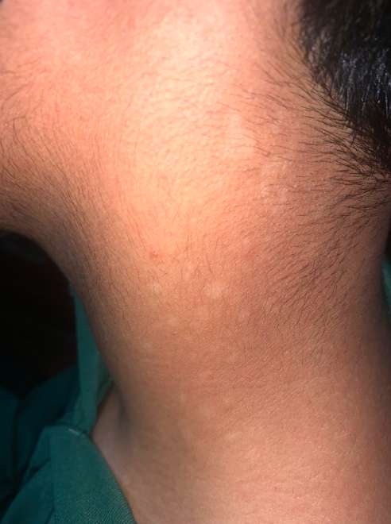
Tinea versicolor (pitryiasis versicolor)
Treatment: Topical antifungal (at GAH, we have miconazole nitrate cream) LA BD for 4 weeks

- 6 month old baby with itchy scaly plaques on cheeks.

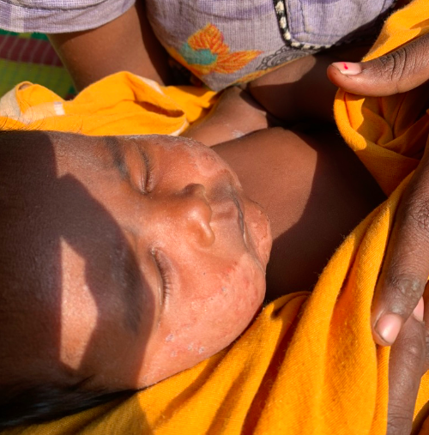
Eczema
Treatment: Topical steroid cream and coconut oil to combat the dryness.
Note: calamine lotion worsens the dryness

Chapter 13: Anesthesia

13.1 General considerations

13.2 Ankle Block
13.3 Axillary Block
13.4 Drug Doses

13.1General Consideraions
Before induction of anesthesia – must go through the checklist before anesthesia for all cases
WHO Anesthesia Safety Checklist
- Is an experienced and trained assistant available to help you with induction?
- Has the patient had no food or drink for the appropriate time period?
- Is there intravenous access that is functional?
- Is the patient on a table that can be rapidly tilted into a head-down position in case of sudden hypotension or vomiting?
- Equipment check:
  - If compressed gas will be used, is there enough gas and a reserve oxygen cylinder?
  - Anesthetic vaporizers are connected?
  - Breathing system that delivers gas to the patient is securely and correctly assembled?
  - Breathing circuits are clean?
  - Resuscitation equipment is present and working?
  - Laryngoscope, tracheal tubes and suction apparatus are ready and clean?
  - Needles and syringes are sterile?
  - Drugs are drawn up into labelled syringes?
  - Emergency drugs are present in the room, if needed?

13.2 Ankle Block
Infiltration anaesthesia is impracticable on the sole of a patient’s foot, because his skin is so thick, especially if he walks barefoot, but you can block the nerves at his ankle quite easily. The nuisance is that there are 5 of them, and you may need to block more than one. Decide which ones you need to block by studying Figures 6-27 and 6-28 (Blue Book) carefully. Avoid blocking all of them because, it is bad practice to place a band of anaesthetic solution subcutaneously all round a limb.
The tibial nerve lies underneath the flexor retinaculum, close to the medial (anterior) side of the Achilles tendon behind the tibial artery, and between the tendons of flexor digitorum longus and flexor hallucis longus. Soon afterwards it divides into the medial and lateral plantar nerves. The tibial nerve supplies the whole of the sole of the foot, except for its most proximal and lateral parts.
The sural nerve lies with the short saphenous vein, behind and below the lateral malleolus. The superficial peroneal nerve runs subcutaneously down the anterolateral side of the ankle.The deep peroneal nerve runs down the anterior surface of the ankle joint between tibialis anterior and extensor hallucis longus under the superior and inferior extensor retinaculae.
The saphenous nerve runs with the long saphenous vein in front of the medial malleolus.
Indications (1) Operations on a patient’s foot. (2) Amputations
The superficial peroneal nerve runs subcutaneously down the anterolateral side of the ankle.The deep peroneal nerve runs down the anterior surface of the ankle joint between tibialis anterior and extensor hallucis longus under the superior and inferior extensor retinaculae.
The saphenous nerve runs with the long saphenous vein in front of the medial malleolus.
Indications (1) Operations on a patient’s foot. (2) Amputations
Drugs & Equipment 0.5 or 1% lignocaine withadrenaline or 0.25 or 0.5% bupivacaine. If pt has vascular disease, don’t add adrenaline.
Method-Lay him face down, with a pillow under his ankles. Clean pts heel, Achilles tendon his medial malleolus.

(a) TIBIAL NERVE. Try to feel the patient’s posterior tibial artery. Raise a wheal slightly lateral to it, or if you cannot feel it, anterior to his Achilles tendon, level with the upper border of his medial maileolus.
Insert a fine 60 to 80 mm needle at right angles to the posterior aspect of his tibia. Try to place it immediately lateral to his tibial artery. If you move the needle medially and laterally, you may be able to elicit paraesthesiae.
If you elicit them, inject 0.5 to 1 ml of solution without adranaline.
If you don’t elicit them, inject the whole 10 to 12 ml of solution against the posterior aspect of his tibia, while you draw back the needle 1 cm.If you have obtained paraeslhesiae, anaesthesia will occur in 5 to 10 minutes. If you have not got them, it may take30 minutes.

b) SURAL NERVE Make a subcutaneous band of infiltration stretching from the patient’s Achilles tendon to the outer border of his lateral malleolus, directly opposite the needle you are using to block his tibial nerve.
Inject 5 to 8 ml solution while you move the needle fan-wise within his subcutaneous tissue, between his lateral malleolus and his Achilles tendon.
Turn the patient onto his back.

(c) SUPERFICIAL PERONIAL Use 5 to 10 ml of solution to make a subcutaneous wheal from the anterior border of his tibia to his lateral malleolus.

(d)DEEP PERONEAL NERVEInsert the needle on the anterior surface of his ankle slightly towards his tibia, between the tendons of his tibialis anterior and his extensor hallucis longus. Inject 5 to 10 ml of solution.

(e) SAPHENOUS NERVE Infiltrate subcutaneusly immediately above his medial malleolus with 5 to 10 ml of solution
CAUTION There is a risk that you might inject the solution into his saphenous vein, so make sure that you aspirate first.

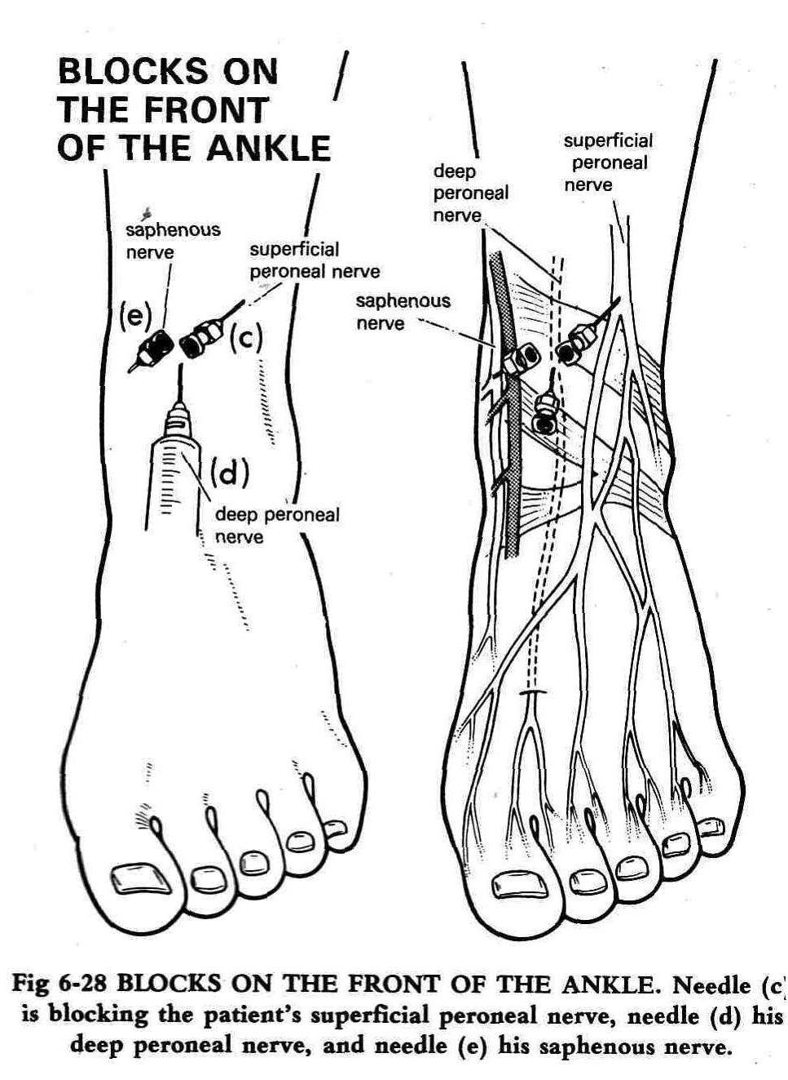
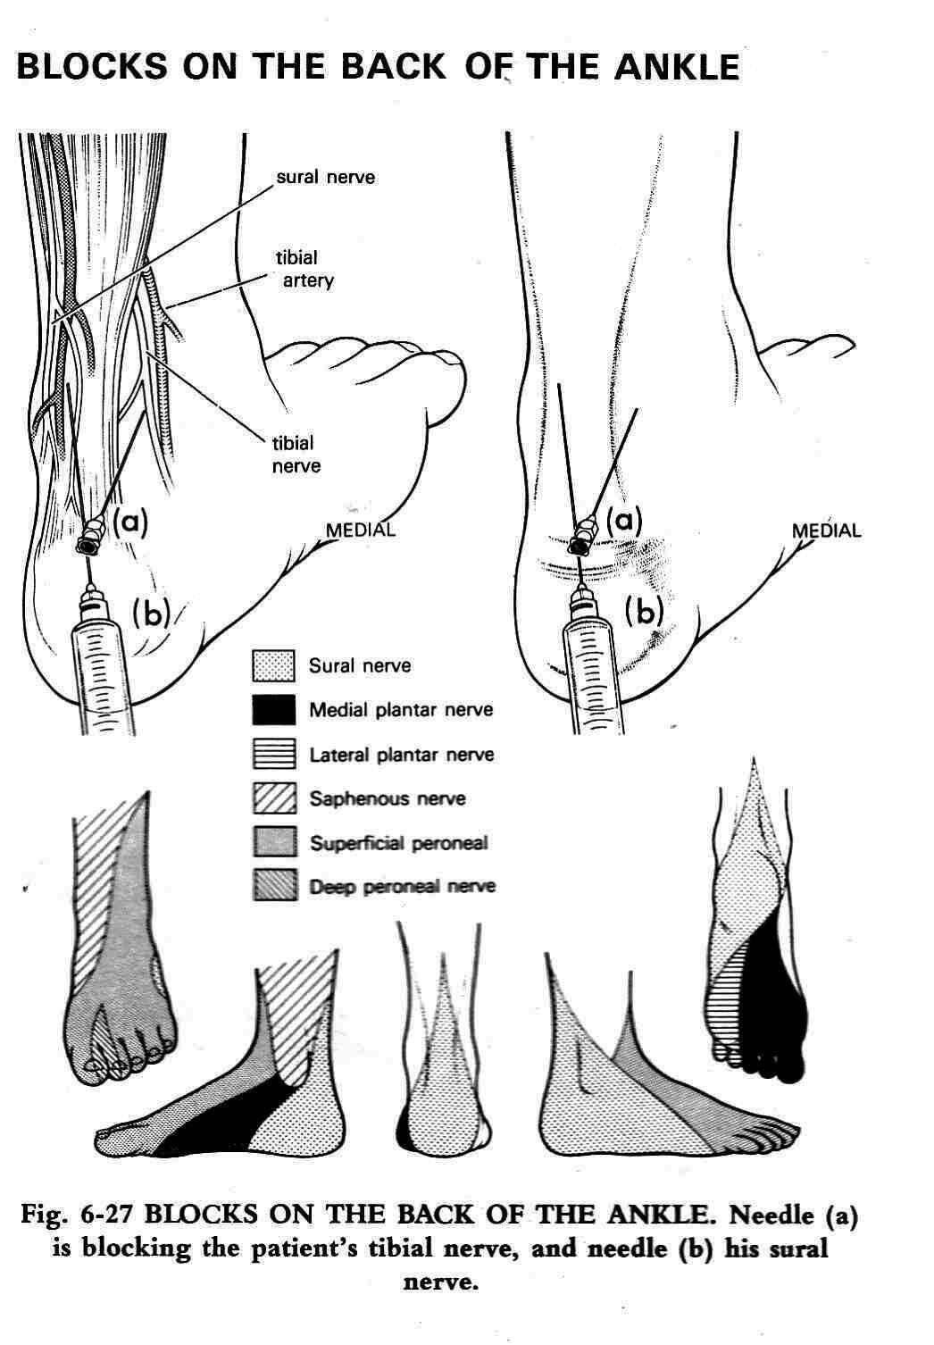

(

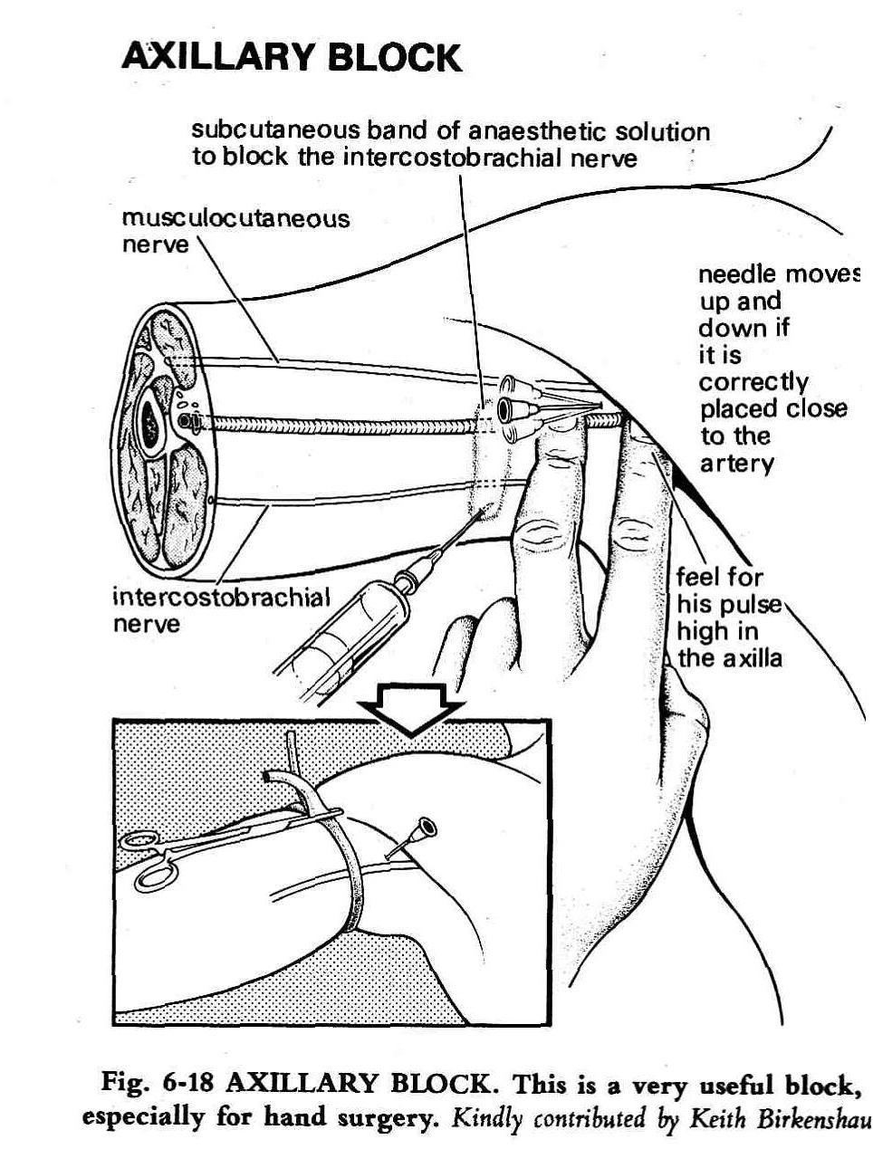

13.3 Axillary Block

INDICATIONS Operations distal to and including a patient’s elbow, especially those on his hand.
CONTRAINDICATIONS
Dislocated shoulder.
Enlarged axillary lymph nodes.
Obesity.
PREMEDICATION See Section on Premedication for Local Anesthesia.
DOSE 30 ml of 0.5% bupivacaine with adrenaline or 1% xylocaine with adrenaline (5mg/kg 2% xylocaine with adrenaline diluted to 1%). In large patients use 40 ml.
EQUIPMENT Use a 0.8x40 mm needle.
METHOD Explain to the patient exactly what you are going to do. Abduct his arm to a right angle, and place it on the table so that his hand is beside his head.
Feel for his axillary pulse with your fingers as high in his axilla as you can under his pectoralis major.
Keep your finger on his axillary pulse and raise a small wheal above it. Now, put a rubber tube around his arm just below the wheal, to act as a tourniquet, and clamp it with a haemostat to to hold the tube tightly in place.Push the needle, without a syringe, through the wheal. It will immediately fall over, as it is not supported by fat.
Pick up the needle again and push it towards his arterial pulse. You will feel resistance, followed by a “give” as you go through the fibrous sheath that protects his axillary nerves and vessels. The needle should lie almost parallel to the artery. H will now stick out, held by skin and fascia. Meanwhile, compress the neurovascular bundle and depress it slightly downwards with your index finger.
If the needle is in the right place, it will jerk up and down because of its closeness to the artery, or he may feel paraesthesiae. When you think the needle is in the right place, aspirate, and inject. Aspirate several times as you inject all but 3 ml of the solution. As you remove the needle, inject the last 3 ml of solution subcutaneously over the artery. This will usually block the intercosto-brachial nerve.
If there is no anaesthesia on the inner side of the patient’s upper arm, you have missed his intercosto-brachial nerve. If you are operating above his elbow, inject a subcutaneous band of solution, as shown in Fig. 6-18. If you are operating on or below his elbow, there is no need to block this nerve.
CAUTION! Be sure to aspirate repeatedly before and during the injection, or you may inject the solution into a vein.
Leave the patient with his arm aside during the 1 period of 20 minutes, then remove the tourniquet.

13.4 Drug Doses
Table 2. Onset, Maximum Dose, and Duration of Anesthetics (Open Table in a new window)
Drug | Onset | Maximum Dose (With Epinephrine) | Duration (With Epinephrine)
Lidocaine | Rapid | 4.5 mg/kg (7 mg/kg) | 120 min (240 min)
Bupivacaine | Slow | 2.5 mg/kg (3 mg/kg) | 4 hours (8 h)
Chloroprocaine | Rapid | 10 mg/kg (15 mg/kg) | 30 min (90 min)
Calculate the maximum tolerable dose by considering the dose to be
http://emedicine.medscape.com/article/2172060-overview May 2014

CHAPTER 14: SURGERIES

Pre-op Preparation

American Society of Anesthesiologists Fasting Recommendations* -Minimum Fasting Period†
• Clear liquids‡ -- -Stop 2 hours prior to procedure
• Breast milk------- Stop 4 hours prior to procedure
• Infant formula--- Stop 6 hours prior to procedure
• Nonhuman milk- Stop 6 hours prior to procedure
• Light meal** ---- Stop 6 hours prior to procedure
• Fried foods, fatty foods, or meat- Additional fasting time (e.g., 8 or more hours)
These recommendations apply to healthy patients who are undergoing elective procedure requiring general anesthesia, regional anesthesia, or procedural sedation and analgesia. They are not intended for women in labor. Following the guidelines do not guarantee complete gastric emptying.
Solid food intake may be safe for up to 6 h before surgery. NPO for 8 hours’ rule may be safer for patients with a higher ASA status
Clear liquids/carbohydrate drinks may be safe for up to 2 h before surgery (in relatively healthy and low risk patients children,adults and obese). A shorter fasting time of less than 8 h and the administration of carbohydrate supplements has been shown to suppress the preoperative stress response
A recent Cochrane review concluded that preoperative oral carbohydrate rich fluids up to 2 h before surgery was associated with a lower postoperative insulin resistance and a significantly reduced length of hospital stay .
In order to avoid dehydration, children undergoing elective procedures may benefit from the liberal oral intake of fluids for up to 2 h before anesthesia. In smaller children, deviation of fasting guidelines should be as short as possible and not longer than 2 h
(Out of Operating Room Anesthesia- Goudra & Kumar p 67
† The fasting periods noted above apply to all ages
‡ Examples of clear liquids include water, fruit juices without pulp, carbonated beverages, clear tea, and black coffee.
§ Since nonhuman milk is similar to solids in gastric emptying time, the amount ingested must be considered when determining an appropriate fasting period.
**A light meal typically consists of toast and clear liquids. Meals that include fried or fatty foods or meat may prolong gastric emptying time. Additional fasting time (e.g., 8 or more hours) may be needed in these cases. Both the amount and type of foods ingested must be considered when determining an appropriate fasting period.
Anesthesiology, V 126 • No 3 376 March 2017: Practice Guidelines for Preoperative Fasting and the Use of Pharmacologic Agents to Reduce the Risk of Pulmonary Aspiration: Application to Healthy Patients Undergoing Elective Procedures

14.2 Safe Surgery & Safe Anesthesia OPERATING ROOM (OR)OPERATION THEATRE(OT)
The operating room is a room specifically for use by the anesthesia and surgical teams and must not be used for other purposes.
Ensure that procedures are established for the correct use of the OR. and all staff is trained to follow them: ♣ Keep all doors to the O.R. closed, except those required for the passage of equipment, personnel and the patient
♣ Store some sutures and extra equipment in the OR to decrease the need for people to enter and leave the O.R. during a case
♣ Keep to a minimum the number of people allowed to enter the OR, especially after an operation has started
♣ Keep the O.R. uncluttered and easy to clean
♣ Between cases, clean and disinfect the table and instrument surfaces
♣ At the end of each day, clean the OR.: start at the top and continue to the floor, including all furniture, overhead equipment and lights. Use a liquid disinfectant at a dilution recommended by the manufacturer ♣ Sterilize all surgical instruments and supplies after use and store them somewhere protected and ready for the next use
The universal protocol:
This is a three-step process to confirm the correct patient, correct site, and correct procedure
Step 1: Verification
This consists of verifying the correct patient, site, and procedure at every stage from the time a decision is made to operate to the time the patient undergoes the operation. This is done at the following instances
· when the procedure is scheduled
· at the time of admission or entry to the operating theatre
· anytime the responsibility for care of the patient is transferred to another person (eg. Duty shift, leaves, etc)
· before the patient leaves the preoperative area or enters the procedure or operation theatre
Step 2: Marking
Marking of the surgical site is a crucial step especially for operations involving limbs, fingers, breast, inguinal hernias, etc). The marking should be made either by the surgeon or a doctor from the operating team preferably at the time of obtaining consent for the surgery

Step 3: Time out
Time out or surgical pause is a brief pause before the incision to confirm the patient, the procedure and the site of operation. Checklist at this point includes the following
· Check the consent form
· Check the site of surgery
· Confirm the identification with the patient (prior to anesthesia if under GA)
· Ensure that the appropriate equipment (mesh, suture materials, instruments) and diagnostics (X ray, USG, CT reports/ images) are available (This is also part of the WHO preoperative checklist which is part of the patient’s inpatient file in GAH)

SPONGE AND INSTRUMENT COUNTS
It is essential to keep track of the materials being used in the OR in order to avoid inadvertent disposal, or the potentially disastrous loss of sponges and instruments in the wound.
An OR requires the following:
♣ Good lighting and ventilation
♣ Dedicated equipment for procedures
♣ Equipment to monitor patients, as required for the procedure
♣ Drugs and other consumables for routine and emergency use
.
It is standard practice to count supplies (instruments, needles and sponges):
♣ Before beginning a case
♣ Before final closure
♣ On completing the procedure
The aim is to ensure that materials are not left behind or lost. Pay special attention to small items and sponges.
Create and make copies of a standard list of equipment for use as a checklist to check equipment as it is set up for the case and then as counts are completed during the case. Include space for suture material and other consumables added during the case. When trays are created with the instruments for a specific case, such as a Caesarean section, also make a checklist of the instruments included in that tray for future reference.
Leave the O.R. ready for use in case of emergency

OPERATIVE PROCEDURE LIST An operative procedure list is needed whenever the surgical team will perform several operations in succession. The list is a planned ordering of the cases on a given day. Elements such as urgency, the age of the patient, diabetes, infection and the length of the procedure should all be considered when drawing up the list.
Operate on “clean” cases before infected cases since the potential for wound infection increases as the list proceeds.
Also consider other factors when making up the operative list: children and diabetic patients should be operated on early in the day to avoid being subjected to prolonged periods without food.

Ensure that between operations:
1Operating theatre is cleaned 2 Instruments are re-sterilized 3.Fresh linen is provided
It is essential to have clear standard procedures for cleaning and the storage of operating room equipment; these must be followed by all staff at all times. The probability of wound infection increases in proportion to the number of breaches of aseptic technique and the length of the procedure

Before induction of anaesthesia: SIGN IN
- PATIENT HAS CONFIRMED
- IDENTITY
- SITE
- PROCEDURE
- CONSENT SITE MARKED
- ANAESTHESIA SAFETY CHECK COMPLETED
- PULSE OXIMETER ON PATIENT AND FUNCTIONING
- DOES PATIENT HAVE A KNOWN ALLERGY?
- DIFFICULT AIRWAY/ASPIRATION RISK? AND EQUIPMENT/ASSISTANCE AVAILABLE
- RISK OF >500ML BLOOD LOSS (7ML/KG IN CHILDREN)?
- AND ADEQUATE INTRAVENOUS ACCESS AND FLUIDS PLANNED

Before skin incision : TIME OUT

CONFIRM ALL TEAM MEMBERS HAVE INTRODUCED THEMSELVES BY NAME AND ROLE SURGEON, ANAESTHESIA PROFESSIONAL AND NURSE VERBALLY CONFIRM
• PATIENT
• SITE
• PROCEDURE
- ANTICIPATED CRITICAL EVENTS
SURGEON REVIEWS:
- WHAT ARE THE CRITICAL OR UNEXPECTED STEPS,
- OPERATIVE DURATION,
- ANTICIPATED BLOOD LOSS?
ANAESTHESIA TEAM REVIEWS:
- ARE THERE ANY PATIENT-SPECIFIC CONCERNS?
NURSING TEAM REVIEWS: HAS STERILITY (INCLUDING INDICATOR RESULTS) BEEN CONFIRMED?
- ARE THERE EQUIPMENT ISSUES OR ANY CONCERNS?
HAS ANTIBIOTIC PROPHYLAXIS BEEN GIVEN WITHIN THE LAST 60 MINUTES? YES NOT APPLICABLE IS ESSENTIAL IMAGING DISPLAYED?

Before patient leaves operating room Sign Out
NURSE VERBALLY CONFIRMS WITH THE TEAM:
- THE NAME OF THE PROCEDURE RECORDED
- THAT INSTRUMENT, SPONGE AND NEEDLE COUNTS ARE CORRECT (OR NOT APPLICABLE)
- HOW THE SPECIMEN IS LABELLED (INCLUDING PATIENT NAME)
- WHETHER THERE ARE ANY EQUIPMENT PROBLEMS TO BE ADDRESSED
- SURGEON, ANAESTHESIA PROFESSIONAL AND NURSE REVIEW THE KEY CONCERNS FOR RECOVERY AND MANAGEMENT OF THIS PATIENT

14.2 Preoperative Ward Instructions
- Check whether consent form is complete
- Weight, height of the patient checked and entered in the chart
- NPO for 6 to 8 h before elective surgery (or as instructed by the anesthetist)
- Make sure the operation site has been marked and that patient has a name band
- IV Cannula – 18G left upper limb unless otherwise specified (20G for cases under LA/sedation)
- IV Fluids: DNS @ 2ml/kg/h or RL/NS for diabetics or RL for hypertensives. To be started 1-2 h before surgery
- Premedication – Tab Clonazapem 0.25mg night before surgery. Tab. Pantoprazole 40mg at 6 am on the day of surgery – check with anesthetist
- Arrange compatible blood if ordered
- Regular medications to be continued as per orders (eg. Eltroxine, Metoprolol, etc)
- Remove dentures/ jewellery/hair care/nail polish/empty bladder before transfer to OT
- Make sure the patient is not taking his/her usual medicines – only the ones ordered after admission. If patient was on aspirin or clopidogrel make sure it was discontinued 5 days before surgery (or as planned by the operating team)
- Clipping hair (NO shaving) in the preop area or on table in OT
- Bath with soap the previous evening of surgery
- Bowel preparation – Soap and water enema on the morning of surgery (if indicated)
- Laparoscopic surgeries – clean the umbilicus with betadine twice the day before surgery
- Foley catheter in ward – For LSCS, and in OT after the antibiotic for other surgeries
- Patient Book, special investigations to be sent to OR (e.g., Doppler, CT, MRI) with the patient
General Instructions:
- Patient relatives to be informed that only one person is allowed inside ward after admission for surgery till discharge
- Eating is not allowed in the ward for the patient’s attenders

POSTOPERATIVE CARE
Look for the following in the Recovery Room:
♣ Airway obstruction
♣ Hypoxia
♣ Hemorrhage: internal or external
♣ Hypotension and/or hypertension
♣ Postoperative pain
♣ Hypothermia, shivering
♣ Vomiting
♣ Residual narcosis
♣ Falling on the floor

The recovering patient is fit for the ward when he or she is:
□ Awake, opens eyes
□ Extubated
□ Breathing spontaneously, quietly and comfortably
□ Can lift head on command
□ Not hypoxic
□ Blood pressure and pulse rate are satisfactory
□ Appropriate analgesia has been prescribed and is safely established

After Spinal Anaesthesia:
- Post op nurse should know what surgery was done and under what type of anesthesia, if there were any problems in the OT and if anything special need to be looked for, and if there is a drain/Foley catheter.
- Vital signs (heart rate, respiratory rate, blood pressure, oxygen saturation and temperature) should be recorded as soon as patient has been transferred and at least every 5 minutes for the first 30 minutes and every 15 minutes thereafter for one hour.
- Inform if there is hypotension - SBP < 80 or fall >20% from baseline Give bolus IV fluids (around 4-5ml/kg) after informing doctor & Mephentermine 3mg IV stat.
- Inform if heart rate is <50 or fall >20% from baseline OR if >100 or increase >20% from baseline.
- Inform if SPO2 <94%. Wake the patient up if sleeping, advise deep breaths, oxygen supplementation as required.
- Inform if RR >30 or <10.
- Inform if temperature <36°C or 96.8°F. Shivering should be treated aggressively.
- Check and record dermatomal level of spinal anaesthesia
- Testing of Bromage scale This will allow continuous assessment of the degree of motor blockade.
- Keep patient NPO till the anesthetic has worn off and there is no bleeding or any postop complication requiring reoperation
- If patient wants to pass urine don’t let him stand up or sit till sensation and motor function has returned..
- If patient has a Urinary catheter check that it is in place and draining well. Keep urine output of 0.5-1ml/kg /h. In patients without a urinary catheter, care must be taken to assess for urinary retention.
- Check and adjust any intravenous infusions.
- Ensure the patient is warm and comfortable.
14 Provide analgesia and / or anti-emetics as required
- If the BP is high the patient may have pain or a full bladder.
15 Once the effect of the spinal anesthetic has worn off encourage ankle movement to prevent DVT
16 Inspect and record the condition of the needle puncture site over the lumbar spine. Infection is a rare but potentially devastating complication. Signs can include fever, headache, and nausea.
Lab investigations as advised
POD1: Check for
- Severe headache
- Postural headache
- Neck stiffness/pain
- Fever
- Photophobia
- Ongoing lower limb weakness, paresthesia
- Urinary incontinence
- Fecal incontinence
- Erythema at spinal entry point
After General anaesthesia/Sedation
- NPO till further orders
- Level of consciousness – fully awake, arousable on calling, not responding
- Head end elevation 15-30°
- Vital signs (heart rate, respiratory rate, blood pressure, oxygen saturation and temperature) should be recorded at least every 5 minutes for the first 30 minutes and every 15 minutes thereafter for one hour.
- Inform if there is >20% decrease or increase in BP from baseline.
- Inform if heart rate is <50 or fall >20% of baseline OR if >100 or increase >20% of baseline.
- Inform if SPO2 <94%. Wake the patient up if sleeping, advise deep breaths, oxygen supplementation if required.
- Inform if RR >30 or <10.
- Inform if temperature <36°C or 96.8°F. Shivering should be treated aggressively.
- Check that the urinary catheter in place, is patent and draining well. Maintain urine output of 0.5-1ml/kg/h. In patients without a urinary catheter, care must be taken to assess for urinary retention
- Check and adjust any intravenous infusions.
- Ensure the patient is warm and comfortable.
- Once patient is awake encourage deep breathing & coughing and ankle exercises
- Provide analgesia and / or anti-emetics as required.
- Lab investigations as advised

14.3 Pre-op/Post op Care for some Common Operations
INGUINAL HERNIA
- Ask pt not to shave at home To clip hair preop in the hospital
- Make sure pt is not coughing and is not constipated
- Preop 2gm cefazolin iv on call and give 1 dose postop
- Inj glcopylorate1ml preop in case ketamine or GA needed if spinal fails
- At surgery suture mesh in place with #0 vicryl urology needle, high ligation of sac with 20 vicryl which can be used to close ext oblique, Skin subcut 30 vicryl
- Post op give IV ondansetron 4mg q8h till po tolerated well
- Post op if pt has not voided after 8hrs place a Foley and remove it next morning
INCISIONAL HERNIA
- Give preop ampiclox, genta, metro if bowel dissection anticipated
- If possible use the hernia mesh system so that the posterior mesh is on the peritoneum under the fascia/muscle and the anterior is on the fascia
- Inj glycopyrolate 1ml preop in case ketamine or GA needed if spinal fails
- Post op give IV ondansetron 4mg q8h till po tolerated well
- Remove the suction drain when drainage< 30ml/24hrs
LAPROSCOPIC HYSTERECTOMY
- Give preop ampiclox, genta, metro and for 5 days postop
- Inj glcopylorate 1ml preop in case ketamine or GA needed if spinal fails
- Catherise pt
- After Sx Keep NPO for 24hrs or pt passes flatus
- Post op check electrolytes if flatus delayed.

14.4 WOUNDS -There are 4 types of wounds
- Clean wounds show no signs of infection or inflammation. They often involve the eyes, skin, or vascular system with no injury to an internal organ. The risk for an infection in this type of wound is usually less than 2%. Can be closed primarily
- Clean-contaminated wounds have no signs of infection at the time of surgery. Examples of this type of wound include surgery on the lungs, appendix and vaginal procedures. The risk for an infection is usually less than 10%. May be cleaned and left open packed with saline guaze
- Contaminated wounds include open, fresh accidental wounds and wounds that involve an internal organ. Blood and other fluids can spill from the organ into the wound. The risk for an infection is usually 13%–20%. Incisions after surgery that involve the gastrointestinal (digestive) tract may be at a high risk of becoming infected. May be cleaned and left open packed with saline guaze
- Dirty-contaminated wounds have an infection that is already present at the time of the surgery. The risk for an infection in these cases is usually about 40%. Eg wounds contaminated with soil or injury with farm implement should be cleaned and left open packed with saline guaze
Wound Location | Time until Removal
Face | 3 to 5 days
Scalp | 7 to 10 days
Arms | 7 to 10 days
Trunk/Torso | 10 to 14 days
Legs | 10 to 14 days
Tops of hands or feet | 10 to 14 days
Palms or soles | 14 to 21 days
Suture Removal

  - Pediatric Surgery
Inguinal hernia in children- Primary inguinal hernia occurs in 1 to 5 percent of all newborns and 9 to 11 percent of those born prematurely. Among low- and very low-birth-weight infants, the frequency of inguinal hernia varies by birth weight as follows:
●500 to 1000 g – 30 to 42 percent
●1000 to 1500 g – 10 percent
●1500 to 2000 g – 3 percent
The incidence in boys is three to four times higher than in girls, with the right side being affected more commonly in both sexes.
The incidence of incarceration ranges from 14 to 31 percent, usually occurring in infants younger than one year of age. Among children with incarcerated inguinal hernias, as many as 85 percent occur before the first birthday.
The definitive management of inguinal hernia is surgical repair. Referral to a surgeon and the timing of the repair depend on whether or not the hernia is reducible. In addition, incarcerated hernias must be reduced as quickly as possible to avoid strangulation of the contents of the hernia sac.
No mass, reducible mass — A convincing history of intermittent groin swelling or a reducible inguinal mass are indications for referral to a surgeon. Once the diagnosis is made, however, repair should be performed soon to avoid complications, such as incarceration. Incarceration has been reported in as many as 13 percent of children awaiting elective repair, with the majority of cases in those less than one year of age. While awaiting surgical evaluation, caretakers should be informed of the signs and symptoms of incarceration and provided with indications for seeking medical attention.
Incarcerated inguinal hernia — An incarcerated inguinal hernia must be emergently reduced, either manually or surgically. Once the diagnosis has been made, children should have nothing by mouth, since emergent surgery may be required to reduce the hernia.
Manual reduction — Unless the child appears extremely ill and has signs of peritonitis, intestinal obstruction, or toxicity from gangrenous bowel, manual reduction should be attempted. Manual reduction is successful in 95 to 100 percent of patients. Elective repair within 24 to 48 hours after successful manual reduction has a lower complication rate than emergent operative reductionThe short delay allows the involved tissues to return to their normal texture before surgery. To minimize the risk of recurrence, definitive hernia repair should be performed within five days (within two days for infants born prematurely) of the manual reduction

14.5 Pediatric Surgery - Hydrocele
A hydrocele is a collection of peritoneal fluid between the parietal and visceral layers of the tunica vaginalis. Hydroceles may be communicating or noncommunicating.
Communicating hydroceles usually develop as a result of failure of the processus vaginalis to close during development; the fluid around the testis is peritoneal fluid Noncommunicating hydroceles have no connection to the peritoneum; the fluid comes from the mesothelial lining of the tunica vaginalis.
Hydroceles are common in newborns The majority of hydroceles in neonates resolve spontaneously, usually by the first or second birthday.
In older children and adolescents,with a h/o with testicular pain and scrotal swelling, noncommunicating hydroceles may be idiopathic or may occur secondary to epididymitis, orchitis, testicular torsion, torsion of the appendix testis or epididymis, trauma, or tumor (reactive hydroceles). Doppler ultrasonography is usually necessary to evaluate these patients further.
Clinical presentation — Patients with hydroceles present with a cystic scrotal mass. A hydrocele that communicates with the peritoneal cavity may increase in size during the day or with the Valsalva maneuver. In contrast, noncommunicating hydroceles are not reducible and do not change in size or shape with crying or straining.
Although rare, large, noncommunicating hydroceles may extend through the inguinal ring and into the abdomen creating an abdominal scrotal hydrocele. This condition is suspected when abdominal extension of the hydrocele into the abdominal cavity is present on examination and confirmed by sonogram
Diagnosis — The diagnosis of hydrocele can be made by physical examination and transillumination of the scroum that demonstrates a cystic fluid collection. Communicating hydroceles are often reducible; noncommunicating hydroceles are not. Doppler ultrasonography may be necessary to evaluate the testicle and rule out a primary cause or to determine if an abdominoscrotal hydrocele is present.
Management — Surgical repair is indicated for communicating hydroceles that persist beyond one to two years of age and for idiopathic, noncommunicating hydroceles that are symptomatic or compromise the skin integrity .The management of asymptomatic hydroceles in a neonate or child younger than one to two years of age usually is supportive. Hydroceles that are present in newborns, whether communicating or noncommunicating, usually resolve spontaneously by the second birthday, unless they are accompanied by an inguinal hernia or are large.
Communicating hydroceles in patients older than two years of age rarely resolve and pose a risk for development of incarcerated inguinal hernia. Surgical repair of communicating hydroceles is usually undertaken on an elective basis.
Idiopathic noncommunicating hydroceles are often asymptomatic. Surgical repair may be indicated for symptomatic complaints and for abdominal scrotal hydroceles [5].
Reactive hydroceles usually resolve with treatment of the underlying condition.
14.6 Pedatric Surgery – Undescended Testes

Most testes that are undescended at birth complete their descent within the first three to four months of life. Spontaneous descent is rare after four months of age.

Timing of surgery — Surgical treatment of undescended testes is recommended as soon as possible after four months of age for congenitally undescended testes and definitely should be completed before the child is two years old as this is associated with improved testicular growth and fertility potential.
In a randomized trial, 149 boys with unilateral palpable undescended testis were assigned to orchiopexy at nine months or three years of age. At 12, 24, 36, and 48 months of age, testes in the nine-month group were larger and had greater increase in size compared with baseline than testes in the three-year group. No significant growth was noted in the three-year group . Testicular biopsies demonstrated a decline in the number of germ and Sertoli cells between nine months and three years
Treatment of undescended testes before puberty also may reduce the risk of testicular cancer, permit earlier detection of testicular masses, and prevent testicular torsion.
Palpable testes -Orchiopexy — . The procedure is performed through either an inguinal or scrotal incision.
Nonpalpable testes-Imaging — Imaging is not routinely warranted to locate nonpalpable testes. Imaging studies lack the sensitivity and the specificity to alter the need for exploratory surgery.
Exploratory surgery — Exploratory surgery (open inguinal or laparoscopic) for the nonpalpable testis is diagnostic and potentially therapeutic. The first surgical objective is to determine whether or not the testis is present; viable testes are positioned and fixed within the scrotum; nonviable testicular remnants are removed. At the time of surgery, approximately 10 percent of boys with nonpalpable testes are found to have blind-ending testicular vessels, indicating an absent testicle.
Examination under anesthesia is the first step in the surgical management of the clinically nonpalpable testis. In a series of 263 nonpalpable testes, 18 percent were palpable in the groin during examination under anesthesia, obviating the need for laparoscopy. In addition, if a "nubbin" is palpated in the scrotum, rapid scrotal exploration can confirm the diagnosis of an atrophied testis. Criteria for making a diagnosis of an atrophied testis include identification of a hemosiderin deposit and/or the clear identification of atretic vas deferens and vessels.
Exploration of the groin is the first step in the open inguinal approach [86]. If cord structures or testicular remnants are found, they are removed and the procedure is terminated. Exploration proceeds to the peritoneum if the groin exploration is negative.
In diagnostic laparoscopy the laparoscope, placed via the umbilicus, is used to examine the inguinal rings, determine the patency of the processus vaginalis, and examine the Wolffian structures and testicular vessels. The finding of blind-ending spermatic vessels, confirming the absent testis, permits termination of the procedure without a groin incision. Groin exploration is carried out if testicular vessels and vas deferens are visualized exiting the internal ring. The laparoscopic identification of an intra-abdominal testis permits planning for the definitive procedure (eg, open versus laparoscopic).
Hormonal treatment for undescended testes is not recommended.

Long-term follow-up — Boys who have undergone treatment for undescended testes have an increased risk of testicular cancer. They should be taught how to perform testicular self-examination during adolescence and instructed to perform the examination monthly,

14.7 Varicocele
A varicocele is a collection of dilated and tortuous veins in the pampiniform plexus surrounding the spermatic cord in the scrotum. The cause of primary or idiopathic varicoceles, that arise spontaneously and are not caused by obstruction of the inferior vena cava, is unknown. One etiologic theory is that primary varicoceles result from increased venous pressure and incompetent valves. Varicoceles occur more commonly on the left side (85 to 95 percent) because the left spermatic vein enters the left renal vein at a 90 degree angle, whereas the right spermatic vein drains at a more obtuse angle directly into the inferior vena cava, facilitating more continuous flow. Approximately 10 to 25 percent of all adolescent males and as many as one-third of all males examined at an infertility clinic have a varicocele. However, only 10 to 15 percent of males with varicoceles have fertility problems.
Clinical presentation and diagnosis — Patients with varicoceles can be asymptomatic or present complaining of a dull ache in or fullness of the scrotum upon standing. The key task for the examiner is to differentiate primary varicocele from secondary varicocele caused by obstruction of the inferior vena cava.
The examination for varicocele initially should be performed with the patient standing. The scrotum is inspected for any visible distention around the spermatic cord (indicative of a grade III varicocele). The scrotum, testes, and cord structures are then gently palpated; a palpable varicocele has the texture of a "bag of worms". Grade II varicoceles are palpable, but nonvisible. The patient should then be asked to perform the Valsalva maneuver; if the varicocele is palpable only with the Valsalva maneuver, it is Grade I.
The patient also should be examined in the supine position. This maneuver will help to differentiate idiopathic or primary from secondary varicocele. Primary varicocele usually is more prominent in the upright position and disappears in supine, whereas secondary varicocele usually does not get much smaller with change in position from upright to supine.
If the varicocele persists in the supine position, has acute onset, or is right-sided (secondary varicocele), then processes that cause inferior vena caval (IVC) obstruction must be ruled out with Doppler ultrasonography. These processes include:
●IVC thrombus
●Right renal vein thrombosis with clot propagation down the IVC
●Abdominal mass (eg, retroperitoneal tumors, kidney tumors, or lymphadenopathy)
Varicocele grade does not correlate well with abnormal semen analysis or infertility in adults. Studies in adolescents correlating varicocele grade and testicular size in adolescents have had conflicting results .
Elevations in unstimulated LH and FSH concentrations may be more predictive
Management — There are no clear guidelines established for treatment of a varicocele in childhood. Referral to an urologist is indicated for patients with pain, decreased testicle size, or large varicocele. Most varicoceles in adolescents are managed conservatively with observation.
1Varicoceles are repaired through surgical ligation or testicular vein embolization under the following circumstances:
●Affected testicular volume is less than that of the unaffected testicle (a difference in size of >10 to 15 percent or >2 mL when assessed by ultrasonography) because loss of testicular volume is associated with a decreased sperm count and testicular growth arrest can be reversed with varicocele repair.
●To alleviate symptoms such as pain, heaviness, or swelling.
●Bilateral varicoceles.
●When obtained, abnormal seminal fluid analysis.
Although grade of varicocele should not be the sole indication for intervention, treatment may be warranted in adolescents with large varicoceles (grade III) and abnormal semen analysis because varicocele repair has been associated with improved semen analysis in adolescents and young men. However, improved fertility and paternity after surgical treatment of varicoceles in adolescents has not been clearly established.
14.8 Testicular cancer
Testicular cancer accounts for 20% of cancer diagnosed in males 15 to 35 years old, rendering it the most common solid tumor in males within this age group. The epidemiology and risk factors for testicular cancer, which include cryptorchidism, family history of testicular cancer, cancer of the other testicle, human immunodeficiency virus (HIV) infection, germ cell neoplasia in situ and race
Clinical presentation — Testicular cancer usually presents as a painless mass discovered by the patient or clinician on physical examination, although rapidly growing germ cell tumors may cause acute scrotal pain secondary to hemorrhage and infarction. Other common signs are testicular enlargement or swelling. Many patients also report an aching feeling in the lower abdomen or scrotum. On examination, intrascrotal malignancies usually are firm, nontender masses that do not transilluminate. Some patients may have gynecomastia.
Diagnosis — Scrotal ultrasound is the initial diagnostic test of choice. It may help to distinguish intrinsic from extrinsic testicular lesions. Several conditions may mimic neoplasia on ultrasound, including inflammation, hematoma, infarct, fibrosis, and tubular ectasia of the rete testis. In cases in which the ultrasound is inconclusive, magnetic resonance imaging (MRI) may help differentiate benign from malignant lesions. In one study no lesion defined as benign by MRI proved to be malignant
Boys with lesions that are consistent with cancer should be referred to a urologist for diagnostic evaluation, which may include blood tests for various tumor markers, and radical inguinal orchiectomy.
The presenting manifestations of testicular cancer are attributable to metastatic disease in approximately 10% of patients. Symptoms vary with the site of metastasis:
●A neck mass (supraclavicular lymph node metastasis)
●Cough or dyspnea (pulmonary metastasis)
●Anorexia, nausea, vomiting, or gastrointestinal hemorrhage (retroduodenal metastasis)
●Lumbar back pain (bulky retroperitoneal disease involving the psoas muscle or nerve roots)
●Bone pain (skeletal metastasis)
●Central or peripheral nervous system symptoms (cerebral, spinal cord, or peripheral root involvement)
●Unilateral or bilateral lower extremity swelling (iliac or caval venous obstruction or thrombosis)
Gynecomastia, which occurs in approximately 5 percent of men with testicular germ cell tumors, usually associated with production of human chorionic hCG by foci of choriocarcinoma or trophoblastic cells in the tumor. These tumors are found in 6- to 10- year-old boys who present with precocious puberty and in 26- to 35-year-old men who present with a testicular mass, gynecomastia, impotence, and loss of libido.

Management — In any man with a solid, firm mass within the testis, testicular cancer must be the diagnosis until proven otherwise as this provides the best opportunity for cure.
Nevertheless, both patient and clinician factors often contribute to a delay in diagnosis. Painless scrotal masses are sometimes ignored, while testicular cancers presenting with scrotal pain are often treated as epididymitis.
The diagnostic evaluation of men with suspected testicular cancer includes scrotal ultrasound followed by radiographic testing, measurement of serum tumor markers, radical inguinal orchiectomy, and in some cases, retroperitoneal lymph node dissection (RPLND). The results are used to determine the histologic type and extent of disease, and to guide therapy. Testicular biopsy is not performed as part of the evaluation due to concern that it may result in tumor seeding into the scrotal sac or metastatic spread of tumor into the inguinal nodes. In addition, since the vast majority of these patients are young men, consideration should be given to fertility issues and sperm cryopreservation during the initial diagnostic evaluation. If possible, a baseline sperm count and sperm banking should be performed prior to the radiographic diagnostic evaluation in order to avoid radiation exposure of the sperm. Bilateral scrotal ultrasound can distinguish intrinsic from extrinsic testicular lesions with a high degree of accuracy and can detect intratesticular lesions as small as 1 to 2 mm in diameter. In men with testicular masses, scrotal ultrasound has become an extension of the physical examination, but it should never be considered a substitute for the latter. A cystic or fluid-filled mass is unlikely to represent malignancy.
CT scan — A high-resolution computed tomography (CT) scan of the abdomen and pelvis, and a chest Xray are generally performed. Chest CT is recommended if the CXR is abnormal or if metastatic disease involving the thorax is strongly suspected.Regional metastases first appear in the retroperitoneal lymph nodes. Serum tumor markers — Blood chemistry profile, CBC, and 3 serum tumor markers: alpha-fetoprotein (AFP), the beta subunit of human chorionic gonadotropin (beta-hCG; since the alpha subunit is common to several pituitary hormones), and lactate dehydrogenase (LDH). Serum levels of AFP and/or beta-hCG are elevated in 80 to 85 percent of men with NSGCTs, even when nonmetastatic. By contrast, serum beta-hCG is elevated in less than 20 percent of testicular seminomas, and AFP is not elevated in pure seminomas. Although serum tumor markers are helpful at the time of initial diagnosis of testicular cancer and for prognostication, their main utility is for subsequent follow-up of disease status after primary treatment.
Radical inguinal orchiectomy — A radical inguinal orchiectomy should be performed to permit histologic evaluation of the primary tumor and to provide local tumor control. Contralateral testicular biopsy at the time of radical orchiectomy in a clinically normal is not recommended, but instead, careful surveillance of the contralateral testis is advocated.
Retroperitoneal lymph node dissection — RPLND is the only reliable method to identify nodal micrometastases given the high false-negative rate with CT scan. It is also the gold standard for providing accurate pathologic staging of the retroperitoneum. Both the number and size of involved retroperitoneal lymph nodes have prognostic importance.

14.9Antibiotic Prophylaxis
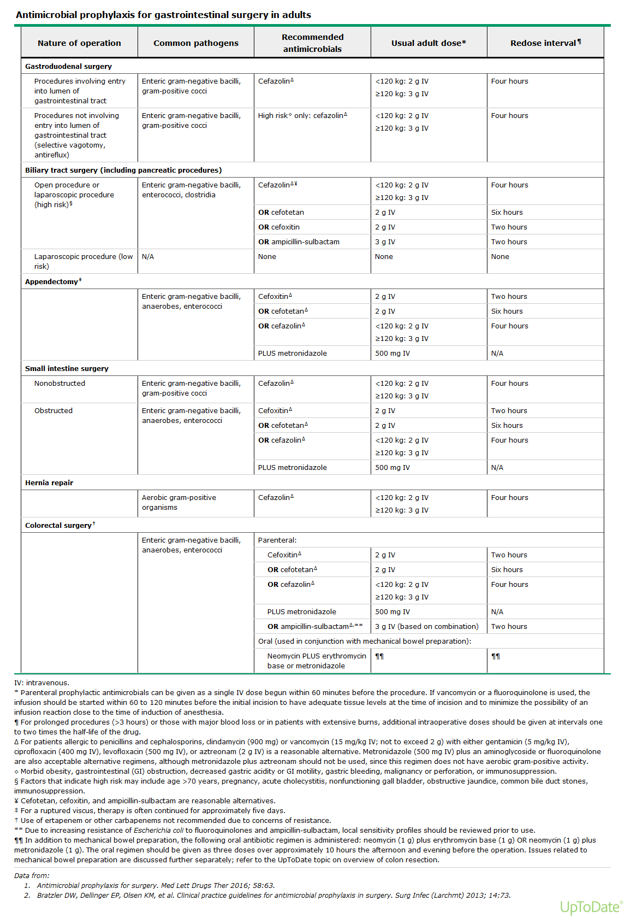

CHAPTER 15: PSYCHIATRIC DISORDERS

15.1Depression
15.2Withdrawals
Alcohol The medical, economic, and psychosocial problems of alcoholism are staggering.
The central and peripheral nervous system complications include chronic brain syndromes, cerebellar degeneration, cardiomyopathy, and peripheral neuropathies.
Direct effects on the liver include cirrhosis, esophageal varices, and eventual hepatic failure.
Indirect effects include protein abnormalities, coagulation defects, hormone deficiencies, and an increased incidence of liver neoplasms.
Fetal alcohol syndrome includes one or more of the following developmental defects in the offspring of alcoholic women: the risk is appreciably higher the more alcohol ingested by the mother each day. (1) low birth weight and small size with failure to catch up in size or weight, (2) mental retardation, with an average IQ in the 60s, and (3) a variety of birth defects, with a large percentage of facial and cardiac abnormalities.
Hallucinosis Alcoholic hallucinosis, which can occur either during or on cessation of a prolonged drinking period, is not a typical withdrawal syndrome and is handled differently. Since the symptoms are primarily those of a psychosis in the presence of a clear sensorium, they are handled like any other psychosis: hospitalization (when indicated) and adequte amounts of antipsychotic medications. Haloperidol, 5 mg orally twice a day for the first day or so, usually ameliorates symptoms quickly, and the medication can be decreased and discontinued over several days as the patient improves. It then becomes necessary to deal with the chronic alcohol abuse, which has been discussed.
Acute Alcohol IntoxicationThe signs of alcoholic intoxication are the same as those of overdosage with any other central nervous system depressant: drowsiness, errors of commission, psychomotor dysfunction, disinhibition, dysarthria, ataxia, and nystagmus. For a 70-kg person, 30-ml of whiskey, a 120- to 180 ml glass of wine, or a 360 ml bottle of beer (roughly 15, 11, and 13 grams of alcohol, respectively) may raise the level of alcohol in the blood by 25 mg/ml. For a 50-kg person, the blood alcohol level would rise even higher (35 mg/ml) with the same consumption. Blood alcohol < 50 mg/ml rarely cause significant motor dysfunction (the legal limit for driving under the influence is commonly 80 mg/ml). Intoxication as manifested by ataxia, dysarthria, and nausea and vomiting indicates a blood level > 150 mg/ml, and lethal blood levels range from 350 mg/ml to 900 mg/ml. In severe cases, overdosage is marked by respiratory depression, stupor, seizures, shock syndrome, coma, and death. Serious overdoses are frequently due to a combination of alcohol with other sedatives.
Alcohol Withdrawal There is a wide spectrum of manifestations of alcohol withdrawal, ranging from anxiety, decreased cognition, and tremulousness, through increasing irritability and hyperreactivity to full-blown delirium tremens (DTs).
The acute withdrawal syndrome is often completely unexpected, occurring when the patient has been hospitalized for some unrelated problem, thus presenting as a diagnostic dilemma. Suspect alcohol withdrawal in every unexplained delirium
Alcohol withdrawal syndrome can be categorized as
- mild,
- moderate, or
- severe withdrawal,
- withdrawal seizures, and
- DTs.
Symptoms of mild withdrawal, including tremor, anxiety, tachycardia, nausea, vomiting, and insomnia begin within 6 hours after the last drink, often before the blood alcohol levels drop to zero, and usually have passed by day 2.
Severe or major withdrawal occurs 48–96 hours after the last drink and is usually preceded by prolonged heavy alcohol use. Symptoms include disorientation, agitation, diaphoresis, whole body tremor, vomiting, hypertension, and hallucinations (visual>tactile>auditory). Moderate withdrawal symptoms and signs fall between those of minor and major withdrawal.

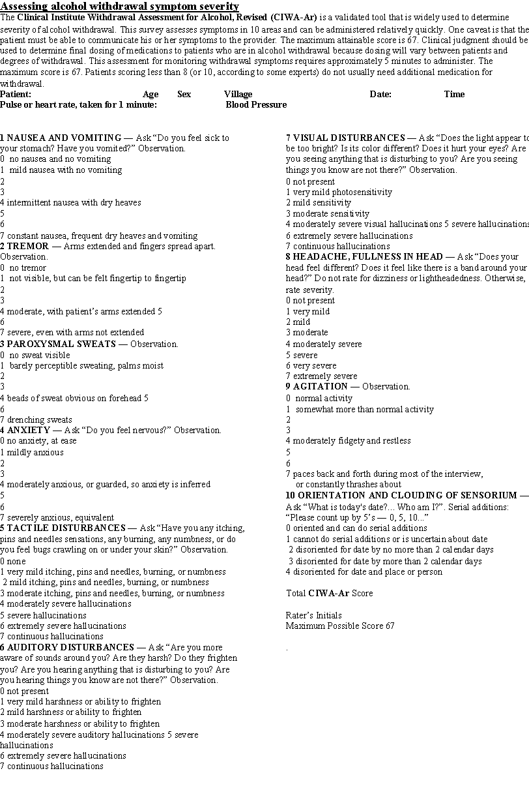

Management of Alcohol Withdrawal -For all hospitalized patients, general management includes ensuring
- adequate hydration,
- correction of elec trolyte imbalances (particularly magnesium, calcium, and potassium), and a
- dministering the vitamins thiamine (100 mg intravenously daily for 3 days then orally daily), Thiamine should be given prior to any glucose- containing solutions to decrease the risk of precipitating Wernicke encephalopathy or Korsakoff syndrome
- folic acid (1 mg orally daily), and a multivitamin orally daily.
.Alcohol withdrawal is treated with benzodiazepines. Continual assessment is recommended to determine the severity of withdrawal, and symptom-driven medication regimens, which have been shown to prevent undersedation as well as oversedation and to reduce total benzodiazepine usage over fixed-dose schedules, should be used.
The severity of withdrawal will determine a patient’s level of care. For those at risk for withdrawal and with mild withdrawal symptoms, admission to a medical unit is adequate. For those with moderate withdrawal, a higher acuity hospital environment is recommended. Those with severe with-drawal should be admitted to the ICU.
AMinimal withdrawal symptoms (CIWA-Ar score < 8)— are suitable for withdrawal prophylaxis with benzodiazepine diazepam orally, tapered over 3 days. Start with diazepam, 5 mg q6h for 1 day, then 5 mg q8h for 1 day, then 5 mg q12h for 1 day, then discontinue. Decrease dosage in patients with liver disease. The protocol calls for nursing assessment of sedation and withdrawal symptoms (CIWA-Ar) q6h. Sedation is assessed 30–60 minutes after each medication dose. The diazepam dose is held for oversedation or if the respiratory rate is < 10 breaths per minute.
B Mild withdrawal symptoms (CIWA-Ar score 8–15)— For CIWA-Ar score >8, doctor must be notified, because this is suggestive of active withdrawal, and escalation of treatment must occur. For patients in mild withdrawal, diazepam orally or intravenously can be used.
Initially, diazepam 5-10mg PO or IV is given q1h for 2 hours. Assess for level of sedation and withdrawal symptoms (CIWA-Ar) q4h. Dosing is adjusted as necessary to control symptoms without excessive sedation. After the first 2 hours, give diazepam 2.5-5 mg orally or IV every 4 hours as needed. Additional doses of benzodiazepines should be given if the CIWA-Ar score remains between 8 and 15.
C. Moderate withdrawal (CIWA-Ar score 16–20)— For patients in moderate withdrawal, give diazepam 10-20 mg orally or IV is given q1h for the first 2 hours. Continuous pulse oximetry and cardiac monitoring should be considered. The degree of sedation should be monitored 30–60 minutes after each oral dose of medication and for 15 minutes after each parenteral dose. CIWA-Ar monitoring should occur every 2 hours. Dosing is adjusted to control symptoms without excessive sedation.
After initial dosing, continue with diazepam 5-10mg orally or IV q2h as needed for CIWA-Ar score between 16 - 20, and diazepam 2.5–5 mg orally or IV q2h for CIWA-Ar score between 8-15

D. Severe withdrawal (CIWA-Ar score greater than 21)—Patients with severe withdrawal are at risk for the development of DTs and should be transferred or admitted to the ICU. IV diazepam is the medication of choice for treating severe withdrawal. Diazepam 5–10mg IV every 15 minutes can be given until patient is calm and sedated but awake. Initial CIWA-Ar monitoring should occur every 30 minutes. The patient can then receive diazepam 10 mg orally or intravenously every hour as needed when the CIWA-Ar score is between 16-20, and diazepam 5–10 mg orally or intravenously every hour as needed when the CIWA-Ar score is between 8 -15.
In limited cases of severe withdrawal requiring frequent diazepam boluses for at least 6 hours, continuous intravenous diazepam infusion can be considered, but the patient must be monitored extremely carefully for signs of respiratory depression. Continuous pulse oximetry and close observance of the patient’s respiratory status is required. Sedation is assessed 15 minutes after each intravenous dose.
If withdrawal symptoms are refractory to escalating diazepam usage, , escalation to propofol should be considered. Patients receiving large doses of diazepam often require intubation for airway protection, at which time initiation of propofol infusion for sedation, in addition to treatment of refractory alcohol withdrawal, is recommended. In all cases, benzodiazepines should be held if the patient is too sedated or has a respiratory rate less than 10 breaths per minute. Do not bolus diazepam in doses greater than 20 mg intravenously. Once a patient has been stable for 24 hours, the diazepam dose can be reduced by 20% daily until withdrawal is complete.
Withdrawal seizures can occur as early as 8hrs and not later than 48 hours post-Alcohol) more prevalent in persons who have a history of withdrawal syndromes
- Generalized tonic-clonic Seizures
- Brief Seizures (<5 minutes) and resolve spontaneously
- If withdrawal is untreated, these seizures can recur in about 60% of patients
- Status Epilepticus is not due to withdrawal
- Sedating doses of diazepam are effective in treating alcohol withdrawal seizures.
- Phenytoin does not appear to be useful in managing alcohol withdrawal seizures per se. Other anticonvulsants are not usually needed unless there is a preexisting seizure disorder.DTs will develop in approximately half of these patients.
- If seizures are focal, associated with trauma or fever, or have an onset more than 48 hours after the last drink, another etiology for seizures must be considered

Delirium tremens
DTs is the most severe form of alcohol withdrawal. It is an acute organic psychosis that usually manifests 48–72 hours after the last drink, but may occur up to 7–10 days later.
It is characterized by extreme mental confusion, agitation, tremor, diaphoresis, sensory hyperacuity, visual hallucinations (often of snakes, bugs, etc) and autonomic hyperactivity (tachycardia and hypertension).
Complications of DTs include (1) dehydration, (2) electrolyte disturbances (hypokalemia, hypomagnesemia), (3) arrhythmias and seizures, and (4) cardiovascular collapse and death..
The mortality rate from DTs, which as upward of 35%, has steadily decreased with early diagnosis and improved treatment.
Management-patients with DTs are treated with escalating doses of diazepam with titration of phenobarbital according to the patient's score on the Riker Sedation Agitation Scale (RSAS) (goal 3-4) or the Richmond Agitation Sedation Scale (RASS) (goal 0 to -2).
Intermittent IV bolus dosing of diazepam is the treatment of choice for drug therapy of DTs. It is administered IV at escalating doses every 10-15 minutes up to 100-150 mg per dose with calculation of the RSAS or RASS after each dose. If the patient reaches the goal, then that dose is used as the maintenance dose. Front-loaded diazepam produces a rapid calming effect with few untoward adverse effects in medically ill patients, required much less total dose of benzodiazepines, and resulted in a shorter duration of treatment, but may result in over sedation and respiratory depression in very elderly persons or those with severe liver disease.It appear to be more effective at preventing the serious complications of seizures and DTs than are shorter-acting benzodiazepines such as alprazolam.
If the goal on the sedation score is not reached, Phenobarbital, a long-acting barbiturate with a half-life of 80-120 hours and a duration of sedation of 4-10 hours, has been used successfully in the treatment of alcohol withdrawal and DTs phenobarbital is administered intravenously at repeated doses of 65-260 mg until the desired goal is reached. A single dose of intravenous phenobarbital given in the emergency department may decrease the subsequent ICU admission rate and decrease the total dose of benzodiazepine required during the hospital course, without any increased adverse effects.. It has well-
As its mechanism of action is different from the benzodiazepines as well as the short-acting barbiturates phenobarbital and benzodiazepines may have synergistic clinical effects, supporting the use of phenobarbital as an adjunct to benzodiazepines.
However, compared with benzodiazepines, even at high doses, phenobarbital has a greater risk of respiratory depression and hypotension and has a lower overall safety profile. It is generally recommended to be reserved for use as an alternative agent when benzodiazepines cannot be used or have not been effective.
Some authorities have recommended phenobarbital as a first-line agent to be given as an initial single large dose up to 10 mg/kg or preferably as repeated small doses (65, 130, or 260 mg IV per dose) for loading until the patient is calm, to be followed by use of benzodiazepines on an as-needed, symptom-triggered basis.
An appropriate use for phenobarbital might be a situation in which agitation has not been controlled well with high doses of benzodiazepines. Then, one could administer a small dose of phenobarbital and repeat every 30 minutes until sedation occurs.

If that fails, then mechanical ventilation and treatment with propofol should be considered. Other drugs to consider when benzodiazepines and phenobarbital is ketamine.
Supportive Care in Delirium Tremens includes
1.Admit to ICU with pulse ox &.cardiac monitering. Providing a calm, quiet, well-lit environment; reassurance; ongoing reassessment;
2.Diagnosis & treatment of any coexisting medical, surgical, and psychiatric conditions
3. Keep NPO
4 Attention to fluid, electrolyte,vitamin deficits
- Administer intravenous (IV) fluids for rehydration, as necessary. Most patients with severe alcohol withdrawal are significantly dehydrated, and their fluid requirements range from 4-10 L in the first 24 hours.
- Because hypoglycemia is common in these patients due to depleted glycogen stores, DNS should be used to prevent hypoglycemia
- Thiamine- routine use of IV (poor enteral absorption in individuals with alcoholism) Thiamine at 100-250 mg once daily for several days is useful in preventing/worsening of Wernicke encephalopathy (confusion, ataxia, ophthalmoplegia) and Wernicke-Korsakoff syndrome which are disastrous in these patients and can remain unrecognized Thiamine has no effect on the symptoms or signs of alcohol withdrawal or on the incidence of seizures or DTs.
- Multivitamins and Folic acid 1mg od IV are frequently administered to these patients, but no evidence exists than vitamin other than thiamine have any benefit in the acute setting.
- Monitor and replace electrolytes as necessary, because persons with alcoholism often have low calcium, magnesium, phosphorous, and potassium
5 Aspiration precautions are often necessary. This may include placing the patient in the left lateral decubitus position or intubating the patient, depending on the patient's level of consciousness.
6.In addition to the immediate withdrawal symptoms, there is evidence of persistent longer-term ones, including sleep disturbances, anxiety, depression, excitability, fatigue, and emotional volatility. These symptoms may persist for 3–12 months, and in some cases they become chronic.

3. Managing other withdrawal-associated conditions—
- Meticulous examination for other medical problems is necessary.
- Alcoholic hypoglycemia can occur with low blood alcohol levels.
- Patients with severe alcohol use disorder commonly have liver disease with associated clotting disorders and are also prone to injury— and the combination all too frequently leads to undiagnosed subdural hematoma.
- Withdrawal Seizures (24-48 hours post-Alcohol)
- Aspiration pneumonia
- Electrolyte disturbance (e.g. Hypomagnesemia, hypokalemia)
- Chronic brain syndromes secondary to a long history of alcohol intake are not clearly responsive to thiamine and vitamin replenishment. Attention to the social and environmental care of this type of patient is paramount.

4. Initiating psychological and social measures—The psychological and behavioral treatment method become the primary considerations after successful treatment of alcoholic hallucinosis or withdrawal. Psychological and social measures should be initiated in the hospital prior to discharge. This increases the possibility of continued posthospitalization treatment.

CHAPTER 16: OTHER MISCELLANEOUS DISORDERS
16.1 Gynecomastia
16.2 Bilateral Parotid Enlargement

16.1 Gynecomastia

Gynecomastia is a benign enlargement of the male breast (usually bilateral but sometimes unilateral) resulting from a proliferation of the glandular component of the breast. It is defined clinically by the presence of a rubbery or firm mass extending concentrically from the nipples. Gynecomastia should be differentiated from pseudogynecomastia (lipomastia), which is characterized by fat deposition without glandular proliferation.
Signs & Symptoms
A thorough history should be obtained that addresses the following:
- Age of onset and duration of the condition
- Any recent changes in nipple size and any pain or discharge from the nipples
- History of mumps, testicular trauma, alcohol use, or drug use
- Family history of gynecomastia
- History of sexual dysfunction, infertility, or hypogonadism
Physical examination should include the following:
- Thorough examination of the breasts, with attention to size and consistency
- Assessment for any nipple discharge or axillary lymphadenopathy
- Testing to differentiate between true gynecomastia and pseudogynecomastia
- Assessment of glandular tissue
- Examination of the testicles, with attention to size and consistency, as well as nodules or asymmetry
- Observation of any signs of feminization
- Checking for any stigmata of chronic liver disease, thyroid disease, or renal disease
Hematoma, lipoma, male sexual dysfunction, and neurofibroma can be included in the differential diagnosis.

Gynocomastia work-up in Males
Patients with physiologic gynecomastia do not require further evaluation. Similarly, asymptomatic and pubertal gynecomastia do not require further tests and should be reevaluated in 6 months.
Further evaluation is necessary in patients with the following:
- Breast size greater than 5 cm (macromastia)
- A lump that is tender, of recent onset, progressive, or of unknown duration
- Signs of malignancy (eg, hard or fixed lymph nodes or positive lymph node findings)
A serum chemistry panel may be helpful in evaluating for renal or liver disease. Free or total testosterone, luteinizing hormone (LH), estradiol, and dehydroepiandrosterone sulfate levels are used to evaluate a patient with possible feminization syndrome. Obtain thyroid-stimulating hormone (TSH) and free thyroxine levels if hyperthyroidism is suspected.
Imaging Studies
Order a mammogram if 1 or more features of breast cancer are apparent upon clinical examination.This can be followed by fine-needle aspiration or breast biopsy, as the case merits.
Obtain a testicular ultrasonogram if the serum estradiol level is elevated and the clinical examination findings suggest the possibility of a testicular neoplasm.
Breast imaging, through mammography or ultrasonography, may be controversial, because gynecomastia is much more common than male breast cancer. The positive predictive value of imaging in males is 55% using mammography and 17% using ultrasonography.
CT: Gynecomastia is often reported on CT scans

Treatment
Generally, no treatment is required for physiologic gynecomastia. Pubertal gynecomastia resolves spontaneously within several weeks to 3 years in approximately 90% of patients. Breasts greater than 4 cm in diameter may not completely regress.
Identifying and managing an underlying primary disorder often alleviates breast enlargement. If hypogonadism (primary or secondary) is the cause of gynecomastia, parenteral or transdermal testosterone replacement therapy is instituted. However, testosterone does have the potential to exacerbate gynecomastia through the aromatization of the exogenous hormone into estradiol.
For patients with idiopathic gynecomastia or with residual gynecomastia after treatment of the primary cause, medical or surgical treatment may be considered.
A major factor influencing initial choice of therapy is the condition’s duration. It is unlikely that any medical therapy will result in significant regression in the late fibrotic stage (12mo or longer) of gynecomastia. Medical therapies, if used, should be tried early in the condition's course. The diagram below is a suggested treatment approach for patients presenting with breast enlargement.
With Clomiphene, an antiestrogen, approx 50% of patients achieve partial reduction in breast size, and approx 20% of patients note complete resolution. Adverse effects, while rare, include visual problems, rash, and nausea.
Tamoxifen, an estrogen antagonist, is effective for recent-onset and tender gynecomastia. Up to 80% of patients report partial to complete resolution. Nausea and epigastric discomfort are the main adverse effects.
Less frequently used Danazol, a synthetic derivative of testosterone, inhibits pituitary secretion of LH and follicle-stimulating hormone (FSH), which decreases estrogen synthesis from the testicles.

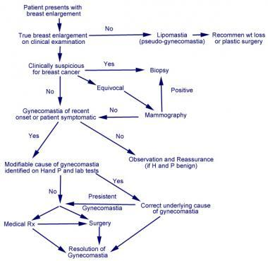
Figure 1: Suggested Algorithm for the Management of Gynecomastia
Breast Surgery-Reduction mammoplasty is considered for patients with macromastia or long-standing gynecomastia or in persons in whom medical therapy has failed. It is also considered for cosmetic reasons (and for accompanying psychosocial reasons).More extensive plastic surgery may be required in patients with marked gynecomastia or who have developed excessive sagging of the breast tissue due to weight loss. If surgery is necessary for patients with pseudogynecomastia, liposuction may be warranted. Complications of surgery include sloughing of tissue due to a compromised blood supply, contour irregularity, hematoma seroma formation, and permanent numbness in the nipple-areolar area.Reference:http://emedicine.medscape.com/article/120858-overview April2014

16.2 Bilateral Parotid Enlargement
Causes
Some of the possible common medical causes of bilateral parotid gland enlargement may include:
- Adenolymphoma
- Amyloidosis
- Bulimia nervosa
- Cirrhosis of liver
- Cystic fibrosis
- Gamma heavy chain disease
- Adenoid cystic carcinoma

Some of the less common causes of Bilateral parotid gland enlargement may include:
- Heerfordt-Waldenstroem syndrome
- HIV-1 disease
- Malabsorption syndrome
- Mikulicz syndrome
- Mumps
- Pancreatitis, chronic
- Parotid adenoma
- Parotid cancer
- Parotitis, acute
- Pituitary tumour (growth hormone secreting)
- Propylthiouracil
- Sarcoidosis
- Sicca syndrome
LAB TESTS
• Angiotensin converting enzyme (Sarcoid)
HIV test
• Autoantibodies (Sjogren’s) - Rheumatoid factor - Antinuclear antibodies - Anti-SSA, Anti-SSB
• Antineutrophil cytoplasmic antibody;ANCA (Wegener’s)
• Hormone levels (eg. TSH)
Sialadenosis - Etiologies •
Endocrine Disorders - Diabetes Mellitus (1/4) - Hypothyroidism
• Alcoholism (autonomic neuropathy)
• Nutritional Disorders - Bulimia (1/3) - Deficiency condition eg. protein (alcoholism) vitamin (niacin, thiamine, vit. A)
Medications - Direct effect on gland eg. iodine compounds - Drug side-effect (adrenergic, cholinergic) eg. antihypertensives (guanethidine) antiemetics (phenothiazine) antiepileptics (phenobarbital) bronchodilators (isoproterenol)

Sialadenosis
Sialadenosis refers to nonneoplastic noninflammatory swelling in association with acinar hypertrophy and ductal atrophy.
Etiologies fall into 5 major categories.
- Nutritional (eg, vitamin deficiency, bulimia)
- Endocrine (eg, diabetes mellitus, hypothyroidism)
- Metabolic (eg, obesity, cirrhosis, malabsorption)
- Inflammatory/autoimmune (eg, Sjögren disease, Heerfordt syndrome)
- Drug induced (eg, thiourea)
Physical examination shows a nontender swelling that is often bilateral and symmetric but can be unilateral and asymmetric
The differential diagnosis of submandibular sialadenitis and sialadenosis includes the following:
- Infectious (acute) cause - Bacterial or viral disease
- Inflammatory cause - Sialolithiasis, radiation-induced disease
- Autoimmune cause - Sjögren disease, lupus
- Granulomatous cause - Tuberculosis, tularemia, sarcoidosis, catscratch disease, actinomycosis
- Drug-related cause - Thiourea
- Neoplastic (benign) cause - Pleomorphic/monomorphic adenoma, oncocytoma, ductal papilloma, hemangioma, foreign body, ranula, lymphoepithelial cyst
- Neoplastic (malignant) cause - Adenoid cystic carcinoma, mucoepidermoid carcinoma, adenocarcinoma, undifferentiated carcinoma, malignant oncocytoma, squamous cell carcinoma
- Endocrine cause - Hypothyroidism, diabetes mellitus
- Metabolic cause - Vitamin deficiency, cirrhosis, obesity, bulimia, malabsorption
Laboratory Studies
See the list below:
- In evaluating the patient with sialadenitis, steps should be taken in the following order: history, physical examination, culture, laboratory investigation, radiography, and if indicated, fine-needle aspiration biopsy (see History and Physical).
- Laboratory investigations should begin with culture of the offending gland (if possible, prior to the administration of antibiotics).
- Blood cultures should be obtained in the patient exhibiting bacteremia or sepsis.
- As a rule, needle aspiration of a suspected abscess is not indicated.
- Routine electrolytes and complete blood cell count with differential should be obtained to assess for any evidence of dehydration or systemic infection.
- If a diagnosis of autoimmunity is entertained, serum analysis for antinuclear antibody, SS-A, SS-B, and erythrocyte sedimentation rate should be conducted.

Abnormal Uterine Bleeding

Menstrual bleeding is labeled as abnormal based on the frequency of menses, regularity of menses, duration of flow, and the volume of flow.

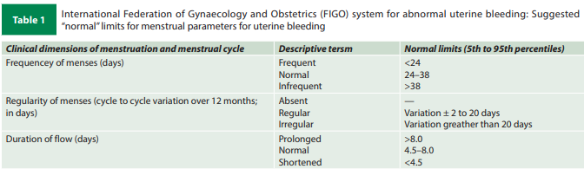

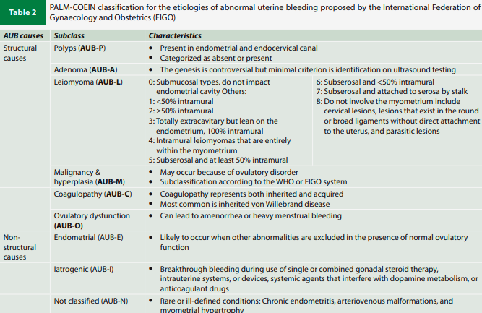

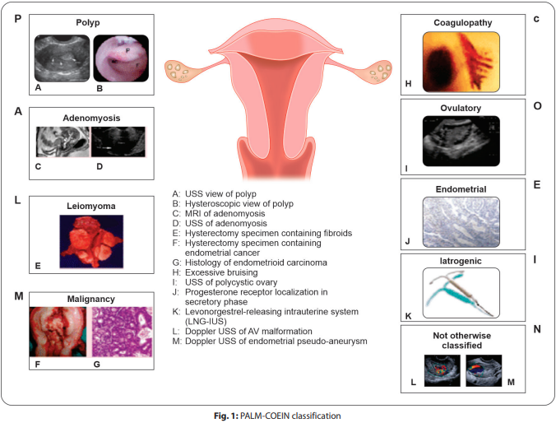

Investigations
- CBC
- TSH
- UPT if applicable
- Trans-abdominal/ Trans-vaginal scan

If acute and excessive bleeding to do
- Bleeding time
- Clotting time
- Platelet count
- PT INR
- aPTT

AUB-P
Endometrial polyp
Definition: Endometrial polyps refer to overgrowths of endometrial glands and stroma within the uterine cavity

May vary few millimeters to centimeters
Seen in reproductive age group to perimenopausal- peak age 40-49 years
Presentation:
- Asymptomatic
- Heavy menstrual bleeding
- Intermenstrual spotting
- Infertility
- Postmenopausal bleeding

O/E:
pallor
abdomen- normal
P/S P/V - if pedunculated polyp- visible through cervical os

USG:
TVS: solitary homogenous lesion with feeding vessel (feeding artery sign on doppler study), if pedunculated - stalk seen, endometrial thickening

Management
asymptomatic- review in 3-6 months
if symptomatic- medical management with cyclical progestins T. Primolut/ Meprate 10 mg OD Day 5-25 for 3 cycles and to review with USG on day 5 of cycle
If polyp >1.5 cm requires- surgical intervention
route: hysteroscopic resection vs polypectomy vs hysterectomy ( consider in postmenopausal bleeding)

AUB-A

Adenomyosis
Definition: Presence of ectopic endometrial glands and stroma in the myometrium

Presentation:
- Heavy menstrual bleeding
- Menometrorrhagia
- Congestive dysmenorrhea
- Pelvic pain
- Dyspareunia

Risk factors:
- Multiparous women
- Early menarche
- short menstrual cycles
- elevated body mass index
- Medications (oral contraceptive pill use, tamoxifen use) and
- prior uterine surgery (dilation and curettage, cesarean section, myomectomy)

O/E:
P/V: boggy, enlarged and tender uterus present

Diagnosis:
- Ultrasound(TVS):

The MUSA (Morphological Uterus Sonographic Assessment) criteria ( 2 or more)
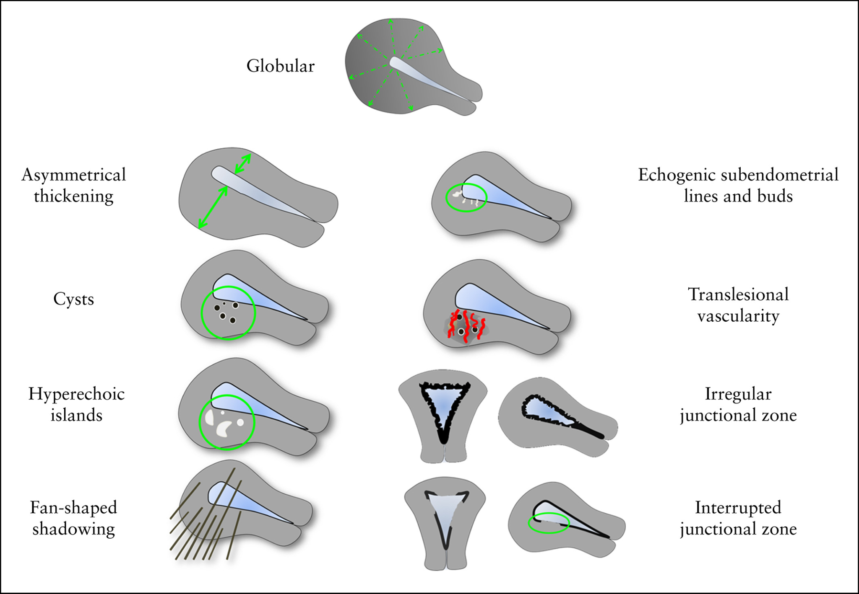

MRI pelvis indicated only for adenomyoma focal adenomyosis) and if gross anatomical alteration

Treatment
- Medical management: NSAIDs ( mefenemic acid), oral progestins, LNG-IUS (Mirena), gonadotrophins
- Surgical: hysterectomy, fertility preserving ( adenomyomectomy in focal adenomyosis)
- Minimally invasive : Endometrial ablation, uterine artery embolisation, MRGFUS

AUB-L
Leiomyoma
Definition: Uterine leiomyoma also known as uterine fibroids are benign tumours of myometrial origin and are the most common solid benign uterine neoplasm

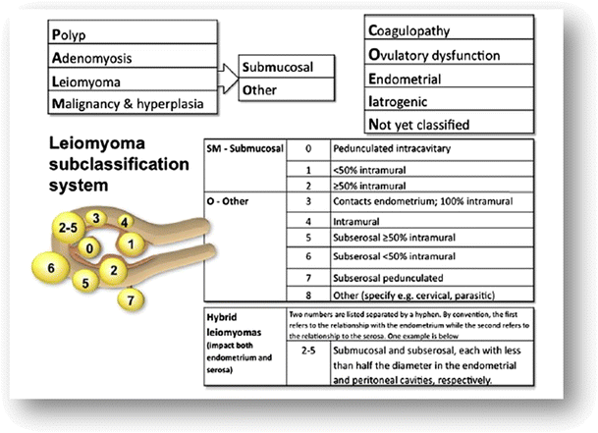

History and presentation
- Incidental finding
- Heavy menstrual bleeding
- Dysmenorrhea
- Subferility
- Intermenstrual bleeding
- Pressure symptoms- urinary obstruction, constipation, mass perception
- Anemia related symptoms- easy fatiguability, shortness of breath, giddiness
- Adverse pregnancy outcomes

Examination
- Pallor
- P/A: uniformly enlarged uterus, arising from pelvis with limited craniocaudal mobility and good side to side mobility
- P/S: cervical fibroid

ACOG recommends TVUS is the initial screening test for AUB and MRI as second-line to be used when the diagnosis is inconclusive, further delineation would affect patient management, or coexisting uterine myomas are suspected.

Treatment
LNG IUS
Oral progestins (luteal phase D15-D28) for 3 cycles
COC ( EE+norethisterone) Mala D for 3 cycles
Submucosal fibroid- for hysteroscopic resection
Failed medical management - for surgical management

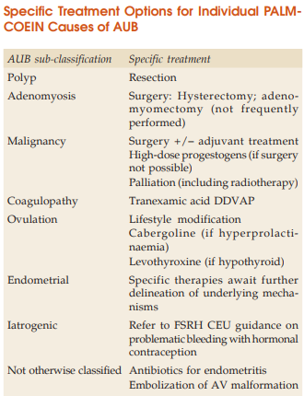
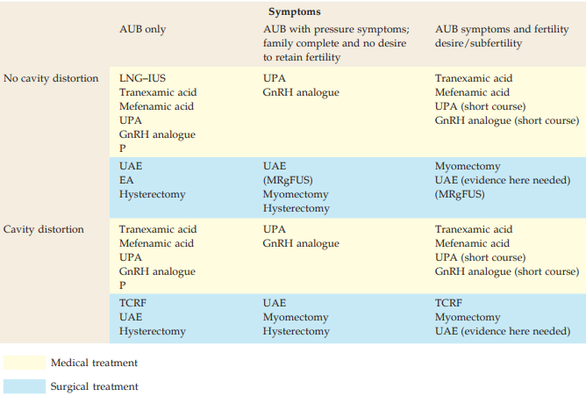

General management guidelines Recommendations of AUB-COEIN:
1. Tranexamic acid is the first-line therapy alone or in combination with NSAID
2. In women desiring effective contraception, LNG-IUS is recommended (Grade A; Level 1)
3. Cyclic oral progestins (from day 5–25) are recommended as the second-line therapy (Grade B; Level 1).
- COCs are recommended in patients desiring effective contraception, but unwilling or unsuitable for LNG-IUS (Grade A; Level 4).
- Centchroman is an option when steroidal hormones and other medical options are not suitable (Grade B; Level 3)
- Use of cyclic luteal-phase progestins is not recommended as a specific therapy for managing AUB (Grade A; Level 4).
- GnRH agonists are recommended as a last resort when medical or surgical treatments for AUB have failed or are contraindicated (Grade B; Level 4).10
- Conservative surgeries, such as ablation, are less often used these days, with increasing popularity of LNG-IUS as a medical ablative therapy.

